REFLECTOR
Newsletter of
St. Paul Lutheran Church
147 West Forest Street
Clyde, Ohio 43410-0296
March 2024


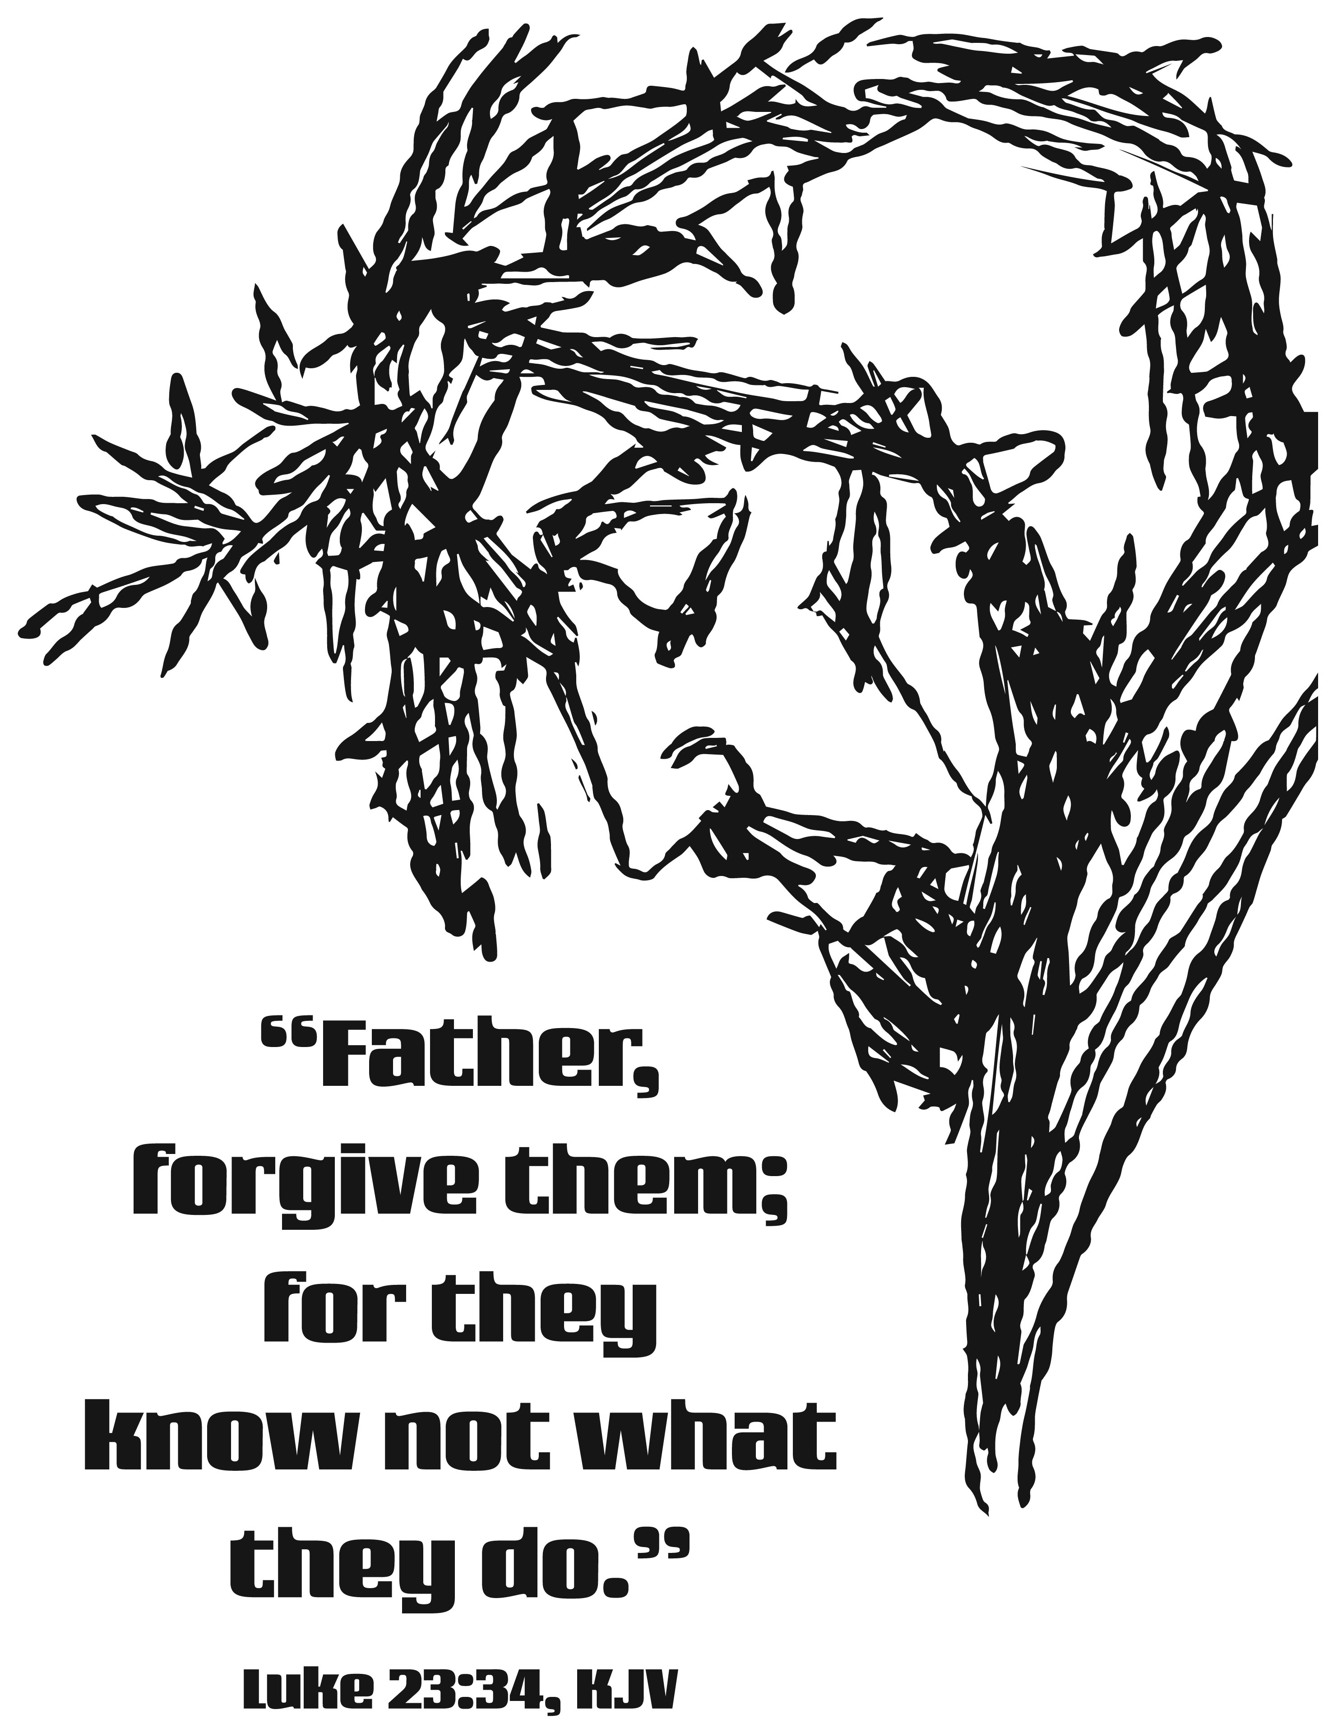



INSIDE - HIGHLIGHTS

Pastor’s Message 2 – 4 March 2024 Birthday’s/Baptism’s 18
Annual Congregational Meeting Comments 5 & 7 March 2024 Calendar 19 & 20
Cross of Lilies & Easter Plant Order Forms 8 Kid’s Page 21
Thank You’s 9 – 11 February 15, 2024 Council Comments 22 – 29
For Your Information 11 – 17



Grace and peace to one and all of my brothers and sisters at St. Paul!

It’s cold, it’s dark, it’s Lent! Many of us say, “Yuck!” Our lives are so busy, so complicated. And during Lent we add even more! Six mid-week services, starting on Ash Wednesday, which shares this particular Wednesday with St Valentine. Valentine was an early church martyr, which we will remember on Ash Wednesday.

The midweek Lenten services will look at our spiritual gifts. Do you know what gifts were given to you by the Holy Spirit when you were baptized? These gifts are the way our good Lord is using you to extend the reign of God!

Each week we will look at 4 gifts and ask ourselves how these gifts can be used at St Paul and in our homes, among our friends. Look for a Spiritual Gifts survey at each entrance. Later in the month, on the 28th, we come to the holiest time of the year, celebrating Maundy Thursday. On Good Friday we are permitted to cry! Holy Saturday begins in grateful anticipation. And then on the last day of March, as the weather if hopefully warming, and every day sees more light, we gather in absolute joy to announce here and everywhere, “HE IS RISEN!! HE IS RISEN INDEED!”

And why celebrate at all, you ask? Because without Jesus, with Jesus taking on OUR sin, we would have absolutely no hope of surviving our own death. Jesus paid the price! He paid our entrance fee into heaven. All because He loves you and me. The gift of thanksgiving, hope, love for our Lord is why we celebrate Holy Easter!

Blessings, all!
Pastor Tim+

              

* * * * * * * * * * * * * * * * * * * * * * * *
GIFTED BY THE SPIRIT!
2024 Lenten Series
When we were baptized, we were given the Holy Spirit as our constant companion. With the Holy Spirit came gifts! Sealed with the cross of Christ, we were also given one or more special, spiritual gifts. On Ash Wednesday, we will have at each doorway a simple Spiritual Gifts Survey for you to take home. Our 7 p.m. mid-week services will gather for prayer and look at four Spiritual Gifts each week for five weeks.

Wednesday, February 21, 2024 ~ we will look at four related spiritual gifts. Wisdom, Teaching, Preaching, Pastor.

Wednesday, February 28, 2024 ~ we will look at Faith, Tongues, Mercy and Hospitality.

Wednesday, March 6, 2024 ~ we will look at Healing, Poverty, Discernment, Prayer

Wednesday, March 13, 2024 ~ we will look at Miracles, Prophecy, Leadership, Evangelism

Wednesday, March 20, 2024 ~ we will look at Service, Giving, Knowledge, Martyrdom

Join us during Lent, to understand our gifts better and to love our Lord even more!

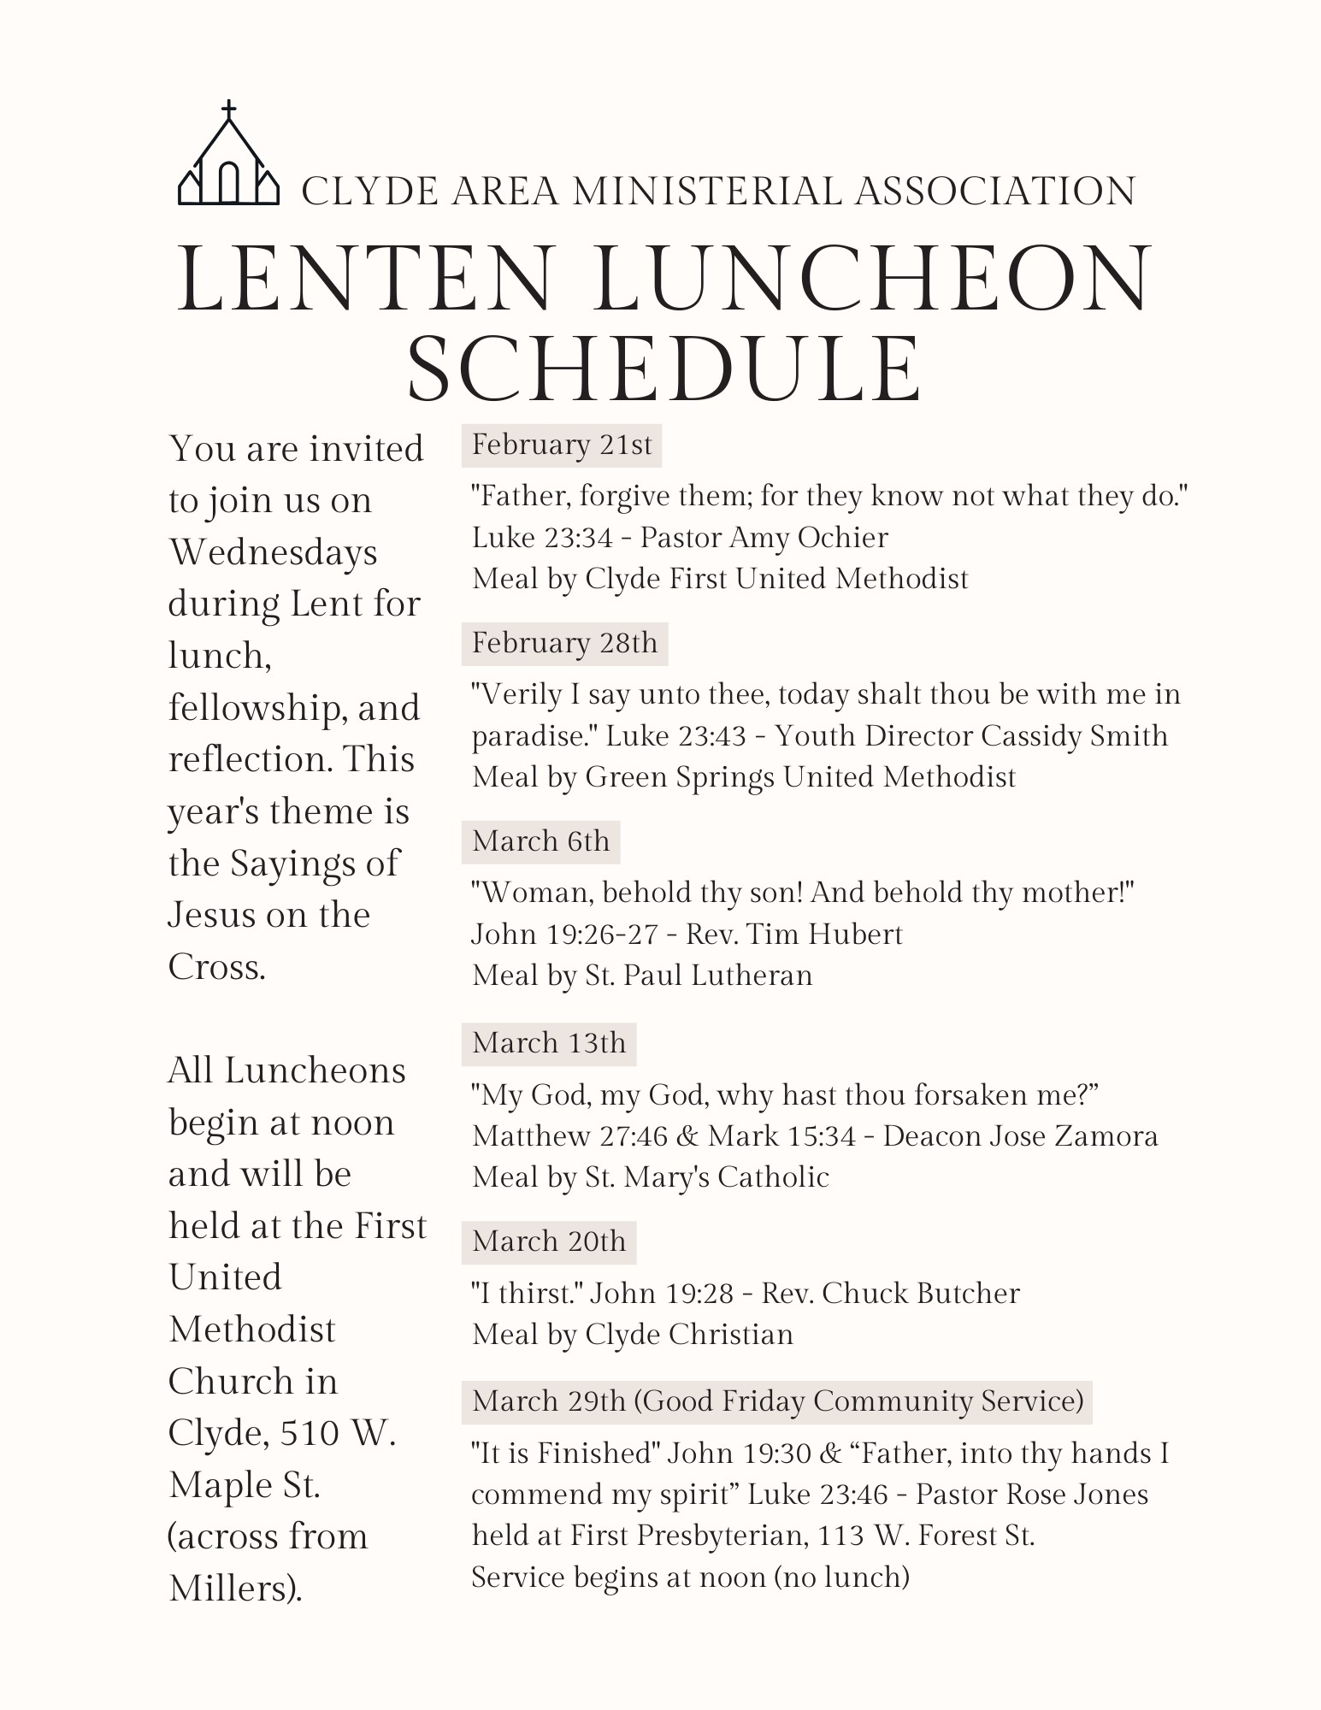

St. Paul Lutheran Church 153rd Annual Congregational Meeting
January 28, 2024
(Unapproved Minutes---will be approved at the Annual Meeting in 2025)

The 153rd Annual Congregational Meeting was called to order by Council President, Kevin Larkins, at 12:55 p.m. following a pot-luck luncheon.

Pastor Tim Hubert opened with prayer.

Attending were 53 members who signed the registry.

Gerry Gosnell moved to accept the minutes of the 152nd Congregational Annual Meeting. Jeff Haughawout seconded the motion.
Motion carried. Minutes approved.

OLD BUSINESS: None

PASTORAL REPORT: See page 4 of Annual Report

CHURCH COUNCIL REPORTS:

EVANGELISM & SOCIAL BOARD: See page 7 of Annual Report. Jim Sieger thanked the congregation for attending social events and for their help in the kitchen on event days.

PARISH EDUCATION & YOUTH BOARD: See page 8-9 of Annual Report. A video containing youth events from throughout the year was played. Cassidy Smith, Youth Director, gave a testimonial and requested help from the congregation for CCYG as she would like CCYG to be weekly and year-round. She reported that Kalahari was great, CCYG is good, and great things are happening in the youth in Clyde. Her overall message was “Love people well”.

PROPERTY: see page 10 of Annual Report. Steve Jess addressed the congregation with a list of repairs/upgrades made in 2023 and future needs of the church to include: cleaning white off front doors, refinishing west doors with consideration of an awning to protect them from the direct sunlight they incur, spruce up downstairs, Parish Hall floors

refinishing, and although money was raised for the numerous capital improvements, by the time they got to the parking lot across the street, the price has increased drastically and can no longer be completed with the money left from that campaign.

STEWARDSHIP & FINANCE: see page 11-12 of Annual Report. Tim Billings explained to the congregation the 2023 worship offering was down compared to 2022. Expenses were down as well, mostly due to payroll. This will not be the case in 2024, so expecting a tough year to come. The Budget Summary was presented and can be located on page 29 of the Annual Report.

WORSHIP BOARD: see page 13 of Annual Report.

OTHER REPORTS

ENDOWMENT COMMITTEE: see page 18 of Annual Report.
Kendall Stuckey moved to distribute money as allocated on the endowment committee annual report. Fred Bouyack seconded the motion. Motion Carried.

Kendall Stuckey moved to retract/vote down the previous distribution as new information was provided that increased the allocation of monies by $10,000. Erin Williams seconded the motion. Motion Carried.

Kendall Stuckey moved to increase total allocations by $10,000, allocating $20,000 from the Mary E. and Burton C. Schwochow Fund to the General Fund of St. Paul Lutheran, $25,000 from the Richard Krauss Youth and Family Ministry Fund to be used for the Youth Director’s Salary, and the rest as written in the endowment committee annual report. Erin Williams seconded the motion. Motion Carried.

Other reports to include the DISASTER RELIEF FUND, GOOD SAMARITAN COMMTTEE, MEMORIAL COMMITTEE, THE WOMEN OF ST. PAUL LUTHERAN CHURCH, ST. PAUL WOMEN’S MISSION ACTION COMMITTEE, ST PAUL LUTHERAN WOMEN 2023 FINANCIAL SUMMARY, AUDIT COMMITTEE, BUDGET COMMITTEE SUMMARY were reviewed with no action.

TREASURER’S REPORT: see pages 30-43 of Annual Report.

Erin Williams moved to accept the treasurer’s report as printed. Tammy Baker seconded the motion. Motion Carried.

Erin Williams moved to accept the budget as printed. Kendall Rieman seconded the motion. Discussion on worship offering ensued. Motion Carried.

NEW BUSINESS:
- Jeff Haughawout requested information on 10:30 service questionnaire and the results. Brandis Stout and Mel Cook reported that a summary was posted by the Worship Board; however, specifics were not provided because some comments were offensive. The summary was subsequently read by Brandis to those in attendance and will be reposted in an upcoming Reflector.
- Deb Arnold questioned whether the 10:30 service was considered Lutheran. As reported in the worship board summary, they did in fact discuss this with visiting pastors as well as Pastor Tim and it contains the necessary elements to be considered a Lutheran Worship Service.
- Steve Jess discussed the lighting issue in the Sanctuary. He reported that our lighting panel for the sanctuary continues to decline and it becomes increasingly difficult to find incandescent bulbs that can be dimmed. To resolve this the following is needed:
  - A new dimmer panel (equipment only) with quotes at $10,500
  - Installation of dimmer panel with quotes at $9800 and $9900

Jeff Haughawout moved to replace the dimmer panel, relamp the sanctuary, purchase LED bulbs, and installation not to exceed $25,000. Terry Langham seconded the motion. Discussion of where the money would come from with 3 options provided to be determined by Property, Stewardship and Finance, and the Treasurer and approved by Church Council. Motion Carried.

Gary Gosnell moved to adjourn the meeting. Fred Bouyack seconded the motion. Motion Carried. Meeting was adjourned by President, Kevin Larkins at 2:05 p.m.

Pastor Tim closed the meeting by leading the attendees in a closing prayer.

Respectfully submitted,
Lisa Rieman
Council Secretary

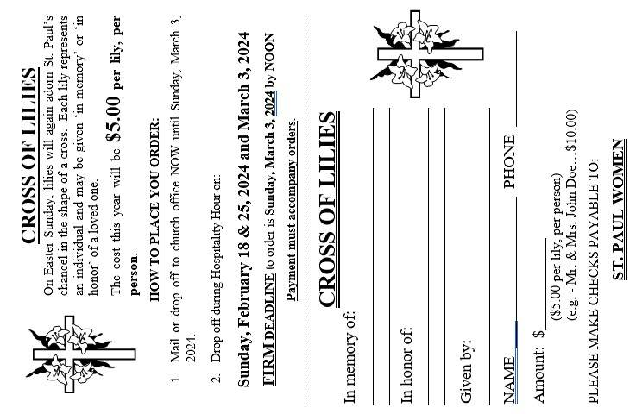
              

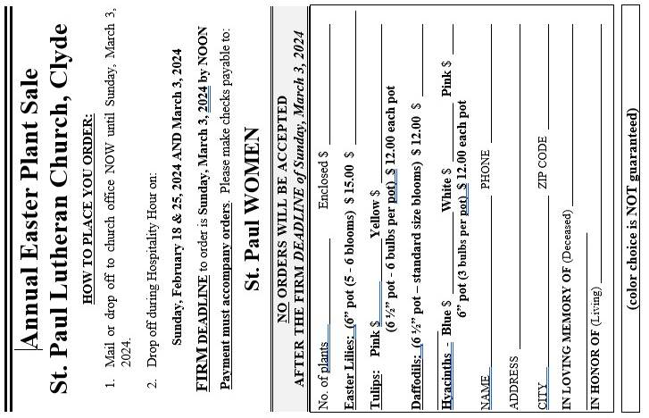


THANK YOU! !

* * * * * * * * * * * * * * * * *

I so much appreciate all the prayers, supportive words, food and cards sent my way since my fall. I am so thankful for my church family and look forward to being with you again.

Becky Zerman

* * * * * * * * * * * * * * * * *

Dear Friends,

Thank you for blessing us with another gift to help change the lives of the “hurts” of this world! We are so grateful for your generosity and compassion towards those needing safe water and the hope of Christ!!

Faithfully Yours,
Ken

* * * * * * * * * * * * * * * * *

Dear St. Paul Lutheran Church,

On behalf of Liberty Center of Sandusky County, I would like to thank you for all of the support that you have given our organization. Because of your total contributions of $1,539.83,

5/10/2023 ~ $469.53
5/10/2023 ~ $548.09
3/30/2023 ~ $522.21

we were able to assist homeless individuals and/or family members.

Sincerely,
Margaret Weisz
Executive Director

* * * * * * * * * * * * * * * * *

Dear St. Paul Evangelical Lutheran Church,

Thank you for your prayers and gifts of $943.86 on January 8, 2024, to support our ministries and workers ~ Diedone & Serafina Panzo.

World Mission Prayer League

* * * * * * * * * * * * * * * * *

Dear Supporter of Community Vision International,

We continue to be very grateful for your faithful partnership through prayers and financial contributions. You made it possible for us to enable visionary consultants (our associates) and the indigenous leaders they work alongside to transform their communities. Your Contributions for 2023 was $500.00 for the Marian E. Humberford.

The Directors, Staff and Associates of Community Vision International

* * * * * * * * * * * * * * * * *

Thanks for your generous donation to Clyde Food Pantry. We appreciate it all so much. And need it so badly. Thanks again.

God Bless You!

Volunteers:
Dana, Denny, Mike, Bruce, Larry, Tom, Sue 1, Sue 2, Sue 3, Sandy Sharon Emily, Ada, Bev

THANK YOU! !


* * * * * * * * * * * * * * * * *

Dear St. Paul Lutheran Church,

Peace and greetings in the name of the Lord Jesus Christ!

We praise God for you and your faithful support of the work and ministry of the NALC. Your generosity and faithfulness to the Lord Jesus Christ and His Church, the NALC, has continues to ensure the strength of our denomination in the future.

Below, please find an overview of your giving to NALC from the past year.

2/28/2023 $261.11
3/27/2023 $234.77
4/16/2023 $274.05

With a total of $769.93

Our prayer is that God will continue to bless you in every way in 2024 and that you, through the power of the Holy Spirit, will be strengthen and renewed in the service to which HE has called you!

In the Love of Jesus Christ,
C. Michael Johnson
NALC Treasurer

* * * * * * * * * * * * * * * * *

I want to thank the members of St Paul for the Miller’s gift card.

Linda Thorbahn

* * * * * * * * * * * * * * * * *
* * * * * * * * * * * * * * * * *

We would like to thank Gerry Gosnell for doing the funeral service for Mark Myles at Foos Funeral Home on December 28, 2023. We appreciate your kind words and thoughtfulness during this difficult time.

Traci Myles, Jenna Jess, Elijah and Dalton

* * * * * * * * * * * * * * * * *

I would like to thank St. Paul Lutheran Church for allowing us to hold Christmas Tree Lane in your parish hall during Winesburg Weekend. We believe we had approximately 400 people visit during the weekend as we had about 360 votes from Friday and Saturday. Thank you to all the groups who decorated a tree to add to our wonderful display of trees. Thank you to Jenna Jess and Alexis Weichman for providing crafts on Saturday and bringing the Grinch with them. And also, to the Women of the Church for holding their Cookie Walk with a great variety of sugary sweets.

Thank you again,

Traci Myles and Deb Bennett

* * * * * * * * * * * * * * * * *

I would like to thank the people of St. Paul for remembering their shut-ins with the altar flowers. Thank you Brandis Stout for your visit and delivery of the flowers. It made a good day for me.

Margaret Bouyack

* * * * * * * * * * * * * * * * *


FOR YOUR INFORMATION

* * * * * * * * * * * * * * * * *

A BIG thank you to all the people who helped set up, prep, serve, clean up and take down before and after the Valentine’s Dinner. Thanks to Bob Kessler, Kendall Stucky and Chris Wood for setting up and taking down tables and chairs. Thanks to Christine Lowe for the cute picture backdrop and helping in the kitchen. Diane Hurst and Katie Speer did a great job decorating the parish hall. Thanks to CCYG for letting us use your decorations! The entire Evangelism and Social Board would like to thank all those who attended the dinner. I’m sure there are people that weren’t mentioned that deserve to be thanked.

Jim Sieger
Chairman of Evangelism & Social

* * * * * * * * * * * * * * * * *


Heidi Bentley-Mendoza
441 South Township Road 1179
Tiffin, OH 44883-1870

Lucy Bush
670 Flat Rock Road – Unit 311
Bellevue, OH 44811-9063

Rev. & Mrs. Edwin Fidler
28520 Westlake Village Dr. – Apt B124
Westlake, OH 44145-6762

Dylan Kimmet
249 West Maple Street
Clyde, OH 43410-1506
* * * * * * * * * * * * * * * * *



WE EXTEND OUR DEEPEST SYMPATHY AND PRAYERS to the family and friends of:

Barbara L. (Berie) Pocock, passed away at the Stein Hospice (Hospice of Northwest Ohio) Sandusky, on Saturday, February 10, 2024.

      

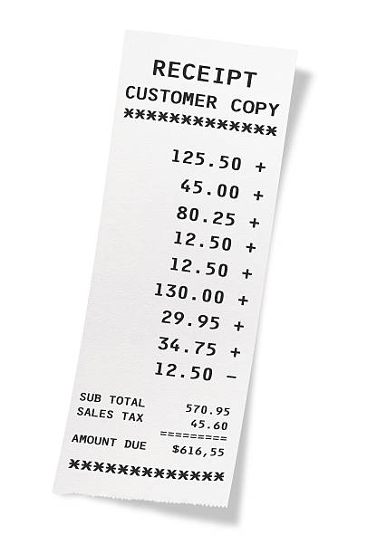

iller’s Super Valu donates to St. Paul Church 1% of the total of all cash register tapes that we save from buying groceries in their store. Keep saving the register tapes! !

M

REMINDER! ! !

February’s grocery receipts are due into the church office by Tuesday, March 12, 2024, so that they may be tallied at St. Paul and turned into Super Valu by Friday, March 15, 2024, for us to receive credit for them. Thank you for your help and cooperation!

FOR YOUR INFORMATION

* * * * * * * * * * * * * * * * *
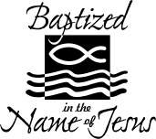

WE WELCOME INTO GOD’S FAMILY through sacrament of Holy Baptism on Sunday, January 28, 2024, at the 10:30 a.m. service, Emma Grace Jones & Riley Parker Jones. Emma was born in Bellevue, OH on May 23, 2019 & Riley was born in Bellevue, OH on January 1, 2018, to Christopher Jones & Ashley Mitchell. Sponsors for Emma & Riley were Ashley Good & Tim Culatta.

* * * * * * * * * * * * * * * * *


We welcome into membership on Sunday, January 28, 2024 @ the 10:30 a.m. service: Millie Burr & Ava Rose Burr. We greet them and receive them into our family at St. Paul.

* * * * * * * * * * * * * * * * *


CCYG
CCYG needs LOTS of empty plastic Easter Eggs by Friday, March 15, 2024.

* * * * * * * * * * * * * * * * *



Nursery Team Schedule for

March 2024

March 3, 2024
Jennie McCoy

March 10, 2024
Dawn Sumner

March 17, 2024
Tammy Baker

March 24, 2024
Ashley Reed

March 31, 2024
Emily Woodland

* * * * * * * * * * * * * * * * *



SET YOUR CLOCKS “1” HOUR AHEAD ON
Sunday, March 10, 2024

FOR YOUR INFORMATION

* * * * * * * * * * * * * * * * *

First Communion class will be held Saturday, March 23, 2024, 11:00 a.m. – 1:00 p.m. in the Parish Hall. A light lunch will be provided. The class is for ages 10 – 15 but is open to all baptized who have not previously participated. Any baptized child may take the course at the discretion of their parents. Parents are encouraged to reach out to Pastor Tim to determine their child’s readiness if unsure. If you or your child are interested in participating and are not yet baptized, please call Stephanie.

Register for the class or get additional information about baptism by calling Stephanie at 419-547-9225.

First Communion will be celebrated on Easter Sunday, March 31, 2024.

* * * * * * * * * * * * * * * * *


St. Paul women will be having a ‘Bake Sale’ on Easter Weekend, Saturday, March 30, 2024 & Sunday, March 31, 2024. We need our bakers to help us out! If you could bake your favorite treats and have them at the church by NOON on Saturday, March 30, 2024, it would be wonderful. Items will be placed on tables in the parish hall with a donation box. Choose your favorite treats and put your donation in the box. This will be available at Saturday night service and both services on Sunday. Through our congregation’s generosity St. Paul women are able to support our various ministries.
* * * * * * * * * * * * * * * * *

* * * * * * * * * * * * * * * * *
ANNUAL
CHICKEN & BISCUIT DINNER
Sunday, March 17, 2024
12:15 a.m. – 1:30 p.m. or sold out

Trinity United Methodist Church
Fellowship Hall
204 North Wayne Street, Fremont

Dinner includes: homemade chicken & biscuits, 2 sides, dessert, beverage

Eat in the Fellowship Hall
or Carry Out Available

For information, please call 419-332-8167

FOR YOUR INFORMATION

* * * * * * * * * * * * * * * * *


If you have a change of address, please notify the church as soon as possible. We are charged for each “Reflector” that is returned. Most of the time that is the ONLY WAY we receive “change of address.” To keep our data base up to date please notify St. Paul by either calling, 419-547-9225 or by email: Sec@StPaulClyde.org Thank you for your cooperation.

* * * * * * * * * * * * * * * * *


DID WE MISS YOUR BIRTHDAY?

Have we missed your birthday or baptism anniversary? If so, we don’t have it in the church database! Please let the church office, 547-9225, know so our records will be complete. Thank you for your help!
* * * * * * * * * * * * * * * * *
St. Paul Communication Information
If you have information for an upcoming event at our church, we would love to help spread the word! Please email all the information to the church office so that it can be posted in the bulletin, on the website, on Facebook, and added to the church calendar.

Include all information so it is complete when it is posted:
- Name & Details of the Event
- Date, Time & Place
- If a RSVP is required, be sure to include:
  - Who to contact
  - How to contact
  - RSVP due date
- Graphics or picture(s) etc.

Email your information to Stephanie at sec@stpaulclyde.org or call her with details at 419-547-9225.

If you have questions for the website or Facebook, contact Mel Cook at support@stpaulclyde.org or 260-450-9575.

* * * * * * * * * * * * * * * * *


My theology is that of the Apostles Creed. I proclaim that the God who is and was and ever shall be; Is my God.

I believe that God the Father is the creator of everything including mankind. I believe that Jesus the Christ the 2nd person of the trinity was conceived by and through the Holy Spirit. Jesus is then born of the Virgin Mary. The Word became flesh and made His dwelling among us. We have seen His glory; the glory of the One and Only, Who came from the Father, full of grace and truth. (John 1:14) NIV.

I believe that Jesus came to earth to serve and above all, save mankind from eternal death. As Jesus suffered a shameful death paying the price of which no man can pay. So that we, you and I may enjoy eternity in Christ forever. “Yes” it is the love of God our heavenly father expressing compassion and love through Jesus that we are forgiven our forever self-centeredness.

I know that Jesus will come a 2nd time to gather the faithful and claim them His own. Are you going to be one of them?

I believe that in the sacrament of holy communion, Jesus is ever so present with in the elements of the bread and wine, “GIVEN”. Jesus is utilizing the elements as a vehicle to enter our very souls, our person and becoming part of us, making us spiritually whole.

Be assured, I believe, in the Holy Spirit, the 3rd person of the trinity know that the Holy Spirit is with us at all times as we experience the tremors of life.

I believe that each and every one of us is born with a sense of right or wrong consensus behavior. The Ten Commandments given by Moses through God are a helpful means of guiding us on the right path leading towards heaven and “GOD”. In the book of Romans 8:1-2 reads that there is no condemnation for those who are in Christ Jesus. For the Law of the Spirit of Life is in Christ Jesus. As St. Paul puts it, it has set us free from the Law of sin and death. For sin separates us from our creator and demerits our relationship with Him. And so, the Holy Spirit is there to lead us in a heavenly direction. I firmly believe that if we maintain a relationship; with God in and through the Holy Spirit we will join the communion of saints in heaven as well as on earth. I just know our sins are forgiven and forgotten through Jesus the Christ and by the Father. And so, I believe that we will be made perfect in the eyes of God as we are resurrected from our sinful nature. We shall live forever with our creator in a world of peace and tranquility.

I believe that the Lord’s Prayer is the most meaningful prayer one can pray. “Why” because Jesus taught us how to pray. Our Father hallowed be Your name, Your kingdom come, Your will be done, on earth as in heaven. Give us today our daily bread. Forgive us our sins as we forgive those who sin against us. Save us from the time of trials and deliver us from evil. For the kingdom, the power and the glory are Yours, now and forever. Amen.

Your Brother in Christ,
Norbert Mayer LC-i

ST PAUL LUTHERAN CHURCH, CLYDE, OHIO
3/2024
SCHOLARSHIP APPLICATION

Name:
Address:
Parents:
Phone Number: Email:
High School GPA: Confirmation Date:

What are your future plans following high school?

What college or tech school do you plan to attend?

High School Activities (clubs, sports, awards)

Community Activities (Scouts, 4-H, etc.)

Church Activities (CCYG, usher, acolyte, choir)

Have you participated in local volunteer activities? (Highway cleanup, helping with Bible School, helping elderly neighbors, etc.)

How has your faith in Jesus Christ and your involvement at St. Paul influenced your life to date?
Two or three paragraphs.



MARCH BIRTHDAYS/BAPTISM ANNIVERSARIES

1 Adam Cunningham
Ian Hilliker
Glenn Misner
4 Allison Barrett
Scott Gray
Mark Pocock
Kevin Powell
Emily Turner
Ronald Watt
5 Cassandra Kelley
Kevin Larkins
Brock Newsome
Kade Newsome
Adam Turner
6 Beverly Bush
Troy Newsome
7 Naomi Gooslin
Jenna (Myles) Jess
Andy Sprouse
Donald Tornow
9 Adam Heminger
Sam Jess
10 Sue Drown
Jacob Lippert
Denise Paul
Ellie Stout
Kim Swartz
12 Colton Wott
13 Bridget Coleman
Alexis Schmidt
14 Mary Waugh
16 Heidi Bentley-Mendoza
Carol Butic
Jace Cook
Vickie Lorentz
Kayla Loudenslager
17 Patsy Aldrich
18 Paul Long
Kevin Shetzer
Sandy Wott
19 Kristen LaFene
Richard Rosen
Kathryn Spence
20 Haley Batesole
21 Travis Smith
Charles Zerman, Sr.

22 Krista Bluhm
Gregory Kuns
Wendy Lippert
23 Judy Campbell
Dylan Kimmet
24 Maegan Brockway
Adam Wahl
Mariah Williams
25 Ashley Reed
26 Alaura Anstead
27 Mary Miller
28 Pastor Kurt Luebkeman
David Wasson
29 Daniel Rogers
LaDonna Tarris
30 Adam Wott
31 Annette Liebold
Kathryn Rosen

MARCH BAPTISM ANNIVERSARY

1 Mike Archer
Tami Schmidt
2 Debra Belcher
Carol Stanley
4 Grace Lantz
6 Sharon Powell
7 Alex Jess
9 Collin Rieman
10 Graham Andrews
Aubriana Manner
Hunter Reed
11 Andrew Bolton
Dorothy Mowry
Robert “Jeff” Shull
12 Mariah Williams
13 Ryan Hall
14 Andrew Zilch
15 Nicholas Baptista
Vincent Garcia
Kari Larkins
Jacob Lippert
Lucile Loudenslager
Christine Potts

16 James Duskin
Beverly Mendoza
17 Claire Pocock
18 Kayla Loudenslager
Betsy Meyer
Karen (Lehmann) Sorg
19 Nicholas Carter
Judy Kuns Dahms
Nick Martinez
20 Ayzreyl Freeze
Ray Freeze, IV
Bryan Leber
Matthew Pocock
Stephen Yates
21 Alexander Barrett
Sue Dinan
Mari Lou Miller
Brooke Ott
Charles Zerman, Sr.
23 Peggie Avers
Ally Sprouse
Autumn Sprouse
26 Kim (Barnes) Heath
27 Matthew Frasher
28 Billy Raypole
Andrea Schoenfeld
Leslie Witt
29 Sandy Wott
30 Bridgette Gooslin
Tamara Myers
Edward Noftz





MARCH 2024
St. Paul Lutheran Church

Sunday | Monday | Tuesday | Wednesday | Thursday | Friday | Saturday
 |  |  |  |  | 1 | 2  8:00 am  Men’s Bible Study  5:00 pm  Holy Communion Worship
3  8:00 am Holy  Communion Worship  9:00 am  Catechism  9:00 am  Sunday School  9:15 am  WOMEN’S Board Meeting  10:30 am Holy  Communion  6:30 pm CCYG  Dartball  Play Off | 4 | 5  6:00 pm  Parish Education & Youth | 6  Noon  1st UMC Lenten Luncheon  7:00 pm  Lenten Service #3 –  “Women, behold they son! And behold thy mother!”  By Rev. Tim Hubert | 7  7:00 pm  Al-Anon Meeting  8:00 pm  AA Meeting | 8 | 9  8:00 am  Men’s Bible Study  5:00 pm  Holy Communion Worship
10  8:00 am  Worship Serv.  9:00 am  Catechism  9:00 am  Sunday School  10:30 am  Worship Service  Dartball  Tournament  Daylight Saving Time BEGINS | 11 | 12  6:00 pm  Property Board | 13  Noon  1st UMC Lenten Luncheon  “My God, my God, why hast thou forsaken me?”  Deacon Jose Zamora  7:00 pm  Lenten Service #4 | 14  5:00 pm  Evangelism / Social Board  6:00 pm  Worship Board  7:00 pm  Al-Anon  8:00 pm  AA Meeting | 15   | 16  8:00 am  Men’s Bible Study  10:00 am  Parish Hall reserved/Food Pantry Pizza Party  5:00 pm  Holy Worship

MARCH 2024
(continued)
St. Paul Lutheran Church

Sunday | Monday | Tuesday | Wednesday | Thursday | Friday | Saturday
17  8:00 am  Holy Communion Worship service  9:00 am Catechism  9:00 am SS  10:30 am  Holy Communion Worship service  6:30 pm – 8:00 pm  CCYG  St. Patrick’s  Day | 18  5:00 pm  Parish Hall reserved / Dartball Banquet | 19  7:00 pm  Stewardship/  Finance Board Meeting   | 20  Noon  1st UMC Lenten Luncheon  “I thirst”  By Rev. Chuck Butcher  7:00 pm  Lenten Service #5 | 21  Reflector Deadline/  noon  7:00 pm  Church Council  7:00 pm  Al-Anon Meeting  8:00 pm  AA Meeting | 22 | 23  8:00 am  Men’s Bible Study  11:00 am  1:00 pm  First Communion Class in parish hall & kitchen  5:00 pm  Holy Communion Worship
24  8:00 am  Holy Communion Worship service  9:00 am Catechism  9:00 am  Sunday School  10:30 am  Holy Communion Worship service  3:00 pm Bunco | 25   | 26 | 27  9:00 am  Quilt Ministry | 28  7:00 pm  Maundy Thursday Service @ St. Paul  7:00 pm  Al-Anon Meeting  8:00 pm  AA Meeting | 29  Noon  Good Friday Service @ 1st Presbyterian Church  “It is Finished” & “Father, into thy hands I commend my spirit”  By Pastor Rose Jones  (NO LUNCH)  7:00 pm  Good Friday Service @ St. Paul | 30  8:00 am  Men’s Bible Study  5:00 pm  Easter Vigil Service
31  8:00 am  Easter Service  9:00 am Catechism  9:00 am SS  10:30 am Easter Service/baptism |  |  | 


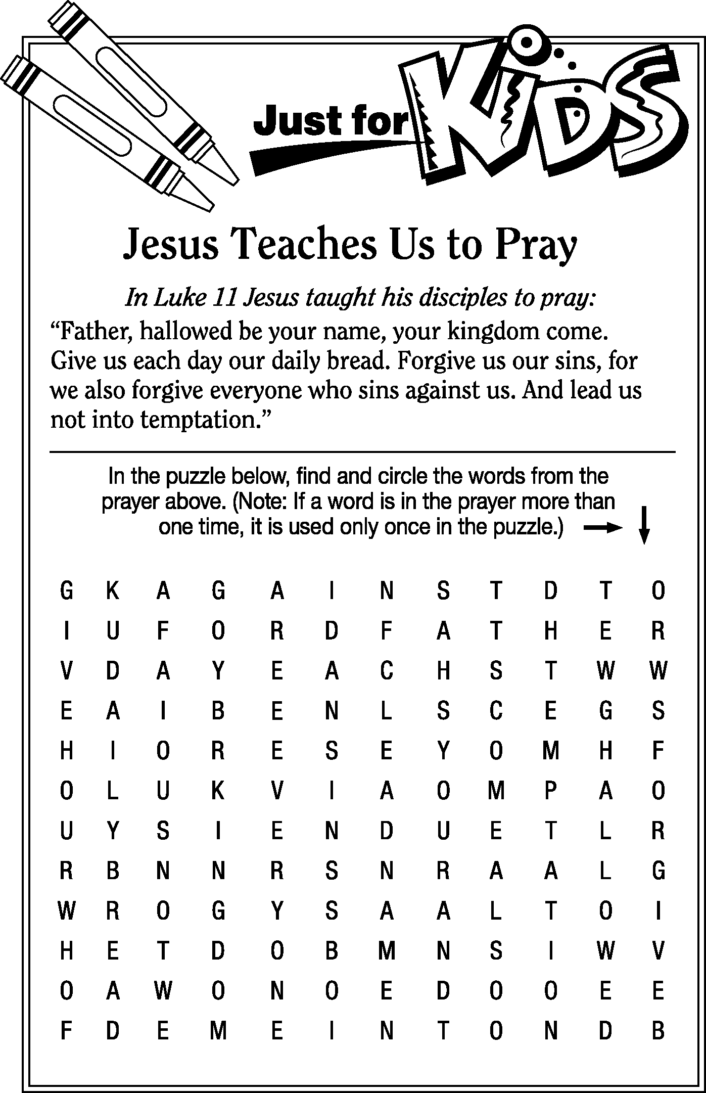

Council Minutes
St. Paul Lutheran Church

Thursday, February 15, 2024

Tammy Baker: Present Tom Billings: Present
John Glass: Absent Diane Hurst: Present
Steve Jess: Present DeAnn Krauss: Present
Terry Langham: Present Kevin Larkins, President: Present
Jennifer McCoy: Present Lisa Rieman, Secretary: Present
Jim Shull, Treasurer: Present Katie Speer: Present
Matt Woodland, Vice President: Present Pastor Tim Hubert: Present

Meeting was called to order by President, Kevin Larkins at 7:00p.m.

Devotions were led by Terry Langham.

SECRETARY’S REPORT:
*Tammy Baker moved to accept the minutes from January. Jennifer McCoy seconded the motion. Motion carried.

EXECUTIVE COMMITTEE: Met; will discuss more when issue is resolved.

OFFICIAL ACTS:
- Baptisms: Emma Grace Jones January 28, 2024
Riley Parker Jones January 28, 2024

- New Members: Ava Rose Burr January 28, 2024
Millie Burr January 28, 2024

PASTORAL REPORT:
Grace and peace to each and every one of you!

George Washington sat in a now famous chair throughout the Constitutional
Convention. Benjamin Franklin, at the end of that convention remarked that he
had wondered if the sun carved into the back of the chair was had been rising or
setting, an analogy to this newly minted United States. He believed the sun was
rising, we had a chance as a country.

We have signs among us too, that St Paul is healing and growing. Thanks be to
God!

I spoke last month about 2 baptisms and 2 new members. This month I speak
about a 17-year-old young man who will be baptized on Easter Sunday
morning. We continue to have visitors checking us out!

There are other signs of healing that I will talk about later. You saw the need
for healing at our last Congregation Meeting.

This morning, we welcomed pastors from the North Central Ohio Mission
District, NALC to St Paul for our monthly meeting. We began in worship, met
in conference and enjoyed a delightful repast!

Wednesday, February 28 at noon, at Clyde 1st Methodist, Cassidy Smith will
speak on the second word from the cross.

Wednesday, March 6, same time and place, I will speak on the third word from
the cross. St Paul provides the meal that day.

I announced last month my grandchildren’s birthday would be sometime in
March, their birth month. Turns out it will be April 6 in Wisconsin. Pr Gerry
has graciously agreed to supply for me that weekend. I apologize for taking a
weekend off. I love our worship together. I love sharing the Good News of
Jesus Christ!

Blessings to each and every one of you!
Pr Tim+

ENDOWMENT COMMITTEE:
St. Paul Lutheran Church
Endowment Committee Minutes
February 7, 2024
Diane Hurst, CC Rep Present
Tom Billings Present
Tony Paradiso, Recording Secretary Absent
Jim Shull, Treasurer Absent
Tim Billings Present
Bev Mendoza Present
Deb Arnold, outgoing secretary Present
Walt Frazier Absent
Deanna Turner Present
Gary Wott, Chairman Present
Barb Gosnell Present
Kendall Rieman Absent

Devotions: Deanna Turner

Secretary’s Report: Deanna Turner read the minutes from the November 15, 2023 meeting. It was noted that wording of “re-elected” to the committee needed to be corrected to “elected” to the committee. Tom Billings moved to approve the minutes as corrected from the November 15, 2023 meeting and Barb Gosnell 2nd the motion, the minutes were APPROVED.

Financial Secretary Report: Deb Arnold presented the financial report as of February 7, 2024. There was discussion over disbursement for both the Schwochow and Mission fund and the need to adjust the percentage to balance the spreadsheet. Tom Billings moved to disperse funds according to congregational approval. Barb Gosnell 2nd the motion. Motion APPROVED.

Reviewed front end transfer amounts as follows:
Mission Endowment Fund - $292/monthly
Capital Improvement Fund – last payout $1,300
Schwochow Fund - $1667/month
Kraus Fund - $2083

Deanna Turner moved to approve fund end transfers as proposed, motion 2nd by Tom Billings. Motion APPROVED.

Deanna Turner moved to accept the financial report, Tom Billings 2nd the motion, motion was APPROVED.

Deb will work with new Financial Secretary to transition duties.

Old Business: The Mission Endowment Fund distributions were approved at the
Congregational meeting on January 28, 2024.

CCYG (Clyde Community Youth Group) $1,600.00
Margaret Hilliker - Mission trip $ 500.00
Heffer International $ 500.00
Water Missions International $ 500.00
Clyde Back Door Food Pantry – Incidentals/Trailer $ 400.00

New Business:
Election of 2024 Officers: Barb Gosnell moved to nominate the following officers for 2024:
Chair – Gary Wott
Financial Secretary – Tom Billings
Recording Secretary – Tony Paradiso with Deanna Turner as back up.

Tom 2nd the motion. Motion APPROVED.

Next Endowment Committee Meeting: Wednesday, May 15, 2024 at 7:00 PM

Devotions: Tom Billings

Chairman Gary Wott led the committee in closing the meeting with the Lord’s Prayer.

Submitted by: Deanna Turner, interim Recording Secretary

EVANGELISM AND SOCIAL BOARD:
-discussed planning for Valentine’s Dinner, which went well. 58 people attended.
-discussed small groups (recovery, bible study, young mothers, etc.)
-touched on basement renovations

MEMORIAL COMMITTEE: Did not meet; Scheduled to meet Feb 21, 2024.

PARISH EDUCATION AND YOUTH:
The meeting had the presence of several guests. The whole meeting was in reference to Cassidy Smith’s resignation letter. This letter was given to the Youth Director Support team (Amy Hilliker, DeAnn Krauss & Tony Paradiso) on Thursday, February 1 when meeting with Pastor Tim, Kevin Larkins & Lisa Rieman.

There was much discussion about the letter and Cassidy’s job as the St Paul Youth
Director including CCYG.

The board then met in executive session to discuss further.

Walt Frasher made a motion to not accept Cassidy Smith’s resignation at this time until further discussion with the Parish Education & Youth Board, Pastor Tim, and Cassidy Smith. 2nd by Tammy Baker, motion passed.

We will ask Church Council to approve this motion.

A meeting is set for Saturday, February 17 at 11:00 a.m. with PEY Board & Pastor Tim for further discussion.

Next meeting: Tuesday, March 5, 2024 – 6:00 pm

*Deann Krauss motioned to not accept resignation of Youth Director at this time. Tom Billings seconded the motion. Motion carried.

PROPERTY BOARD:
- downspouts backing up
- getting updated parking lot quotes.
- Received direction from Stewardship and Finance on paying for sanctuary lighting. Currently getting a third quote for installation. Received $336 in donations from the Valentine’s dinner to put toward lighting.
- Brian visited meeting to provide input for basement upgrades; need consensus on what to do moving forward on this project.

STEWARDSHIP AND FINANCE BOARD:
Giving for January 2024 is down from January of 2023 by 16.75%. We took in $20,269 versus $24,348 in 2023

This is below our calculated 12 month budgeted estimate of $28,291 which is normal. January is usually a low/slow month.

Discussed in depth some changes to how the financial secretary provides information to the treasurer and the board to help streamline and reduce her workload.

Making recommendation to distribute first fruits money to the following, each receiving 20%:
NALC, ST PAUL DISASTER RELIEF, LUTHERAN WORLD RELIEF, LUTHERAN SOCIAL SERVICES, NALS (NALC SEMINARY)

Visited by representatives of the property board, Steve Jess and Tom Billings, to ask that funds be made available for the lighting project and repair to the parking lot, that was already approved by the congregation several years ago.

Discussion on where the monies for lighting project and parking lot, totaling $56,000 ensued, with no clear recommendation to council.

Sherry Bouyack will be contacting renter on rent being behind.

Submitted by Tim Billing, chair

*Tammy Baker motioned to accept Treasurer’s Report. DeAnn Krauss seconded. Motion carried.

*Lisa Rieman motioned to accept distribution of First Fruits as recommended by Stewardship and Finance. Jennifer McCoy seconded the motion. Motion carried.

*Tom Billings motioned to take, but not to exceed $25,000 from Property Improvement Fund to pay for lighting project. Steve Jess seconded the motion. Motion carried.

WORSHIP BOARD:
1. Bev Mendoza still seeking members for Chime Choir.
2. Midweek Lenten Vesper, Wednesdays of Lent at 7:00 p.m. also mid-week
Lenten Luncheon at noon at First United Methodist.
3. Worship Board is asking all members to wear their name tags during
services.
4. Feather banners are here, ushers need to put up before services and take
down after services end.

5. Holy Week Schedule, Maundy Thursday, March 28 at 7:00 p.m. with Holy
Communion, Good Friday, March 29 at 7:00 p.m., Saturday, March 30,
Easter Vigil at 5:00 p.m., Easter Sunday services at 8:00 a.m. and 10:30
am.
6. First Communion instructions for ages 10 to 15 will be Saturday, March
23. To include bread baking.
7. Ordering sandwich boards to Welcome all to St. Paul Lutheran Church and
CCYG, to be displayed at church entrances.

OLD BUSINESS: None

NEW BUSINESS:
- Naomi can no longer carry out her position on the Good Samaritan Board. Linda Thorbahn offered to replace her.

*Terry Langham moved to accept Linda Thorbahn to carry out the duration of Naomi’s term on the Good Samaritan Committee. Steve Jess seconded the motion. Motion carried.

NEW EVENTS HAPPENING IN MARCH 2024:
Wednesday, March 6, 13 and 20, 2024 @ Noon ~ Lenten Luncheon @ 1 st UMC
Wednesday, March 6, 13 and 20, 2024 @ 7:00 p.m. ~ Lenten Services @ St. Paul
Sunday, March 10, 2024 ~ Daylight Saving Time BEGINS
Saturday, March 16, 2024 @ 10:00 a.m. ~ Parish Hall reserved – Food Pantry Pizza Party

Monday, March 18, 2024 @ 5:00 p.m. ~ Parish Hall reserved – Dartball Banquet
Saturday, March 23, 2024 @ 11:00 a.m. – 1:00 p.m. ~ First Communion Class in
parish hall & kitchen
Thursday, March 28, 2024 @ 7:00 p.m. ~ Maundy Thursday Service @ St. Paul
Friday, March 29, 2024 @ Noon ~ Good Friday Service @ 1st Presbyterian Church
(NO LUNCH)
Friday, March 29, 2024 @ 7:00 p.m. ~ Good Friday Service @ St. Paul Lutheran
Church
Saturday, March 30, 2024 @ 5:00 p.m. ~ Easter Vigil Service
Sunday, March 31, 2024 @ 8:00 a.m. ~ Easter Services
Sunday, March 31, 2024 @ 10:30 a.m. ~ Easter Services / Baptism / Salazar

Next Meeting: 3rd Thursday, March 21, 2024 at 7:00 p.m.

Devotions next council meeting: Steve Jess

Meeting adjourned at 8:05 p.m. with the Lord’s Prayer.

Respectfully submitted,
Lisa Rieman

NON-PROFIT ORGANIZATION
U. S. POSTAGE PAID
PERMIT #26
CLYDE, OHIO 43410-0296
St. Paul Lutheran Church
147 West Forest Street
PO Box 296
Clyde, OH 43410-0296

ADDRESS SERVICE REQUESTED



Office Phone: 419-547-9225
Pastor Tim Hubert ~ 217-778-8017
Stephanie Stull ~ Office Manager ~ Editor ~ 419-547-9225
Cassidy Smith, Youth Director ~ 517-740-9412
Brian Farrar, P & W Leader ~ 419-271-3085

Pastor’s email: pastor@stpaulclyde.org
Office Manager’s email: sec@StPaulClyde.org
Church Web site: http://www.stpaulclyde.org
LCMC website: http://www.lcmc.net
NALC website: http://thenalc.org
SOLA PUBLISHING website: http://www.solapublishing.org

2024 CHURCH COUNCIL

Tammy Baker – Parish Ed & Youth 419-603-0698 Terry Langham – Evangelism/Social 419-765-0757
Tom Billings – Property 419-765-0279 Kevin Larkins –President – Prop & Worship 567-201-3838
John Glass – Worship 419-680-4033 Jennie McCoy – Stewardship /Finance 419-680-2001
Diane Hurst – Evangelism/Social 419-603-9469 Lisa Rieman – Secre - Evangelism/Social 989-450-2801
Steve Jess – Property 419-307-3042 Katie Speer – Evangelism/Social 419-681-6484
DeAnn Krauss – Parish Ed & Youth 419-937-7514 Matt Woodland – Vice-Pres. –Steward /Fin 419-603-0567

