REFLECTOR
Newsletter of
St. Paul Lutheran Church
147 West Forest Street
Clyde, Ohio 43410-0296
March 2025

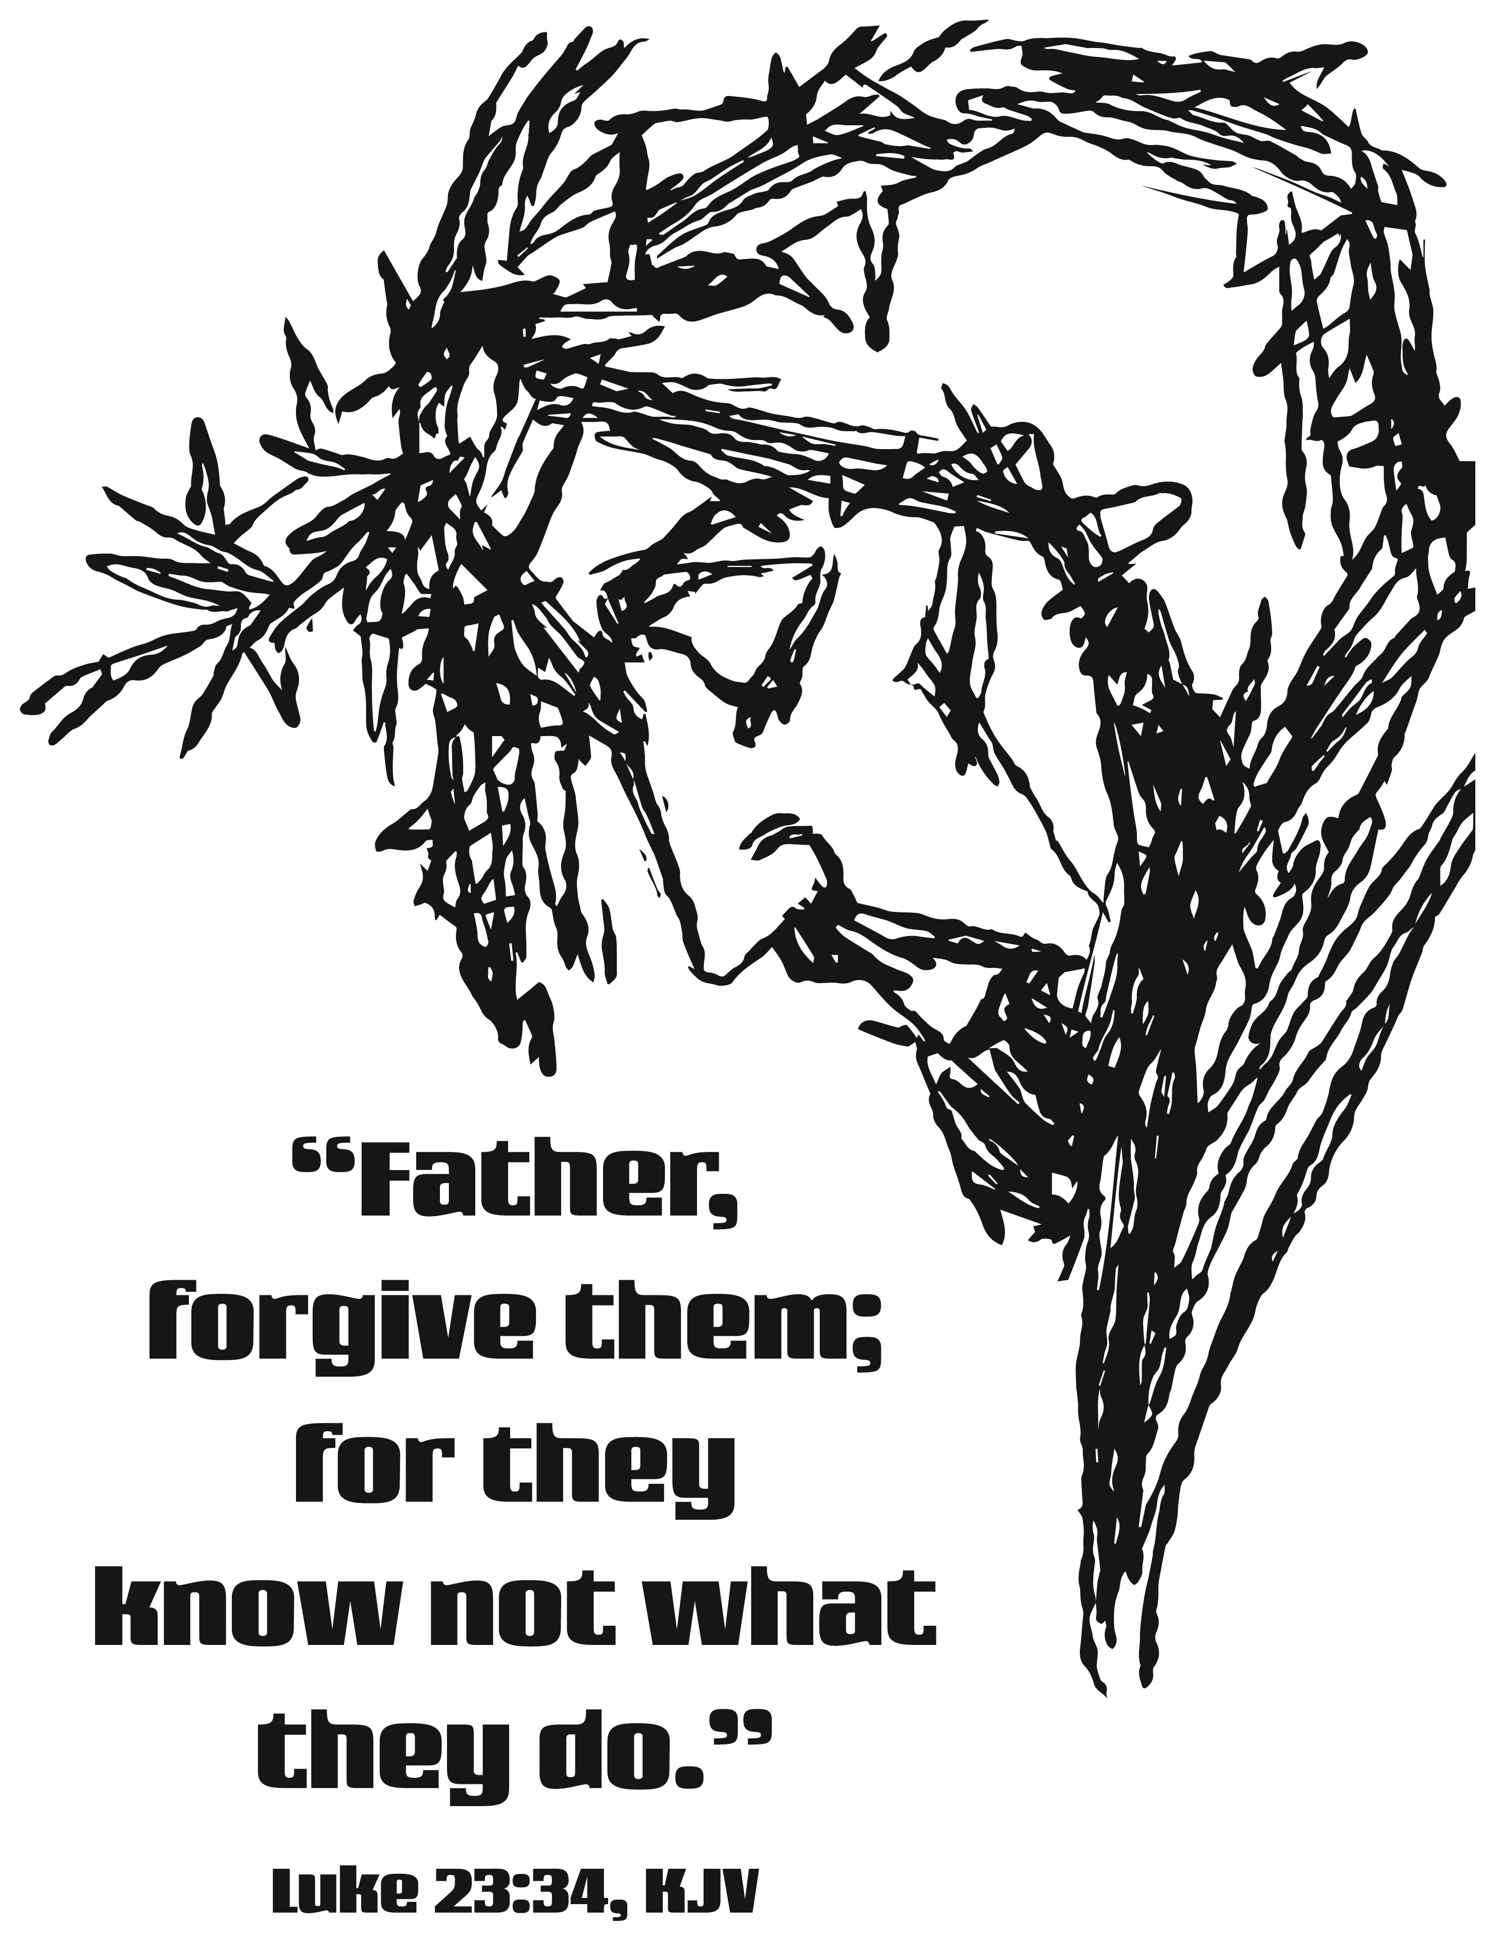



INSIDE - HIGHLIGHTS

Pastor’s Message 2 Scholarship Application Form 12 & 13
Midweek Lenten Services 3 & 4 March 2025 Birthday’s/Baptism’s 14
Call Committee – SAVE THE DATE 5 March 2025 Calendar 15 & 16
Cross of Lilies & Easter Plant Order Forms 6 & 7 Annual Congregational Mtg Comments 19 – 21
Thank You’s 8 February 20, 2025 Council Comments 22 – 29
For Your Information 9 – 11


March 2025

Grace and peace, all!

I would like to begin here with an apology! My fault. My own fault. My own most grievous fault! I shared misinformation. A few weeks ago, I heard from three different people that St Mary’s Roman Catholic church was closing. My care and concern was for both the role that St Mary’s plays in Clyde and for the members of St Mary’s. A few days later, I asked a priest friend of mine about the news. He hadn’t heard anything about St Mary’s closing. A few days after that Deacon Jose contacted me and said the St Mary’s wasn’t closing. I am relieved!

Deacon Jose is writing an apology for me in his newsletter. This is my apology! I’m so sorry! Not all stories are true! If you have friends that attend St Mary’s, please express my apology to them as well! Any congregation that closes is a loss to the whole community. I’m grateful that St Mary’s isn’t closing.

Thank you for your patience with me. I’m not perfect. Only Jesus is, and that is the faith and hope we share with the good people and Deacon Jose at St Mary’s.

Having said that, when our new pastor comes, he or she won’t be perfect either. What can you do about that? Pray for your new pastor. Help your new pastor. Forgive your new pastor. Don’t yell at your new pastor. Don’t spread rumors about your new pastor. Verify everything. I was just reminded myself about that.

And especially, love each other! Love the people in the other services. In fact, visit the other services just to meet and enjoy the people in those services! You may not “groove” to traditional hymns or contemporary songs, but the people are your brothers and sisters in Christ Jesus. Love them well!

Finally, let’s enjoy the healing of Lent, slowing down to reflect on what our sin has done to our Lord, before we celebrate His overwhelming victory on Easter! The color for Lent is purple. Hint, hint!

Peace and Blessings to all!
Pastor Tim+

              

* * * * * * * * * * * * * * * * * * * * * * * *
LENTEN MIDWEEK WEDNESDAY DEVOTIONS!

2025 Lenten Series

Wednesdays @ 7:00 pm @ St. Paul Lutheran Church

Wednesday, March 12, 2025: A Lutheran Looks at Lent
Lent is our time to spiritually prepare for Easter. How does being a Lutheran help us to spiritually prepare? Each week we will look at the Lutheran “Solas” asking where Faith Alone, Word Alone, Grace Alone help us understand Lent!

Wednesday, March 19, 2025: The Lord’s Prayer as Lent
How does being a Lutheran help us pray? How does prayer help us prepare for Easter?

Wednesday, March 26, 2025: The Creed as Lent
Creed is what we believe. What do Lutherans believe?

Wednesday, April 2, 2025: The First Table as Lent
The First Table of the 10 Commandments are numbers 1-3. These are first because these are the most important.

Wednesday, April 9, 2025: The Second Table as Lent
The Second Table of the 10 Commandments are number 4-10 and are an explanation of the First Table, a living out of the First Table.

Join us during Lent! !

       

Clyde Area Ministerial Association
Community Lenten Luncheons Schedule

Wednesdays at noon
All lunches will be taking place at 1st United Methodist Church (Clyde)

THE STATIONS OF THE CROSS

Wednesday, March 12, 2025
“Stations 1 & 2” ~ Jesus prays in the Garden of Gethsemane; Jesus is betrayed & arrested.

Presented by Rev. Gerry Gosnell
Meal by Clyde First United Methodist Church

Wednesday, March 19, 2025
“Stations 3 & 4” ~ Jesus is condemned by the Sanhedrin; Jesus is denied by Peter three times.

Presented by Pastor Amy Ochier
Meal by Green Springs First United Methodist Church

Wednesday, March 26, 2025
“Stations 5 & 6” ~ Jesus is judged by Pilate; Jesus is scourged and crowned with thorns.

Presented by Deacon Norbert Mayer (St. Paul Lutheran Church)
Meal by St. Mary’s Catholic Church

Wednesday, April 2, 2025
“Stations 7 – 9” ~ Jesus takes up His cross; Jesus is helped by Simon of Cyrene to carry His cross; Jesus meets the women of Jerusalem.

Presented by Pastor Rose Jones
Meal by First Presbyterian Church

Wednesday, April 9, 2025
“Stations 10 – 12” ~ Jesus is crucified; Jesus promises His kingdom to the repentant thief; Jesus entrusts Mary and John to each other.

Presented by Rev. Tim Hubert
Meal by St. Paul Lutheran Church

COMMUNITY GOOD FRIDAY SERVICE

Friday, April 18, 2025 held at
Clyde Christian Church, 206 South Main Street, Clyde
@ NOON

(no lunch)

“Stations 13 & 14” ~ Jesus dies on the cross and Jesus is laid in the tomb.

Presented by Rev. Chuck Butcher



SAVE THE DATE! March 22, 2025

The St. Paul Call Committee and the North American Lutheran Church invite you to participate in a workshop determining our top ministry needs for our next Pastor. ALL adult members of St. Paul are invited to a Congressional Workshop on March 22, 2025. The workshop will begin at 9:00 am in the worship hall and end at about 2:30 pm. Lunch will be served by the Women of the Church.

In this workshop, we will study Biblical guidance for what it means to minister as disciples of Christ. We will use that knowledge to assess our congressional strengths, acknowledge our growth areas, and heal from past hurts. Together we will form a refined vision of our congregation - who we are, and who we want to be. We will begin to open our hearts to the Pastor that God intends for St. Paul.

Your insights, ideas, and experiences are important! Every member of St. Paul has something to share. Please, prayerfully consider attending this workshop!

Materials including Bibles and writing tools will be provided. A sign-up sheet will be provided during each service in the weekend(s) leading up to the workshop.

CROSS OF LILIES
On Easter Sunday, lilies will again adorn St. Paul’s chancel in the shape of a cross. Each lily represents an individual and may be given ‘in memory’ or ‘in honor’ of a loved one.
The cost this year will be $5.00 per lily, per person.

HOW TO PLACE YOU ORDER:

- Mail or drop off to church office NOW until Monday, March 31, 2025.
- Drop the orders off in green boxes.

FIRM DEADLINE TO order is Monday, March 31, 2025, by NOON

Payment must accompany orders.

CROSS OF LILIES
In memory of:

In honor of:

Given by:

NAME PHONE

Amount: $
($5.00 per lily, per person)
(e.g. - Mr. & Mrs. John Doe…$10.00)

PLEASE MAKE CHECKS PAYABLE TO:

ST. PAUL WOMEN

Annual Easter Plant Sale
St. Paul Lutheran Church, Clyde

HOW TO PLACE YOU ORDER:

- Mail or drop off to church office NOW until Monday, March 31, 2025.
- Drop the orders off in green boxes.

FIRM DEADLINE to order is Monday, March 31, 2025 by NOON

Payment must accompany orders. Please make checks payable to:

St. Paul WOMEN

NO ORDERS WILL BE ACCEPTED
AFTER THE FIRM DEADLINE of Monday, March 31, 2025
By NOON
No. of plants Enclosed $

Easter Lilies: (6” pot (5 - 6 blooms) $ 15.00

Tulips: Pink Yellow Red
(6 ½” pot - 6 bulbs per pot) $ 12.00 each pot

Daffodils: (6 ½” pot – standard size blooms) $ 12.00

Hyacinths - Blue White Pink
6” pot (3 bulbs per pot) $ 12.00 each pot

NAME PHONE

ADDRESS

CITY ZIP CODE

IN LOVING MEMORY OF (Deceased)

IN HONOR OF (Living)

(color choice is NOT guaranteed)

THANK YOU! !

* * * * * * * * * * * * * * * * *


The Worship Board would like to thank “WILL MILLER” for so graciously volunteering to make the lovely crosses for our “All Saint’s Cross Board” and the “Baptismal Crosses”. Again, Thank You “Will” for sharing your God’s given gift of talent in this way!
* * * * * * * * * * * * * * * * *

Dear Friends,

I am deeply grateful for your generous gift to Samaritan’s Purse. Your support – and especially your prayers – are a tremendous blessing as we relieve suffering in Jesus’ Name.

Samaritan’s Purse has teams and equipment in California preparing to help families by sifting through the ashes of what once were their homes to search for meaningful items that may have survived the flames. We also continue to work in four states in the wake of Hurricane Helene. We have begun the long process of repairing and rebuilding houses and replacing mobile homes for hundreds of families in western North Carolina and eastern Tennessee and we are assisting churches as they repair and rebuild.

As we work in crisis situations here and around the world, we want people to know that God loves them and has not forgotten them. We would appreciate your continued prayers. May God bless you.

Sincerely,
Franklin Graham

* * * * * * * * * * * * * * * * *

Thank you to the women of St. Paul for the luncheon following my sister Mary’s funeral. Thank you for all the kind words, prayers and cards during her illness and passing. Also, many thanks for the “Good Cheer Bad” that she received before Christmas. Thank you, Pastor Tim, for the visits and the food for her journey!

God Bless You All,
Diane Hurst

(sorry Diane for the oversite of placing this
Thank You in last months Reflector)

* * * * * * * * * * * * * * * * *

St. Paul family & friends,

Thank you for being part of Mildred House’s homegoing! The Pastor, the ladies, the delicious food, the friendship over the decades! We so appreciate all that you did to make our day less stressful – missing mom but celebrating that she is home!
Thank you!
The “House girls”,

Marilyn Bennett
Barb Mraz
Cindi Arbogast
Ronda Robey

* * * * * * * * * * * * * * * * *

Thank you to DeAnn Krauss for delivering the beautiful chancel bouquet. They brightened up our day.
Blessings,
Linda Thorbahn

THANK YOU! !

* * * * * * * * * * * * * * * * *

Dear Valued Supporter,

Thank you so much for your contribution to Pontifex in 2024. We are very grateful for your generous donation which allows us to do so much for people in need in our community!

Your contribution has made it possible for us to continue our weekly food box outreach, soup kitchens, showers for the homeless, shelter when temperatures are dangerous, our Community Christmas and many other ways to help people in our community.

Thank you again for your faithfulness in your contribution of $522.00!

Janis Nowak ~ President/Founder
Samuel Dagg ~ Vice-President

* * * * * * * * * * * * * * * * *


There will be a Special Farewell Breakfast for Gerry & Barb Gosnell on Sunday, March 23, 2025, at 9:00 am. Join us to wish them well in this new chapter of their life.

* * * * * * * * * * * * * * * * *
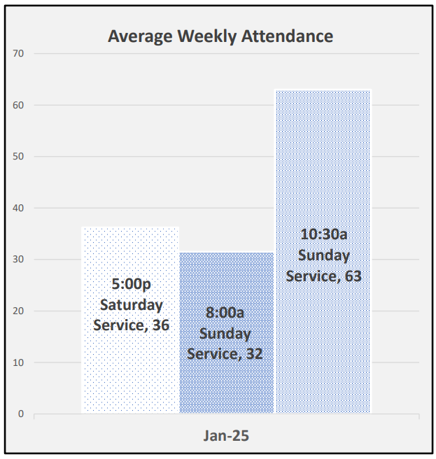
* * * * * * * * * * * * * * * * *
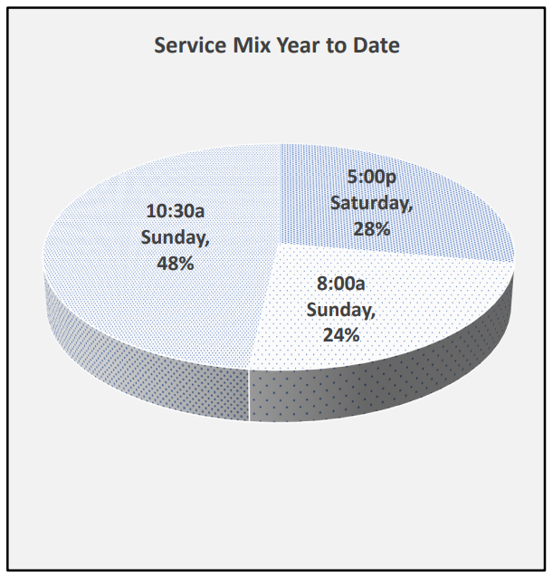

FOR YOUR INFORMATION


* * * * * * * * * * * * * * * * * * *


WE EXTEND OUR DEEPEST SYMPATHY AND PRAYERS to the family and friends of:

Starleen Sue (Weilnau) Meyer, passed away unexpectedly in Ft. Pierce, Florida surrounded by her loving family on Friday, January 23, 2025, from a massive stroke,

And to the family and friends of:

Jane Burkett Perrin, passed away on Tuesday, January 28, 2025. Funeral will be held at a later date.

* * * * * * * * * * * * * * * * *


Nicholas & Rachael Baptista
1840 County Road 296
Bellevue, OH 44811-9450

Mike & Joely Beeker
105 Caleb Drive
Clyde, OH 43410-3009

* * * * * * * * * * * * * * * * *

WELCOME
MARY ELLEN WOLLENSLEGEL

Please welcome Mary Ellen Wollenslegel as accompanist/pianist for this Saturday evening’s service. Mary Ellen and her husband, Mark, are members of Good Shepherd. She presently plays on Sundays at Vickery Methodist Church and subs at Good Shepherd. We appreciate her talents and look forward to having her at St. Paul.

      



iller’s Super Valu donates to St. Paul Church 1% of the total of all cash register tapes that we save from buying groceries in their store. Miller Super Valu gave St. Paul a check for $68.68. Keep saving the register tapes! !

M

REMINDER! ! !

February’s grocery receipts are due into the church office by Wednesday, March 12, 2025, so that they may be tallied at St. Paul and turned into Super Valu by Saturday, March 15, 2025, for us to receive credit for them. Thank you for your help and cooperation!

FOR YOUR INFORMATION

* * * * * * * * * * * * * * * * *
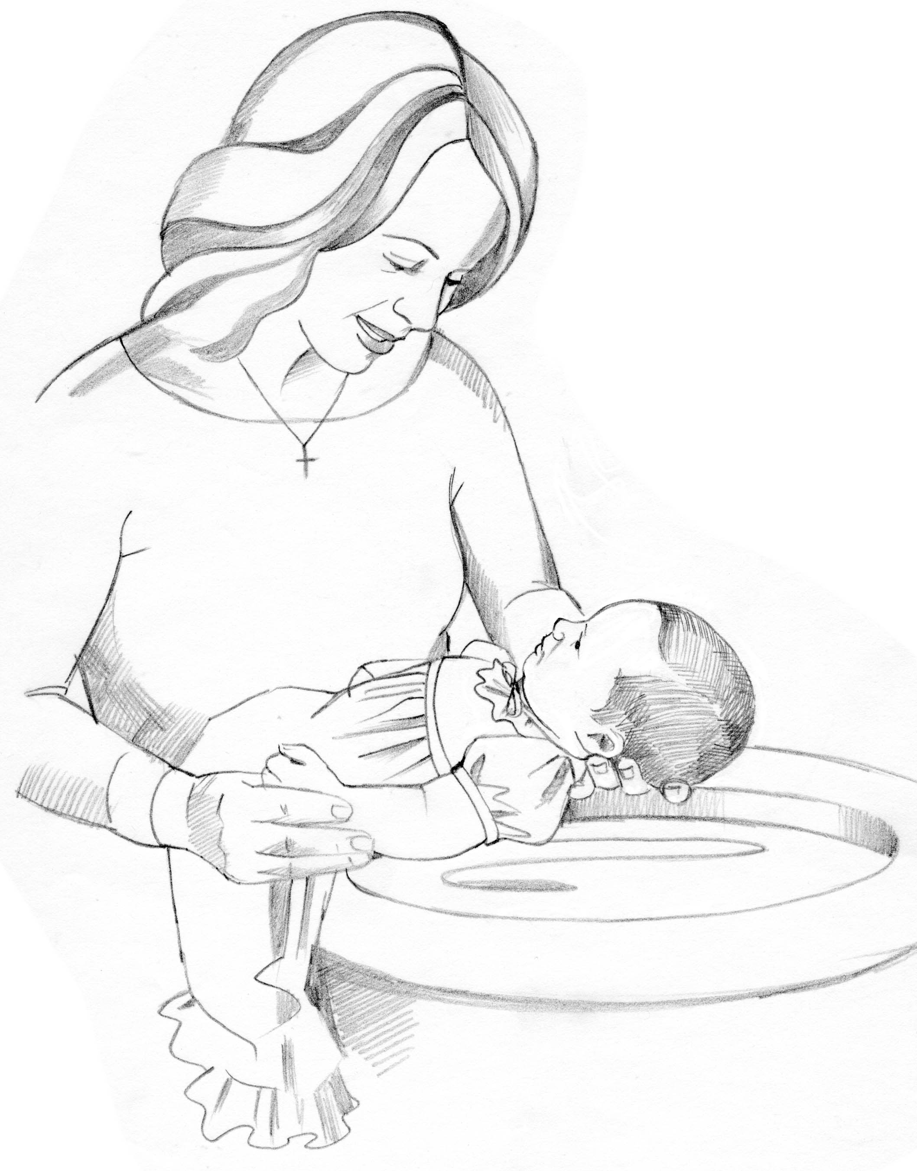
WE WELCOME INTO GOD’S FAMILY through sacrament of Holy Baptism on Saturday, February 15, 2025, at the 5:00 pm service, Ensley James Dearth, daughter of Chad & Nicole (nee: Bartson) Dearth. Ensley was born in Bellevue, OH on July 13, 2018. Sponsors for Ensley are Alaini Carlson & Boby Roeser. We also welcome Ensley’s brother, Crew Sanford Dearth through sacrament of Holy Baptism on Saturday, February 15, 2025, at the 5:00 pm service. Crew was born in Bellevue, OH on March 29, 2024, to Chad & Nicole (nee: Bartson) Dearth. Sponsors for Crew are Amaya Carlson & Johnny Loparo.

* * * * * * * * * * * * * * * * * * *

WE WELCOME INTO GOD’S FAMILY through sacrament of Holy Baptism on Sunday, February 16, 2025, Rylee Ann Recker, daughter of Adam & Jenna (nee: Hoppe) Recker.
Rylee was born in Bellevue, Ohio on September 27, 2024. Sponsors for Rylee are Jordan Michaels & Lucas Recker. Proud grandparents are Tim & Jackie Hoppe.

* * * * * * * * * * * * * * * * *

* * * * * * * * * * * * * * * * *



Nursery Team Schedule for

March 2025

March 2, 2025
Lisa Rieman

March 9, 2054
Katie Speer

March 16, 2025
Jackie Hoppe

March 23, 2025
Christine Potts

March 30, 2025
Carol Jones

* * * * * * * * * * * * * * * * *



SET YOUR CLOCKS “1” HOUR AHEAD ON
Sunday, March 9, 2025

ST PAUL LUTHERAN CHURCH, CLYDE, OHIO
1/2025
SCHOLARSHIP APPLICATION
(requirements on back of form)

Name: _________________________________________________________________

Address: _______________________________________________________________

Parents: ________________________________________________________________

Phone Number: _______________________ Email: _________________________

High School GPA: _____________________ Confirmation Date: ______________

What are your future plans following high school?

What college or tech school do you plan to attend?

High School Activities (clubs, sports, awards)

Community Activities (Scouts, 4-H, etc.)

Church Activities ( CCYG, usher, acolyte, choir)

Have you participated in local volunteer activities? (Highway cleanup, helping with Bible School, helping elderly neighbors, etc.)

(OVER)

How has your faith in Jesus Christ and your involvement at St. Paul influenced your life to date?
Two or three paragraphs.

SCHOLARSHIP REQUIREMENTS

- Must be a high school graduating senior.
- Must be a confirmed member of St. Paul.
- Application must be turned in by May 1st of each year.
- Must be used 12 months from the date awarded.

Revised: 1/12/2025

MARCH BIRTHDAYS/BAPTISM ANNIVERSARIES

1 Adam Cunningham
Ian Hilliker
Glenn Misner
2 Leo Dinan
4 Allison Barrett
Scott Gray
Mark Pocock
Kevin Powell
Emily Turner
Ronald Watt
5 Cassandra Kelley
Kevin Larkins
Brock Newsome
Kade Newsome
Adam Turner
6 Beverly Bush
Troy Newsome
7 Naomi Gooslin
Jenna (Myles) Jess
Andy Sprouse
Donald Tornow
9 Adam Heminger
Sam Jess
10 Sue Drown
Jacob Lippert
Denise Paul
Ellie Stout
Kim Swartz
12 Colton Wott
13 Bridget Coleman
Alexis Schmidt
14 Mary Waugh
16 Heidi Bentley-Mendoza
Carol Butic
Jace Cook
Vickie Lorentz
Kayla Loudenslager
17 Patsy Aldrich
18 Kevin Shetzer
Sandy Wott
19 Kristen LaFene
Richard Rosen
Kathryn Spence
20 Haley Batesole
21 Travis Smith
Charles Zerman, Sr.

22 Krista Bluhm
Gregory Kuns
Wendy Lippert
23 Judy Campbell
Dylan Kimmet
24 Maegan Brockway
Adam Wahl
Mariah Williams
25 Ashley Reed
26 Alaura Anstead
27 Mary Miller
28 Pastor Kurt Luebkeman
David Wasson
29 Crew Dearth
Daniel Rogers
LaDonna Tarris
30 Adam Wott
31 Annette Liebold
Kathryn Rosen

MARCH BAPTISM
ANNIVERSARY

1 Mike Archer
Tami Schmidt
2 Debra Belcher
Carol Stanley
4 Grace Lantz
6 Sharon Powell
7 Alex Jess
9 Collin Rieman
10 Graham Andrews
Aubriana Manner
Hunter Reed
11 Andrew Bolton
Dorothy Mowry
Robert “Jeff” Shull
12 Mariah Williams
13 Ryan Hall
14 Andrew Zilch
15 Nicholas Baptista
Vincent Garcia
Kari Larkins
Jacob Lippert
Lucile Loudenslager
Christine Potts

16 James Duskin
Beverly Mendoza
17 Claire Pocock
18 Kayla Loudenslager
Betsy Meyer
Karen (Lehmann) Sorg
19 Nicholas Carter
Judy Kuns Dahms
Nick Martinez
20 Ayzreyl Freeze
Ray Freeze, IV
Bryan Leber
Matthew Pocock
Stephen Yates
21 Alexander Barrett
Mari Lou Miller
Brooke Ott
Charles Zerman, Sr.
23 Peggie Avers
Ally Sprouse
Autumn Sprouse
26 Kim (Barnes) Heath
27 Matthew Frasher
28 Andrea Schoenfeld
Leslie Witt
29 Sandy Wott
30 Bridgette Gooslin
Tamara Myers
Edward Noftz
31 Maverick Salazar



MARCH 2025
St. Paul Lutheran Church

Sunday | Monday | Tuesday | Wednesday | Thursday | Friday | Saturday
 |  |  |  |  |  | 1  8:00 am  Men’s  Bible Study  5:00 pm  Worship
2  8:00 am  Holy  Communion  9:15 am  Sunday School  9:15 am  Women’s Board  10:30 am  Holy Communion  5:00 pm  CCYG | 3  6:00 pm  Women’s Bible Study  7:30 pm  Dartball HOME with St. John’s #3 | 4  1:00 pm  Pericope  6:00 pm  Parish Education & Youth Board Meeting | 5  6:00 pm  Youth Choir practice  7:00 pm  Ash Wednesday Service   | 6  7:00 pm  Al-Anon Meeting  8:00 pm  AA Meeting | 7   | 8  8:00 am  Men’s Bible Study  5:00 pm  Holy Worship Service  Cub Scout
9  8:00 am  Holy  Communion  9:15 am  Sunday School  10:30 am  Holy Communion  5:00 pm  CCYG  Dartball Make Ups  Daylight Saving Time BEGINS | 10  6:00 pm  Women’s Bible Study   | 11  1:00 pm  Pericope  6:00 pm  Property Board Meeting | 12  12:00 pm  Community Lenten Luncheon @ 1st UMC  6:00 pm  Youth Choir  7:00 pm  Lenten Service @ St. Paul | 13  4:00 pm  Worship Board Meeting  5:00 pm  Evangelism / Social Board  7:00 pm  Al-Anon Meeting  8:00 pm  AA Meeting | 14   | 15  8:00 am  Men’s Bible Study  5:00 pm  Holy Communion Worship

MARCH 2025
Continued

St. Paul Lutheran Church

Sunday | Monday | Tuesday | Wednesday | Thursday | Friday | Saturday
16  8:00 am  Holy  Communion  9:15 am  Sunday School  10:30 am  Holy Communion  Noon  Dartball Playoffs @ St. Paul | 17  6:00 pm  Women’s Bible Study  St. Patrick’s  Day | 18  1:00 pm  Pericope  7:00 pm  Stewardship / Finance Board | 19  11:30 am  Clyde Ministerial Meeting  12:00 pm  Community Lenten Luncheon @  1st UMC  6:00 pm  Youth Choir  7:00 pm  Lenten Service | 20  Reflector Deadline/  noon  7:00 pm  Church Council  7:00 pm  Al-Anon Meeting  8:00 pm  AA Meeting | 21    Pastor on vacation | 22  8:00 am  Men’s Bible Study  9:00 am-  2:30 pm  Call Committee Workshop  5:00 pm  Holy Communion Worship  Pastor on vacation
23  8:00 am Holy  Communion  9:00 am  Farewell Breakfast for Gerry & Barb Gosnell  9:15 am SS  10:30 am Holy Communion  3:00 pm  Bunco  5:00 pm  CCYG  Pastor on vacation | 24  6:00 pm  Women’s Bible Study    Pastor Tim on vacation | 25  1:00 pm  Pericope  Pastor Tim on vacation | 26  9:00 am –  Noon  Quilt Ministry  12:00 pm  Community Lenten Luncheon @ 1st UMC  6:00 pm  Youth Choir  7:00 pm  Lenten Service | 27  7:00 pm  Al-Anon Meeting  8:00 pm  AA Meeting | 28   | 29  8:00 am  Men’s Bible Study  5:00 pm  Holy Communion Worship Service
30  8:00 am Holy  Communion  9:15 am SS  10:30 am Holy Communion  5:00 pm CCYG | 31  6:00 pm  Women’s Bible Study  6:00 pm  Dartball BANQUET |  | 




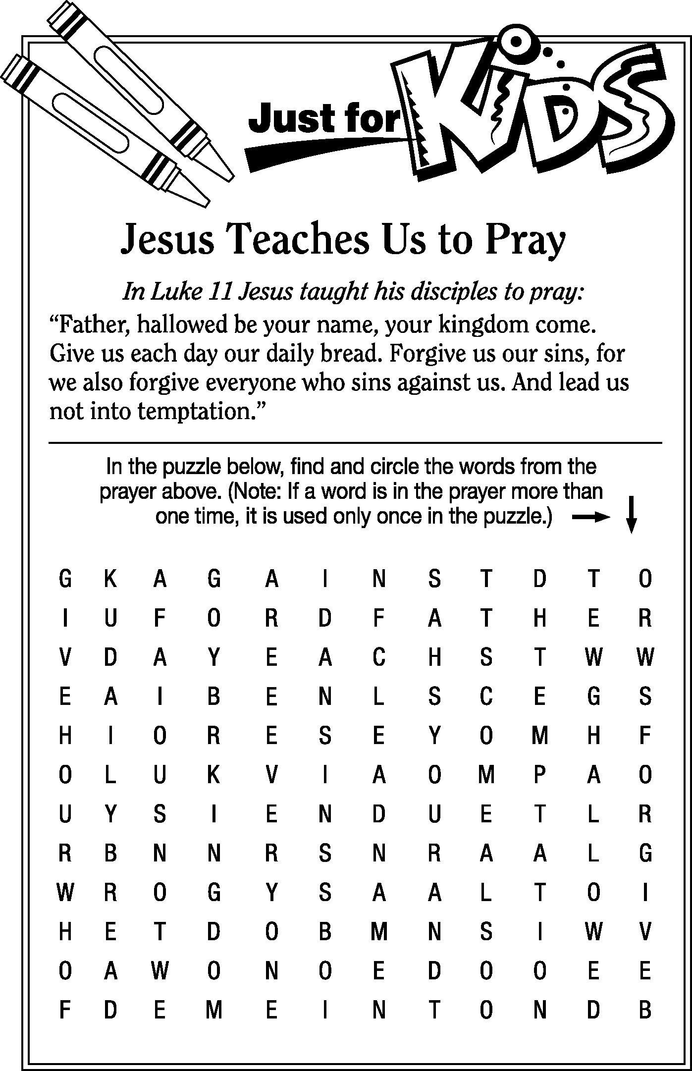

St. Paul Lutheran Church 154rd Annual Congregational Meeting
January 26, 2025
(Unapproved Minutes---will be approved at the Annual Meeting in 2026)

The 154th Annual Congregational Meeting was called to order by Council President, Kevin Larkins, at 12:35 p.m. following a pot-luck luncheon.

Pastor Tim Hubert opened with prayer.

Attending were 42 members who signed the registry.

DeAnn Krauss moved to accept the minutes of the 153nd Congregational Annual Meeting. Kendall Stucky seconded the motion.
Motion carried. Minutes approved.

OLD BUSINESS: None

PASTORAL REPORT: See page 6 of Annual Report

CHURCH COUNCIL REPORTS:

EVANGELISM & SOCIAL BOARD: See page 11 of Annual Report. Jim Sieger thanked the member of this board for their efforts and recognized the Women of the Church for all they do.

PARISH EDUCATION & YOUTH BOARD: See page 12-13 of Annual Report. A video of CCYG youth members giving strong testimonies on how they have turned their lives toward God and the influence that the Kalahari retreat has played in their lives was played.

PROPERTY: see page 14 of Annual Report. Steve Jess addressed the congregation with a list of repairs/upgrades made in 2024 as detailed in the report and the current status of some ongoing upgrades.

STEWARDSHIP & FINANCE: see page 15-16 of Annual Report. Tim Billings explained to the congregation the 2024 worship offering continues to go down while expenses continue to rise. Although we finished the year in the black, we have expenses that were not used, like that of a youth director. At the current rate, we will be in an $80,000 deficit after 4 years. Matt Woodland also spoke and encouraged/challenged the congregation to increase giving by $4 a week to make up for this deficit. The Budget Summary was presented and can be located on page 33 of the Annual Report.

WORSHIP BOARD: see page 17 of Annual Report.

OTHER REPORTS
EUCHARIST TEAMS: see page 18 of annual report.

ENDOWMENT COMMITTEE: see page 21 of Annual Report.
Kendall Stuckey moved to distribute money as allocated on the endowment committee annual report. DeAnn Krauss seconded the motion. Motion Carried.

Other reports to include the DISASTER RELIEF FUND, GOOD SAMARITAN COMMTTEE, MEMORIAL COMMITTEE, THE WOMEN OF ST. PAUL LUTHERAN CHURCH, ST. PAUL WOMEN’S MISSION ACTION COMMITTEE, ST PAUL LUTHERAN WOMEN 2024 FINANCIAL SUMMARY, AUDIT COMMITTEE, BUDGET COMMITTEE SUMMARY were reviewed with no action.

Jane Hilton spoke on behalf of the Women’s Mission Action Committee and explained how they have separate funds for their missions, the largest of those is maintaining the kitchen. They have been investing their funds with Edward Jones, which is paying off. She also thanked Brenda Sieger for her wonderful, unwavering leadership. The Women’s Mission provides missions locally and internationally. If you have one that you would like considered, contact Jane Hilton.

TREASURER’S REPORT: see pages 34-42 of Annual Report.

Kendall Rieman moved to accept the treasurer’s report as printed. Kendall Stucky seconded the motion. Motion Carried.

Fred Gesell moved to accept the budget as printed. DeAnn Krauss seconded the motion. Motion Carried.

NEW BUSINESS:
- A ballot was issued to change the wording of the constitution regarding the call committee from the call committee being “6 members appointed” to “6 members and not to exceed 12 members appointed”. Discussion ensued. The vote tally was as follows: 33-YES, 3-NO. (Some attendees either left early or did not vote) It will be placed on ballot next annual meeting for required 2/3 approval to go into effect.
- If anyone is having trouble and would like to give electronically, you can contact Sherry Bouyack for assistance.

Jeff Haughawout moved to adjourn the meeting. Fred Gesell seconded the motion. Motion Carried. Meeting was adjourned by President, Kevin Larkins at 2:05 p.m.

Pastor Tim closed the meeting by leading the attendees in a closing prayer.

Respectfully submitted,
Lisa Rieman
Council Secretary

Council Minutes
St. Paul Lutheran Church

Thursday, February 20, 2025

Tammy Baker: Present Tim Billings: Present
Tom Billings: Present John Glass: Absent
Diane Hurst: Present Terry Langham: Present
Jennifer McCoy: Present Lisa Rieman, Secretary: Present
Jim Shull, Treasurer: Present Katie Speer: Absent
Kendall Stucky: Present Tom Thorbahn, Vice President: Present
Matt Woodland, President: Present Pastor Tim Hubert: Present

Meeting was called to order by President, Matt Woodland at 7:02 p.m.

Devotions were led by Terry Langham.

SECRETARY’S REPORT:
*Kendall Stucky motioned to accept the minutes from January as written.
Tom Thorbahn seconded the motion. Motion carried.

EXECUTIVE COMMITTEE: Did not meet

OFFICIAL ACTS:
1. Baptism: Ensley James Dearth 2/15/2025
Crew Sanford Dearth 2/15/2025
Rylee Ann Recker 2/16/2025

2. Transfer Out: Dean Auxter to St. John Lutheran Church in Port
Clinton, OH

PASTORAL REPORT:
Council Report
20 February 2025

Grace and peace to each and every one of you!
“The weather outside is frightful…” Thank you for your faithfulness to Christ
and church, coming even when it is “frightful” outside! The weather has

reduced our worship attendance at times, affecting our services differently every
Sunday. Two weeks ago, our 5 pm service had only fifteen in worship. Last
week that same service had 66 in attendance. Wow!

Our Call Committee is beginning its work. Now is the time for prayer! We
need to improve our reputation in the community. We need to grumble less and
help more. Now is the time for prayer. We need to look adorable, a place
where any pastor would love to serve!

Sunday School is smaller this year. Thank you Sunday School teachers and
helpers! I’m told that not all of our member children attend our Sunday School.
Another prayer concern.

We’re keeping inside more this winter than previous winters. Our members are
down with the flu and whatever too. What can I tell you? This is Michigan
weather, except not the same snow. Growing up there, I was always outside in
the fresh air and rarely sick. Just sayin’.

And thank you again for allowing me to share your life and ministry at St Paul.
We have so many wonderful members, a well kept secret in Clyde. Invite a
friend or family member to come with you to Sunday School and our worship
service, maybe even work with you here at church!

Blessings to each and every one of you!

Pr Tim+

ENDOWMENT COMMITTEE:
Discussed payouts from endowment for 2025. Tim Billings is stepping down; therefore, council needs to appoint a replacement.

*Tom Thorbahn motioned to appoint the member with the next highest number of votes, which is Kendall Stucky, to Endowment to fill the empty seat. This position will end in December 2026. Tom Billings seconded the motion. Motion carried.

EVANGELISM AND SOCIAL BOARD:
Had our meeting with Worship Board

1. February 28, 2025, 8:00 p.m., St. Paul will host the Worldwide Gathering

Twenty-Five. This is a Christian event; this is the time of the U.S. session.
Come and participate as long as you want, will continue till 12:00 a.m.
program will be on Facebook live and also online until Mar. 9.
2. March 31, 2025, Dartball Banquet
3. Committee will distribute Bookmarks to adults and bracelets to children at
the Easter weekend services.
4. The Bible mailboxes use about 45-50 Bibles each year.
5. Disaster Relief kits for NALC Disaster Response in collaboration with Good Shepard in Vickery, Ohio were discussed.

*Lisa Rieman motioned to move forward in requesting the congregation’s assistance with Disaster Relief Kits. Tim Billings seconded. Motion carried.

MEMORIAL COMMITTEE: Did not meet prior to today’s meetings

To: St. Paul Lutheran Church Council
From: Sherry Frasher, Secretary Memorial Committee
Date: January 29, 2025
Subject: Proposed Continuing Resolution to St. Paul Lutheran Constitution
SPECIFIC DUTIES OF THE MEMORIAL COMMITTEE
(See constitution C13.07)

During our Memorial Committee Meeting on January 21, 2025, our current
procedure for allowing memorials to remain under deceased congregates name
for two years before moving the deceased congregates funds to the undesignated line item was discussed. This “rule” was decided by the committee some time ago to allow the family two years time for grieving before any decision making. Jim Shull, Treasurer, keeps track of the date the memorial funds are received within his financial statement for this committee. A suggestion was made by Pastor Tim that we add this rule/procedure as a Continuing Resolution to the Church Constitution.
Therefore, the Memorial Committee is requesting that the following Continuing
Resolution be considered for approval. If approved, to be followed by the
Constitutional regulations to add as a Continuing Resolution to the St. Paul
Lutheran Church Constitution.

C00.02 n.
Memorials received shall be kept under the deceased congregates name for a
period not to exceed two years. If those memorial funds are not used within
two years, those funds shall be moved to the unrestricted funds line item by the
church treasurer.

To: St. Paul Lutheran Church Council
From: Sherry Frasher, Secretary Memorial Committee
Date: February 1, 2025
Subject: Request for Approval of Purchase from Memorial Funds

Per our Memorial Committee meeting on January 21, 2025, the Memorial
Committee is requesting $600 from the Karen Sawyer memorial to be used
toward the cost of Tithe and Offering boxes. Karen Sawyer’s family was
contacted by Sherry Bouyack, and the family has approved the use of Karen
Sawyer’s memorial for this purpose.

The remaining amount for the tithe and offering boxes is as follows:
Karen Sawyer Memorial $600.00
Offering Plate Memorial $ 81.15
Unrestricted Memorial $137.53
Total $818.68

Please note that all voting members of the Memorial Committee have approved
this request. Therefore, please submit this request for approval by Church
Council.

*Tim Billings motioned to approve Memorial Committee’s request to change the Continuing Resolution C13.07 (C00.02): Memorials received shall be kept under the deceased congregates name for a period not to exceed two years. If those memorial funds are not used within two years, those funds shall be moved to the unrestricted funds line item by the church treasurer. Tom Thorbahn seconded the motion. Motion carried.
*Tom Thorbahn moved to approve all three recommended transfer of funds to pay for the tithe and offering boxes as stated above. Tammy Baker seconded the motion. Motion carried.

DISASTER RELIEF COMMITTEE: Did not meet.

GOOD SAMARITAN COMMITTEE: Did not meet

PARISH EDUCATION AND YOUTH:
Tuesday, February 4, 2025 – 6:00 p.m.

Present: Tammy Baker, Steve Jess, Walt Frasher, DeAnn Krauss, Tony
Paradiso, Jim Shull, Pastor Tim Hubert

1. Sunday School update:
- SS is still going well.
- SS kids choir sang at the 10:30 service February 16.

2. Catechism:
- Confirmation will be May 4 at the 10:30 service.
Discussed what we need to do prior. There will be a celebration
after the service for the families & the congregation with cake.

3. CCYG
- Change of plans including bringing back games at the beginning
of the night and a new date schedule for all 7 th -12 th grades.
Time remains 6:30-8:00 p.m.
First date (2/16) was postponed because of weather and it will be
February 23. Then March 2, 16, 30, April 13, 27, & May 4 will be the finale.

4. Discussed Acolyte Training which will take 1-1.5 hours. Information
will be sent to 4th & 5th grades along with 6th & 7th grades once a date is
chosen.

5. Discussed 1st Communion instruction which will be 1-1.5 hours including making
their communion bread. The information will be sent to 4th graders & is open to anyone older who has not been through 1st communion once a date is chosen.
6. The Youth Director open position was talked about and will be revisited next
month. All were informed there are so many Youth Director type positions open everywhere.

Next meeting: Tuesday, March 4, 2025 - 6:00 p.m.

PROPERTY BOARD:
- Holding off on replacing door until warmer weather.
- Will be replacing the bulbs in the sanctuary soon.
- Stone facing on front landing needs tended to

- Discussed carpeting in secretary’s office. Not currently in budget; however, may consider funds from property improvement.

At council, snow removal and timing of removal prior to services was discussed as well as use of parking lot by nonmembers.

STEWARDSHIP AND FINANCE BOARD:
- Discussed reinvestment of funds that have matured.
- Discussed moving credit card to earn a cash back.
- Discussed First Fruits allocation, recommending 20% go to the following:
  - DeeDee Ponzo
  - Sisters in Shelter
  - Lutheran World Relief
  - Giving Birthdays
  - Lutheran Social Services

*Treasurer’s report did not go out ahead for review. Therefore, council will review next month for approval.

*Kendall Stucky motioned to use the First Fruits as recommended by Stewardship and Finance. Tom Billings seconded. Motion carried.

WORSHIP BOARD:
February 13, 2025
Present: Kendall Stucky, Kevin Larkins, Pastor Tim, Walt Frasher, Sandy
Kessler, Lisa Rieman, Tom Thorbahn plus Evangelism/Social Board
members: Jim and Brenda Sieger, Katie Speer, Terry Langham, Diane
Hurst.

1. First Communion, May 4, 2025, at 10:30 a.m., training will be Saturday,
May 3, 2025, children of the proper age will be contacted.
2. First United Methodist Church will be hosting the Lenten Luncheons
beginning Wednesday, March 12, 2025, at noon, through April 9.
3. Ash Wednesday services, Wednesday, March 5, 2025. Maundy Thursday,
April 17, 2025, at 7:00 p.m., Good Friday, April 18. 2025 at 7:00 p.m.,
Easter Vigil, Saturday, April 19, 2026, at 5:00 p.m., Easter Services,
Sunday, April 20, 2025, at 8:00 a.m. and 10:30 a.m.

4. Working on organist/pianist schedule. Presently we have Vicki Smith
returning for Saturday evening, with Mary Ellen Wollenslegel as a sub.
Working on Sunday morning. Pastor Tim’s wife, Royce, will be here
Easter weekend.
5.Discussed Usher training, each service should work with those interested.

*Lisa Rieman motioned to hire Vicki Smith and Mary Ellen Wollenslegel as part time replacement organists. Tom Thorbahn seconded. Motion carried.

*Tim Billings motioned to allow Worship Board to screen candidates for organist. Kendall Stucky seconded. Motion carried.

OLD BUSINESS:
*Tim Billings motioned to keep ballots for 1 year following elections. Tom Thorbahn seconded. Motion carried.

NEW BUSINESS:
CALL COMMITTEE
1. Committee has received Call Process Manuals from both NALC and LCMC.
2. Committee had a Zoom Call with Pastor Shelly Schultz, NALC Parish
Representative, and Kathy Pennington, Mission District Dean. We
went over responsibilities of the Call Committee, and the process of initiating
a call.
3. We plan to talk to Christian Huntley who will help us navigate the LCMC
Call process.
4. We have also been in contact with, Paul Gruetter, about holding a
congregational workshop. The date will be Saturday 3-22 from 9-2 (lunch
served) at St Paul. More to come on the committee’s efforts to drive
attendance. We are asking all members of St Paul attend. This announcement
will be in the March Reflector.
5. At our next meeting we will work on the St. Paul Ministry Statement and the
St. Paul Congregational Profile to be approved by Church Council. Council
will meet on 3-20 and the workshop is on 3-22. The committee will be asking
council to set a special meeting to approve our Ministry Statement and
Congregational Profile no more than 2 weeks after the 3-22 call workshop and
subsequent Call committee meeting. This will then be submitted to the NALC
and the LCMC for posting on their websites.

QR CODE FEES will be discussed at next Stewardship and Finance meeting.

NEW EVENTS HAPPENING IN March 2025:
Monday, March 3, 10, 17, 24 & 31, 2025 @ 6:00 pm – 7:30 m ~~ Women’s Bible
Study
Wednesday, March 5, 2025 @ 7:00 pm ~ Ash Wednesday Service
Wednesday, March 12, 19 & 26, 2025 @ noon ~ Community Lenten Luncheons @
First UMC
Wednesday, March 12, 19 & 26, 2025 @ 7:00 pm ~ Lenten Services
Sunday, March 16, 2025 ~ Dartball Playoffs @ St. Paul, Clyde
Monday, March 17, 2025 ~ St. Patrick’s Day
Friday, March 21, 2025 – Monday, March 24, 2025 ~ Pastor on vacation
Monday, March 31, 2025 ~ Dartball Banquet @ St. Paul

Next Meeting: 3rd Thursday: March 20, 2025 at 7:00 p.m.

Devotions next council meeting: Tammy Baker

Tim Billing motioned to adjourn meeting. Meeting adjourned at 9:19 p.m. with the Lord’s Prayer.

Respectfully submitted,
Lisa Rieman

NON-PROFIT ORGANIZATION
U. S. POSTAGE PAID
PERMIT #26
CLYDE, OHIO 43410-0296
St. Paul Lutheran Church
147 West Forest Street
PO Box 296
Clyde, OH 43410-0296

ADDRESS SERVICE REQUESTED



Office Phone: 419-547-9225
Pastor Tim Hubert ~ 217-778-8017
Stephanie Stull ~ Office Manager ~ Editor ~ 419-547-9225
Brian Farrar, P & W Leader ~ 419-271-3085

Pastor’s email: pastor@stpaulclyde.org
Office Manager’s email: sec@StPaulClyde.org
Church Web site: http://www.stpaulclyde.org
LCMC website: http://www.lcmc.net
NALC website: http://thenalc.org
SOLA PUBLISHING website: http://www.solapublishing.org

2025 CHURCH COUNCIL

Tammy Baker – Parish Ed & Youth 419-603-0698 Jennie McCoy – Parish Ed & Youth 419-680-2001
Tim Billings – Stewardship/Finance 419-307-0377 Lisa Rieman – Secretary - Worship 989-450-2801
Tom Billings – Property 419-765-0279 Katie Speer – Evangelism/Social 419-681-6484
John Glass – Worship 419-680-4033 Kendall Stucky – Property 419-618-7136
Diane Hurst – Evangelism/Social 419-603-9469 Tom Thorbahn – Vice-Pres – Worship 419-366-8135
Terry Langham – Evangelism/Social 419-765-0757 Matt Woodland – President –Steward /Fin 419-603-0567

