REFLECTOR
The Newsletter of
St. Paul Lutheran Church
147 West Forest Street
Clyde, Ohio 43410-0296
June 2025



Sunday, June 15, 2025



INSIDE - HIGHLIGHTS

Pastor’s Page 2 For Your Information 7 – 10
Women’s Page 3 June 2025 Birthday’s/Baptism’s 11
Homebound & shut-in members 4 June 2025 Calendar 12 & 13
Thank You Messages 5 & 6 May 2025 Council Comments 14 – 19



Grace and peace to each and every one of you!

Volunteers! Thank you dear Lord for all of our volunteers! No church could operate without members volunteering their time, talent and money! Most volunteers don’t expect to be thanked or praised. Their gifts are given to our Lord.

In healthy congregations, volunteers are recognized, thanked, appreciated. Healthy volunteers rarely need to be thanked. I remember a woman in a former parish that taught toddlers in Sunday School for over 50 years. When I thanked her, she said she loved these kids and that was thanks enough.

In unhealthy congregations, volunteers are ignored, un-thanked and criticized! Unhealthy congregations have self-appointed volunteer bosses. Sometimes these bosses are also hard workers, getting frustrated when others don’t work around the church as hard as they do. Sometimes bosses are just bossy! “Do as I say, not as I do” types.

Church staff are special targets in unhealthy congregations. Some people think they are the boss of the staff. As boss, they then think they have the right to criticize the staff, work for their removal, tell stories to other members about the staff which often times aren’t even true.

Another way of looking at this is that Jesus is our boss and we are all the employees. Looking critically at each other betrays our Lord Jesus who looks at all of us with love. We have each other right now. We have a wonderful staff right now. Let’s help each other, love each other, defend each other.

Soon we will have a new pastor. Help…don’t criticize! No pastor is perfect. No pastor has wonderful skills in every area of ministry. Only Jesus was perfect. Pastors aren’t. So learn to help each other now, so that when the new pastor arrives, the culture of help will be extended to him or her. Love each other as Jesus loves you!

Blessings to each and every one of you!

Pastor Tim+

St. Paul Women Mission Action – 1st Quarter 2025

Quilt Ministry – We did not meet in January due to the cold weather. We were back in action for Feb and March and completed 4 mission quilts; also 1 was completed in November, 2024. Completed mission quilts will be donated to the North American Lutheran Church sometime later in the year.

Mission Action bids a fond, but sad, farewell to our friend, Barb Gosnell. Barb was a faithful supporter of our mission activities for many years, including making quilt tops, sharing her sewing expertise & knowledge, and freely sharing her fellowship. She could always be counted on to lend a hand or donate needed last-minute supplies for our “kits” campaigns. We wish her and Gerry Godspeed in this next phase of their life together.

Used Postage stamp update – Yes, we are still collecting used postage stamps. Please be sure to trim to ¼” of the stamp edge, always leaving the perforations un-damaged. Foreign stamps and 1st class U.S. commemorative stamps are the most sought-after. Place your donations in the designated basket in the donation area located in the lower level by the elevator entrance.

Women’s Bible Study – We are currently viewing the 4th season of “The Chosen” drama series. Any interested woman is welcome to join in at any time! We meet on Wednesday nights, 6 PM to 7:30 PM in the Sunday School youth room. An accompanying study guide is used, but it is NOT necessary to attend. The cost of the study guide is $10 and can purchased on Amazon, for convenience. The study guide makes a great personal tool to use along with viewing the series at home. A few extra copies of previous seasons are available in the donation area, back entrance. Feel free to pick up a copy!

For the Team,
Jane Hilton, 419-547-7270



REACHING OUT IN…

OUR CONGREGATION

The following is a list of our members that are currently in a nursing home or assisted care facility. Please keep these folks in your prayers, and perhaps make a visit, send a card or letter or call them and let them know we care!

Naomi Conley
PO Box 297
Clyde, OH 43410-0297

Florence Pocock
Riverview Nursing Home
8180 West State Route 163 ~ Room 310
Oak Harbor, OH 43449-8855

Tina Walker
Symphony at Mentor
8155 Mentor Hills Drive – Room 308A
Mentor, OH 44060-7862

The following is a list of our members that are currently ‘homebound’. Please also keep these folks in your prayers, and perhaps send a card or letter or call them and let them know we care!

Patsy Aldrich
3453 Limerick Road
Clyde, OH 43410-1426

Thelma Blair
730 Perry Street
Sandusky, OH 44870-3719

Larry Bower
1200 Burkholder Road
Clyde, OH 43410-1206

Bev Bush
3620 Limerick Road
Clyde, OH 43410-1431

Sharon Duskin
210 Meadow Lane
Clyde, OH 43410-1958

Jim & Norma Fish
500 Race Street
Clyde, OH 43410-1823

Janet Kauble
684 South County Road 232
Fremont, OH 43420-9231

LaVerde Kuns
4252 County Road 177
Green Springs, OH 44836-9610

Jeanette Pumphrey
1381 Franks Avenue
Clyde, OH 43410-1443

Carlos & Joyce Weiker
1897 East County Road 181
Green Springs, OH 44836-9626

Sandy Wott
3889 County Road 175
Clyde, OH 43410-9511



THANK YOU!

* * * * * * * * * * * * * * * * *

Dear Parish Education & Youth Board & Beloved Church Family,

Thank you all so very much for the beautiful flowers. I truly will miss the joy I shared directing the Youth Choir. It has been a privilege and a honor to serve this congregation and our Lord!

Love in Christ,
Carol Jones

* * * * * * * * * * * * * * * * *

Dear Friends,

Thank you for your congregation’s gift of $366.32 to Lutheran World Relief! I am so grateful for your generous support of Lutheran World Relief! It is because of caring congregations like yours that Lutheran World Relief has been able to serve our hurting world for 80 years and it is because of your compassion that our ministry together will continue helping children and families who need it most.

Yours always in Christ,
Ambassador Daniel V. Speckhard
President and CEO

* * * * * * * * * * * * * * * * *

The volunteers at the Back Door Food Pantry in Clyde would like to thank the CCYG for their generous donation of canned goods. The food is much appreciated.

Thank you!

* * * * * * * * * * * * * * * * *

Dear Friends of St. Paul Lutheran Church,

April is a month of hope, inspiration and Easter blessings! Thank you for being the hope, inspiration and blessing that you continue to be for the clients we serve. Your gift of $366.32 received on 4/23/2025 and serving LSS Ministries.

During uncertain times, clients turn to our agency for needs that we are able to meet due to your generosity. This cannot be measured or summed up by a small thank you. Our mission is fulfilled with the assistance of wonderful individuals like you.

Thank you,

Tracia Jaksetic
Vice-President
Lutheran Social Services of Northwestern Ohio

* * * * * * * * * * * * * * * * *

Dear St. Paul Evangelical Lutheran Church,

Thank you for your prayers and gifts of $366.32 on May 2, 2025, to support our ministries and workers ~ Diedone & Serafina Panzo.

World Mission Prayer League

* * * * * * * * * * * * * * * *



THANK YOU!

* * * * * * * * * * * * * * * * *

Women of St. Paul would like to thank everyone who donated soup, baked goods and candy for the Easter Bake Sale. A BIG thank you to all those who so generously donated money for items purchased. This bake sale helps St. Paul Women to support the many missions we help.

Brenda Sieger
* * * * * * * * * * * * * * * * *

I would like to thank all the ladies who donated food for the June Miller, Don Tornow and Diane Dagg’s funeral luncheons. Thanks to all who worked to set up, work at the luncheon and clean up. I would like to welcome two new ladies to the funeral call list: Millie Burr and Denise McCullen. We could not provide this fellowship for grieving families without your help.

Brenda Sieger
Barb Meyer
* * * * * * * * * * * * * * * * *

A BIG thank you to Deb Arnold, Sherry Frasher and Sandy Kessler for supplying home-made cookies for the bloodmobile. I know the cookies are appreciated by all those who donate blood!

Brenda Sieger
* * * * * * * * * * * * * * * * *

I would like to thank Deb Arnold, Walt & Sherry Frasher, DeAnn Krauss, Kevin & Michelle Larkins, Barb Meyer and Jim Sieger for all their work. We spent over three hours deep cleaning the kitchen and back entry way. Many hands make light work.

Brenda Sieger

* * * * * * * * * * * * * * * * *

BLOODMOBILE

“THANK YOU!” to ALL who helped to support the Red Cross Bloodmobile that was held at St. Paul parish hall on Thursday, May 15, 2025, from 12 noon – 6:00 p.m. We appreciate those who donated blood, the volunteers who gave of their time (Diane, Kathy, Bob, Brenda, Jim, Tom) and the Women of St. Paul who baked cookies.

Thanks to ALL the donors who presented on such a cold, chilly winter day! 8 units of whole blood were collected. This was a GREAT TEAM EFFORT!

~ Sandy Kessler ~
Volunteer Coordinator

* * * * * * * * * * * * * * * * *
OLD AGE

At the church’s Golden-Agers banquet the following was shared by Sister Bertha. She began her piece by saying, “You can tell you’re getting older and heading toward the sweet by ‘n by when…”

You sit in a rocking chair and can’t get it going. You burn the midnight oil after 8:00 pm. You look forward to a dull evening. Your knees buckle and your belt won’t. Your little black book contains only names ending in M.D. Your back goes out more than you do. You decide to procrastinate and never get around to it. Dialing long distance wears you out. You walk with your head held high, trying to get used to your bifocals. AND you sink your teeth into a steak, and they stay there.

FOR YOUR INFORMATION!

* * * * * * * * * * * * * * * * *


WE EXTEND OUR DEEPEST SYMPATHY AND
PRAYERS to the family and friends of:

June E. Miller sadly passed away on Saturday, April 26, 2025,

Donald G. Tornow, passed away on Tuesday, April 29, 2025, at the age of 86 following a battle with cancer,

The Rev. Lance Franke passed away on Thursday, May 8, 2025,

And to the family & friends of:

Diane Jane (Ferrall) Dagg, passed away on Monday, May 12, 2025, surrounded by the love she so freely gave to others.

* * * * * * * * * * * * * * * * *


WE EXTEND CONGRATULATIONS TO:

Brody & Brittany (nee: Shetzer) Fultz on the birth of a son, Booker Leland Fultz, born on Tuesday, April 8, 2025, in Bellevue, OH. Booker was also welcomed by proud grandparents, Joe & Connie Shetzer.

* * * * * * * * * * * * * * * * *

WE WELCOME INTO GOD’S FAMILY through sacrament of Holy Baptism on Saturday, April 26, 2025, at the 5:00 p.m. service, Luke Damon Runion. Luke was born in Bellevue, OH on April 5, 2012, to Damon & Angie Runion. Welcome Luke!

* * * * * * * * * * * * * * * * *


If you have a change of address, please notify the church as soon as possible. We are charged for each “Reflector” that is returned. Most of the time that is the ONLY WAY we receive “change of address.” To keep our data base up to date please notify St. Paul by either calling, 419-547-9225 or by email: Sec@StPaulClyde.org Thank you for your cooperation.



FOR YOUR INFORMATION!

* * * * * * * * * * * * * * * * *
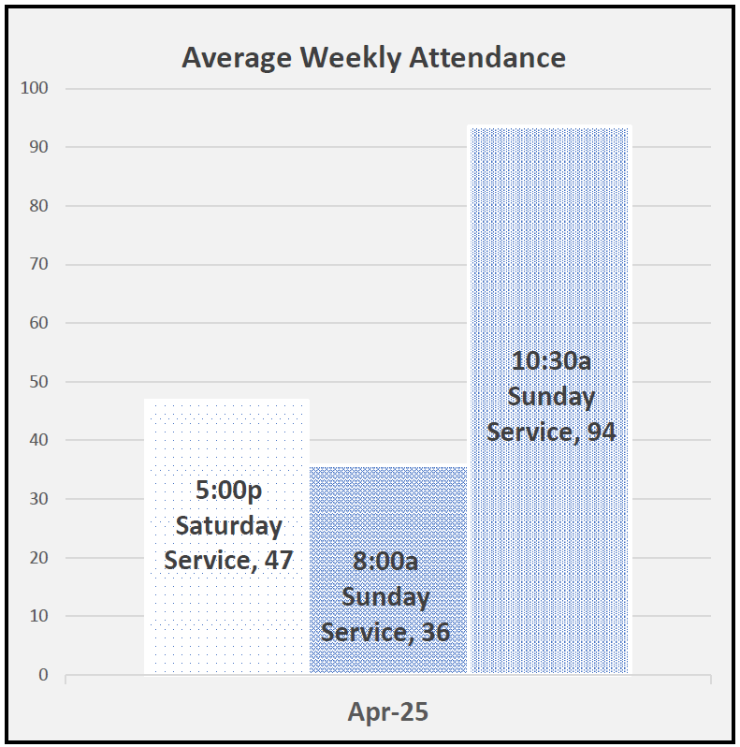

* * * * * * * * * * * * * * * * *

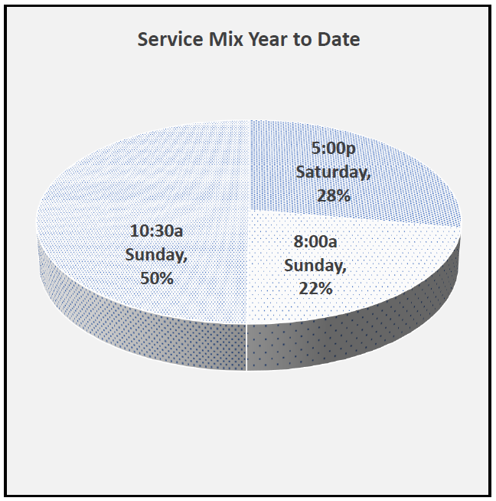
* * * * * * * * * * * * * * * * *
DISHES NEED PICKED UP

There are dishes left in the parish hall kitchen from funeral dinners & special events. Please take time to stop and check the table in the parish hall and see if one could be the dish, casseroles, bowls or pans you are missing.

* * * * * * * * * * * * * * * * *
A STANDUP GUY

During the pandemic, a Maryland man used “dad jokes” to lift neighbors’ spirits. Tom Schruben jotted down a joke-of-the-day on a curbside whiteboard. Hearing people chuckle and chat eased the isolation.

Schruben and his wife, Ann, became intentional about seeking joy after two of their children died. They vowed to “find happiness again” and share it. For Father’s Day last year, Schruben held a Bad Dad Joke contest, donating entry fees to a local charity. Here are a few of his favorites:

- If two vegans get into an argument, is it still considered a beef?
- I ordered a chicken and an egg from Amazon. I’ll let you know.
- What do you call a bear with no teeth? A gummy bear.

FOR YOUR INFORMATION!

* * * * * * * * * * * * * * * * *

iller’s Super Valu donates to St. Paul Church 1% of the total of all cash register tapes that we save from buying groceries in their store. Miller Super Valu gave St. Paul a check for $60.69. Please keep saving the register tapes and turning them into the church! !

M

REMINDER! ! !

May’s grocery receipts are due into the church office by Thursday, June 12, 2025, so that they may be tallied at St. Paul and turned into Super Valu by Sunday, June 15, 2025, for us to receive credit for them. Please make sure your receipts are in the church office NO LATER THAN Thursday, June 12, 2025. Thank you for your help and cooperation!

* * * * * * * * * * * * * * * * *


Friday, June 20, 2025
* * * * * * * * * * * * * * * * *

DID WE MISS YOUR BIRTHDAY?

Have we missed your birthday or baptism anniversary? If so, we do not have it in the church database! Please let the church office, 547-9225, so our records will be complete. Thank you for your help!

* * * * * * * * * * * * * * * * *



Saturday, June 14, 2025

FOR YOUR INFORMATION!

* * * * * * * * * * * * * * * * *

The top 10 statements pastors would like to hear

10. Hey, it’s my turn to sit in the front pew!
9. I was so enthralled, I never noticed the sermon went overtime by 20 minutes.
8. Personally, I find witnessing more enjoyable than golfing.
7. Pastor, I’ve decided to give our church the $500.00 a month I used to send to the TV evangelists.
6. I volunteer to be the permanent Sunday School teacher for the Junior High Class.
5. Forget the denominational guidelines – let’s pay our pastor a good living wage.
4. I love it when we sing hymns we’ve never sung before!
3. Since we’re all here, let’s start the worship service early.
2. Pastor, we’d like to send you to that Bible seminar in the Bahamas.
1. Nothing inspires me and strengthens my commitment like the annual business meeting.

~ Ryan Ahlgrim and Randy J. Roth ~

* * * * * * * * * * * * * * * * *

* * * * * * * * * * * * * * * * *

On Sunday, May 4, 2025, at the 10:30 am service, we rejoice as “4” young adults come forward to affirm their baptism. These young adults have completed catechetical instruction. The young adults are:

Aisley Fae Anstead
Ray Arley Freeze, IV
Jeremy Michael Lantz
Audra Pearl Lowe

* * * * * * * * * * * * * * * * *

* * * * * * * * * * * * * * * * *

“A father’s words are like a thermostat that sets the temperature in the house.”

~ Paul Lewis ~

* * * * * * * * * * * * * * * * *

JUNE BIRTHDAYS/BAPTISM ANNIVERSARIES

- Benjamin LaFene
Kristin (Anstead) Zilles
2 Alexis Chambers
Michael Myers
3 Nancy Thomas
4 Adriana Barnes-Ortman
Jamie (Hoppe) Dempsey
Clay Pocock
5 Jeffrey Kuns
Norbert Mayer
Linda Miller
Jared Moe
6 Kristina Biddle
Robert Kessler
Jeff Pocock
Janet Zilch
7 Erin Gray
Waylon Pena
8 David Parkhurst
Marc Wayland-Smith
9 Garrison Swartz
12 Gregory Corthell
Jeff Thurn
13 Sue Dinan
14 Andrew Brown
15 Sherry Frasher
Barb Loose
Cora Davenport
16 Sophia Behney
Aric Billings
Robert Cullen
Emma Davis
Elishia Styczynski
17 Ayden Behney
Logan Speer
18 Herb Bouyack, Jr.
Caden Davis
Bronx Johnson
Audra Lowe
Paul Nichols
Donielle Yates
19 Ryker Freeze
Jacqueline Wasson
Blake Williams
20 Susan Nichols
21 Kelly Baker
Brittany (Shetzer) Fultz
Lori McCauley
Braxton Ott

22 Jodi Noble
23 Krista Jo (Duskin) Balogh
Mason Woodland
24 Riley Andecover
Jeremiah Glass
25 Greg Avery
Deborah Cunningham
26 Kennedy Funkhouser
Dorothy Mowry
Andrew Raschke
27 Keyli Billings
Pari Carter
Penelope Davenport
Shelby Davenport
Maria Hill
Joshua Liebold
Wally Potts
Barbara Scheck
Christopher Snyder
Matthew Woodland
28 Nicholas Shull
Ryleigh Zilles
29 Tina Bogner
Aimee Kidd
Bowen Schoch
Connie Shetzer
30 Kendra Klos
Linda Pocock

- Destiny Brown
Nancy Dagg
Rafael Mendoza
Teresa Mendoza
Sandra Michaels
Rachel Waugaman
- Heidi Bentley-Mendoza
Patrick Potts
- Samuel Billings
Jennifer Canale
Trenton Elfring
- Margaret Bouyack
- Steve Jess
Kyle Larkins
Greta Rosen
Tina Walker
Brandyce Wott

- David Davis
Caitlyn Kimmet
Dylan Kimmet
Wendy Lippert
Ada Williams
- Kim Swartz
- Sue Mayes
Maximus Yates
- Alexis Schmidt
Carolyn Stout
- Darci Anstead
Pari Carter
Adam Noftz
Elizabeth Smith
13 Jackson Brockway
David Wasson
14 Wyatt Speer
- Kristen LaFene
16 Randi Barnett
Timothy Hoppe
Jim Sieger
Emily Turner
17 Nancy Estep
Alek Gregg
Madyson Gregg
Thomas Kowalski Gary Schwochow
- Katrina Walton
- Joni Mussell
Troy Newsome
- Blair Andrews
Jarrod Nichols
- Baylor Mussell
Steven Pearson
- Vickie Aldrich
Michael Holmes, II
- Jackie Bower
Sam Jess
- Abigal Dendinger
- Kate (Jess) Cook
- Danni Elfring
Danyelle Lantz
Tony Shull
30 Tom Miller


JUNE 2025

St. Paul Lutheran Church
Sunday | Monday | Tuesday | Wednesday | Thursday | Friday | Saturday
1  8:00 am  Holy  Communion  9:15 am  WOMEN’s Board Meeting  10:30 am  Holy Communion / 1st Communion | 2 | 3  1:00 pm  Pericope Meeting  7:00 pm  Parish Education / Youth Board Meeting | 4  6:00 pm  Women’s Bible Study   | 5  7:00 pm  Al-Anon Meeting  8:00 pm  AA Meeting | 6 | 7  8:00 am –  9:30 am  Men’s Bible Study  5:00 pm  Holy Communion Worship Service
8  8:00 am  Holy  Communion  10:30 am  Holy Communion  PENTECOST  SUNDAY | 9 | 10  1:00 pm  Pericope Meeting  6:00 pm  Property Board Meeting | 11  6:00 pm  Women’s Bible Study | 12  6:00 pm  Worship Board  7:00 pm  Al-Anon Meeting  8:00 pm  AA Meeting | 13 | 14  8:00 am –  9:30 am  Men’s Bible Study  5:00 pm  Holy Communion Worship Service  FLAG DAY


JUNE 2025
(continued)

St. Paul Lutheran Church

Sunday | Monday | Tuesday | Wednesday | Thursday | Friday | Saturday
15  8:00 am  Holy Communion  10:30 am  Holy Communion  FATHER’S DAY | 16   | 17  1:00 pm  Pericope Meeting  7:00 pm  Stewardship/  Finance Board  Meeting | 18  11:30 am  Clyde Ministerial Meeting  6:00 pm  Women’s Bible Study | 19  Reflector Deadline/  Noon  7:00 pm  Church Council  7:00 pm  Al-Anon Mtg  8:00 pm  AA Meeting | 20   | 21  8:00 am  Men’s Bible Study  5:00 pm  Holy Communion  Worship Service
22  8:00 am  Holy Communion  10:30 am  Holy Communion  3:00 pm –  5:00 pm  BUNCO | 23 | 24  1:00 pm  Pericope Meeting | 25  9:00 am  Quilt Ministry  6:00 pm  Women’s Bible Study | 26  7:00 pm  Al-Anon Meeting  8:00 pm  AA Meeting | 27 | 28  8:00 am  Men’s Bible Study  5:00 pm  Holy Communion
29  8:00 am  Holy  Communion  10:30 am  Holy  Communion | 30 |  | 

Council Minutes
St. Paul Lutheran Church

Thursday, May 15, 2025

Tammy Baker: Present Tim Billings: Present
Tom Billings: Present John Glass: Present
Diane Hurst: Absent Terry Langham: Absent
Jennifer McCoy: Absent Lisa Rieman, Secretary: Present
Jim Shull, Treasurer: Absent Katie Speer: Present
Kendall Stucky: Present Tom Thorbahn, Vice President: Present
Matt Woodland, President: Present Pastor Tim Hubert: Present

Meeting was called to order by President, Matt Woodland at 7:03 p.m.

Devotions were led by Tammy Baker.

SECRETARY’S REPORT:
*Tom Thorbahn motioned to accept the revised minutes from the April council meeting to state that Katie Speer was present. Tim Billing seconded the motion. Motion carried.

EXECUTIVE COMMITTEE: Did not meet officially; however, via text confirmed that the three members of executive committee will serve as one vote on disaster relief until that position is filled. Executive committee also approved using a lawyer to respond to a lawyer request involving an estate settlement/trust.

OFFICIAL ACTS:
1. Baptism: Luke Damon Runion April 26, 2025

2. Confirmation: Aisley Fae Anstead May 4, 2025
Ray Arley Freeze, IV May 4, 2025
Jeremy Michael Lantz May 4, 2025
Audra Pearl Lowe May 4, 2025

3. Funeral: June E. (Schrader) Miller April 26, 2025

4. Graveside: Karen Zartman April 18, 2025

PASTORAL REPORT:
Council Report
15 May 2025

Grace and peace to each and every one of you!

Volunteers! Thank you dear Lord for all of our volunteers! No church could
operate without members volunteering their time, talent and money! Most
volunteers don’t expect to be thanked or praised. Their gifts are given to our
Lord.

In healthy congregations, volunteers are recognized, thanked, appreciated.
Healthy volunteers rarely need to be thanked. I remember a woman in a former
parish that taught toddlers in Sunday School for over 50 years. When I thanked
her, she said she loved these kids and that was thanks enough.

In unhealthy congregations, volunteers are ignored, un-thanked and criticized!
Unhealthy congregations have self-appointed volunteer bosses. Sometimes
these bosses are also hard workers, getting frustrated when others don’t work
around the church as hard as they do. Sometimes bosses are just bossy! “Do as
I say, not as I do” types.

Church staff are special targets in unhealthy congregations. Some people think
they are the boss of the staff. As boss, they then think they have the right to
criticize the staff, work for their removal, tell stories to other members about the
staff which often times aren’t even true.

Another way of looking at this is that Jesus is our boss and we are all the
employees. Looking critically at each other betrays our Lord Jesus who looks
at all of us with love. We have each other right now. We have a wonderful
staff right now. Let’s help each other, love each other, defend each other.

Soon we will have a new pastor. Help…don’t criticize! No pastor is perfect.
No pastor has wonderful skills in every area of ministry. Only Jesus was
perfect. Pastors aren’t. So learn to help each other now, so that when the new
pastor arrives, the culture of help will be extended to him or her. Love each
other as Jesus loves you!

Blessings to each and every one of you!
Pr Tim+

ENDOWMENT COMMITTEE: Did not meet

EVANGELISM AND SOCIAL BOARD: Did not meet

MEMORIAL COMMITTEE: Did not meet

DISASTER RELIEF COMMITTEE: Did not meet. Had discussions for helping a local family; however, decided not needed at this time.

GOOD SAMARITAN COMMITTEE: Did not meet

PARISH EDUCATION AND YOUTH: Did not meet
Parish Ed & Youth Update:

1. Sunday School:
- Last day May 18th .
- Many thanks for the amazing Sunday School/Catechism teachers we are
blessed to have who dedicate their time to help our children learn about Jesus.
- Dawn Sumner (4/5th grade teacher) is retiring after 22 years of teaching & we
THANK her for all her time spent teaching so many kids about Jesus.
- Which leads us to the need for a teacher to help for that grade. It is not taught
alone. We are fortunate to have 2 teachers/class. Jackie Hoppe is the other
teacher, so feel free to ask her about it.
2. Confirmation did happen on Sunday, May 4 at the 10:30 service for Aisley Anstead,
Ray Freeze, Jeremy Lantz, and Audra Lowe.
3. Acolyte training did happen on Saturday May 10. We now have 10 new acolytes &
you will see them lighting the candles.
4. First communion:
- Sunday, June 1 at the 10:30 service.
- First communion class will be held Saturday, May 31, 10:30 a.m.-noon.
- 5. CCYG ended on May 4th for this school year with a Night of Worship & Canned
- Food Drive for the Clyde Food Pantry, the community was invited. Over 250 cans were collected. Attendance was about 85, mostly from the community.
- There were 5 seniors recognized & honored for graduation
- With the year ending, we want to THANK Sam Dagg for the messages he provided & to Brian Farrar for putting the band together with the worship music this year. Along with a giant THANK YOU to all the Leaders & the band members who gave up their Sunday evenings for all the kids helping them to learn more about Jesus.

6. Vacation Bible School (VBS) for the community will be held at the Methodist
church on July 13-17th.

Next meeting: Tuesday, June 2 at 7:00 p.m.

PROPERTY BOARD:
Property Board Meeting Minutes May 13th , 2025

Present: Tom Billings, Steve Jess, Bob Kessler, DeAnn Krauss, Kendall
Stucky, Dave Zilch and Pastor Tim

Agenda updates:
1. Wooden door replacement - Received updated quote from Capitol
Aluminum. Review options. Getting additional quotes.
2. Our Spectrum internet service continues to be spotty. Does anyone have
any experience with other providers (fiber)? DeAnn is comparing plans
for our Spectrum account and Omni. Review costs. Will check pricing
from Frontier.
3. Office carpet replacement. Get a second quote. Snyders or York
4. Stone façade on the parish hall porch. Had two more contractor look at
the job. Waiting for quotes from both.
5. Clean sanctuary carpet. Will get Adrians, Stanley Steamer and York
quotes.
6. Handicap accessible door operator at the elevator entrance. Will contact
Northwood Door to investigate costs.
7. Outlet in Brian’s office for internet switch. Complete
8. Water drainage issue in courtyard. Contacting Darr’s

I have set the Lord always before me; because he is at my right hand, I
shall not be shaken.

Next Meeting: Tuesday June 10th at 6:00 PM

STEWARDSHIP AND FINANCE BOARD:

*Tim Billings motioned to accept the treasurer’s report. Kendall Stucky seconded. Motion carried.

- $8,000 deficit. Expenditures are down. Income is the problem.
- Stewardship Awareness Program to begin in the Fall.

- Discussion on financial aspects of new internet and the need for Call Committee to have Zoom meetings for interviewing pastors.
- Discussed sound room
- Kyle Klinski was able to raise all the money needed for his mission trip. Thank you to all who contributed.
- Discussed possibly using some left over money from the lighting project for the sound room.
- 2 new First Fruits recipients to include CASA and a local firefighter group.
- Discussion on CCYG Kalahari trip and the need for a down payment in June to be able to attend in January.
- CCYG-money for a thank you party was discussed.

WORSHIP BOARD:
May 8, 2025
Present: Kendall Stucky, Bev Mendoza, Sandy Kessler, Tom Thorbahn, Walt
Frasher, Pastor Tim

1. Thank you to Royce Hubert for playing the organ during Holy Week.
2. Easter weekend attendance 230.
3. CCYG Night of Worship well attended.
4. Discussion on inviting Pastor Didi for a weekend to go over his new
missionary call.
5. Walt told us of the new line drop by Spectrum, should help during
Facebook transmissions of services
*John Glass motioned to reach out to Pastor Didi and offer a hotel, goodwill offering, and reimburse his time to come discuss his new missionary call. Tom Thorbahn seconded. Motion carried.

OLD BUSINESS:

None

NEW BUSINESS:
- Disaster Relief-Emily Dendinger accepted. Still reaching out to others.
- Bouncy House discussion

- Lawyer, Maggie Pearce, was contacted regarding a trust.

*Tom Thorbahn moved to appoint Emily Dendinger to both the Disaster Relief Board and the Good Samaritan Board. Katie Speer seconded the motion. Motion carried.

NEW EVENTS HAPPENING IN JUNE 2025:
Sunday, June 1, 2025 @ 10:30 am Service ~ 1st Communion
Sunday, June 8, 2025 ~ Pentecost Sunday
Saturday, June 14, 2025 ~ Flag Day
Sunday, June 15, 2025 ~ Father’s Day

Next Meeting: 3rd Thursday: June 19, 2025 at 7:00 p.m.

Devotions next council meeting: Jennifer McCoy

Meeting adjourned at 8:10 p.m. with the Lord’s Prayer.

Respectfully submitted,
Lisa Rieman

St. Paul Lutheran Church
NON-PROFIT ORGANIZATION
U. S. POSTAGE PAID
PERMIT #26
CLYDE, OHIO 43410-0296
147 West Forest Street
PO Box 296
Clyde, OH 43410-0296

ADDRESS SERVICE REQUESTED



Office Phone: 419-547-9225
Pastor Tim Hubert ~ 217-778-8017
Stephanie Stull ~ Office Manager ~ Editor ~ 419-547-9225
Brian Farrar, P & W Leader ~ 419-271-3085

Pastor’s email: pastor@stpaulclyde.org
Office Manager’s email: sec@StPaulClyde.org
Church Web site: http://www.stpaulclyde.org
LCMC website: http://www.lcmc.net
NALC website: http://thenalc.org
SOLA PUBLISHING website: http://www.solapublishing.org

2025 CHURCH COUNCIL

Tammy Baker – Parish Ed & Youth 419-603-0698 Jennie McCoy – Parish Ed & Youth 419-680-2001
Tim Billings – Stewardship/Finance 419-307-0377 Lisa Rieman – Secretary - Worship 989-450-2801
Tom Billings – Property 419-765-0279 Katie Speer – Evangelism/Social 419-681-6484
John Glass – Worship 419-680-4033 Kendall Stucky – Property 419-618-7136
Diane Hurst – Evangelism/Social 419-603-9469 Tom Thorbahn – Vice-Pres – Worship 419-366-8135
Terry Langham – Evangelism/Social 419-765-0757 Matt Woodland–President–Steward /Fin 419-603-0567

