The Newsletter of
St. Paul Lutheran Church
147 West Forest Street
Clyde, Ohio 43410-0296
August 2026
REFLECTOR

Inside Highlights

Pastor’s Letter…………2&3
Special Congregational Meeting…3
Women’s News……………4
Thank You’s……………….5
For Your Information………6&7
August Birthdays………….8
August Calendar…………9&10
Council Minutes………….10-16

Hello Church Family,
A while back, I spoke about the importance of recognizing our “One More.” Each of us has someone in our life who needs the hope of the Gospel. It may be a friend, coworker, neighbor, or family member who is living apart from Christ. Their name may already be on your heart. You may have prayed for them for years, encouraged them, invited them to church, or tried to speak with them about Jesus. And maybe you are still waiting for the right opportunity.
There will always be one more person who needs hope, one more person who needs encouragement, and one more person who needs to hear the good news of Jesus Christ. So what can we do? We can pray.
Prayer is not the least thing we can do. It is one of the most powerful things we can do. Sometimes we say, “All I can do is pray,” as though prayer is what remains after everything else has failed. But prayer is not a last resort. It should be our first response. Through prayer, we bring the people we love before the throne of the God who created them, knows them completely, and loves them more deeply than we ever could.

Our prayer list at St. Paul’s continues to grow. There are people facing sickness, grief, uncertainty, difficult decisions, and burdens that many of us may never fully see. Every name on that list represents a real person with a real need, and I believe this is a time for us to band together as brothers and sisters in Christ and become even more intentional about praying for one another.
Scripture tells us in 1 Peter 5:7 to cast all our anxieties upon the Lord, “because He cares for you.” Think about that promise. The God of all creation invites us to place our cares into His hands. He does not become irritated when we come to Him, and He does not get tired of hearing the same names brought before Him again and again. He cares for us, and He delights when His children trust Him enough to bring their burdens before Him.
Prayer is powerful, not because we always know the perfect words to say, but because of the One to whom we are praying. We are coming before the Most High God, the One who heals, comforts, strengthens, provides, restores, and saves. We can pray boldly for healing, wisdom, peace, restored relationships, and open doors. Most importantly, we can pray for people to come to repentance and faith in Jesus Christ.
Because of the growing number of needs within our church family, I would love to begin a weekly prayer group next month. My hope is that we can gather once each week for intentional prayer, bringing the needs of our congregation, our community, and our “One More” before the throne of God. The exact day and time have not yet been finalized, but I believe this could become a powerful and meaningful ministry within our church.
Prayer does not mean that we do nothing else. We continue loving, serving, inviting, encouraging, and sharing the truth of God’s Word. But all of those things must be covered in prayer because only God can change a heart. Only the Holy Spirit can awaken faith. Only Jesus can save.
So I want to challenge each of us to identify our “One More.” Who is the friend, neighbor, coworker, or family member God has placed upon your heart? Write down their name and pray for them consistently. Ask God to soften their heart and draw them toward Christ. Ask Him to give you wisdom, courage, and the right opportunity to speak. Ask Him to help you love them patiently and faithfully.
And when God answers, when that person takes a step toward Jesus, do not stop looking. There will always be one more person to pray for, one more person to encourage, one more person to invite, and one more person who needs to hear that Jesus Christ died for sinners, rose from the grave, and offers forgiveness and eternal life to all who trust in Him.
Church, let us become a people who pray first, pray faithfully, and pray expectantly. Let us band together as brothers and sisters in Christ, carrying one another’s burdens and bringing every name, every need, and every “One More” before the Lord. Prayer is not the least we can do. It is one of the greatest privileges and most powerful gifts God has given us.
Together in Christ,
Pastor Sam

Special congregational meeting August 9th

Property Board requested and Church Council approved a special congregational meeting for
August 9, 2026 after the 10:30 service. The meeting is to vote to approve or reject several
projects that the property board brought to the council meeting on July 16th.
1. Replace the failing air conditioning unit for the sanctuary.
2. Address the water infiltration that is occurring in the masonry around the south
sanctuary doors.
3. Replace several sections of concrete outside the southwest corner of the sanctuary that
are cracked and becoming a safety hazard.
4. Replace the flower beds outside the east side of the parish hall along the driveway with
concrete.
5. Install ADA operators on one door in the elevator entrance, the men’s room door and
lady’s room door on the Sunday School side of the building.
6. Security camera upgrades for the entire building. Additional cameras would also be
installed.
7. New blinds for the parish hall windows.
8. Re-key the entire building for increased safety and security purposes.

Women’s News
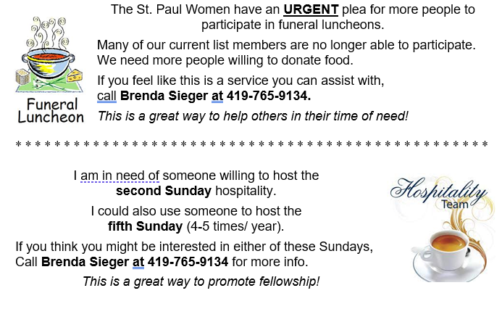
St. Paul Women’s Mission Action – 2nd Quarter 2026
Quilt Ministry – Our Mission Quilt assembling continued in the 2nd
quarter, with 4 completed. We also assembled 2 lap quilts for local use.
Many thanks to Linda, Joanne, and Shirley for their steadfastness!
Mission Quilts assembled this year will be given to Lutheran World
Relief in October, during their in-gathering. This is quite the scene to
experience: vehicles of all kinds lining up to fill a large semi-trailer!
The quilt ministry meets on the 4th Wednesday of each month, with
some exceptions, 9AM to NOON in the church basement sewing room.
Interested persons can refer to the weekly/monthly calendars in the
Sunday bulletins OR the monthly Reflector. We use donated fabric
(cotton OR poly/cotton), donated 60X80 quilt tops, and clean,
unstained flat sheets. We are in need of solid- color flat sheets especially.
Stamps for the Wounded – This is the group we save our new/used
postage stamps for. Commemoratives are the most-desired, along with
all the related postage stamp collecting supplies. Foreign stamps also! If
you are down-sizing your collection, this group is a great place for your
“extras” to end up! Leave your stamps/supplies in the donation area by
the elevator entrance. Wounded vets use the stamps for rehab and
active military can start a new hobby, all based on availability and
interest.
For the Team,
Jane Hilton (419-547-7270) – land line Catlady18@roadrunner.com
Thank You’s

Dear St. Paul Evangelical Lutheran Church,

On behalf of everyone at The Liberty Center, I want to extend our heartfelt gratitude for your generous monetary donation of $425.76 for May and $350.05 for June and $379.72 for July. Your support plays a vital role in our ongoing mission to provide shelter, hope, and a new beginning to individuals experiencing homelessness in our community.

Thanks to your kindness, we are able to offer not only a safe and warm place to stay but also essential services such as nutritious meals, case management, life skills training and in some instances domestic violence crisis intervention to homeless individuals and families.

It is because of our donors like you that we are able to continue our vital work and expand our reach to help more individuals each day. Our goal is to assist our residents in breaking the cycle of poverty that some have experienced for years. We are truly grateful for your trust and partnership in this effort.

Thank you so much for supporting the Libert Center and making a difference in the lives of the homeless individuals and families in Sandusky County.
Sincerely,

Mary Beaver

Office Manager
Volunteer Coordinator

Sharing the sentiments of
Margaret Weisz, LISW-S
Executive Director

Dear St. Paul Lutheran Church,

Thank you for all that you do for Heartbeat. We are so blessed to be surrounded by such generous people. We are able to reach out to those in need on a daily basis because of you! Thank you for all that you do for this ministry.

Jeanine Van Der Laar
Bookkeeper
So then, as we have opportunity, let us do good to everyone, and especially to those who are of the household of faith. ~ Galatians 6:10

Dear St. Paul Lutheran Church,

Thank you for your prayers and gift of $1000.00. Your financial contribution helps Prayer League global workers share the gospel with those least able to have heard or benefited from its transforming power.

Kyle Scott
Executive Director

Dear St. Paul Lutheran Church,

Thank you for your generous contribution of $379.72 to Heartbeat. We are so blessed by the continual support of the community members. We greatly appreciate you!

Jeanine Van Der Laar
Bookkeeper

FOR YOUR INFORMATION!

* * * * * * * * * * * * * * * * *

Dear LCMC Congregations,
We want to see where God’s work is being UNLEASHED in your congregation and community this year!
From worship, fellowship, and celebrations to service projects, education, and missions, we are looking for inspiring images and stories that celebrate faith, ministry, service, and the life of the local church.
Our annual photo contest offers LCMC congregations a chance to share their work and ministry with other churches and leaders throughout the association.
Detailed captions are an important part of each entry, helping readers understand the people, places, and stories behind each image.
Selected photos and stories will be featured in upcoming LCMC newsletters as a way to encourage and inspire others in their ministry and to showcase the life, work, and talents of the local church through a creative lens.
The photo contest is online only and all entries must be received by November 2, 2026 to be eligible.
We look forward to hearing from you!
Email Ashley Reed asst.sec@stpaulclyde.org to get the link to register and see the rules.

* * * * * * * * * * * * * * * * *
St. Paul will receive 4% cash back from ChristianBook.com when you “SUPPORT YOUR CHURCH” by:

1. Searching St. Paul Lutheran Clyde
2. Scanning the QR Code on the left
3. Type RHQCYS in the search bar
in the payment section during check out. This website offers a wide variety of Christian books, Bibles, learning material and much more.
Please feel free to reach out to Ashley Reed for more information or assistance at 419-547-9225 or asst.sec@stpaulclyde.org
* * * * * * * * * * * * * * * * *
If you or a loved one needs an electric lift chair, please reach out to
Tom Thorbahn 419-366-8135 or
Kevin Larkins 567-201-3838.

FOR YOUR INFORMATION!

* * * * * * * * * * * * * * * * *
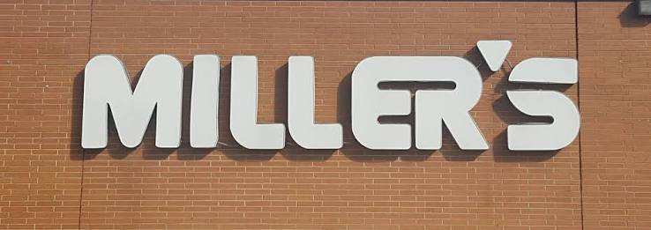
Millers will give St. Paul 1% of the total receipt sales if you turn them in!! Please get a receipt and turn them into the church office or the offering plate. Every little bit helps!
* * * * * * * * * * * * * * * * *

BOOKS for FREE
You will find a table in the Parish Hall filled with books that are offered free for the
taking. Please visit the table and take as many as you wish.
Happy reading!

* * * * * * * * * * * * * * * * *

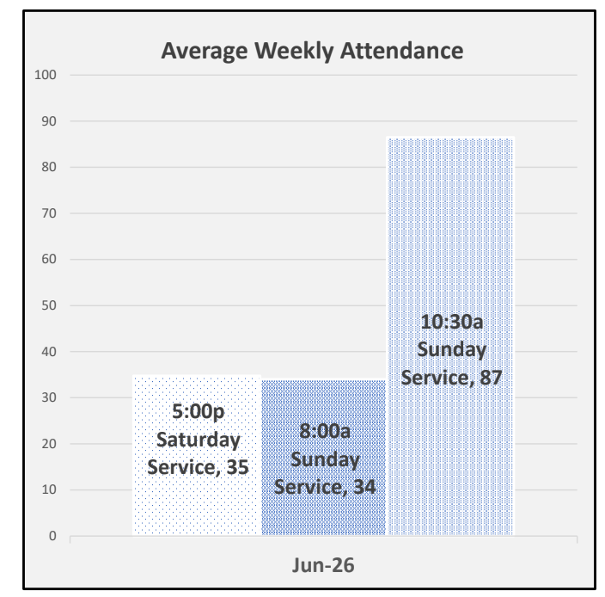
* * * * * * * * * * * * * * * * *
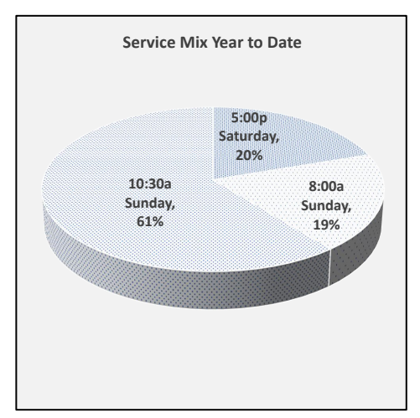
* * * * * * * * * * * * * * * * *
Congratulations to Zac and Keylie (Billings) Foote who tied the knot on July 18th!


August Birthdays

1 Ayzreyl Freeze

5 Kinsley Funkhouser

8 Steve Keown

9 Lilly Jones

Grady Ott

13 Edward Noftz

Reagan Zilles

14 Beverly O’Donnell

Dawn Sumner

16 Jeannie Cleveland

Jeanie Kimmet

17 Jamie Farrar

19 Tate Prenzlin

20 Payton Smith

22 Chloe Bannerman

James Duskin

Kandy Thurn

25 Mary Wott

26 Mel Cook

August 2026
St. Paul Lutheran Church

Sunday | Monday | Tuesday | Wednesday | Thursday | Friday | Saturday
1
8am
Men’s Bible Study

5pm
Worship
2  8am  Worship  10:30am  Worship | 3  6:30pm  Co-Ed Bible Study | 4  6:30  Men’s Bible Study  7:00pm  Parish Ed & Youth | 5  6pm  Women’s Bible Study | 6  7pm  Al-Anon  8pm  AA | 7 | 8  8am  Men’s Bible Study

9  8am  Worship  10:30am  Worship | 10  6:30pm  Co-Ed Bible Study | 11  6pm  Property  6:30pm  Men’s Bible Study | 12  6pm  Women’s Bible Study | 13  5pm  Evangelism/ Social  6pm  Worship  7pm  Al-Anon  8pm  AA | 14 | 15  8am  Men’s Bible Study  5pm  Worship
16  8am  Worship  10:30am  Worship | 17  6:30pm  Co-Ed Bible Study | 18  6:30pm  Men’s Bible Study  7pm  Stewardship/ Finance | 19  6pm  Women’s Bible Study | 20  7pm  Council  7pm  Al-Anon  8pm  AA | 21 | 22  8am  Men’s Bible Study  5pm  Worship
23  8am  Worship  10:30am  Worship | 24  6:30pm  Co-Ed Bible Study | 25  6:30pm  Men’s Bible Study | 26  9am  Quilt  Ministry  6pm  Women’s Bible Study | 27  7pm  Al-Anon  8pm  AA | 28 | 29  8am  Men’s Bible Study  5pm  Worship
30  8am  Worship  10:30am  Worship | 31  6:30pm  Co-Ed Bible Study

Council Minutes
St. Paul Lutheran Church
Thursday, July 16th, 2026

Tammy Baker: Present Tim Billings: Present
Tom Billings: Present John Glass: Present
Kevin Larkins: Present Walker Davenport: Present
Jennifer McCoy: Present Kyle Klinski, Secretary: Present
Jim Shull, Treasurer: Present Steve Jess: Present
Kendall Stucky: Present Tom Thorbahn, Vice President: Present
Matt Woodland, President: Present Pastor Samuel Dagg: Present

Meeting was called to order by President Matt Woodland at 7:02 p.m.

Devotions were led by Tom Thorbahn.

Guests:
Sandy Kessler
● Discussed recent baptisms and the way they were conducted.
SECRETARY’S REPORT:
Corrections to the June minutes were reviewed:
● Worship Board:
○ The sentence went from “Discussed Advent Services: The board agreed
that we are not planning to hold any Advent services in December. ” to
“Discussed Mid-Week Advent Services: The board agreed that we are
not planning to hold any Mid-Week Advent services in December.”
Motion to approve the corrections:
● Motion by: Kendall Stucky
● Seconded by: Tammy Baker
● Outcome: Motion carried.
Approval of the June minutes:
● Motion by: Tim Billings
● Seconded by: Kendall Stucky
● Outcome: Motion carried.
EXECUTIVE COMMITTEE: Did not meet.
Safety Team: Discussed obtaining locks for doors that are currently unsecured.
OFFICIAL ACTS:
Pastoral Visits
Nursing Home Visits: 3
Home Visits: 7
Hospital Visits: 0
In-Office Visits: 11
Outside of Office Visits: 9
TOTAL: 30
Follow‐up phone calls/texts: 100+
Funerals
None

Baptisms
None

First Communions
None

New Members Installed
None

Meetings and Events
Parish Ed & Youth: June 23, 2026
Tuesday Men’s Bible Study: June 23, July 7, and July 14, 2026
Premarital Counseling: June 25 and July 15, 2026
Worship Board: July 9, 2026
Evangelism Board: July 15, 2026
Stewardship: July 14, 2026
Pontifex Meetings and Events
None

ENDOWMENT COMMITTEE: Did not meet.
August meeting cancelled. Next meeting moved to September 16th at 7:00 PM.
EVANGELISM AND SOCIAL BOARD:
Project Buckets
● John to get Ashley information on what to put on the packing slips
o Ashley will print the project slips for us.
● Need to determine how long we want to give for a deadline on when the buckets need returned.
● John would like to keep these projects ongoing if possible
● Action Items:
o This weekend after the 10:30 service: Sam and Walker will separate the buckets and get them set up in the front of the sanctuary, as many as possible.
● Sam and Walker will place the printed slips into the appropriate buckets.
Clyde Fair (September 18–20)
Setup
● Tent setup: Thursday at 5:00 PM
o Walker/Shelby will be available for this.
● Add another banner to the back of the tent (Sam said we have 2, so nothing needed to be purchased here) so St. Paul's name is more visible
Coordination
● Coordinate with the City of Clyde
o John/Matt will work on this
● Need to coordinate booth setup and teardown volunteers
Booth Activities
Question Boards
● Reuse activity boards from last year.
Guess How Many Candies
● Will need to get container & candy
Football Throwing Game
● Consider using tires with chimes inside them, we want to make sure it makes noise to attract attention to the booth.
o Kevin and John Dagg recommended building this, Sam will talk to his dad about this.
● John will coordinate the prize footballs with the Dendingers.
Supplies
● Bibles
o Current inventory is sufficient; no additional order needed.
Equipment
Walker and Shelby will provide:
● Tent
● Tables
● Chairs
● Fans
● Light

Preferred Volunteers
● Ariah
● Brian
● Jamie
● Stouts
● Dendingers
● Steve & Karen
● Ashley Reed
● Pam Caudill
● Keyli & Zach (?)
● Christina Lowe
● Tanner (?)
● Kyle K.
*** We will need to get a good list of volunteers for this, Sam will not be available Friday/Saturday due to a wedding, and Walker/Shelby will not be available after Thursday as we will be out of town.
Booth Hours
Friday
● 4:00 PM – 10:00 PM
Saturday
● 10:00 AM – 11:00 PM
Sunday
● No activities
Fall Fun Fest
● "Fall Fun Fest" with dunk the pastor (might be cold), food trucks, games, live music (Jamie
and Brian?) etc.
o Early November
● Do this during winesburg weekend?
▪ Too cold, moved to Halloween
o Halloween
● Would make it more fall festival-y
● Food trucks?
▪ BBQ Food truck (Sam)?
▪ Nana's Kitchen?
▪ Nana Papa's popcorn (John)?
▪ High Line? Coffee?
● Would have activities like:
▪ Pumpkin painting
▪ Cornhole/other yard games
MEMORIAL COMMITTEE: Did not meet.
DISASTER RELIEF COMMITTEE: Did not meet.
GOOD SAMARITAN COMMITTEE: Did not meet.
PARISH EDUCATION AND YOUTH:
Present: Tammy Baker, Walt Frasher, Steve Jess, Karen Jess, Jennie McCoy, Tony Paradiso, Jim Shull, DeAnn Krauss, Pastor Sam Dagg
Next meeting: August 4 - 7:00 p.m.
● We met to discuss the potential candidate for the Director of Youth & Family
Ministry job. She was interested but decided not to pursue it further, as the
compensation was not enough for her to leave her current position.
● Tonight’s main topic was a discussion about the job and how to move forward
in our search. Different ideas were brought up.
● We agreed we need our church video updated with Pastor Sam in the video for
when a candidate looks at our website.
● It was decided tonight’s meeting would take the place of the July 7th meeting.
● Since we last met, several important preparations have been completed for our
Sunday School program. The Sunday School materials have been ordered, a
registration QR code has been created, the monthly songs and accompanying
dance movements have been selected, and a volunteer flyer has been
prepared to help recruit additional Sunday School helpers.
● A huge thank you to Amy Hillikier for the countless hours she has dedicated to
preparing for the new school year. Her hard work and commitment help ensure
that our Sunday School program continues to thrive.
● The videographer will be at all church services on July 25 & 26th to capture
new video for the congressional part of the video to be updated.
A motion was presented to update the congregational video, with funding allocated from the Youth Director line item up to $1,500.
● Motion by: Jennifer McCoy
● Seconded by: John Glass
● Outcome: Motion carried.
PROPERTY BOARD:
Property Board Meeting Minutes July 14th, 2026
Present: Steve Hess, Duane Kimmet, Dave Zilch
Work completed before the meeting:
1. Two office chairs in the parish hall were taken out of the office and
replaced temporarily with two choir chairs.
2. Worked on the window screens in the parish hall. Four of them had portions
pushed in. Two were able to be fixed and two more need attention.
For Discussion:
1. Schindler Elevator has received the required half payment for the elevator
repairs, and it could take up to six weeks before the repair is completed.
2. Lightning repairs. A can light is out in the sanctuary hallway by the elevator.
Bulbs have been replaced.
3. No parking letter for the neighbors. A rough draft of a letter to be put on the
neighbors’ cars was circulated and approved. The letter asks the car owners to
move their cars at service times.
4. Sanctuary air conditioner - Gundlach provided a replacement quote. We are
still waiting for Bayside and Honey Creek quotes. We will need to have a special
congregational meeting to ask for money to replace the unit. Other projects
will be presented for approval at the same meeting.
○ Concrete repair at the southwest corner of the building.
○ Filling the flower beds on the east side with concrete.
○ Handicap door operators
○ Security cameras
○ Blinds in the parish hall
5. Discussed the possibility of getting all side doors in the church re-keyed for
security reasons.
6. Discussed securing a musical engineer to set up the worship team’s earbuds.
Funding for this work has already been pledged.
“I praise you, for I am fearfully and wonderfully made. Wonderful are your works; my soul knows it very well.” Psalm 139:14
Next Meeting: Tuesday August 11th at 6:00 PM
A motion was presented to call a special congregational meeting on August 9th,
immediately following the 10:30 AM service, for the purpose of requesting approval of funds for the listed item.
● Motion to accept: Tim Billings
● Seconded by: Jim Shull
● Outcome: Motion carried.
STEWARDSHIP AND FINANCE BOARD:
Discussed the list of upcoming needs from the Property Board and the long‐term
vision for managing expenses, including determining appropriate funding sources.
The team noted the desire to avoid drawing down all available cash reserves, leading to discussion of a potential capital campaign and congregational pledge effort. Also expressed interest in addressing the congregation directly regarding the air conditioner situation.
Treasurer’s Report was reviewed.
● Motion to accept: Kevin Larkins
● Seconded by: Tim Billings
● Outcome: Motion carried.
Financial Summary:
● Total income to end of month: $157,745.76
● Expenses: $140,313.34
● Surplus: $17,432.42
WORSHIP BOARD:
July 9, 2026
Present: Kendall Stucky, Terry Langham, Sandy Kessler, Pastor Sam, Kyle Klinski, Tom Thorbahn, Brian Farrar, John Glass
● The board confirmed that there will not be mid‐week Advent Services this year.
● Discussed gluten‐free Communion wafers; currently two individuals supply
their own.
● Bibles have been delivered and will be used in the pews, Bible mailboxes, the
Clyde Fair, and other needed areas; will continue to monitor inventory.
● Received an update on the Music Engineer funding: $1,000 received, $1,200
pledged, with $1,600 still needed.
● Distributed Signs You Might Be a Modern‐Day Pharisee by Frank Powell for
members to review and discuss at the next meeting.
Next Meeting: September 10, 2026
Devotions: Terry Langham
OLD BUSINESS:
● Discussed current rumors circulating within the congregation and broader
community.

NEW BUSINESS:
● Women’s Ministry Fundraiser: The board discussed the request for the
Women’s Ministry to hold a Bingo Fundraiser night.
○ Motioned to accept: Kevin Larkins
○ Seconded by: Tammy Baker.
○ Outcome: Motion carried.
● New Office Hours Suggestion 8:00 am till 3:30 pm with a 30-minute lunch
break.
○ Motioned to accept: Kendall Stucky
○ Seconded by: Kevin Larkins
○ Outcome: Motion carried.
NEW EVENTS HAPPENING IN AUGUST 2026:
● Enjoy what’s left of Summer!
Next meeting: 3rd Thursday: August 20th, 2026 at 7:00 pm
Devotions next council meeting: Walker Davenport
Meeting adjourned at 9:40 p.m. with the Lord’s Prayer.

Submitted by:
Kyle Klinksi, Secretary

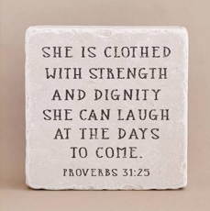

We are excited to welcome Jamie Farrar as the new Secretary at St. Paul!
Jamie will be in the church office Monday through Friday from 8:00 a.m. to 3:30 p.m., with a 30-minute lunch break.
If you need assistance, please contact the church office at 419-547-9225, call or text Jamie directly at 419-603-6731, or email her at sec@stpaulclyde.org.
Ashley's office hours will be limited going forward, so we encourage everyone to reach out to Jamie first for assistance.
Please join us in giving Jamie a warm St. Paul welcome!


147 West Forest Street
PO Box 296
Clyde, Ohio 43410-0296

Office Phone: 419-547-9225
Pastor Samuel Dagg ~ 567-342-2137
Council President Matt Woodland ~ 419-366-8135
Ashley Reed Assistant Secretary ~ 419-547-9225
Brian Farrar, P & W Leader ~ 419-271-3085
Jamie Farrar, Office Manager ~ 419-603-6731

Pastor’s email: pastor@stpaulclyde.org
Council President’s email prez@stpaulclyde.org
Assistant Secretary’s email asst.sec@stpaulclyde.org
Church Website: stpaulclyde.org
LCMC website: http://www.lcmc.net
NALC website: http://thenalc.org

2026 CHURCH COUNCIL

Tammy Baker – Parish Ed & Youth 419-603-0698 Kyle Klinski – Secretary – Worship 419-603-7793
Tim Billings – Stewardship/Finance 419-307-0377 Kevin Larkins – Evangelism/Social 567-201-3838
Tom Billings – Property 419-765-0279 Jennie McCoy – Parish Ed & Youth 419-680-2001
Walker Davenport – Evangelism/Social 419-463-8180 Kendall Stucky – Worship 419-618-7136
John Glass – Worship 419-680-4033 Tom Thorbahn – Vice-Pres – Evange/Social 419-366-8135
Steve Jess – Property 419-307-3042 Matt Woodland–President–Steward/Fin 419-603-0567

