St. Paul Lutheran Church
147 West Forest Street
Clyde, OH

Reformation Sunday
Contemporary Service
Sunday, October 27, 2024
10:30 am

Welcome/Announcements

Opening Song

Children’s Time

Confession & Forgiveness

Worship Songs

Scripture Reading

Sermon
“Free For??”
based on John 8:31-36
Rev. Dr. Tim Hubert
Prayers
for the sick and those in need:

Betty
Gene
Toni
Judy
Terry
Danyelle
Pastor Amy
Bill
Maverick
Mary
Ed
Joanne

DEPLOYED
Michael

Holy Communion

The Lord’s Prayer

Closing Song

Parting Blessing
Go in peace. Serve the Lord.
Thanks be to God.

Post – Service Music
* * * * * * * * * * * * * * * * * * * * * * * *


Our Good Shepherd calls us into the safekeeping of this fold. May all gathered here feel the welcome and love of God in Christ.

* * * * * * * * * * * * * * * * * * * * * * * *

THE ALTAR FLOWERS are given to the glory of God by Tim Billings.

* * * * * * * * * * * * * * * * * * * * * * * *

THE CHANCEL FLOWER ARRANGEMENT is given to the Glory of God in celebration of the 50th wedding anniversary on Saturday, October 26, 2026, of John & Sherri Glass.

* * * * * * * * * * * * * * * * * * * * * * * *


WE EXTEND OUR DEEPEST SYMPATHY AND
PRAYERS to the family and friends of:

Sue E. (Keegan) Dinan, passed away at her home on Friday, October 18, 2024.
* * * ** * * * * * * * * * * * * * * * * * * *

DAYLIGHT SAVINGS TIME ENDS ON SUNDAY, November 3, 2024, SO PLEASE

SET YOUR CLOCKS
BACK “1” HOUR ON
SUNDAY, November 3, 2024
October 27, 2024 – November 3, 2024
Sunday the  27th | 8:00 am ~ Holy Communion Worship  9:15 am ~ Sunday School  10:30 am ~ Holy Communion Worship  3:00 pm – 5:00 pm ~ Bunco  Congregational Voting Meeting
Monday the 28th | 7:30 pm ~ Dartball Practice AWAY @ Elmore #12
Tuesday the 29th | 1:00 pm ~ Pericope Meeting
Wednesday the 30th | 6:00 pm ~ Youth Choir practice  7:30 pm ~ Bible Study
Thursday the 31st | 7:00 pm – 8:00 pm ~ Al-Anon Meeting  8:00 pm ~ AA Meeting  SET UP PARISH HALL for RUMMAGE SALE
Friday the 1st | 9:00 am – 5:00 pm ~ Rummage Sale  All Saints Day
Saturday the 2nd | 8:00 am – 9:30 am ~ Men’s Bible Study  9:00 am – 1:00 pm ~ Rummage Sale  5:00 pm ~ Holy Communion Service
Sunday the  3rd   | 8:00 am ~ Holy Communion Worship  9:15 am ~ Sunday School  9:15 am ~ Women’s Board Meeting  10:30 am ~ Holy Communion Worship  All Saints Sunday
* * * * * * * * * * * * * * * * * * * * * * * *
ON THE “MEMORY BOARD” in the hall across from the sacristy, a cross represents each person of our congregation who has died since the last “All Saint’s Day”. These crosses will be presented to the families during the church services on the weekend of Saturday, November 2, 2024 & at BOTH services on Sunday, November 3, 2024. We will remember those who have passed into the nearer presence of Christ these past 12 months during the weekend services.

The crosses were placed on the “Memory Board” for:

John J. Baker
Sue E. (Keegan) Dinan
Rev. Paul Richard Long
Mark Allen Myles
Janet I. (Bouyack) Parkhurst
Jerry William Parkhurst
Carol A. (Chinnis) Taylor
Erika E. Wott
Richard William Wott, Jr.

* * * * * * * * * * * * * * * * * * * * * * * *
Women’s Bible Study for
Wednesday, October 30, 2024

Please note that the Women’s Bible Study for Wednesday, October 30, 2024, will be canceled as I’ll be out of town visiting family. We will resume Wednesday, November 6, 2024. If you have questions, please call
Sherry Frasher @ 419-765-7016.

* * * * * * * * * * * * * * * * * * * * * * * *
OFFICIAL NOTICE!!

CONGREGATIONAL VOTING MEETING
Saturday, October 26, 2024 &
Sunday, October 27, 2024

Elections for:

Church Council
Endowment Committee
Memorial Committee
Nominating Committee
Lutheran Social Service Agencies
Ohio Mission District & NALC Convocations

Elections will be held after each worship service.

* * * * * * * * * * * * * * * * * * * * * * * *


We offer many different ways to donate to St Paul Lutheran Church. The following QR code is the latest way. It can be used to direct you to St. Paul Lutheran Church’s electronic giving sign up page. You can always give using the church envelopes, the link on St Paul’s website at stpaulclyde.org, or donate by texting Donate/Donations to 844-440-0253 as well. Thank you for your continued support!


NOMINATING COMMITTEE
Voting Congregational Meeting is
Saturday, October 26, 2024 & Sunday, October 27, 2024

(* = incumbent)

I. Church Council: (4 terms expire need 8 on ballot)

Marilyn Bennett Norbert Mayer
Tim Billings Kendall Stucky
Fred Bouyack Tom Thorbahn
DeAnn Krauss * Matt Woodland *

II. Endowment Fund Committee: (need 3 – need 6 on ballot)

Deb Arnold Bob Kessler
Greg Avery Collin Rieman
Sherri Glass Dan Rogers

III. Memorial Committee: (At-Large Members) need
1 representative for 3-year term (need 2 on ballot)

Jackie Hoppe
Jill Wott

IV. Nominating Committee: (need 2) (need 4 on ballot)

Carol Jones Dawn Sumner
Tony Paradiso Linda Yates

V. Representatives for Social Service Agencies: Lutheran Social Services, Lutheran Homes Society & Williston Lutheran Home of Mercy (need 1 couple representatives for 1-year term ~ need 2 couples on ballot)

Walt & Sherry Frasher
Terry & Faye Langham

VI. Ohio Mission District Convocation & NALC Convocation Delegates:
(need 1 – need 2 on ballot)

Terry Langham
Kevin Larkins

Members of 2024 Nominating Committee:
Tammy Baker, Peg Hirt, DeAnn Krauss (Council Rep.)



DROP OFF OF ITEMS BEGIN on
Monday, October 28, 2024, in parish hall

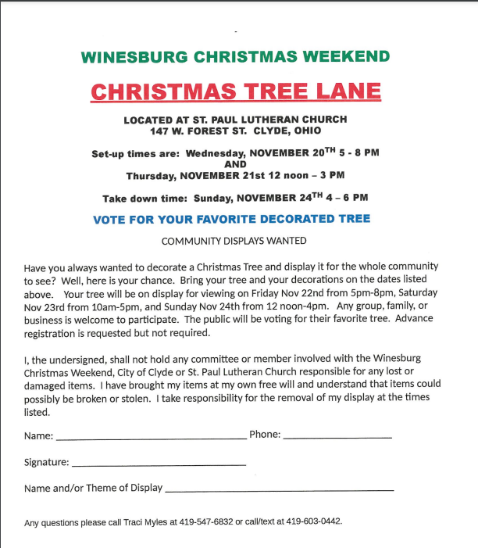

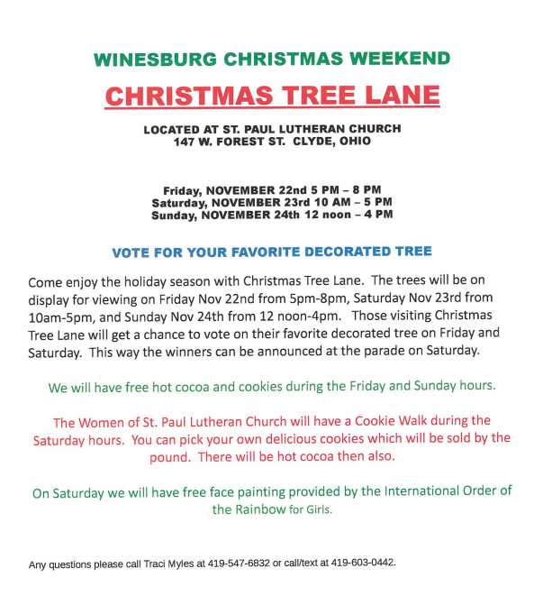

* * * * * * * * * * * * * * * * * * * * * * * *
HARVEST DINNER
(Baked Steak)
CARRY OUTS ONLY
Saturday, November 2, 2024
5:00 p.m. – 6:30 p.m.

First Presbyterian Church
113 West Forest Street
Clyde, Ohio

$12.00 adults ~ $6.00 children (10 & under)
* * * * * * * * * * * * * * * * *
ROAST BEEF DINNER
Saturday, November 2, 2024
4:00 p.m. until sold out

Congregational UCC of Castalia
205 Main Street
Castalia, Ohio

Dine In or Drive Through

$12.00 meal

Menu: slow roasted beef, home cooked mashed potatoes with gravy, green beans, salad bar (dine in)/cole slaw (drive through), dinner roll, dessert

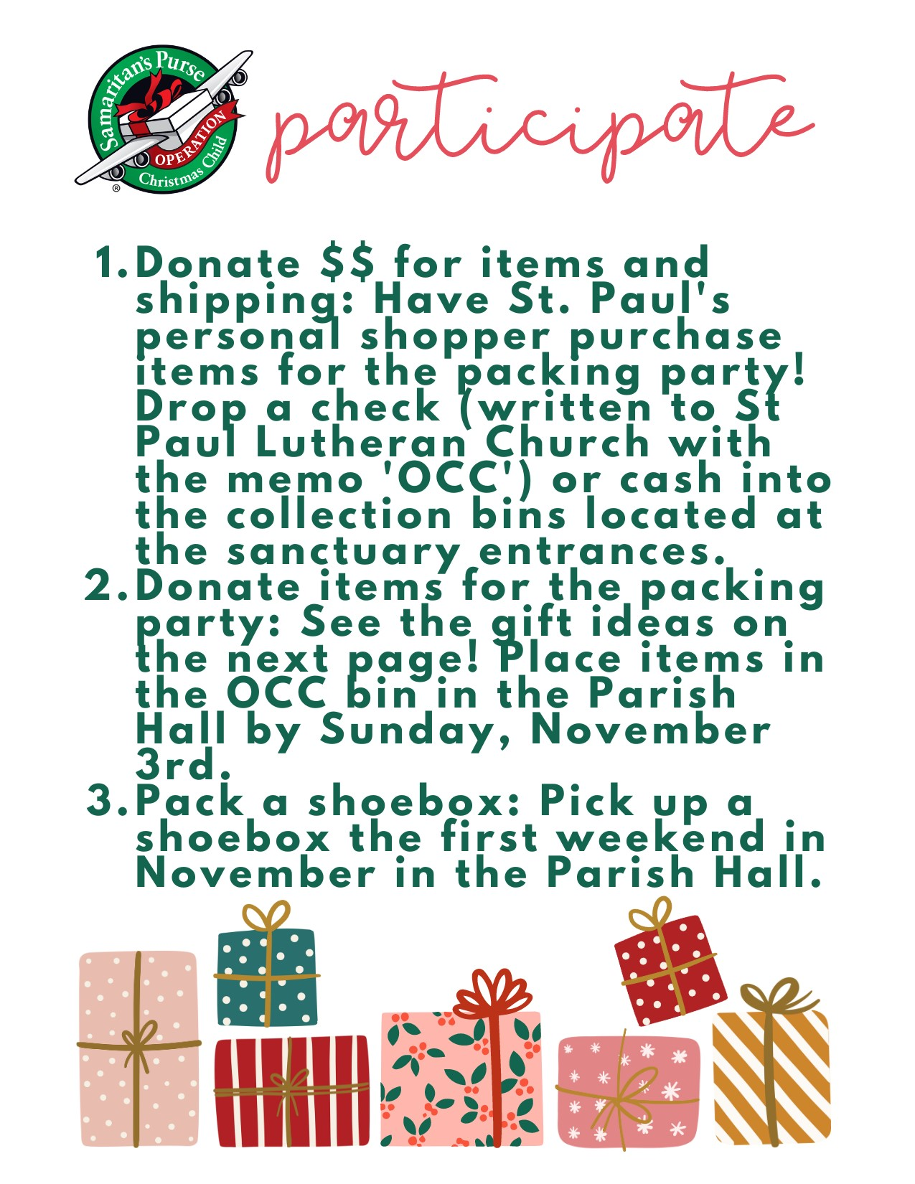



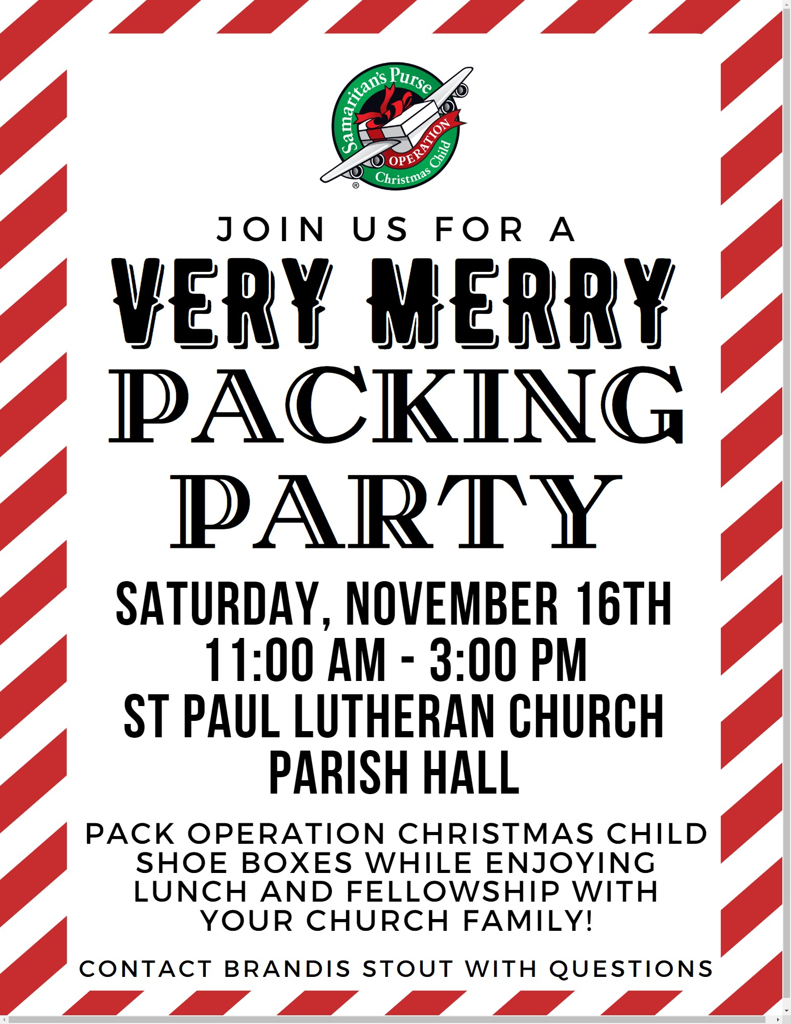

10:30 a.m. Service
ACOLYTE: Ray Freeze

USHERS: Steve Jess
Tammy Baker
Dawn Sumner
Kris Wott

COUNTERS: Mel Cook
Karen Jess

NURSERY WORKER: Jackie Hoppe

* * * * * * * * * * * * * * * * * * * * * * * *

The Rev. Dr. Tim Hubert Phone: 217-778-8017

Office Manager – Stephanie Stull Phone: 419-547-9225

Clerical Secretary – Sherry Bouyack Phone: 419-547-9225

Custodian – Terry Langham Phone: 419-547-9225

Treasurer – Jim Shull Phone: 419-355-6499

P & W Leader – Brian Farrar Phone: 419-271-3085

http://www.stpaulclyde.org

* * * * * * * * * * * * * * * * * * * * * * * *
OUR STEWARDSHIP Totals for Year-to-Date 2024

Worship Attendance for weekend of October 19 & 20, 2024 145

Income from January – August 2024 $ 215,747.27
Expense for January – August 2024 $ 223,562.15
Shortage for January – August 2024 $ -7,814.88

