Reformation Sunday
ELW Holy Communion
Traditional Service
Sunday, October 27, 2024
8:00 am

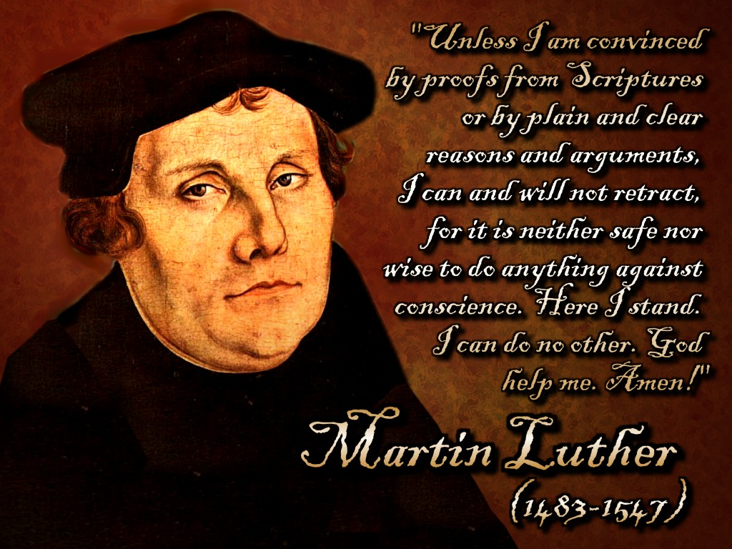

ST. PAUL LUTHERAN CHURCH
147 West Forest Street
Clyde, Ohio

Reformation Sunday

October 27, 2024

8:00 am

Holy Communion ~ Setting Four

* = those who are able may stand
Song numbers with “BB” are from the “The Best of the Best” songbook

Prelude

Bell & Announcements

*Confession & Forgiveness Pg. 94
P: In the name of the Father,
and of the ☩ Son,
and of the Holy Spirit.

C: Amen.

P: God of all mercy and consolation, come to the help of your people, turning us from our sin to live for you alone. Give us the power of your Holy Spirit that we may confess our sin, receive your forgiveness and grow into the fullness of Jesus Christ, our Savior and Lord.

C: Amen.

P: Let us confess our sin in the presence of God and of one another.

P: Most merciful God,

C: we confess that we are captive to sin and cannot free ourselves. We have sinned against you in thought, word, and deed, by what we have done and by what we have left undone. We have not loved you with our whole heart; we have not loved our neighbors as ourselves. For the sake of your Son, Jesus Christ, have mercy on us. Forgive us, renew us, and lead us, so that we may delight in your will and walk in your ways, to the glory of your holy name. Amen.

P: In the mercy of almighty God, Jesus Christ was given to die for us, and for his sake God forgives us all our sins. As a called and ordained minister of the church of Christ, and by his authority, I therefore declare to you the entire forgiveness of all your sins, in the name of the Father, and of the ☩ Son, and of the Holy Spirit.

C: Amen.

*The Hymn “We All Are One in Mission” No. 576

*The Apostolic Greeting Pg. 147
P: The grace of our Lord Jesus Christ, the love of God, and the communion of the Holy Spirit be with you all.
C: And also with you.

*The Kyrie Pg. 147
P: In peace, let us pray to the Lord.
C: Lord, have mercy.

P: For the peace from above, and for our salvation, let us pray to the Lord.
C: Lord, have mercy.

P: For the peace of the whole world, for the well-being of the church of God, and for the unity of all, let us pray to the Lord.
C: Lord, have mercy.

P: For this holy house, and for all who offer here their worship and praise, let us pray to the Lord.
C: Lord, have mercy.

P: Help, save, comfort, and defend us gracious Lord.
C: Amen.

The Hymn of Praise Pg. 149

Refrain
P: This is the feast of victory for our God. Alleluia.

1. Worthy is Christ, the Lamb who was slain, whose blood set us free to be people of God. Power and riches and wisdom and strength, and honor and blessing and glory are his.

Refrain
This is the feast of victory for our God. Alleluia.

2. Sing with all the people of God and join in the hymn of all creation: Blessing and honor and glory and might be to God and the Lamb forever. Amen.

Refrain
This is the feast of victory for our God, for the Lamb who was slain has begun his reign. Alleluia. Alleluia.

The Prayer of the Day (in unison)
O Lord God, heavenly Father, pour out your Holy Spirit upon your faithful people. Keep them steadfast in your grace and truth, protect and comfort them in all temptation, defend them against all enemies of your Word, and bestow upon the Church your saving peace; through your Son, Jesus Christ, our Lord, who lives and reigns with you and the Holy Spirit, one God, now and forever. Amen.

The First Lesson ~ Revelation 14:6-7
⁶I saw another angel flying directly overhead, with an eternal gospel to proclaim to those who dwell on earth, to every nation and tribe and language and people. ⁷And he said with a loud voice, “Fear God and give him glory, because the hour of his judgment has come, and worship him who made heaven and earth, the sea and the springs of water.”

L: The Word of the Lord.
C: Thanks be to God.

Psalm 46
¹God is our refuge and strength, a very present help in trouble.

²Therefore we will not fear though the earth gives way, though the mountains be moved into the heart of the sea,

³though its waters roar and foam, though the mountains tremble at its swelling.

⁴There is a river whose streams make glad the city of God, the holy habitation of the Most High.

⁵God is in the midst of her; she shall not be moved; God will help her when morning dawns.

⁶The nations rage, the kingdoms totter; he utters his voice, the earth melts.

⁷The Lord of hosts is with us; the God of Jacob is our fortress.

⁸Come, behold the works of the Lord, how he has brought desolations on the earth.

⁹He makes wars cease to the end of the earth; he breaks the bow and shatters the spear; he burns the chariots with fire.

¹⁰“Be still, and know that I am God. I will be exalted among the nations, I will be exalted in the earth!”

¹¹The Lord of hosts is with us; the God of Jacob is our fortress.

L: Here ends the reading of the Psalm.
C: Thanks be to God.

The Second Lesson ~ Romans 3:19-28
¹⁹Now we know that whatever the law says it speaks to those who are under the law, so that every mouth may be stopped, and the whole world may be held accountable to God. ²⁰For by works of the law no human being will be justified in his sight, since through the law comes knowledge of sin. ²¹But now the righteousness of God has been manifested apart from the law, although the Law and the Prophets bear witness to it — ²²the righteousness of God through faith in Jesus Christ for all who believe. For there is no distinction: ²³for all have sinned and fall short of the glory of God, ²⁴and are justified by his grace as a gift, through the redemption that is in Christ Jesus, ²⁵whom God put forward as a propitiation by his blood, to be received by faith. This was to show God’s righteousness, because in his divine forbearance he had passed over former sins. ²⁶It was to show his righteousness at the present time, so that he might be just and the justifier of the one who has faith in Jesus. ²⁷Then what becomes of our boasting? It is excluded. By what kind of law? By a law of works? No, but by the law of faith. ²⁸For we hold that one is justified by faith apart from works of the law.

L: The Word of the Lord.
C: Thanks be to God.

*The “Gospel Acclamation” Pg. 151
Alleluia. Lord, to whom shall we go? You have the words of eternal life. Alleluia.

P: The Holy Gospel according to St. John, the 8th chapter.
C: Glory to You, O Lord.

*The Gospel ~ John 8:31-36
³¹Jesus said to the Jews who had believed him, “If you abide in my word, you are truly my disciples, ³²and you will know the truth, and the truth will set you free.” ³³They answered him, “We are offspring of Abraham and have never been enslaved to anyone. How is it that you say, ‘You will become free’?” ³⁴Jesus answered them, “Truly, truly, I say to you, everyone who practices sin is a slave to sin. ³⁵The slave does not remain in the house forever; the son remains forever. ³⁶So if the Son sets you free, you will be free indeed.”

P: The Gospel of the Lord.
C: Praise to You, O Christ.

Moment with Children

The Sermon “Free For??”
John 8:31-36
Rev. Dr. Tim Hubert

*The Hymn “The Church of Christ, in Every Age” No. 729

*Prayers of Intercession
Let us intercede before the Father of our Lord Jesus Christ for the sake of the Church, the world, and one another.

A brief silence

Thank You, heavenly Father, for Your Holy Spirit, for His life-giving and purifying fire, for His gifts of wisdom and understanding, counsel and might, knowledge and fear of the Lord, and joy in Your presence. Thank You for reforming, renewing, and sustaining Your one, holy, catholic, and apostolic Church on earth.

Lord, in Your mercy, hear our prayer.

Pour out Your Spirit upon the Church. Make it Your holy habitation. Keep it steadfast in Your Word. Strengthen it in the face of temptation and defend it from evil. Reform and purify it from sin and error and bestow on it Your saving peace.

Lord, in Your mercy, hear our prayer.

Be the refuge and strength of Christians when they are persecuted for confessing Jesus as Lord. Grant them the strength to endure, even to giving their life in faithful witness to Him. Give us the courage and will to defend their witness, provide for their needs, and boldly confess the faith and the hope we share in Christ.

Lord, in Your mercy, hear our prayer.

Be to this congregation our help and our redeemer. Gladden our hearts with the joy of Your saving love. Empower us to share our joy, and Your love, with those who do not know either. We pray for the NALC, area congregations and today for Central Bedford Lutheran Parish.

Lord, in Your mercy, hear our prayer.

Pour out Your Spirit upon the teachers and theologians of the Church. Cause them to hand on as of first importance the Gospel of salvation through Jesus Christ. Bless church schools, colleges, and seminaries, so that they write Your words upon the hearts of many.

Lord, in Your mercy, hear our prayer.

Exalt Yourself among the nations and speak Your holy word to the leaders of the world. Establish among all peoples that peace which the world cannot give and teach us to do justice, love mercy, and walk humbly before You.

Lord, in Your mercy, hear our prayer.

We long for You to break the bow, shatter the spear, and make war to cease throughout the world. Until that day, direct and strengthen all who take up arms in defense of life and liberty. Be their very present help in times of trouble and places of danger. Prosper all they do that accomplishes Your will. Bring them home safely and soon.

Lord, in Your mercy, hear our prayer.

We lift before you the needs of all whose lives are shaken by suffering. Especially we pray for:

Betty
Gene
Toni
Judy
Terry
Danyelle
Pastor Amy
Bill
Maverick
Mary
Ed
Joanne

DEPLOYED
Michael

Be in their midst and let them not be overthrown. Give them Your saving help, and say to them, ‘be still, and know that I Am God.’ Restore them to health and hope that they may proclaim the awesome things You have done.

Lord, in Your mercy, hear our prayer.

Most holy Lord, we give You thanks for the lives of all Your faithful people whom You have claimed and redeemed through the precious blood of Jesus. Grant that we may humbly follow in their footsteps, boldly trust in Your promises, faithfully proclaim Your Word and cheerfully serve in Your Name. Bring us, through the merits of our Savior, into Your Kingdom, there, with all the redeemed, we shall glorify You in the power of Your Spirit forever.

Lord, in Your mercy, hear our prayer.

Into Your hands, gracious Father, we commend all for whom we pray, trusting in Your mercy; for the sake of Your Son, Jesus Christ our Lord. Amen.

*The Apostles’ Creed (back cover of hymnal)

The Peace of the Lord Pg. 152
P: The peace of the Lord be with you.
C: And also, with you.

*The Passing of the Peace (please remain in place)

The Offering

*The Offering Prayer (#3)
Blessed are you, O God, maker of all things. Through your goodness you have blessed us with these gifts: our possessions. Use us, and what we have gathered, in feeding the world with your love, through the one who gave himself for us, Jesus Christ, our Savior and Lord. Amen.

*The Great Thanksgiving Pg. 152
P: The Lord be with you.
C: And also, with you.

P: Lift up your hearts.
C: We lift them to the Lord.

P: Let us give thanks to the Lord our God.
C: It is right to give our thanks and praise.

*The Proper Preface
P: It is indeed right, our duty and our joy, that we should at all times and in all places give thanks and praise to You, almighty and merciful God. You reveal Your glory as the glory of the Father, the Son, and the Holy Spirit; equal in majesty, undivided in splendor, one Lord, one God, ever to be adored in Your eternal glory. And so, with all the choirs of angels, with the church on earth and the hosts of heaven, we praise Your name and join their unending hymn:

*“Holy, Holy, Holy…” Pg. 153
Holy, holy, holy Lord,
Lord God of power and might,
heav’n and earth are full of your glory.
Hosanna in the highest.
Blessed is he who comes in the name of the Lord.
Hosanna in the highest.

*The Words of Institution
In the night in which he was betrayed,
our Lord Jesus took bread, and gave thanks;
broke it, and gave it to his disciples, saying:
Take and eat; this is my body, given for you.
Do this for the remembrance of me.

Again, after supper, he took the cup, gave thanks,
and gave it for all to drink, saying:
This cup is the new covenant in my blood,
shed for you and for all people for the forgiveness of sin.
Do this for the remembrance of me.

*The “Lord’s Prayer” Pg. 154
P: Gathered into one by the Holy Spirit, let us pray as Jesus taught us.

Our Father, who art in heaven,
hallowed be thy name,
thy kingdom come,
thy will be done,
on earth as it is in heaven.

Give us this day our daily bread;
and forgive us our trespasses,
as we forgive those
who trespass against us;
and lead us not into temptation,
but deliver us from evil.

For thine is the kingdom,
and the power, and the glory,
forever and ever. Amen.

*Invitation to Communion Pg. 154
Come to the banquet, for all is now ready.

Holy Communion
All baptized believers in Jesus Christ as Lord are invited to receive communion today. Please follow the directions of the ushers. Children who have not yet received their “first communion” are also invited to come forward, to receive a blessing.

*The Post Communion Blessing
The body and blood…

*Prayer After Communion
P: Let us pray.
O God, we give You thanks that You have set before us this feast, the body and blood of Your Son. By Your Spirit strengthen us to serve all in need and to give ourselves away as bread for the hungry, through Jesus Christ our Lord.
C: Amen.

*The Hymn “A Mighty Fortress Is Our God” No. 504

Youth Choir
“Bless the Lord Oh My Soul / Ten Thousand”

*The Benediction Pg. 155

*The Dismissal
P: Go in peace. . .
C: Thanks be to God.

The Postlude

* * * * * * * * * * * * * * * * * * * * * * * *

Our Good Shepherd calls us into the safekeeping of this fold. May all gathered here feel the welcome and love of God in Christ.

* * * * * * * * * * * * * * * * * * * * * * * *

THE ALTAR FLOWERS are given to the glory of God by Tim Billings.

* * * * * * * * * * * * * * * * * * * * * * * *

THE CHANCEL FLOWER ARRANGEMENT is given to the Glory of God in celebration of the 50th wedding anniversary on Saturday, October 26, 2026, of John & Sherri Glass.

* * * * * * * * * * * * * * * * * * * * * * * *


WE EXTEND OUR DEEPEST SYMPATHY AND
PRAYERS to the family and friends of:

Sue E. (Keegan) Dinan, passed away at her home on Friday, October 18, 2024.
* * * ** * * * * * * * * * * * * * * * * * * *

DAYLIGHT SAVINGS TIME ENDS ON SUNDAY, November 3, 2024, SO PLEASE

SET YOUR CLOCKS
BACK “1” HOUR ON
SUNDAY, November 3, 2024
October 27, 2024 – November 3, 2024
Sunday the  27th | 8:00 am ~ Holy Communion Worship  9:15 am ~ Sunday School  10:30 am ~ Holy Communion Worship  3:00 pm – 5:00 pm ~ Bunco  Congregational Voting Meeting
Monday the 28th | 7:30 pm ~ Dartball Practice AWAY @ Elmore #12
Tuesday the 29th | 1:00 pm ~ Pericope Meeting
Wednesday the 30th | 6:00 pm ~ Youth Choir practice  7:30 pm ~ Bible Study
Thursday the 31st | 7:00 pm – 8:00 pm ~ Al-Anon Meeting  8:00 pm ~ AA Meeting  SET UP PARISH HALL for RUMMAGE SALE
Friday the 1st | 9:00 am – 5:00 pm ~ Rummage Sale  All Saints Day
Saturday the 2nd | 8:00 am – 9:30 am ~ Men’s Bible Study  9:00 am – 1:00 pm ~ Rummage Sale  5:00 pm ~ Holy Communion Service
Sunday the  3rd   | 8:00 am ~ Holy Communion Worship  9:15 am ~ Sunday School  9:15 am ~ Women’s Board Meeting  10:30 am ~ Holy Communion Worship  All Saints Sunday
* * * * * * * * * * * * * * * * * * * * * * * *
ON THE “MEMORY BOARD” in the hall across from the sacristy, a cross represents each person of our congregation who has died since the last “All Saint’s Day”. These crosses will be presented to the families during the church services on the weekend of Saturday, November 2, 2024 & at BOTH services on Sunday, November 3, 2024. We will remember those who have passed into the nearer presence of Christ these past 12 months during the weekend services.

The crosses were placed on the “Memory Board” for:

John J. Baker
Sue E. (Keegan) Dinan
Rev. Paul Richard Long
Mark Allen Myles
Janet I. (Bouyack) Parkhurst
Jerry William Parkhurst
Carol A. (Chinnis) Taylor
Erika E. Wott
Richard William Wott, Jr.

* * * * * * * * * * * * * * * * * * * * * * * *
Women’s Bible Study for
Wednesday, October 30, 2024

Please note that the Women’s Bible Study for Wednesday, October 30, 2024, will be canceled as I’ll be out of town visiting family. We will resume Wednesday, November 6, 2024. If you have questions, please call
Sherry Frasher @ 419-765-7016.

* * * * * * * * * * * * * * * * * * * * * * * *
OFFICIAL NOTICE!!

CONGREGATIONAL VOTING MEETING
Saturday, October 26, 2024 &
Sunday, October 27, 2024

Elections for:

Church Council
Endowment Committee
Memorial Committee
Nominating Committee
Lutheran Social Service Agencies
Ohio Mission District & NALC Convocations

Elections will be held after each worship service.

* * * * * * * * * * * * * * * * * * * * * * * *


We offer many different ways to donate to St Paul Lutheran Church. The following QR code is the latest way. It can be used to direct you to St. Paul Lutheran Church’s electronic giving sign up page. You can always give using the church envelopes, the link on St Paul’s website at stpaulclyde.org, or donate by texting Donate/Donations to 844-440-0253 as well. Thank you for your continued support!


NOMINATING COMMITTEE
Voting Congregational Meeting is
Saturday, October 26, 2024 & Sunday, October 27, 2024

(* = incumbent)

I. Church Council: (4 terms expire need 8 on ballot)

Marilyn Bennett Norbert Mayer
Tim Billings Kendall Stucky
Fred Bouyack Tom Thorbahn
DeAnn Krauss * Matt Woodland *

II. Endowment Fund Committee: (need 3 – need 6 on ballot)

Deb Arnold Bob Kessler
Greg Avery Collin Rieman
Sherri Glass Dan Rogers

III. Memorial Committee: (At-Large Members) need
1 representative for 3-year term (need 2 on ballot)

Jackie Hoppe
Jill Wott

IV. Nominating Committee: (need 2) (need 4 on ballot)

Carol Jones Dawn Sumner
Tony Paradiso Linda Yates

V. Representatives for Social Service Agencies: Lutheran Social Services, Lutheran Homes Society & Williston Lutheran Home of Mercy (need 1 couple representatives for 1-year term ~ need 2 couples on ballot)

Walt & Sherry Frasher
Terry & Faye Langham

VI. Ohio Mission District Convocation & NALC Convocation Delegates:
(need 1 – need 2 on ballot)

Terry Langham
Kevin Larkins

Members of 2024 Nominating Committee:
Tammy Baker, Peg Hirt, DeAnn Krauss (Council Rep.)



DROP OFF OF ITEMS BEGIN on
Monday, October 28, 2024, in parish hall

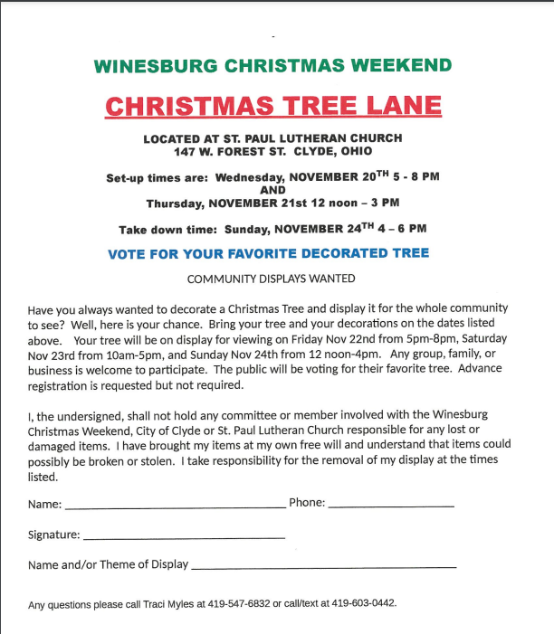



* * * * * * * * * * * * * * * * * * * * * * * *
HARVEST DINNER
(Baked Steak)
CARRY OUTS ONLY
Saturday, November 2, 2024
5:00 p.m. – 6:30 p.m.

First Presbyterian Church
113 West Forest Street
Clyde, Ohio

$12.00 adults ~ $6.00 children (10 & under)
* * * * * * * * * * * * * * * * *
ROAST BEEF DINNER
Saturday, November 2, 2024
4:00 p.m. until sold out

Congregational UCC of Castalia
205 Main Street
Castalia, Ohio

Dine In or Drive Through

$12.00 meal

Menu: slow roasted beef, home cooked mashed potatoes with gravy, green beans, salad bar (dine in)/cole slaw (drive through), dinner roll, dessert

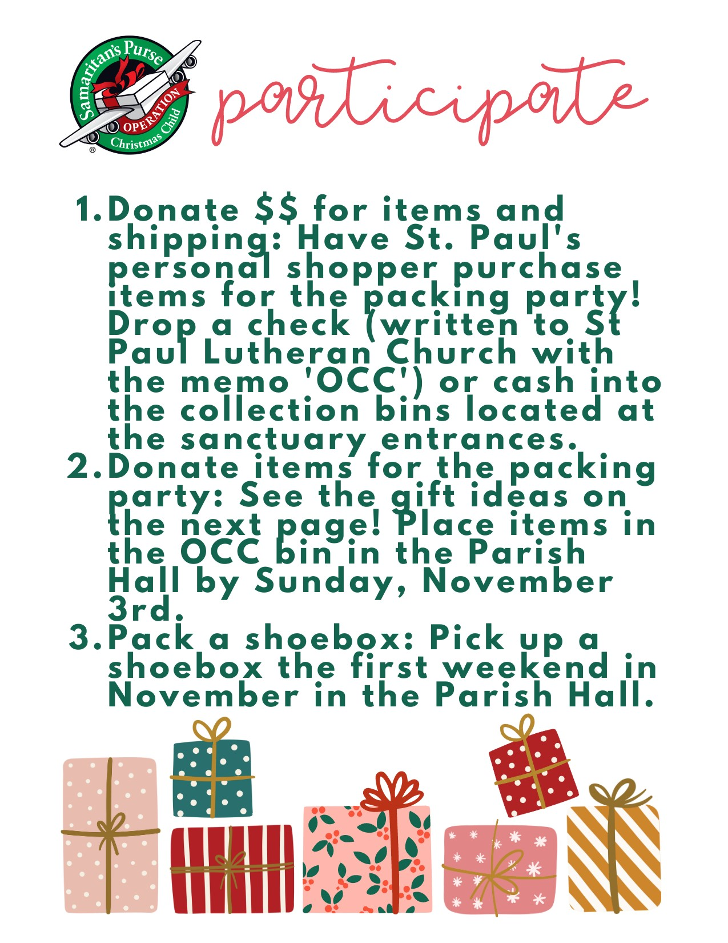



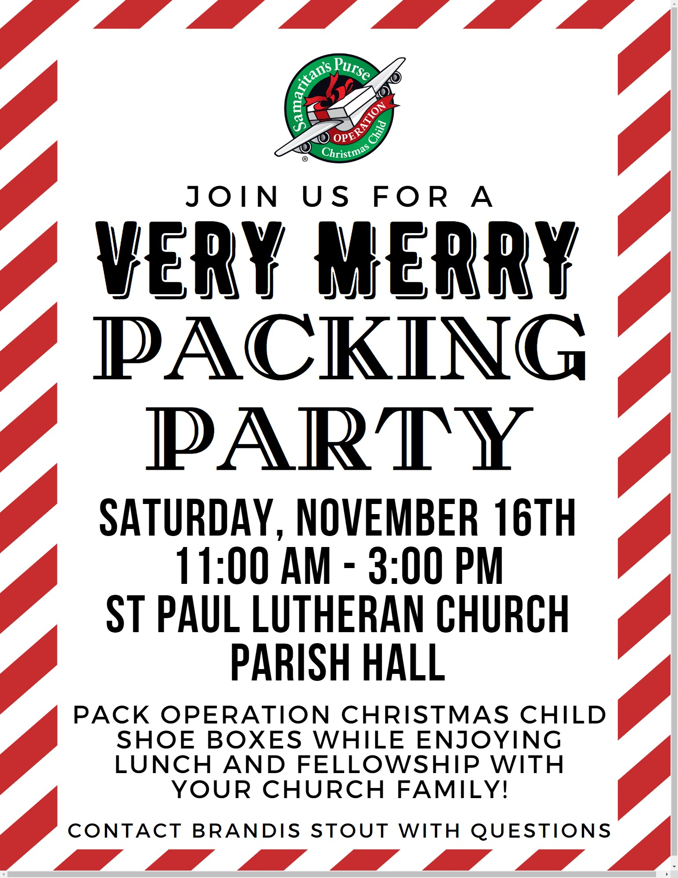

8:00 a.m. Service

COMPUTER TECH: Matt Woodland

READER: Duane Kimmet

USHERS: Tim Billings
Deb Davenport
Tanner Davenport
Duane Kimmet

* * * * * * * * * * * * * * * * * * * * * * * *

The Rev. Dr. Tim Hubert Phone: 217-778-8017

Office Manager – Stephanie Stull Phone: 419-547-9225

Clerical Secretary – Sherry Bouyack Phone: 419-547-9225

Custodian – Terry Langham Phone: 419-547-9225

Treasurer – Jim Shull Phone: 419-355-6499

P & W Leader – Brian Farrar Phone: 419-271-3085

Organists
Barb Gosnell
Linda Thorbahn

http://www.stpaulclyde.org

* * * * * * * * * * * * * * * * * * * * * * * *
OUR STEWARDSHIP Totals for Year-to-Date 2024

Worship Attendance for weekend of October 19 & 20, 2024 145

Income from January – August 2024 $ 215,747.27
Expense for January – August 2024 $ 223,562.15
Shortage for January – August 2024 $ -7,814.88

