All Saints Sunday
Sunday November 1, 2026
8:00 am



147 West Forest Street Clyde, Ohio
Prelude, Bell & Announcements
Confession & Forgiveness Pg. 94
P: In the name of the Father, and of the ☩ Son, and of the Holy Spirit.
C: Amen.
P: God of all mercy and consolation, come to the help of your people, turning us from our sin to live for you alone. Give us the power of your Holy Spirit that we may confess our sin, receive your forgiveness and grow into the fullness of Jesus Christ, our Savior and Lord.
C: Amen.
P: Let us confess our sin in the presence of God and of one another.
P: Most merciful God,
C: We confess that we are captive to sin and cannot free ourselves. We have sinned against you in thought, word, and deed, by what we have done and by what we have left undone. We have not loved you with our whole heart; we have not loved our neighbors as ourselves. For the sake of your Son, Jesus Christ, have mercy on us. Forgive us, renew us, and lead us, so that we may delight in your will and walk in your ways, to the glory of your holy name. Amen.
P: God who is rich in mercy, loved us even when we were dead in sin, and made us alive together with Christ. By grace you have been saved. In the name of Jesus Christ, the entirety of your sins are forgiven. Almighty God strengthen you with power through the Holy Spirit, that Christ may live in your hearts through faith.
C: Amen.
Hymn: “For All Saints” vs 1-4 #422

The Apostolic Greeting Pg. 147
P: The grace of our Lord Jesus Christ, the love of God, and the communion of the Holy Spirit be with you all.
C: And also with you.
The Kyrie Pg. 147
P: In peace, let us pray to the Lord.
C: Lord, have mercy.
P: For the peace from above, and for our salvation, let us pray to the Lord.
C: Lord, have mercy.
P: For the peace of the whole world, for the well-being of the church of God, and for the unity of all, let us pray to the Lord.
C: Lord, have mercy.
P: For this holy house, and for all who offer here their worship and praise, let us pray to the Lord.
C: Lord, have mercy.
P: Help, save, comfort, and defend us gracious Lord.
C: Amen.
The Hymn of Praise Pg. 149
P: This is the feast of victory for our God. Alleluia.
Worthy is Christ, the Lamb who was slain, whose blood set us free to be people of God. Power and riches and wisdom and strength, and honor and blessing and glory are his.
This is the feast of victory for our God. Alleluia.
Sing with all the people of God and join in the hymn of all creation: Blessing and honor and glory and might be to God and the Lamb forever. Amen.
This is the feast of victory for our God, for the Lamb who was slain has begun his reign. Alleluia. Alleluia.
The Prayer of the Day
Almighty God, you have knit together your people in one communion and fellowship in the mystical body of your Son, Christ, our Lord. Grant us grace to follow your blessed saints in all virtuous and godly living, that we may come to those ineffable joys which you have prepared for those who love you; through your Son, Jesus Christ, our Lord, who lives and reigns with you and the Holy Spirit, one God, now and forever. Amen.
The First Reading: Revelation 7:9-17
⁹After this I looked, and behold, a great multitude that no one could number, from every nation, from all tribes and peoples and languages, standing before the throne and before the Lamb, clothed in white robes, with palm branches in their hands, ¹⁰and crying out with a loud voice, “Salvation belongs to our God who sits on the throne, and to the Lamb!” ¹¹And all the angels were standing around the throne and around the elders and the four living creatures, and they fell on their faces before the throne and worshiped God, ¹²saying, “Amen! Blessing and glory and wisdom and thanksgiving and honor and power and might be to our God forever and ever! Amen.” ¹³Then one of the elders addressed me, saying, “Who are these, clothed in white robes, and from where have they come?” ¹⁴I said to him, “Sir, you know.” And he said to me, “These are the ones coming out of the great tribulation. They have washed their robes and made them white in the blood of the Lamb. ¹⁵“Therefore they are before the throne of God, and serve him day and night in his temple; and he who sits on the throne will shelter them with his presence. ¹⁶They shall hunger no more, neither thirst anymore; the sun shall not strike them, nor any scorching heat. ¹⁷For the Lamb in the midst of the throne will be their shepherd, and he will guide them to springs of living water, and God will wipe away every tear from their eyes.”
L: The Word of the Lord.
C: Thanks be to God.
Psalm 149
¹Praise the Lord! Sing to the Lord a new song, his praise in the assembly of the godly!
²Let Israel be glad in his Maker; let the children of Zion rejoice in their King!
³Let them praise his name with dancing,
making melody to him with tambourine and lyre!
⁴For the Lord takes pleasure in his people; he adorns the humble with salvation.
⁵Let the godly exult in glory; let them sing for joy on their beds.
⁶Let the high praises of God be in their throats and two-edged swords in their hands,
⁷to execute vengeance on the nations and punishments on the peoples,
⁸to bind their kings with chains and their nobles with fetters of iron,
⁹to execute on them the judgment written! This is honor for all his godly ones. Praise the Lord!
L: Here ends the reading of the Psalm.
C: Thanks be to God.
The Second Reading: 1 John 3:1-3
¹See what kind of love the Father has given to us, that we should be called children of God; and so we are. The reason why the world does not know us is that it did not know him. ²Beloved, we are God’s children now, and what we will be has not yet appeared; but we know that when he appears we shall be like him, because we shall see him as he is. ³And everyone who thus hopes in him purifies himself as he is pure.

L: The Word of the Lord.
C: Thanks be to God.
The Gospel Acclamation Pg. 151
Alleluia. Lord, to whom shall we go? You have the words of eternal life. Alleluia.
P: The Holy Gospel according to St. Matthew, the 5th chapter.
C: Glory to You, O Lord.
The Gospel: Matthew 5:1-12
¹Seeing the crowds, he went up on the mountain, and when he sat down, his disciples came to him. ²And he opened his mouth and taught them, saying: ³“Blessed are the poor in spirit, for theirs is the kingdom of heaven. ⁴“Blessed are those who mourn, for they shall be comforted. ⁵“Blessed are the meek, for they shall inherit the earth. ⁶“Blessed are those who hunger and thirst for righteousness, for they shall be satisfied. ⁷“Blessed are the merciful, for they shall receive mercy. ⁸“Blessed are the pure in heart, for they shall see God. ⁹“Blessed are the peacemakers, for they shall be called sons of God. ¹⁰“Blessed are those who are persecuted for righteousness’ sake, for theirs is the kingdom of heaven. ¹¹“Blessed are you when others revile you and persecute you and utter all kinds of evil against you falsely on my account. ¹²Rejoice and be glad, for your reward is great in heaven, for so they persecuted the prophets who were before you.
P: Gospel of the Lord
C: Praise to You, O Christ.

Sermon “Our Hope & Our Future” Matthew 5:1-12
Pastor Sam Dagg
The Hymn “Shall We Gather at the River” 4vs #423
Our Risen Saints

Edward Thurn Jr.
Patsy J. Aldrich
LaVerde A. Kuns
Jeffery Miller
Todd Baker
Jackie Bower
Naomi Conley
Joan Marie Peterson
Robert E. Gray Jr.
Donald Edwin Franks
Tom Kochendoerfer

Prayers of Intercession
Vickie Aldrich
Gwendolyn Baughn
Molly Binder
Michelle Borodkin
Courtney Bouyack
Toni Dagg
Crew Dearth
Sharon Duskin
Becky Karr
Kris Larkins
Denise McCubbin
Matt Pumphrey
Maverick Salazar
Lindsay Sooy
Larry Sumner
Conner Whaley
Sandy Wott
Dean Tea
Matt Woodland
Terry Langham
Judy Campbel
Carol Kohs
Larry Bower
Vickie Smith
Family & Friends of
Joyce Weiker
THE APOSTLES’ CREED (back cover of the hymnal)
The Peace of the Lord Pg. 152
P: The peace of the Lord be with you.
C: And also, with you.
The Passing of the Peace
The Offering

The Offering Prayer
Blessed are you, O God, maker of all things. Through your goodness you have blessed us with these gifts: our possessions. Use us, and what we have gathered, in feeding the world with your love, through the one who gave himself for us, Jesus Christ, our Savior and Lord. Amen.
The Great Thanksgiving Pg. 152
P: The Lord be with you.
C: And also, with you.
P: Lift up your hearts.
C: We lift them to the Lord.
P: Let us give thanks to the Lord our God.
C: It is right to give our thanks and praise.
The Proper Preface
P: It is indeed right, our duty and our joy, that we should at all times and in all places give thanks and praise to You, almighty and merciful God. You reveal Your glory as the glory of the Father, the Son, and the Holy Spirit; equal in majesty, undivided in splendor, one Lord, one God, ever to be adored in Your eternal glory. And so, with all the choirs of angels, with the church on earth and the hosts of heaven, we praise Your name and join their unending hymn:
C: Holy, holy, holy Lord,
Lord God of power and might,
heav’n and earth are full of your glory.
Hosanna in the highest.
Blessed is he who comes in the name of the Lord.
Hosanna in the highest.
The Words of Institution
The Lord’s Prayer Pg. 154
P: Gathered into one by the Holy Spirit, let us pray as Jesus taught us.
C: Our Father, Who art in heaven, hallowed be Thy name, Thy kingdom come, Thy will be done, on earth as it is in heaven. Give us this day our daily bread; and forgive us our trespasses, as we forgive those who trespass against us; and lead us not into temptation, but deliver us from evil. For Thine is the kingdom, and the power, and the glory, forever and ever. Amen.
Invitation to Communion Pg. 154 P: Come to the banquet, for all is now ready.
Holy Communion
All baptized believers in Jesus Christ as Lord are invited to receive communion today. Please follow the pastor’s instructions.
The Post Communion Blessing
P: The body and blood of our Lord Jesus Christ strengthen you and keep you in His grace.
C: Amen.
Prayer After Communion
P: Let us pray.
C: O God, we give You thanks that You have set before us this feast, the body and blood of Your Son. By Your Spirit strengthen us to serve all in need and to give ourselves away as bread for the hungry, through Jesus Christ our Lord. Amen.
The Hymn “Borning Cry” 4vs #732
The Benediction
P: May the Lord bless you and keep you;
the Lord make his face shine on you and be gracious to you;
the Lord turn his face toward you and give you peace.

In the name of the Father,
and of the ☩ Son,
and of the Holy Spirit.
C: Amen.
The Dismissal
P: GO IN PEACE. SERVE THE LORD!
C: Thanks be to God.
The Postlude
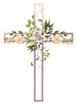
* * * * * * * * * * * * * * * * * * * * * * * * * * * * * * * * * * * * * * * * * *
ALTAR FLOWERS
The altar flowers are given to the Glory of God by Deanna Turner in loving memory of her parents Jackson and Rose Turner’s wedding anniversary on Oct. 19th.

* * * * * * * * * * * * * * * * * * * * * * * * * * * * * * * * * * * * * * * * * *

New Altar Flower Sign-Up 2027
The new altar flower sign-up is located in Ashley’s mailbox by the office. Please fill out all 3 slots and any specific instructions for flowers. Thank you!

* * * * * * * * * * * * * * * * * * * * * * * * * * * * * * * * * * * * * * * * * *

Women’s Bible Study Notice
The Women’s Bible Study will not be meeting on November 4, 2026. We will resume meeting on November 11, 2026. We will be reviewing “The Chosen” Season 5 while looking forward to viewing and discussing “The Chosen” Season 6. Please consider joining us in the Sunday School Youth Room. If you have questions, please call Sherry Frasher @ 419-765-7016.
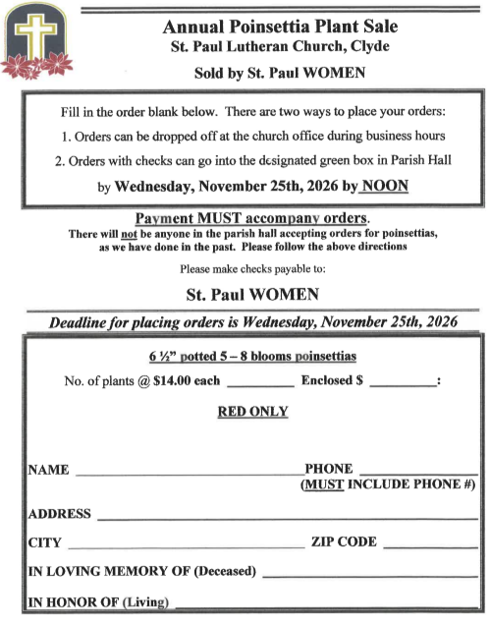
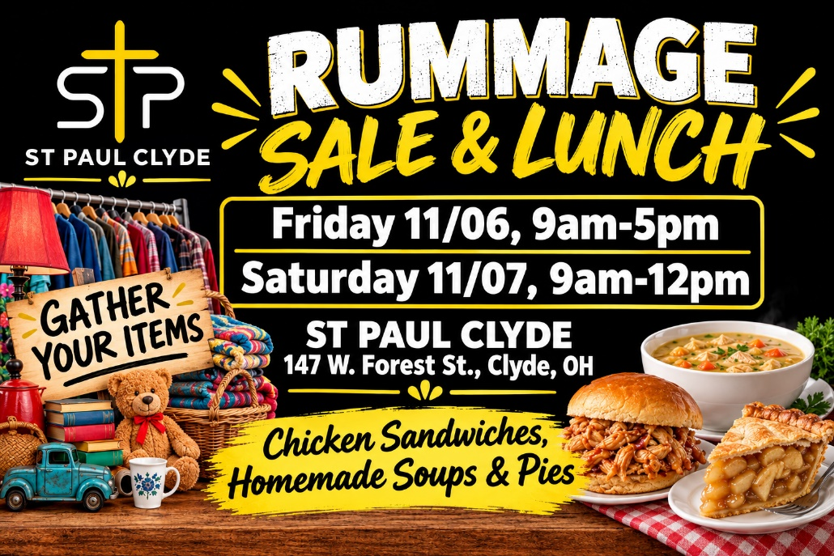
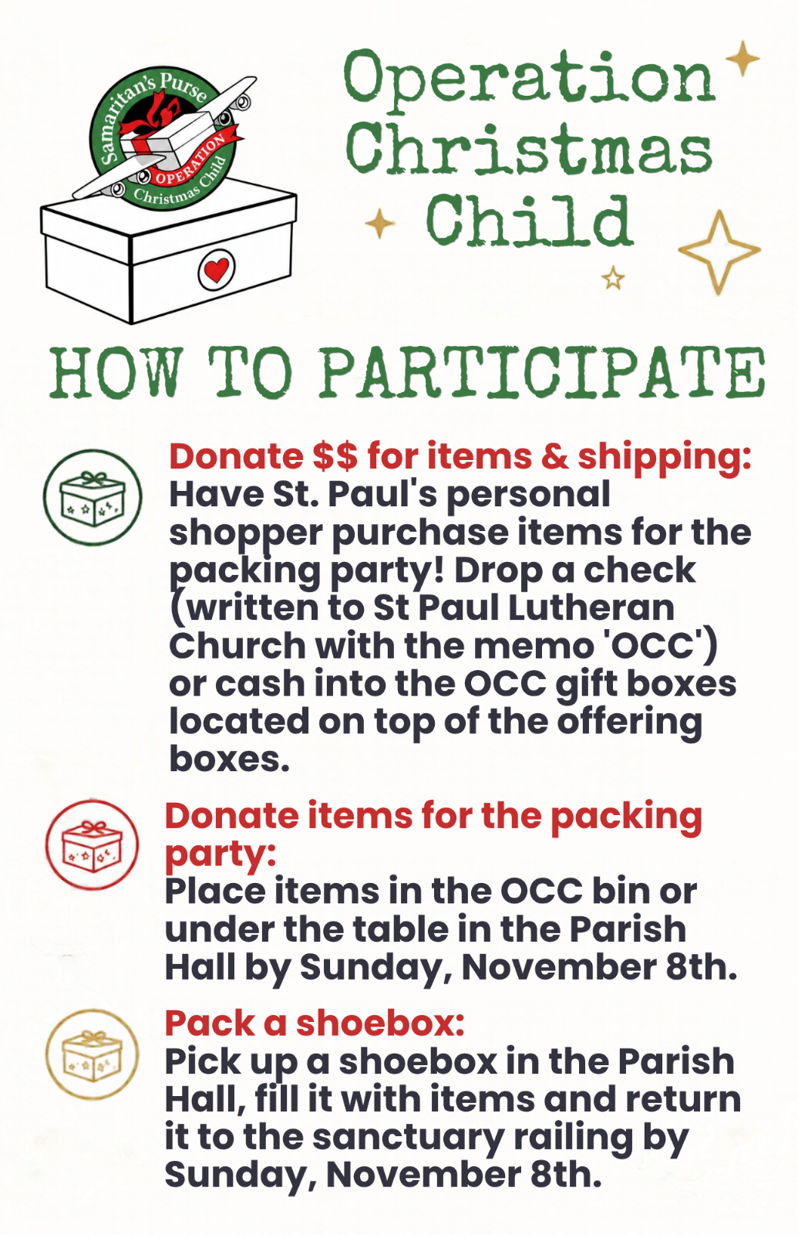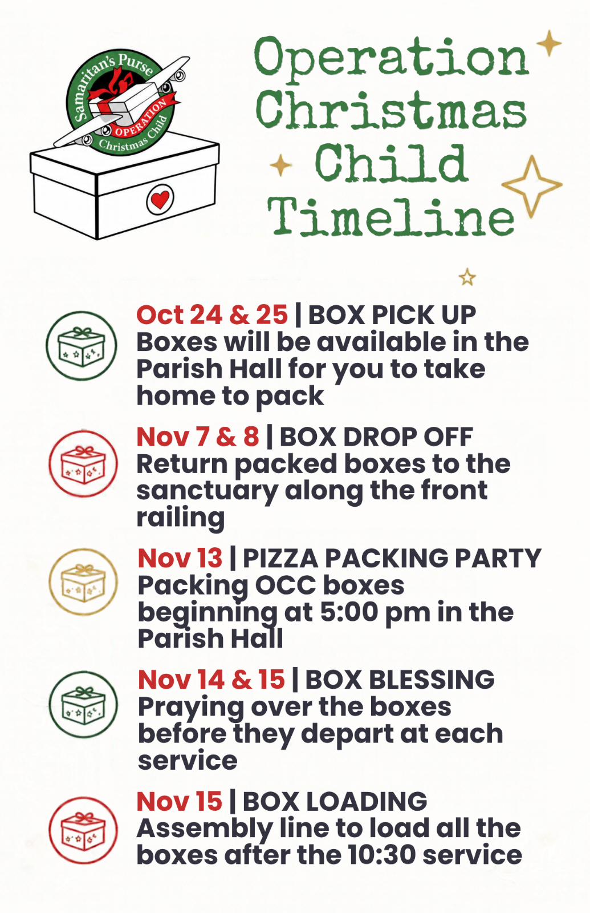Drop-Off Begins Monday Nov. 2, 2026! November 2026
Sunday  1 | 8:00 am ~ Worship  9:15 am ~ Women’s Meeting  10:30 am ~ Worship
Monday  2 | 6:30 pm ~ Co-Ed Bible Study  7:30 pm ~ Dartball vs St. Paul’s #1
Tuesday  3 | 6:30 pm ~ Men’s Bible Study  7:00 pm ~ Parish Ed & Youth Meeting
Wednesday
4
Thursday  5 | 7:00 pm ~ Al-Anon Meeting  8:00 pm ~ AA Meeting
Friday  6 | 9:00 am-5pm ~ RUMMAGE SALE
Saturday  7 | 8:00 am ~ Men’s Bible Study  9:00 am-12:00 pm ~ RUMMAGE SALE  5:00 pm ~ Worship
Sunday  8 | 8:00 am ~ Worship  10:30 am ~ Worship
October 24-25 Attendance: 161
8:00 am Service
COMPUTER TECH: Kevin Larkins
READER: Barb Wahl
USHERS: Kevin Larkins
Michelle Larkins
Jim Sieger
Brenda Sieger

* * * * * * * * * * * * * * * * * * * * * * * * * * * * * * * * * * * * * * * * *
Church Office Phone: 419-547-9225
Jamie Farrar Phone: 419-603-6731
sec@stpaulclyde.org
Pastor Samuel Dagg Phone: 567-342-2137
pastor@stpaulclyde.org
Matt Woodland ~ Council President Phone: 419-603-0567
prez@stpaulclyde.org
Jim Shull ~ Treasurer Phone: 419-355-6499
treas@stpaulclyde.org
Brian Farrar ~ P & W Leader Phone: 419-547-9225
pwl@stpaulclyde.org
Sherry Bouyack ~ Clerical Secretary Phone: 419-547-9225
fisec@stpaulclyde.org
Amber Brown ~ Youth Director Phone: 732-580-5034
youthdirector@stpaulclyde.org

Organist
Mary Ellen Wollenslegel

