St. Paul Lutheran Church
147 West Forest Street
Clyde, OH

All Saints Sunday
Contemporary Service
Sunday, November 3, 2024
10:30 am

Welcome/Announcements

Opening Song

Children’s Time

Confession & Forgiveness

Worship Songs

Scripture Reading

Sermon
“Blessed are you when…”
based on Matthew 5:1-12
Rev. Dr. Tim Hubert
Prayers
for the sick and those in need:

Betty
Gene
Toni
Judy
Danyelle
Pastor Amy
Peyton
Bill
Maverick
Mary
Ed
Joanne

DEPLOYED
Michael

for those who have passed:

John J. Baker
Sue E. (Keegan) Dinan
Rev. Paul Richard Long
Mark Allen Myles
Janet I. (Bouyack) Parkhurst
Jerry William Parkhurst
Carol A. (Chinnis) Taylor
Erika E. Wott
Richard William Wott, Jr.

Holy Communion

The Lord’s Prayer

Closing Song

Parting Blessing
Go in peace. Serve the Lord.
Thanks be to God.

Post – Service Music

* * * * * * * * * * * * * * * * * * * * * * *


Welcome to worship this All-Saints Sunday Weekend. As we remember the faithful who have gone before us, we also rejoice to be called saints of God through baptism.

* * * * * * * * * * * * * * * * * * * * * * * *

THE ALTAR FLOWERS are given to the glory of God in honor of the 14th birthday on Sunday, October 27, 2024, of Jeremy Lantz & the 17th birthday on Thursday, November 7, 2024, of Jonathan Lantz.

* * * ** * * * * * * * * * * * * * * * * * * *
PRAY FOR ALL OUR HOMEBOUND AND/OR IN MEDICAL CARE FACILITIES:

Thelma Blair, Bev Bush, Diane Dagg, Jim & Norma Fish, Mildred House, Janet Kauble, LaVerde Kuns, Florence Pocock, Jeanette Pumphrey, Tina Walker, Carlos & Joyce Weiker, Sandy Wott, Rodger Yates. If you know of other members who are not listed, please inform the church office, 419-547-9225.
* * * ** * * * * * * * * * * * * * * * * * * *


DAYLIGHT SAVINGS TIME ENDS ON SUNDAY, November 3, 2024, SO PLEASE

SET YOUR CLOCKS
BACK “1” HOUR ON

SUNDAY, November 3, 2024

November 3, 2024 – November 10, 2024
Sunday the  3rd   | 8:00 am ~ Holy Communion Worship  9:15 am ~ Sunday School  9:15 am ~ Women’s Board Meeting  10:30 am ~ Holy Communion Worship  5:00 pm ~ CCYG  All Saints Sunday
Monday the 4th | 7:30 pm ~ Dartball HOME with Grace #24
Tuesday the 5th | 1:00 pm ~ Pericope Meeting  6:00 pm ~ Parish Education/Youth Board Meeting
Wednesday the 6th | 6:00 pm ~ Women’s Bible Study  6:00 pm ~ Youth Choir practice  Pastor on vacation
Thursday the 7th | 7:00 pm – 8:00 pm ~ Al-Anon Meeting  8:00 pm ~ AA Meeting  Pastor on vacation
Friday the 8th | Pastor on vacation
Saturday the 9th | 8:00 am – 9:30 am ~ Men’s Bible Study  5:00 pm ~ Holy Communion Service  Pastor on vacation
Sunday the  10th | 8:00 am ~ Holy Communion Worship  9:15 am ~ Sunday School  10:30 am ~ Holy Communion Worship  Pastor on vacation
* * * * * * * * * * * * * * * * * * * * * * * *
ON THE “MEMORY BOARD” in the hall across from the sacristy, a cross represents each person of our congregation who has died since the last “All Saint’s Day”. These crosses will be presented to the families during the church services on the weekend of Saturday, November 2, 2024 & at BOTH services on Sunday, November 3, 2024. We will remember those who have passed into the nearer presence of Christ these past 12 months during the weekend services.

The crosses were placed on the “Memory Board” for:

John J. Baker
Sue E. (Keegan) Dinan
Rev. Paul Richard Long
Mark Allen Myles
Janet I. (Bouyack) Parkhurst
Jerry William Parkhurst
Carol A. (Chinnis) Taylor
Erika E. Wott
Richard William Wott, Jr.

* * * * * * * * * * * * * * * * * * * * * * * *


We offer many different ways to donate to St Paul Lutheran Church. The following QR code is the latest way. It can be used to direct you to St. Paul Lutheran Church’s electronic giving sign up page. You can always give using the church envelopes, the link on St Paul’s website at stpaulclyde.org, or donate by texting Donate/Donations to 844-440-0253 as well. Thank you for your continued support!
* * * * * * * * * * * * * * * * * * * * * * * *


The results of the elections held on Saturday, October 26, 2024, and Sunday, October 27, 2024, weekend is as follows:

CHURCH COUNCIL
Tim Billings, Kendall Stucky,
Tom Thorbahn, Matt Woodland

ENDOWMENT COMMITTEE
Greg Avery, Bob Kessler, Collin Rieman

MEMORIAL COMMITTEE
Jackie Hoppe

NOMINATING COMMITTEE - 2025 Ballot
Dawn Sumner, Linda Yates

LUTHERAN SOCIAL SERVICE AGENCIES
Walt & Sherry Frasher

OHIO MISSION DISTRICT CONVOCATION &
NALC CONVOCATION
Kevin Larkins
* * * * * * * * * * * * * * * * * * * * * * * *

on
Tuesday,
November 5, 2024

* * * * * * * * * * * * * * * * * * * * * * * *
FOOD PANTRY NEEDS
For our Thanksgiving offering this year, we are asking everyone to donate personal and household items for the Back Door Food Pantry instead of the usual peanut butter. The pantry is able to get all the peanut butter they need for the government supplies. Any that comes in will be donated to the Pontifex in Fremont. Thank you.

* * * * * * * * * * * * * * * * * * * * * * * *


FROM THE CHURCH OFFICE

Anyone who will be leaving Ohio for warmer weather for more than a month, please give the office your address and dates away. We will continue to mail the newsletter to you! Also, please turn in college students addresses. Thanks so much for your cooperation!
Clyde Food Pantry & Liberty Center
Needs
Clyde Food Pantry:
1. Peanut Butter they will take.
2. A significant need is -- jars of jelly.

Bathroom/Hygiene Needs:
1. Bottles of shampoo/conditioner
2. Feminine Hygiene Products -- women are asking for these items
3. Laundry Soap
4. Men & Women -- Depends
5. Tooth Brushes & Toothpaste

Liberty Center Needs:
1. Regular Laundry Detergent -- Liquid
2. Dryer Sheets
3. Free and Clear -- Liquid Laundry Detergent
4. Canned Tuna Fish -- water
5. Spaghetti O's
6. Spaghetti O's -- w/meatballs
7. Tomato Soup
8. Boxes of -- Scalloped Potatoes
9. Size 6 -- Baby Diapers
10. Juices -- Big Need
11. BBQ Sauce
12. Canned Fruit -- Pears/Peaches/Fruit Cocktail
13. Apple Sauce Cups
14. Black Pepper
15. Gallon -- Zip Lock Bags
16. Paper Towels
17. 9" Paper Plates -- Great Value
18. Toilet Bowl -- Cleaner
19. All Purpose Cleaner
20. 13 Gallon -- White trash bags
21. Aluminum Foil
22. Female -- Tampons
23. Boxes of -- Individual Potato Chips
24. Kroger -- Gift Cards
25. Walmart -- Gift Cards
26. Bleach

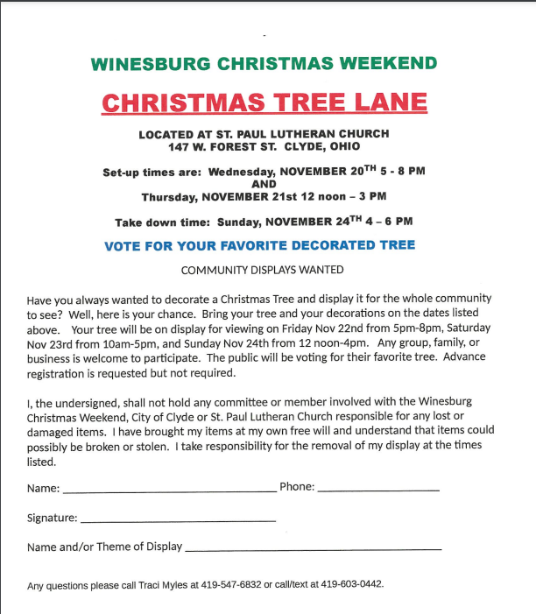



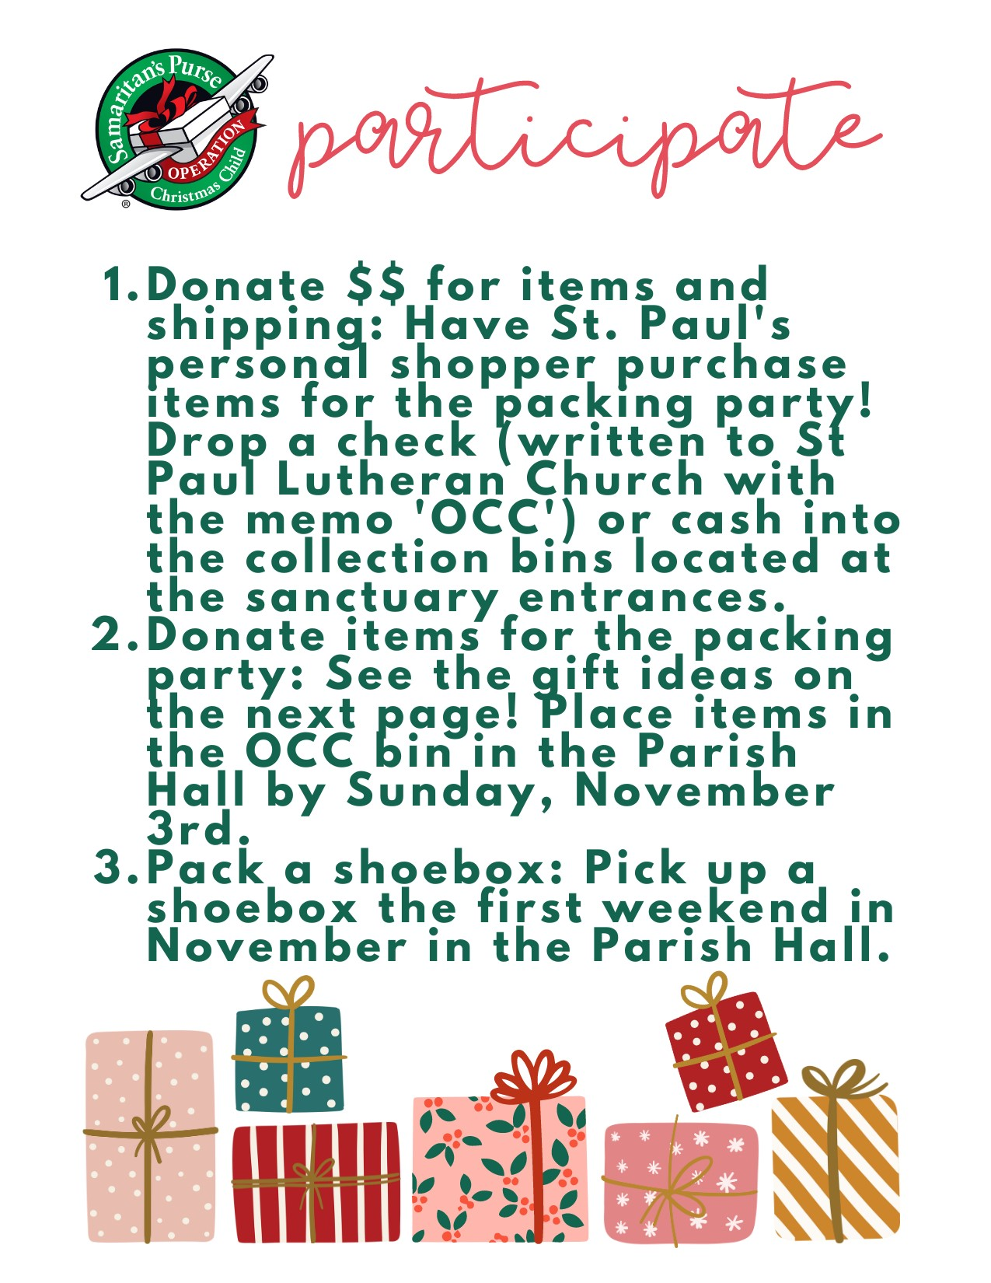



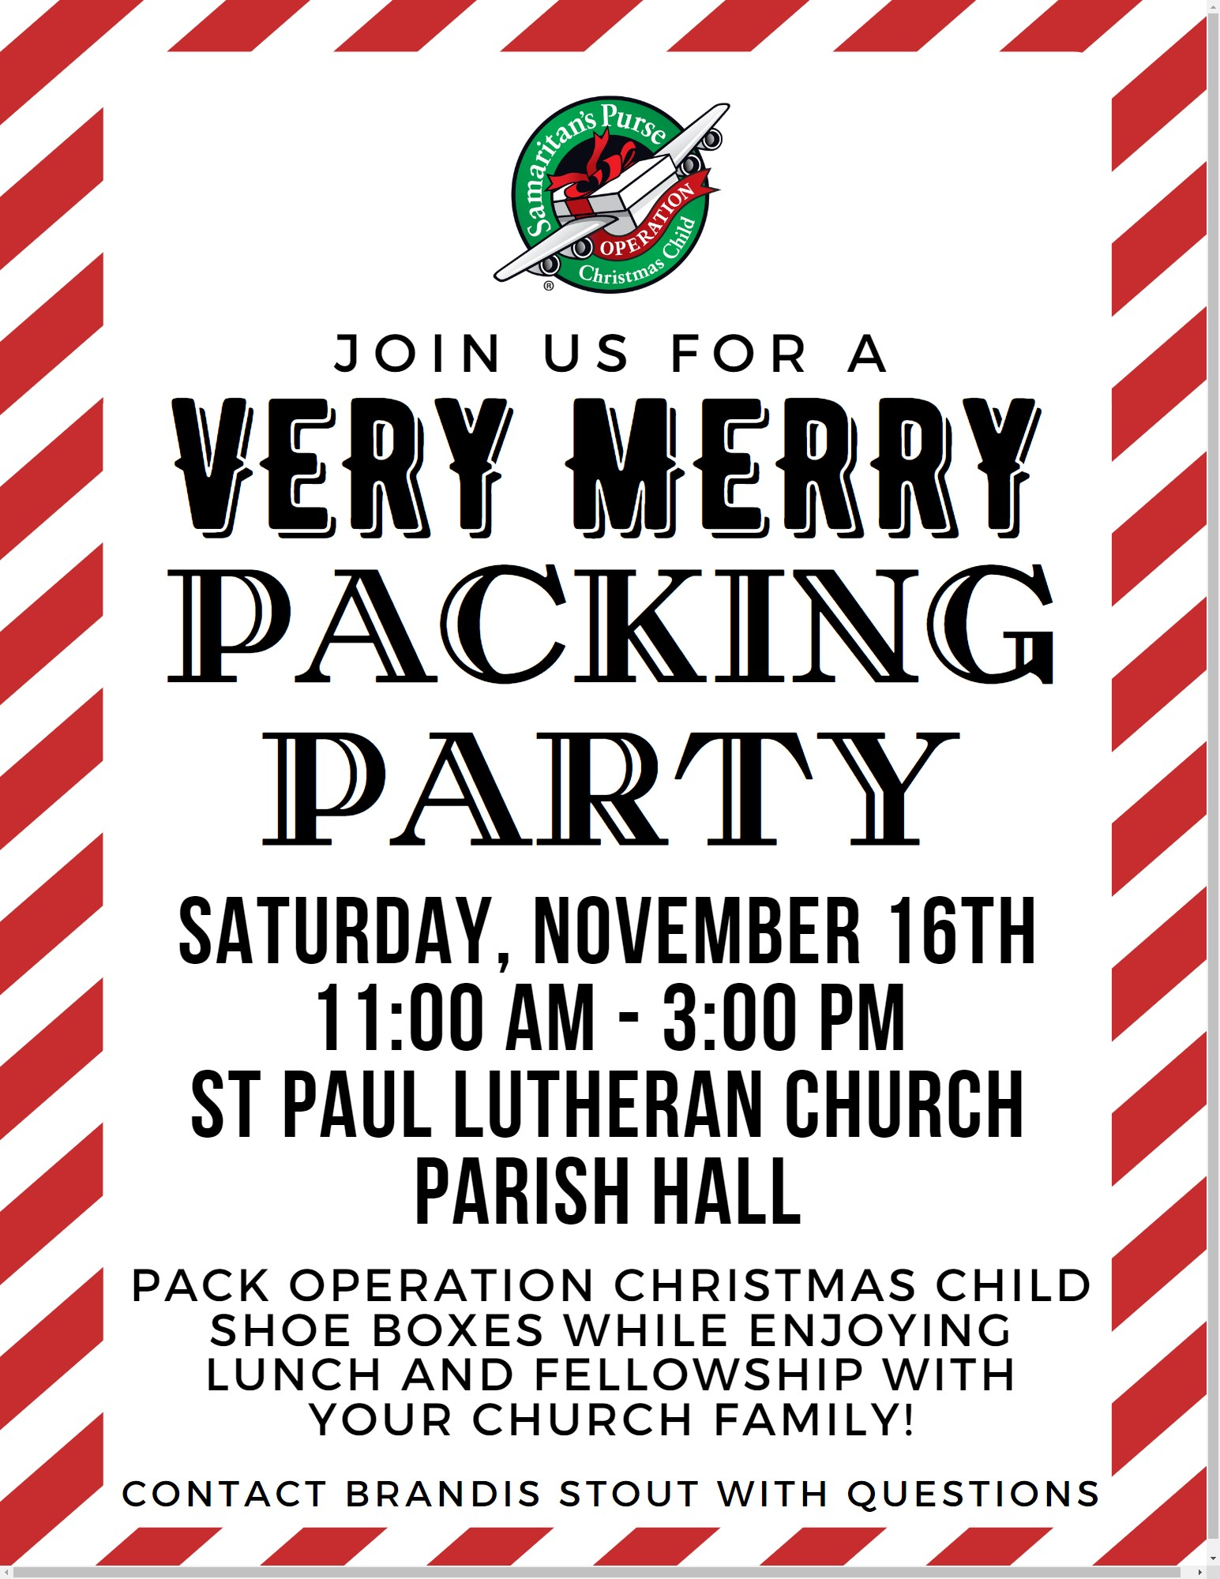

10:30 a.m. Service
ACOLYTE: Jeremy Lantz

USHERS: Gary Wott
Keyli Billings
Tom Billings
Steve Jess

COUNTERS: Karen Jess
Jennie McCoy

NURSERY WORKER: Christine Potts

* * * * * * * * * * * * * * * * * * * * * * * *

The Rev. Dr. Tim Hubert Phone: 217-778-8017

Office Manager – Stephanie Stull Phone: 419-547-9225

Clerical Secretary – Sherry Bouyack Phone: 419-547-9225

Custodian – Terry Langham Phone: 419-547-9225

Treasurer – Jim Shull Phone: 419-355-6499

P & W Leader – Brian Farrar Phone: 419-271-3085

http://www.stpaulclyde.org

* * * * * * * * * * * * * * * * * * * * * * * *
OUR STEWARDSHIP Totals for Year-to-Date 2024

Worship Attendance for weekend of October 26 & 27, 2024 125

Income from January – August 2024 $ 215,747.27
Expense for January – August 2024 $ 223,562.15
Shortage for January – August 2024 $ -7,814.88

