All Saints Sunday
ELW Holy Communion
Traditional Service
Sunday, November 3, 2024
8:00 am

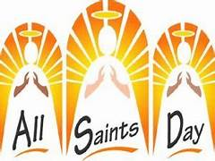

ST. PAUL LUTHERAN CHURCH
147 West Forest Street
Clyde, Ohio

All Saints Sunday

November 3, 2024

8:00 am

Holy Communion ~ Setting Four

* = those who are able may stand
Song numbers with “BB” are from the “The Best of the Best” songbook

Prelude

Bell & Announcements

WELCOME

(All who are able, stand at the invitation of the presiding minister.)

Confession and Forgiveness

(All may make the sign of the cross, the sign that is marked at baptism, as the presiding minister begins.)

In the name of the Father, and of the ☩ Son, and of the Holy Spirit.

Amen.

Let us pray,
Almighty God, to whom all hearts are open, all desires known, and from whom no secrets are hid; cleanse the thoughts of our hearts by the inspiration of your Holy Spirit, that we may perfectly love you and worthily magnify your holy name, through Jesus Christ our Lord. Amen.

If we say we have no sin, we deceive ourselves, and the truth is not in us. But if we confess our sins, God who is faithful and just will forgive our sins and cleanse us from all unrighteousness.

(Silence is kept for reflection and self-examination.)

Most merciful God,
we confess that we are in bondage to sin and cannot free ourselves. We have sinned against you in thought, word, and deed, by what we have done and by what we have left undone. We have not loved you with our whole heart; we have not loved our neighbors as ourselves. For the sake of your Son, Jesus Christ, have mercy on us. Forgive us, renew us, and lead us, so that we may delight in your will and walk in your ways, to the glory of your holy name. Amen.

ABSOLUTION

(The presiding minister announces God’s forgiveness.)

Almighty God, in his mercy, has given his Son to die for us and, for his sake, forgives us all our sins. As a called and ordained minister of the Church of Christ, and by his authority, I therefore declare to you the entire forgiveness of all your sins, in the name of the Father, and of the ☩ Son, and of the Holy Spirit. Amen.

*The Hymn “Christ Is Made the Sure Foundation” No. 645

*The Apostolic Greeting Pg. 147
P: The grace of our Lord Jesus Christ, the love of God, and the communion of the Holy Spirit be with you all.
C: And also with you.

*The Kyrie Pg. 147
P: In peace, let us pray to the Lord.
C: Lord, have mercy.

P: For the peace from above, and for our salvation, let us pray to the Lord.
C: Lord, have mercy.

P: For the peace of the whole world, for the well-being of the church of God, and for the unity of all, let us pray to the Lord.
C: Lord, have mercy.

P: For this holy house, and for all who offer here their worship and praise, let us pray to the Lord.
C: Lord, have mercy.

P: Help, save, comfort, and defend us gracious Lord.
C: Amen.

The Hymn of Praise Pg. 149

Refrain
P: This is the feast of victory for our God. Alleluia.

1. Worthy is Christ, the Lamb who was slain, whose blood set us free to be people of God. Power and riches and wisdom and strength, and honor and blessing and glory are his.

Refrain
This is the feast of victory for our God. Alleluia.

2. Sing with all the people of God and join in the hymn of all creation: Blessing and honor and glory and might be to God and the Lamb forever. Amen.

Refrain
This is the feast of victory for our God, for the Lamb who was slain has begun his reign. Alleluia. Alleluia.

The Prayer of the Day (in unison)
Almighty God, You have knit together Your people in one communion and fellowship in the mystical body of Your Son, Christ, our Lord. Grant us grace to follow Your blessed saints in all virtuous and godly living, that we may come to those ineffable joys which You have prepared for those who love You; through Your Son, Jesus Christ, our Lord, Who lives and reigns with You and the Holy Spirit, one God, now and forever. Amen.

The First Lesson ~ Revelation 7:2-17
²I saw another angel ascending from the rising of the sun, with the seal of the living God, and He called with a loud voice to the four angels who had been given power to harm earth and sea, ³saying, “Do not harm the earth or the sea or the trees, until we have sealed the servants of our God on their foreheads.” ⁴And I heard the number of the sealed, 144,000, sealed from every tribe of the sons of Israel: ⁵12,000 from the tribe of Judah were sealed, 12,000 from the tribe of Reuben, 12,000 from the tribe of Gad, ⁶12,000 from the tribe of Asher, 12,000 from the tribe of Naphtali, 12,000 from the tribe of Manasseh, ⁷12,000 from the tribe of Simeon, 12,000 from the tribe of Levi, 12,000 from the tribe of Issachar, ⁸12,000 from the tribe of Zebulun, 12,000 from the tribe of Joseph, 12,000 from the tribe of Benjamin were sealed. ⁹After this I looked, and behold, a great multitude that no one could number, from every nation, from all tribes and peoples and languages, standing before the throne and before the Lamb, clothed in white robes, with palm branches in their hands, ¹⁰and crying out with a loud voice, “Salvation belongs to our God who sits on the throne, and to the Lamb!” ¹¹And all the angels were standing around the throne and around the elders and the four living creatures, and they fell on their faces before the throne and worshiped God, ¹²saying, “Amen! Blessing and glory and wisdom and thanksgiving and honor and power and might be to our God forever and ever! Amen.” ¹³Then one of the elders addressed me, saying, “Who are these, clothed in white robes, and from where have they come?” ¹⁴I said to him, “Sir, you know.” And he said to me, “These are the ones coming out of the great tribulation. They have washed their robes and made them white in the blood of the Lamb. ¹⁵Therefore they are before the throne of God, and serve Him day and night in His temple; and he who sits on the throne will shelter them with his presence. ¹⁶They shall hunger no more, neither thirst anymore; the sun shall not strike them, nor any scorching heat. ¹⁷For the Lamb in the midst of the throne will be their shepherd, and He will guide them to springs of living water, and God will wipe away every tear from their eyes.”

L: The Word of the Lord.
C: Thanks be to God.

Psalm 149
¹Praise the Lord! Sing to the Lord a new song, His praise in the assembly of the godly!

²Let Israel be glad in his Maker; let the children of Zion rejoice in their King!

³Let them praise His name with dancing, making melody to Him with tambourine and lyre!

⁴For the Lord takes pleasure in His people; He adorns the humble with salvation.

⁵Let the godly exult in glory; let them sing for joy on their beds.

⁶Let the high praises of God be in their throats and two-edged swords in their hands,

⁷to execute vengeance on the nations and punishments on the peoples,

⁸to bind their kings with chains and their nobles with fetters of iron,

⁹to execute on them the judgment written! This is honor for all His godly ones. Praise the Lord!

L: Here ends the reading of the Psalm.
C: Thanks be to God.

The Second Lesson ~ 1 John 3:1-3
¹See what kind of love the Father has given to us, that we should be called children of God; and so we are. The reason why the world does not know us is that it did not know Him. ²Beloved, we are God’s children now, and what we will be has not yet appeared; but we know that when He appears we shall be like Him, because we shall see Him as He is. ³And everyone who thus hopes in Him purifies himself as He is pure.

L: The Word of the Lord.
C: Thanks be to God.

*The “Gospel Acclamation” Pg. 151
Alleluia. Lord, to whom shall we go? You have the words of eternal life. Alleluia.

P: The Holy Gospel according to St. Matthew, the 5th chapter.
C: Glory to You, O Lord.

*The Gospel ~ Matthew 5:1-12
¹Seeing the crowds, {Jesus} went up on the mountain, and when He sat down, His disciples came to Him. ²And He opened His mouth and taught them, saying: ³“Blessed are the poor in spirit, for theirs is the kingdom of heaven. ⁴Blessed are those who mourn, for they shall be comforted. ⁵Blessed are the meek, for they shall inherit the earth. ⁶Blessed are those who hunger and thirst for righteousness, for they shall be satisfied. ⁷Blessed are the merciful, for they shall receive mercy. ⁸Blessed are the pure in heart, for they shall see God. ⁹Blessed are the peacemakers, for they shall be called sons of God. ¹⁰Blessed are those who are persecuted for righteousness’ sake, for theirs is the kingdom of heaven. ¹¹Blessed are you when others revile you and persecute you and utter all kinds of evil against you falsely on my account. ¹²Rejoice and be glad, for your reward is great in heaven, for so they persecuted the prophets who were before you.”

P: The Gospel of the Lord.
C: Praise to You, O Christ.

Moment with Children

The Sermon “Blessed are you when…”
Matthew 5:1-12
Rev. Dr. Tim Hubert

*The Hymn “For All the Saints” No. 422
(verses 1, 2, 3, 5)

*Prayers of Intercession
Let us intercede before the Father of our Lord Jesus Christ for the sake of the Church, the world, and one another.

A brief silence

Thank You, dear Lord, for those forgiven sinners we call saints, for giving us a glimpse of Your glory shining through their words and deeds. Thank You that, in Jesus, You have wiped away all their tears and taken away all their shame. Thank You for promising this to us, too.

Lord, in Your mercy, hear our prayer.

Save and defend Your Church, purchased with the blood of Christ. Give it righteous pastors and bishops. Defend it when it is attacked. Purify and heal it when it sins. Make it perfect in love and good works. Keep it steadfast in the faith once delivered to the saints, so that one holy Church may bear witness to You, the creator and redeemer of all.

Lord, in Your mercy, hear our prayer.

Give Your persecuted Church the blessings promised by Jesus. Let it rejoice in being united to His Passion. Give it the peace that passes human understanding. Grant repentance and faith to all who hate the name of Jesus. Give them grace to bind up the wounds they have inflicted upon the Body of Christ.

Lord, in Your mercy, hear our prayer.

Draw to Yourself the hearts of this congregation’s members. Guide our minds, fill our imaginations, control our wills, so that we may be wholly Yours. Use us as You will, always to Your glory and the welfare of Your people. We pray for the NALC, area congregations and today for Christ Lutheran Church of Dubois and for Reverend Amy Miller and Reverend John Miller.

Lord, in Your mercy, hear our prayer.

Set before us the example of Your saints, great and small. Inspire us by their faith, generosity, and compassion. Strengthen us to endure, as they did, hardship and persecution for the sake of proclaiming Christ crucified to an unbelieving world.

Lord, in Your mercy, hear our prayer.

With reverence and affection, we remember before You those who have shaped our faith and influenced our lives in godly ways. We entrust to Your tender care our beloved dead who are now at rest in You:

John J. Baker
Sue E. (Keegan) Dinan
Rev. Paul Richard Long
Mark Allen Myles
Janet I. (Bouyack) Parkhurst
Jerry William Parkhurst
Carol A. (Chinnis) Taylor
Erika E. Wott
Richard William Wott, Jr.

We commend all nations into Your merciful care. Let everyone live in peace and be guided by Your providence. Give those in authority the wisdom to know Your will and the strength to do it. Grant to them – and to all of us! - a double portion of Your Spirit, so that justice, mercy, righteousness, and peace may prevail.

Lord, in Your mercy, hear our prayer.

We ask Your special blessing as many of us approach a national election. Give us wisdom, discernment, and the grace to put Your will for our country above personal or partisan interests. Grant us a peaceful and uncontested outcome and transfer of power. Bless us with Your healing and holy Spirit.

Lord, in Your mercy, hear our prayer.

Comfort with the grace of Your Holy Spirit all who are in sorrow or need, sickness or adversity, especially:

Betty
Gene
Toni
Judy
Danyelle
Pastor Amy
Peyton
Bill
Maverick
Mary
Ed
Joanne

DEPLOYED
Michael

Give wholeness and hope to all who cry out to You for help. Have mercy on the dying and comfort the grieving. And to all, grant a measure of Your love, shielding them with Your tender care.

Lord, in Your mercy, hear our prayer.

Heavenly Father, we give You thanks for all of our blessed dead who rest now in Your care. Raise them to the life promised to all whom You have redeemed by the Cross and Resurrection of Your Son. Grant that we, who walk as yet by faith and not by sight, may by Your Holy Spirit continue our course on earth with steadfast hope, constant love, and unquenchable joy. Gather us, with all of Your people, at that eternal high feast that celebrates Your victory over sin and death, won for us in Christ Jesus our Lord.

Lord, in Your mercy, hear our prayer.

Into Your hands, gracious Father, we commend all for whom we pray, trusting in Your mercy; for the sake of Your Son, Jesus Christ our Lord. Amen.

*The Apostles’ Creed (back cover of hymnal)

The Peace of the Lord Pg. 152
P: The peace of the Lord be with you.
C: And also, with you.

*The Passing of the Peace (please remain in place)

The Offering

*The Offering Prayer (#3)
Blessed are you, O God, maker of all things. Through your goodness you have blessed us with these gifts: our possessions. Use us, and what we have gathered, in feeding the world with your love, through the one who gave himself for us, Jesus Christ, our Savior and Lord. Amen.

*The Great Thanksgiving Pg. 152
P: The Lord be with you.
C: And also, with you.

P: Lift up your hearts.
C: We lift them to the Lord.

P: Let us give thanks to the Lord our God.
C: It is right to give our thanks and praise.

*The Proper Preface
P: It is indeed right, our duty and our joy, that we should at all times and in all places give thanks and praise to You, almighty and merciful God. You reveal Your glory as the glory of the Father, the Son, and the Holy Spirit; equal in majesty, undivided in splendor, one Lord, one God, ever to be adored in Your eternal glory. And so, with all the choirs of angels, with the church on earth and the hosts of heaven, we praise Your name and join their unending hymn:

*“Holy, Holy, Holy…” Pg. 153
Holy, holy, holy Lord,
Lord God of power and might,
heav’n and earth are full of your glory.
Hosanna in the highest.
Blessed is he who comes in the name of the Lord.
Hosanna in the highest.

*The Words of Institution
In the night in which he was betrayed,
our Lord Jesus took bread, and gave thanks;
broke it, and gave it to his disciples, saying:
Take and eat; this is my body, given for you.
Do this for the remembrance of me.

Again, after supper, he took the cup, gave thanks,
and gave it for all to drink, saying:
This cup is the new covenant in my blood,
shed for you and for all people for the forgiveness of sin.
Do this for the remembrance of me.

*The “Lord’s Prayer” Pg. 154
P: Gathered into one by the Holy Spirit, let us pray as Jesus taught us.

Our Father, who art in heaven,
hallowed be thy name,
thy kingdom come,
thy will be done,
on earth as it is in heaven.

Give us this day our daily bread;
and forgive us our trespasses,
as we forgive those
who trespass against us;
and lead us not into temptation,
but deliver us from evil.

For thine is the kingdom,
and the power, and the glory,
forever and ever. Amen.

*Invitation to Communion Pg. 154
Come to the banquet, for all is now ready.

Holy Communion
All baptized believers in Jesus Christ as Lord are invited to receive communion today. Please follow the directions of the ushers. Children who have not yet received their “first communion” are also invited to come forward, to receive a blessing.

*The Post Communion Blessing
The body and blood…

*Prayer After Communion
P: Let us pray.
O God, we give You thanks that You have set before us this feast, the body and blood of Your Son. By Your Spirit strengthen us to serve all in need and to give ourselves away as bread for the hungry, through Jesus Christ our Lord.
C: Amen.

*The Hymn “Blest Are They” No. 728

Youth Choir
“Give Me Oil in My Lamp”

*The Benediction Pg. 155
P: The Lord bless you and keep you; the Lord make his face to shine upon you, and be gracious to you; the Lord lift up his countenance upon you, and give you peace. In the name of the Father, and of the ☩ Son, and of the Holy Spirit.
C: Amen.

*The Dismissal
L: Go in peace. . .
C: Thanks be to God.

The Postlude

* * * * * * * * * * * * * * * * * * * * * * *


Welcome to worship this All-Saints Sunday Weekend. As we remember the faithful who have gone before us, we also rejoice to be called saints of God through baptism.

* * * * * * * * * * * * * * * * * * * * * * * *

THE ALTAR FLOWERS are given to the glory of God in honor of the 14th birthday on Sunday, October 27, 2024, of Jeremy Lantz & the 17th birthday on Thursday, November 7, 2024, of Jonathan Lantz.

* * * ** * * * * * * * * * * * * * * * * * * *
PRAY FOR ALL OUR HOMEBOUND AND/OR IN MEDICAL CARE FACILITIES:

Thelma Blair, Bev Bush, Diane Dagg, Jim & Norma Fish, Mildred House, Janet Kauble, LaVerde Kuns, Florence Pocock, Jeanette Pumphrey, Tina Walker, Carlos & Joyce Weiker, Sandy Wott, Rodger Yates. If you know of other members who are not listed, please inform the church office, 419-547-9225.
* * * ** * * * * * * * * * * * * * * * * * * *


DAYLIGHT SAVINGS TIME ENDS ON SUNDAY, November 3, 2024, SO PLEASE

SET YOUR CLOCKS
BACK “1” HOUR ON

SUNDAY, November 3, 2024

November 3, 2024 – November 10, 2024
Sunday the  3rd   | 8:00 am ~ Holy Communion Worship  9:15 am ~ Sunday School  9:15 am ~ Women’s Board Meeting  10:30 am ~ Holy Communion Worship  5:00 pm ~ CCYG  All Saints Sunday
Monday the 4th | 7:30 pm ~ Dartball HOME with Grace #24
Tuesday the 5th | 1:00 pm ~ Pericope Meeting  6:00 pm ~ Parish Education/Youth Board Meeting
Wednesday the 6th | 6:00 pm ~ Women’s Bible Study  6:00 pm ~ Youth Choir practice  Pastor on vacation
Thursday the 7th | 7:00 pm – 8:00 pm ~ Al-Anon Meeting  8:00 pm ~ AA Meeting  Pastor on vacation
Friday the 8th | Pastor on vacation
Saturday the 9th | 8:00 am – 9:30 am ~ Men’s Bible Study  5:00 pm ~ Holy Communion Service  Pastor on vacation
Sunday the  10th | 8:00 am ~ Holy Communion Worship  9:15 am ~ Sunday School  10:30 am ~ Holy Communion Worship  Pastor on vacation
* * * * * * * * * * * * * * * * * * * * * * * *
ON THE “MEMORY BOARD” in the hall across from the sacristy, a cross represents each person of our congregation who has died since the last “All Saint’s Day”. These crosses will be presented to the families during the church services on the weekend of Saturday, November 2, 2024 & at BOTH services on Sunday, November 3, 2024. We will remember those who have passed into the nearer presence of Christ these past 12 months during the weekend services.

The crosses were placed on the “Memory Board” for:

John J. Baker
Sue E. (Keegan) Dinan
Rev. Paul Richard Long
Mark Allen Myles
Janet I. (Bouyack) Parkhurst
Jerry William Parkhurst
Carol A. (Chinnis) Taylor
Erika E. Wott
Richard William Wott, Jr.

* * * * * * * * * * * * * * * * * * * * * * * *


We offer many different ways to donate to St Paul Lutheran Church. The following QR code is the latest way. It can be used to direct you to St. Paul Lutheran Church’s electronic giving sign up page. You can always give using the church envelopes, the link on St Paul’s website at stpaulclyde.org, or donate by texting Donate/Donations to 844-440-0253 as well. Thank you for your continued support!
* * * * * * * * * * * * * * * * * * * * * * * *



The results of the elections held on Saturday, October 26, 2024, and Sunday, October 27, 2024, weekend is as follows:

CHURCH COUNCIL
Tim Billings, Kendall Stucky,
Tom Thorbahn, Matt Woodland

ENDOWMENT COMMITTEE
Greg Avery, Bob Kessler, Collin Rieman

MEMORIAL COMMITTEE
Jackie Hoppe

NOMINATING COMMITTEE - 2025 Ballot
Dawn Sumner, Linda Yates

LUTHERAN SOCIAL SERVICE AGENCIES
Walt & Sherry Frasher

OHIO MISSION DISTRICT CONVOCATION &
NALC CONVOCATION
Kevin Larkins
* * * * * * * * * * * * * * * * * * * * * * * *

on
Tuesday,
November 5, 2024

* * * * * * * * * * * * * * * * * * * * * * * *
FOOD PANTRY NEEDS
For our Thanksgiving offering this year, we are asking everyone to donate personal and household items for the Back Door Food Pantry instead of the usual peanut butter. The pantry is able to get all the peanut butter they need for the government supplies. Any that comes in will be donated to the Pontifex in Fremont. Thank you.

* * * * * * * * * * * * * * * * * * * * * * * *


FROM THE CHURCH OFFICE

Anyone who will be leaving Ohio for warmer weather for more than a month, please give the office your address and dates away. We will continue to mail the newsletter to you! Also, please turn in college students addresses. Thanks so much for your cooperation!
Clyde Food Pantry & Liberty Center
Needs

Clyde Food Pantry:
1. Peanut Butter they will take.
2. A significant need is -- jars of jelly.

Bathroom/Hygiene Needs:
1. Bottles of shampoo/conditioner
2. Feminine Hygiene Products -- women are asking for these items
3. Laundry Soap
4. Men & Women -- Depends
5. Tooth Brushes & Toothpaste

Liberty Center Needs:
1. Regular Laundry Detergent -- Liquid
2. Dryer Sheets
3. Free and Clear -- Liquid Laundry Detergent
4. Canned Tuna Fish -- water
5. Spaghetti O's
6. Spaghetti O's -- w/meatballs
7. Tomato Soup
8. Boxes of -- Scalloped Potatoes
9. Size 6 -- Baby Diapers
10. Juices -- Big Need
11. BBQ Sauce
12. Canned Fruit -- Pears/Peaches/Fruit Cocktail
13. Apple Sauce Cups
14. Black Pepper
15. Gallon -- Zip Lock Bags
16. Paper Towels
17. 9" Paper Plates -- Great Value
18. Toilet Bowl -- Cleaner
19. All Purpose Cleaner
20. 13 Gallon -- White trash bags
21. Aluminum Foil
22. Female -- Tampons
23. Boxes of -- Individual Potato Chips
24. Kroger -- Gift Cards
25. Walmart -- Gift Cards
26. Bleach





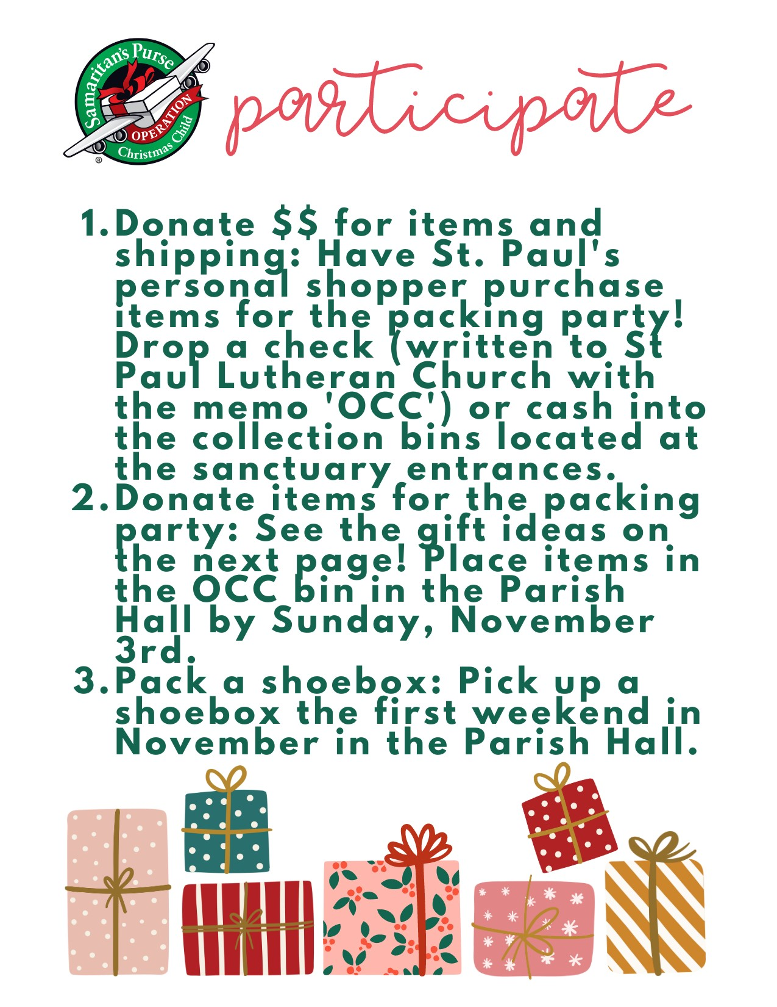



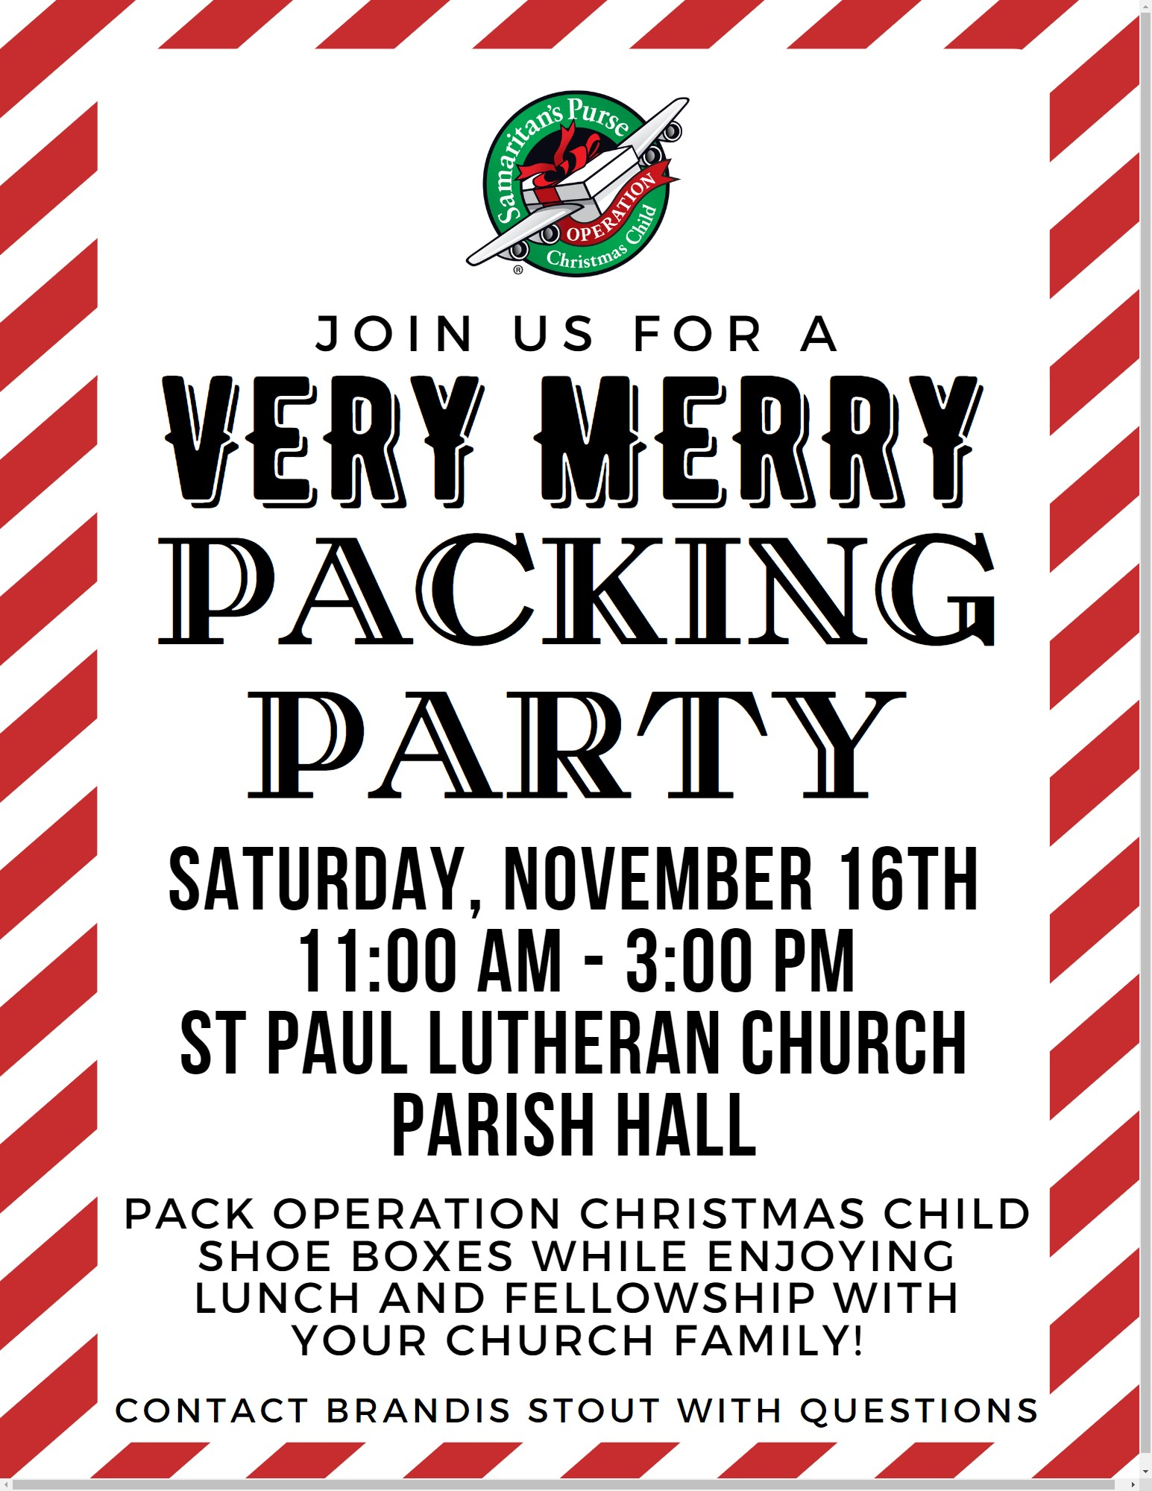

8:00 a.m. Service

COMPUTER TECH: Ashley Reed

READER: Tom Thorbahn

USHERS: Kevin Larkins
Michelle Larkins
Brenda Sieger
Jim Sieger

* * * * * * * * * * * * * * * * * * * * * * * *

The Rev. Dr. Tim Hubert Phone: 217-778-8017

Office Manager – Stephanie Stull Phone: 419-547-9225

Clerical Secretary – Sherry Bouyack Phone: 419-547-9225

Custodian – Terry Langham Phone: 419-547-9225

Treasurer – Jim Shull Phone: 419-355-6499

P & W Leader – Brian Farrar Phone: 419-271-3085

Organists
Barb Gosnell
Linda Thorbahn

http://www.stpaulclyde.org

* * * * * * * * * * * * * * * * * * * * * * * *
OUR STEWARDSHIP Totals for Year-to-Date 2024

Worship Attendance for weekend of October 26 & 27, 2024 125

Income from January – August 2024 $ 215,747.27
Expense for January – August 2024 $ 223,562.15
Shortage for January – August 2024 $ -7,814.88

