24th Sunday after Pentecost
Sunday November 8, 2026
8:00 am

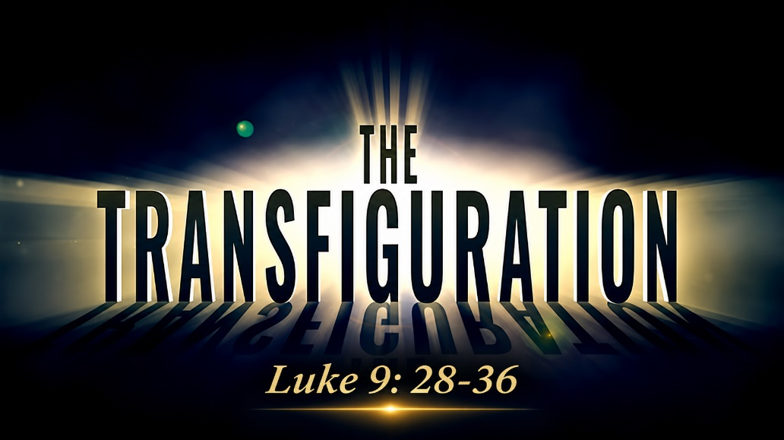

147 West Forest Street Clyde, Ohio
Prelude, Bell & Announcements
Confession & Forgiveness Pg. 94
P: In the name of the Father, and of the ☩ Son, and of the Holy Spirit.
C: Amen.
P: God of all mercy and consolation, come to the help of your people, turning us from our sin to live for you alone. Give us the power of your Holy Spirit that we may confess our sin, receive your forgiveness and grow into the fullness of Jesus Christ, our Savior and Lord.
C: Amen.
P: Let us confess our sin in the presence of God and of one another.
P: Most merciful God,
C: We confess that we are captive to sin and cannot free ourselves. We have sinned against you in thought, word, and deed, by what we have done and by what we have left undone. We have not loved you with our whole heart; we have not loved our neighbors as ourselves. For the sake of your Son, Jesus Christ, have mercy on us. Forgive us, renew us, and lead us, so that we may delight in your will and walk in your ways, to the glory of your holy name. Amen.
P: God who is rich in mercy, loved us even when we were dead in sin, and made us alive together with Christ. By grace you have been saved. In the name of Jesus Christ, the entirety of your sins are forgiven. Almighty God strengthen you with power through the Holy Spirit, that Christ may live in your hearts through faith.
C: Amen.
Hymn: “I Want to Walk as a Child of the Light” 3vs #815

The Apostolic Greeting Pg. 147
P: The grace of our Lord Jesus Christ, the love of God, and the communion of the Holy Spirit be with you all.
C: And also with you.
The Kyrie Pg. 147
P: In peace, let us pray to the Lord.
C: Lord, have mercy.
P: For the peace from above, and for our salvation, let us pray to the Lord.
C: Lord, have mercy.
P: For the peace of the whole world, for the well-being of the church of God, and for the unity of all, let us pray to the Lord.
C: Lord, have mercy.
P: For this holy house, and for all who offer here their worship and praise, let us pray to the Lord.
C: Lord, have mercy.
P: Help, save, comfort, and defend us gracious Lord.
C: Amen.
The Hymn of Praise Pg. 149
P: This is the feast of victory for our God. Alleluia.
Worthy is Christ, the Lamb who was slain, whose blood set us free to be people of God. Power and riches and wisdom and strength, and honor and blessing and glory are his.
This is the feast of victory for our God. Alleluia.
Sing with all the people of God and join in the hymn of all creation: Blessing and honor and glory and might be to God and the Lamb forever. Amen.
This is the feast of victory for our God, for the Lamb who was slain has begun his reign. Alleluia. Alleluia.
The Prayer of the Day
Almighty, eternal God, show mercy to your children who humbly pray, that we who have no confidence in our worth may not be judged but tenderly received. Grant this, we pray, through Jesus Christ, your Son, our Lord, who lives and reigns with you and the Holy Spirit, one God, now and forever. Amen.
The First Reading: Exodus 34:29-35
²⁹When Moses came down from Mount Sinai, with the two tablets of the testimony in his hand as he came down from the mountain, Moses did not know that the skin of his face shone because he had been talking with God. ³⁰Aaron and all the people of Israel saw Moses, and behold, the skin of his face shone, and they were afraid to come near him. ³¹But Moses called to them, and Aaron and all the leaders of the congregation returned to him, and Moses talked with them. ³²Afterward all the people of Israel came near, and he commanded them all that the Lord had spoken with him on Mount Sinai. ³³And when Moses had finished speaking with them, he put a veil over his face. ³⁴Whenever Moses went in before the Lord to speak with him, he would remove the veil, until he came out. And when he came out and told the people of Israel what he was commanded, ³⁵the people of Israel would see the face of Moses, that the skin of Moses’ face was shining. And Moses would put the veil over his face again, until he went in to speak with him.
L: The Word of the Lord.
C: Thanks be to God.
Psalm 99:1-9
¹The Lord reigns; let the peoples tremble! He sits enthroned upon the cherubim; let the earth quake!
²The Lord is great in Zion; he is exalted over all the peoples.
³Let them praise your great and awesome name! Holy is he!
⁴The King in his might loves justice. You have established equity; you have executed justice and righteousness in Jacob.
⁵Exalt the Lord our God; worship at his footstool! Holy is he!
⁶Moses and Aaron were among his priests, Samuel also was among those who called upon his name. They called to the Lord, and he answered them.
⁷In the pillar of the cloud he spoke to them; they kept his testimonies and the statute that he gave them.
⁸O Lord our God, you answered them; you were a forgiving God to them, but an avenger of their wrongdoings.
⁹Exalt the Lord our God, and worship at his holy mountain; for the Lord our God is holy!
L: Here ends the reading of the Psalm.
C: Thanks be to God.
The Second Reading: 2 Peter 1:16-21
¹⁶For we did not follow cleverly devised myths when we made known to you the power and coming of our Lord Jesus Christ, but we were eyewitnesses of his majesty. ¹⁷For when he received honor and glory from God the Father, and the voice was borne to him by the Majestic Glory, “This is my beloved Son, with whom I am well pleased,” ¹⁸we ourselves heard this very voice borne from heaven, for we were with him on the holy mountain. ¹⁹And we have the prophetic word more fully confirmed, to which you will do well to pay attention as to a lamp shining in a dark place, until the day dawns and the morning star rises in your hearts, ²⁰knowing this first of all, that no prophecy of Scripture comes from someone’s own interpretation. ²¹For no prophecy was ever produced by the will of man, but men spoke from God as they were carried along by the Holy Spirit.

L: The Word of the Lord.
C: Thanks be to God.
The Gospel Acclamation Pg. 151
Alleluia. Lord, to whom shall we go? You have the words of eternal life. Alleluia.
P: The Holy Gospel according to St. Luke, the 9th chapter.
C: Glory to You, O Lord.
The Gospel: Luke 9:28-36
²⁸Now about eight days after these sayings he took with him Peter and John and James and went up on the mountain to pray. ²⁹And as he was praying, the appearance of his face was altered, and his clothing became dazzling white. ³⁰And behold, two men were talking with him, Moses and Elijah, ³¹who appeared in glory and spoke of his departure, which he was about to accomplish at Jerusalem. ³²Now Peter and those who were with him were heavy with sleep, but when they became fully awake they saw his glory and the two men who stood with him. ³³And as the men were parting from him, Peter said to Jesus, “Master, it is good that we are here. Let us make three tents, one for you and one for Moses and one for Elijah”—not knowing what he said. ³⁴As he was saying these things, a cloud came and overshadowed them, and they were afraid as they entered the cloud. ³⁵And a voice came out of the cloud, saying, “This is my Son, my Chosen One; listen to him!” ³⁶And when the voice had spoken, Jesus was found alone. And they kept silent and told no one in those days anything of what they had seen.
P: Gospel of the Lord
C: Praise to You, O Christ.
Sermon “The Transfiguration” Luke 9:28-36
Pastor Sam Dagg
The Hymn “Sweet Hour of Prayer” vs 1-3 CCLI 32273

Prayers of Intercession
Vickie Aldrich
Gwendolyn Baughn
Molly Binder
Michelle Borodkin
Courtney Bouyack
Toni Dagg
Crew Dearth
Sharon Duskin
Becky Karr
Kris Larkins
Denise McCubbin
Matt Pumphrey
Maverick Salazar
Lindsay Sooy
Larry Sumner
Conner Whaley
Sandy Wott
Dean Tea
Matt Woodland
Terry Langham
Judy Campbel
Carol Kohs
Larry Bower
Vickie Smith
Patrick Stout
Family & Friends
of Evelyn Liebe

THE APOSTLES’ CREED (back cover of the hymnal)
The Peace of the Lord Pg. 152
P: The peace of the Lord be with you.
C: And also, with you.
The Passing of the Peace
The Offering
The Offering Prayer
Blessed are you, O God, maker of all things. Through your goodness you have blessed us with these gifts: our possessions. Use us, and what we have gathered, in feeding the world with your love, through the one who gave himself for us, Jesus Christ, our Savior and Lord. Amen.
The Great Thanksgiving Pg. 152
P: The Lord be with you.
C: And also, with you.
P: Lift up your hearts.
C: We lift them to the Lord.
P: Let us give thanks to the Lord our God.
C: It is right to give our thanks and praise.
The Proper Preface
P: It is indeed right, our duty and our joy, that we should at all times and in all places give thanks and praise to You, almighty and merciful God. You reveal Your glory as the glory of the Father, the Son, and the Holy Spirit; equal in majesty, undivided in splendor, one Lord, one God, ever to be adored in Your eternal glory. And so, with all the choirs of angels, with the church on earth and the hosts of heaven, we praise Your name and join their unending hymn:
C: Holy, holy, holy Lord,
Lord God of power and might,
heav’n and earth are full of your glory.
Hosanna in the highest.
Blessed is he who comes in the name of the Lord.
Hosanna in the highest.
The Words of Institution
The Lord’s Prayer Pg. 154
P: Gathered into one by the Holy Spirit, let us pray as Jesus taught us.
C: Our Father, Who art in heaven, hallowed be Thy name, Thy kingdom come, Thy will be done, on earth as it is in heaven. Give us this day our daily bread; and forgive us our trespasses, as we forgive those who trespass against us; and lead us not into temptation, but deliver us from evil. For Thine is the kingdom, and the power, and the glory, forever and ever. Amen.
Invitation to Communion Pg. 154 P: Come to the banquet, for all is now ready.
Holy Communion
All baptized believers in Jesus Christ as Lord are invited to receive communion today. Please follow the pastor’s instructions.
The Post Communion Blessing
P: The body and blood of our Lord Jesus Christ strengthen you and keep you in His grace.
C: Amen.
Prayer After Communion
P: Let us pray.
C: O God, we give You thanks that You have set before us this feast, the body and blood of Your Son. By Your Spirit strengthen us to serve all in need and to give ourselves away as bread for the hungry, through Jesus Christ our Lord. Amen.
The Hymn “Will You Come and Follow Me” 5vs #798
The Benediction
P: May the Lord bless you and keep you;
the Lord make his face shine on you and be gracious to you;
the Lord turn his face toward you and give you peace.
In the name of the Father,
and of the ☩ Son,
and of the Holy Spirit.
C: Amen.
The Dismissal
P: GO IN PEACE. SERVE THE LORD!
C: Thanks be to God.
The Postlude
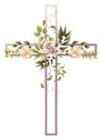
* * * * * * * * * * * * * * * * * * * * * * * * * * * * * * * * * * * * * * * * * *
ALTAR FLOWERS
The altar flowers are given to the Glory of God in honor of Jonathan Lantz’s 19th birthday Nov. 7th.

* * * * * * * * * * * * * * * * * * * * * * * * * * * * * * * * * * * * * * * * * *

New Altar Flower Sign-Up 2027
The new altar flower sign-up is located in Ashley’s mailbox by the office. Please fill out all 3 slots and any specific instructions for flowers. Thank you!

* * * * * * * * * * * * * * * * * * * * * * * * * * * * * * * * * * * * * * * * * *

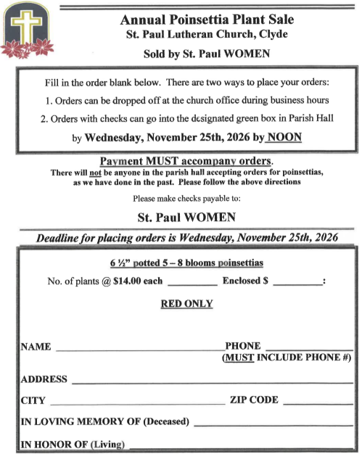
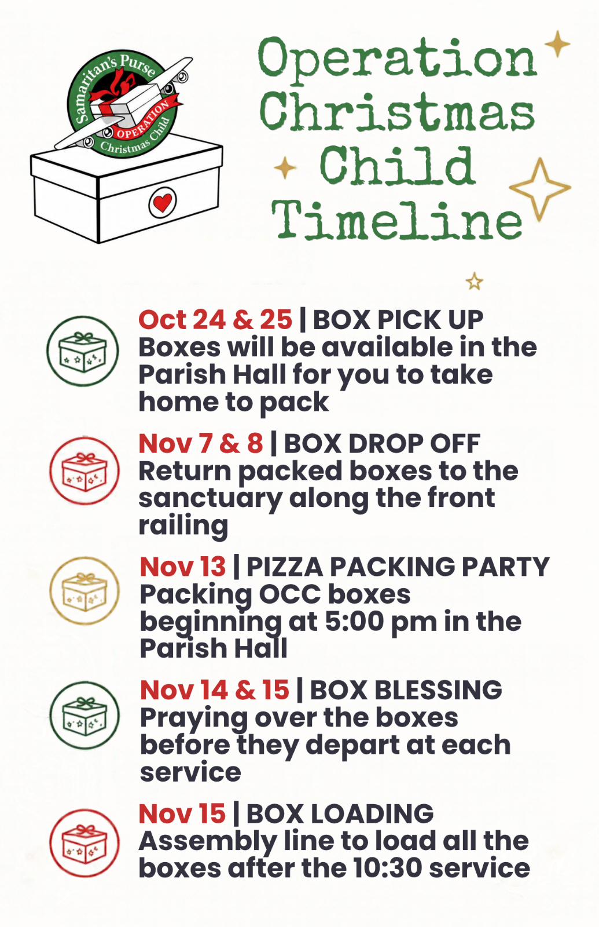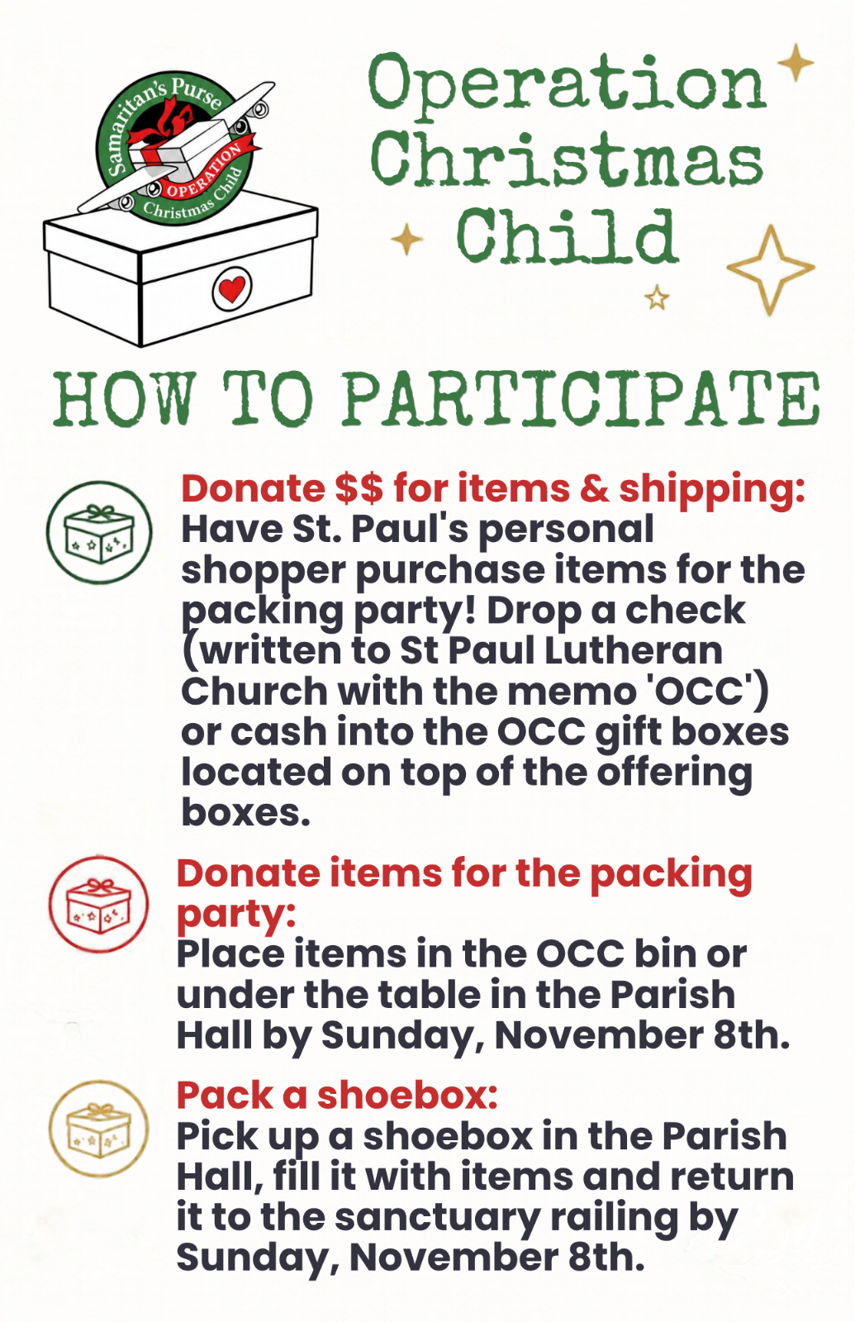
November 2026
Sunday  8 | 8:00 am ~ Worship  10:30 am ~ Worship  Pastor Sam’s vacation 11/8/26-11/22/26
Monday  9 | 6:30 pm ~ Co-Ed Bible Study
Tuesday  10 | 6:00 pm ~ Property Meeting  6:30 pm ~ Men’s Bible Study
Wednesday  11 | 6:00 pm~ Women’s Bible Study
Thursday  12 | 6:00 pm ~ Worship Meeting  7:00pm ~ Evangelism/Social Meeting  7:00 pm ~ Al-Anon Meeting  8:00 pm ~ AA Meeting
Friday  13 | 5:00- 7:00 pm ~ Pizza Packing Party
Saturday  14 | 8:00 am ~ Men’s Bible Study  5:00 pm ~ Worship
Sunday  15 | 8:00 am ~ Worship  10:30 am ~ Worship
October 31/November 1- Attendance: 173
8:00 am Service
COMPUTER TECH: Barb Wahl
READER: Diane Hurst
USHERS: Tim Billings
Jeff Haughawout
Diane Hurst
Bob Kessler

* * * * * * * * * * * * * * * * * * * * * * * * * * * * * * * * * * * * * * * * *
Church Office Phone: 419-547-9225
Jamie Farrar Phone: 419-603-6731
sec@stpaulclyde.org
Pastor Samuel Dagg Phone: 567-342-2137
pastor@stpaulclyde.org
Matt Woodland ~ Council President Phone: 419-603-0567
prez@stpaulclyde.org
Jim Shull ~ Treasurer Phone: 419-355-6499
treas@stpaulclyde.org
Brian Farrar ~ P & W Leader Phone: 419-547-9225
pwl@stpaulclyde.org
Sherry Bouyack ~ Clerical Secretary Phone: 419-547-9225
fisec@stpaulclyde.org
Amber Brown ~ Youth Director Phone: 732-580-5034
youthdirector@stpaulclyde.org

Organist
Mary Ellen Wollenslegel

