St. Paul Lutheran Church
147 West Forest Street
Clyde, OH

Third Sunday of Advent
Contemporary Service
Sunday, December 15, 2024
10:30 a.m.

Welcome/Announcements

Opening Song

3rd Sunday of Advent Wreath Lighting
* The Hymn “Light One Candle . . .” (verses 1 – 3) No. 240

Children’s Time

Worship Songs

Confession & Forgiveness

Scripture Reading

Sermon
“The Peace of God!”
based on Philippians 4:4-7
The Rev. Dr. Tim Hubert
Prayers
for the sick and those in need:

Jerry
Ruth
Betty
Gene
Tim
Toni
Danyelle
Pastor Amy
Bill
Mary
Ed
Joanne

Holy Communion

The Lord’s Prayer

Closing Song

Parting Blessing
Go in peace. Serve the Lord.
Thanks be to God.

Post – Service Music
* * * * * * * * * * * * * * * * * * * * * * * *

Welcome to the promise of Advent: Amid barren trees, Isaiah announces spring growth – a “shoot” representing new life in Jesus (11:1).

* * * * * * * * * * * * * * * * * * * * * * * *
THE ALTAR FLOWERS are given to the glory of God in memory of my mom, Jane Frederick, who passed away 17 years ago on December 18th given by DeAnn Krauss & Tony Paradiso.

* * * * * * * * * * * * * * * * * * * * * * * *


ALTAR FLOWER CHART & COMMUNION BREAD
SIGN UP SHEET

The signup sheets for the Altar Flowers and the Communion Bread signup sheet are located on the side of the refrigerator.

December 15, 2024 – December 22, 2024

Sunday the  15th | 8:00 am ~ Holy Communion Worship  9:15 am ~ Sunday School  10:30 am ~ Holy Communion Worship  5:00 pm ~ CCYG
Monday the 16th | 7:30 pm ~ Dartball AWAY @ with St. John’s #3
Tuesday the 17th | 1:00 pm ~ Pericope Meeting  7:00 pm ~ Stewardship/Finance Board Meeting
Wednesday the 18th | 11:30 am ~ Clyde Ministerial Meeting  6:00 pm ~ Youth Choir practice  7:00 pm ~ Advent Service
Thursday the 19th | 7:00 pm ~ Church Council  7:00 pm – 8:00 pm ~ Al-Anon Meeting  8:00 pm ~ AA Meeting
Friday the 20th

Saturday the 21st | 8:00 am – 9:30 am ~ Men’s Bible Study  5:00 pm ~ Holy Communion Service
Sunday the  22nd | 8:00 am ~ Holy Communion Worship  9:15 am ~ Sunday School  10:30 am ~ Holy Communion Worship
* * * * * * * * * * * * * * * * * * * * * * * *

Women’s Bible Study
Update

The Women’s Bible Study on Wednesday evenings at 6:00 pm has been postponed until after the Holidays. We will resume meeting on Wednesday, January 8, 2025, at 6 pm. The Chosen Season Two, Episode Seven will be our next Bible Study. Remember, you can jump in at any time during our sessions. We also have extra Season One and Two Interactive Bible Study books available for $10.00 each. If you have any questions, please call Sherry Frasher at 419-765-7016.

* * * * * * * * * * * * * * * * * * * * * * * *



We are forming a Call Committee for a new Pastor. Please prayerfully consider whether you're being called to be involved with the committee. If you would like to participate, please contact Lisa Rieman by phone or text to (989) 450-2801. Thank you!

* * * * * * * * * * * * * * * * * * * * * * *


If you would like the full Treasurer’s Report, please supply your name & email address to the church office.
* * * * * * * * * * * * * * * * * * * * * * * *

“BUNCO” has been
CHANGED for December from the 4th Sunday to the 5th Sunday.

Looking forward to seeing you on:

Sunday, December 29, 2024!

* * * * * * * * * * * * * * * * * * * * * * *


We offer many different ways to donate to St Paul Lutheran Church. The following QR code is the latest way. It can be used to direct you to St. Paul Lutheran Church’s electronic giving sign up page. You can always give using the church envelopes, the link on St Paul’s website at stpaulclyde.org, or donate by texting Donate/Donations to 844-440-0253 as well. Thank you for your continued support!

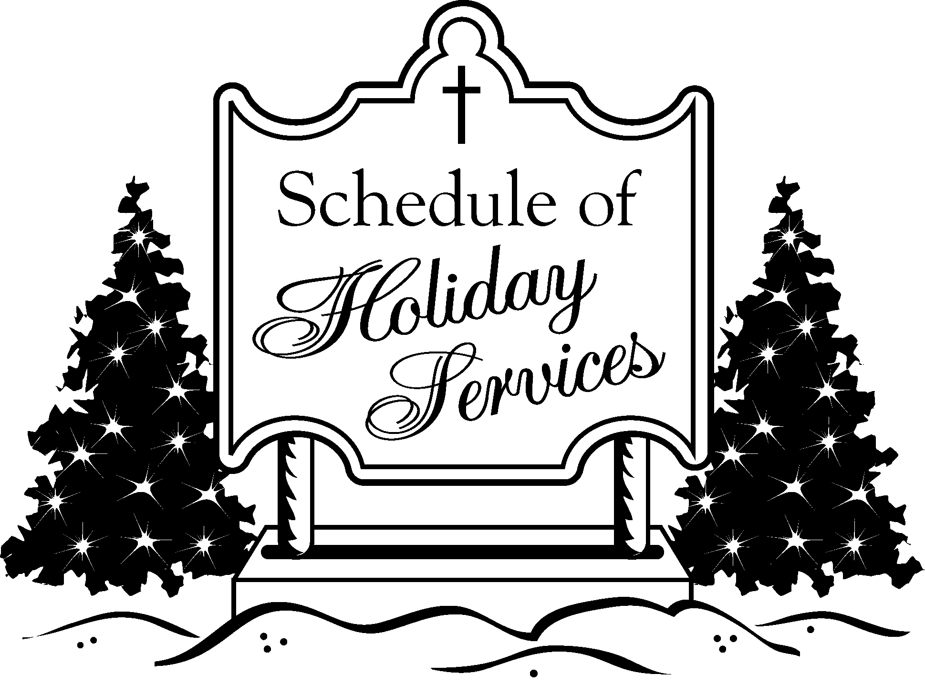

Saturday - December 21, 2024 Service
5:00 pm – Worship Service

Sunday - December 22, 2024 Service
8:00 am – Worship Service
10:30 am – Worship Service

Tuesday – December 24, 2024 Service
“2024 Christmas Eve Services”
4:00 pm – Christmas Eve Service (contemporary)
7:00 pm – Christmas Eve Service (traditional)

Saturday - December 28, 2024
5:00 pm Service

Sunday – December 29, 2024
8:00 am & 10:30 am

10:30 a.m. Service
ACOLYTE: Audra Lowe

USHERS: Gary Wott
Collin Rieman
Kendall Rieman
Deanna Turner

COUNTERS: Jackie Hoppe
Lisa Rieman

NURSERY WORKER: Emily Woodland

* * * * * * * * * * * * * * * * * * * * * * * *

The Rev. Dr. Tim Hubert Phone: 217-778-8017

Office Manager – Stephanie Stull Phone: 419-547-9225

Clerical Secretary – Sherry Bouyack Phone: 419-547-9225

Custodian – Terry Langham Phone: 419-547-9225

Treasurer – Jim Shull Phone: 419-355-6499

P & W Leader – Brian Farrar Phone: 419-271-3085

http://www.stpaulclyde.org

* * * * * * * * * * * * * * * * * * * * * * * *
OUR STEWARDSHIP Totals for Year-to-Date 2024

Worship Attendance for weekend of December 7 & 8, 2024 127

Income from January – November 30, 2024 $ 289,459.78
Expense for January – November 30, 2024 $ 301,016.76
Shortage for January – November 30, 2024 $ -11,556.98

