First Sunday After Christmas
December 28, 2025
10:30 am

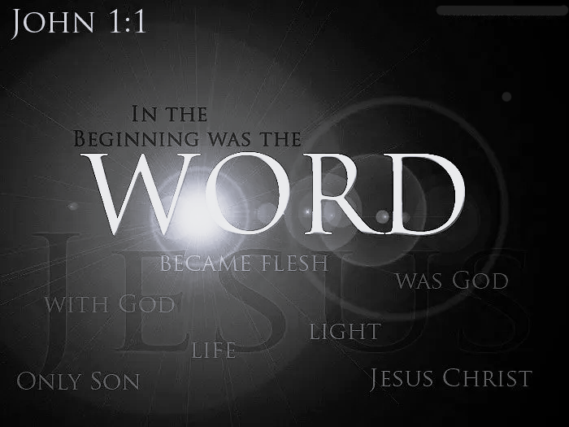

St. Paul Lutheran Church
147 W. Forest Street Clyde, Ohio
Opening Song
“Take You at Your Word” by Cody Carnes
Welcome & Announcements
Worship
“King of Kings” by Hillsong Worship
Sermon
"In the Beginning"
John 1
Pastor Sam Dagg
Sermon Notes:

Pastoral Prayer

Patsy Aldrich
Vickie Aldrich
Michelle Borodkin
Tim Cooper
Toni Dagg
Crew Dearth
Tamara Fardinka
MJ Holmes
Aleigh Jones
Laverde Kuns
Terry Langham
Bob Royster
Sue Mayes
Karen Nimms
Maverick Salazar
Jeff Shull
Dustin Sumner
Conner Whaley
Sandy Wott

Words of Institution
The Lord's prayer
Communion
"Lead Me To The Cross" by Hillsong Worship
Closing Song
“O Come All Ye Faithful (His Name Shall Be)” by
Melodie Malone
Benediction
Isaiah 60:1 “Arise, shine, for your light has come, and the glory of the Lord has risen upon you.”
Dismissal
P: Go in peace. Serve the Lord!
C: Thanks be to God!

* * * * * * * * * * * * * * * * * * * * * * * * * * * * * * * * * * * * * * * * * *

THE ALTAR FLOWERS are given to the glory of God in celebration of the 91st birthday of my dad, Gene Ross, on December 21, 2025, given by his daughter Tammy.

* * * * * * * * * * * * * * * * * * * * * * * * * * * * * * * * * * * * * * * * *


Please join us in the Un-Hanging of the Greens on January 4th, 2026 after the late service.
A light lunch will be provided.

Gather in fellowship to be fed by His word at the following Bible Study groups:

- The Co-Ed study will begin on Jan 5th and will continue to meet Mondays at 6:30pm.
- The Women’s study will resume Jan 7th and will continue to meet Wednesdays at 6pm.
- The Men’s study will continue to meet Saturdays at 8am.
- The Men’s Mid-Week study will begin in January, stay tuned for the day and time.

* * * * * * * * * * * * * * * * * * * * * * * * * * * * * * * * * * * * * * * * * *

Membership Class
Hosted by Pastor Sam



Want more info?!? Email Pastor Sam pastor@stpaulclyde.org

December 28, 2025 – January 4, 2026
Sunday the 28th | 8:00 am ~ Holy Communion Worship  9:15 am ~ Sunday School  10:30 am ~ Holy Communion Worship  3:00 pm ~ BUNCO
Monday the 29th | Dartball Break - Will Resume Jan 5th  Co-Ed Bible Study Will Begin Jan 5th
Tuesday the 30th
Wednesday the 31st | Women’s Bible Study Will Resume Jan 7th
Thursday the 1st | Office is Closed for New Year’s Day
Friday the 2nd
Saturday the 3rd | 8:00 am ~ Men’s Bible Study  5:00 pm ~ Holy Communion Worship
Sunday the 4th | 8:00 am ~ Holy Communion Worship  9:15 am ~ Sunday School  10:30 am ~ Holy Communion Worship  11:30 am ~ Unhanging of the Greens  12:00 pm ~ Parish Hall Rental

10:30 am Service
ACOLYTE:

USHERS: Steve Jess
Tammy Baker
Dawn Sumner
Kris Wott
COUNTERS: Mel Cook
Karen Jess
NURSERY WORKER: Katie Speer
* * * * * * * * * * * * * * * * * * * * * * * * * * * * * * *
Pastor Samuel Dagg Phone: 567-342-2137
pastor@stpaulclyde.org
Matt Woodland ~ Council President Phone: 419-603-0567
prez@stpaulclyde.org
Stephanie Stull ~ Office Manager Phone: 419-547-9225
sec@stpaulclyde.org
Sherry Bouyack ~ Clerical Secretary Phone: 419-547-9225
fisec@stpaulclyde.org
Jim Shull ~ Treasurer Phone: 419-355-6499
treas@stpaulclyde.org
Brian Farrar ~ P & W Leader Phone: 419-271-3085
pwl@stpaulclyde.org
Ashley Reed ~ Assistant Secretary Phone: 419-547-9225 asst.sec@stpaulclyde.org
* * * * * * * * * * * * * * * * * * * * * * * * * * * * * * * * * * * * * * * * * * * * * * * * * * *


We offer many different ways to donate to St Paul Lutheran Church. The following QR code is the latest way. It can be used to direct you to St. Paul Lutheran Church’s electronic giving sign up page. You can always give using the church envelopes, the link on St Paul’s website at stpaulclyde.org, or donate by texting Donate/Donations to 844-440-0253 as well. Thank you for your continued support!

