Third Sunday of Easter
Sunday, April 19, 2026
10:30 am



147 West Forest Street Clyde, Ohio
Opening Song
“Firm Foundation” by Cody Carnes
Welcome & Announcements
Baptism (Pg. 227 in the Red Hymnal)
Raiden Michael Hayward and Zaiden Lee Stacy
Confession & Forgiveness
Worship
“Open The Eyes Of My Heart” by Michael W. Smith
Sermon
"Opened Eyes" ~ Luke 24:13-35 ~ Pastor Sam Dagg
Pastoral Prayer
Vickie Aldrich
Gwendolyn Baughn
Michelle Borodkin
Jack Cooper
Tim Cooper
Toni Dagg
Crew Dearth
Louie Duskin
Sharon Duskin
John Glass
Steve Jess
Becky Karr
Kris Larkins
Karen Nimms
Matt Pumphrey
Maverick Salazar
Sue Shull
Lindsay Sooy
Larry Sumner
Conner Whaley
Sandy Wott

Words of Institution
The Lord's prayer
First Communion:
Owen Dale Cook, Danni Rose Elfring,
Stella Elizabeth Gibbs, Raiden Michael Hayward, Blake Gilbert Williams, and Zaiden Lee Stacy
Communion
(Song: "There Was Jesus" by Zach Williams & Dolly Parton)
Closing Song
“Christ Our King” by Passion
Benediction
Dismissal
P: Go in peace. Serve the Lord!
C: Thanks be to God!

* * * * * * * * * * * * * * * * * * * * * * * * * * * * * * * * * * * * * * * * * *
THE ALTAR FLOWERS are given to the glory of God in honor of Erin William’s 35th birthday on April 26th, 2026, given by her family.

* * * * * * * * * * * * * * * * * * * * * * * * * * * * * * * * * * * * * * * * *

2026 Easter Attendance
5pm ~ 35 8am ~ 84 10:30am ~ 159


* * * * * * * * * * * * * * * * * * * * * * * * * * * * * * * * * * * * * * * * * *
Patsy J. Aldrich, age 93, passed away Friday, April 10, 2026, at her home. May God be with her family.


* * * * * * * * * * * * * * * * * * * * * * * * * * * * * * * * * * * * * * * * * *
We welcome into God’s Family through Holy Baptism:
Raiden Michael Hayward on April 19, 2026,
at the 10:30am service.
Zaiden Lee Stacy on April 19, 2026, at the 10:30am service. Zaiden’s sponsors are Thomas and Erica Hoffman.

We are pleased to invite all our 70+ members
to attend a Fellowship Dinner on June 7, 2026.
Invites have been sent out, if you did not receive one, please call the office 419-547-9225 and let Ashley know. 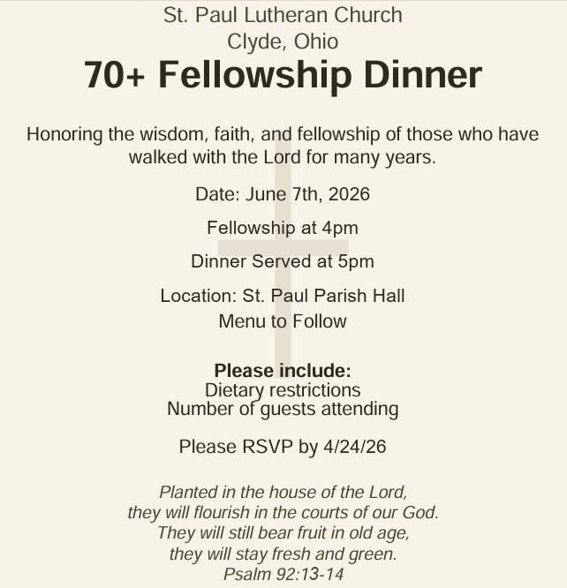
In honoring our 70+ members we need volunteers! Please see the sign-up sheets on the clipboards for more details or contact Walker Davenport at 419-463-8180.
LOVE PACKAGES
Do you have older Bibles or religious materials-books, paperbacks, magazines, daily devotionals, CDs, DVDs, Biblical puzzles & games, puppets, nativity sets, or anything that helps teach the gospel-just sitting around because you’re not sure what to do with them? We have a plan…the company Love Packages collects all these items, sorts them by category & sends them overseas to share the word of God.
We will begin collecting these items in the Parish Hall on April 6th. There will be a container marked as such. We will end the collection on May 1st. We have a volunteer who will drive our donations to their collection point in Delaware, Ohio.
Love Packages started in Butler, IL and has a 2nd location in Decatur, AL. Once the materials are sorted, they are shipped overseas in a 20-ton container. Monetary donations are accepted to maintain and expand the ministry. The priority is to pay for the container expenses. There are also “unseen” costs for fuel and truck expenses to pick up the donations from publishers and other ministries. They note the most important element is to pray because the ministry is depending on God, not people.
Any questions contact DeAnn Krauss 419-937-7514
Their website is lovepackages.org if you’d like to check them out.


Love Offering Collection
We are collecting a “Love Offering” in support of Maverick Salazar who is a member here. Maverick was born with hypoplastic left heart syndrome. His first open heart surgery was at 4 days old, and then 8 months, and then 2 years old. At 8 years old he needed a pacemaker and in 2024 needed surgery to replace it.
He is now 19 years old. In December 2025 he went into atrial fibrillation. After further testing he was told he now needs a combined heart and liver transplant.
Since birth he has been treated at The University of Michigan Hospital and for this transplant was sent for an evaluation to the Cleveland Clinic and is now being scheduled to go to Duke University Hospital in Durham, North Carolina for evaluation, searching for a hospital willing to take on his complex case.
On top of this, he just found out that before you can be listed for a heart and liver transplant, he will need his wisdom teeth pulled, which needs completed at U of M Hospital because he needs cardiology anesthesia.
All of this means extended travel, long hospital stays, months away from normal life, and ongoing medical expenses before and after surgery.
Our purple “Love Offering” containers will be at each entrance, and we will be collecting through Sunday, April 19th.
Monetary donations are appreciated, but prayer is vital. Please pray for wisdom for the doctors and for God’s strength to surround Maverick and his family.
Thank you,
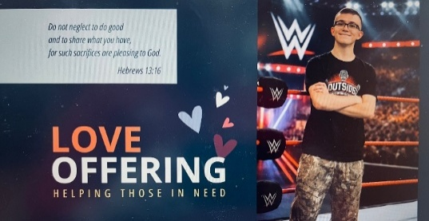
Blessings!

April 19, 2026 – April 26, 2026
Sunday the 19th | 8:00 am ~ Worship  9:15 am ~ Sunday School  10:30 am ~ Worship & First Communion
Monday the 20th | 6:30 pm ~ Co-Ed Bible Study
Tuesday the 21st | 6:30pm ~ Men’s Bible Study
Wednesday the 22nd | 9:00 am ~ Quilt Ministry  6:00 pm ~ Women’s Bible Study
Thursday the 23rd | 7:00 pm ~ Al-Anon Meeting  8:00 pm ~ AA Meeting
Friday the 24th
Saturday the 25th | 8:00 am ~ Men’s Bible Study  5:00 pm ~ Worship
Sunday the 26th | 8:00 am ~ Worship  9:15 am ~ Sunday School  10:30 am ~ Worship  3:00 pm ~ BUNCO

April 11-12, 2026, Attendance ~ 153

10:30 am Service
ACOLYTE:
USHERS: Gary Wott
Kendall Rieman
Lisa Rieman
Deanna Turner
COUNTERS: Jackie Hoppe
Lisa Rieman
NURSERY WORKER: Dawn Sumner
* * * * * * * * * * * * * * * * * * * * * * * * * * * * * * * * * * * *
Church Office Phone: 419-547-9225
Pastor Samuel Dagg Phone: 567-342-2137
pastor@stpaulclyde.org
Matt Woodland ~ Council President Phone: 419-603-0567
prez@stpaulclyde.org
Sherry Bouyack ~ Clerical Secretary Phone: 419-547-9225
fisec@stpaulclyde.org
Jim Shull ~ Treasurer Phone: 419-355-6499
treas@stpaulclyde.org
Brian Farrar ~ P & W Leader Phone: 419-271-3085
pwl@stpaulclyde.org
Ashley Reed ~ Assistant Secretary Phone: 419-547-9225 asst.sec@stpaulclyde.org
* * * * * * * * * * * * * * * * * * * * * * * * * * * * * * * * * * * * * * * * * * * * * * * * * * *


We offer many ways to donate to St Paul Lutheran Church. The above QR code is the latest way. It can be used to direct you to St. Paul Lutheran Church’s electronic giving sign up page. You can always give using the church envelopes, the link on St Paul’s website at stpaulclyde.org, or donate by texting Donate/Donations to 844-440-0253 as well. Thank you for your continued support!

