St. Paul Lutheran Church
147 West Forest Street
Clyde, OH

Easter Sunday
Contemporary Service
Sunday, April 20, 2025
10:30 am

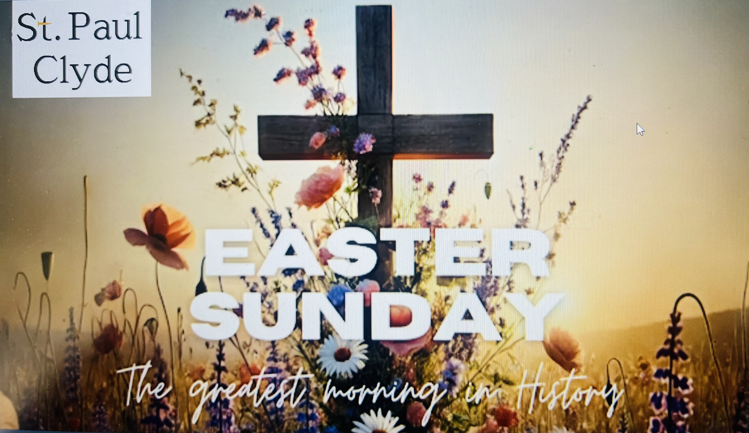

Opening Song
“O Praise the Name” by Hillsong

Welcome/Announcements

Children’s Time

Confession & Forgiveness

Worship Songs
“Glorious Day” by Passion
“Your Great Name” by Natalie Grant

Scripture Reading

Sermon
“On the First Day”
based on John 20:1-18
The Rev. Dr. Tim Hubert

Prayers
for the sick and those in need:

Ron
Hazel
Betty
Tim
Diane
Toni
Crew
Rebecca
Bill
Larry
Linda
Ed
Ed

DEPLOYED
Kyle

Words of Institution

Holy Communion
“Death Was Arrested” by North Point Worship

The Lord’s Prayer

Closing Song
“Forever” by Kari Jobe
“What a Beautiful Name” by Hillsong

Parting Blessing
Go in peace. Serve the Lord.
Thanks be to God.

Post – Service Music

* * * * * * * * * * * * * * * * * * * * * * * *


Christ is risen! Alleluia! Welcome to worship – and to resurrection life – on this most joyous day.

* * * * * * * * * * * * * * * * * * * * * * * *

THE ALTAR FLOWERS are given to the glory of God in honor of the 16th birthday on Thursday, April 24, 2025, for our daughter, Kinsey Wahl given by her family

* * * * * * * * * * * * * * * * * * * * * * * *


ATTENTION 2025 GRADUATING
HIGH SCHOOL SENIORS

St. Paul Lutheran Church will be awarding a $1,500.00 scholarship to a graduating high school senior, who is a member of St. Paul Lutheran Church. The application for this award is in the April Reflector or is available from the church office. All applications MUST BE turned into the church office no later than Thursday, May 1, 2025. A winner will be selected, and the award will be presented during the winner’s high school award ceremony.

* * * * * * * * * * * * * * * * * * * * * * * *
April 20, 2025 – April 27, 2025

Sunday the  20th   | 8:00 am ~ Holy Communion Easter Worship  9:15 am ~ Sunday School  10:30 am ~ Holy Communion Easter Worship
Monday the 21st | OFFICE CLOSED  (in observance of Easter)
Tuesday the 22nd | 1:00 pm ~ Pericope Meeting
Wednesday the 23rd | 9:00 am – Noon ~ Quilt Ministry  6:00 pm ~ Women’s Bible Study
Thursday the 24th | 7:00 pm ~ Al-Anon Meeting  8:00 pm ~ AA Meeting
Friday the 25th

Saturday the 26th | 8:00 am – 9:30 am ~ Men’s Bible Study  9:30 am – 5:00 pm ~ Parish Hall reserved  5:00 pm ~ Holy Communion Service/baptism
Sunday the  27th | 8:00 am ~ Holy Communion Worship  9:15 am ~ Sunday School  10:30 am ~ Holy Communion  3:00 pm ~ Bunco  6:30 pm ~ CCYG

10:30 am Service
ACOLYTE:

USHERS: Gary Wott
Lisa Rieman
Kendall Rieman
Deanna Turner

COUNTERS: Jackie Hoppe
Lisa Rieman

NURSERY WORKER: Dawn Sumner

* * * * * * * * * * * * * * * * * * * * * * * *

The Rev. Dr. Tim Hubert Phone: 217-778-8017

Office Manager – Stephanie Stull Phone: 419-547-9225

Clerical Secretary – Sherry Bouyack Phone: 419-547-9225

Custodian – Terry Langham Phone: 419-547-9225

Treasurer – Jim Shull Phone: 419-355-6499

P & W Leader – Brian Farrar Phone: 419-271-3085

http://www.stpaulclyde.org

* * * * * * * * * * * * * * * * * * * * * * * *
OUR STEWARDSHIP Totals for Year-to-Date 2025

Worship Attendance for weekend of April 12 & 13, 2025 165

Income from January – March 31, 2025 $ 79,687.15
Expense for January – March 31, 2025 $ 86,035.60
Shortage for January – March 31, 2025 $ 7,750.1

* * * * * * * * * * * * * * * * * * * * * * * *


We offer many different ways to donate to St Paul Lutheran Church. The following QR code is the latest way. It can be used to direct you to St. Paul Lutheran Church’s electronic giving sign up page. You can always give using the church envelopes, the link on St Paul’s website at stpaulclyde.org, or donate by texting Donate/Donations to 844-440-0253 as well. Thank you for your continued support!

