Fourth Sunday of Easter
Sunday, April 26, 2026
10:30 am

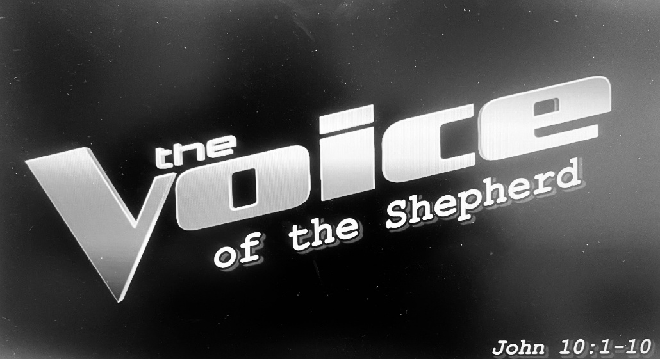

147 West Forest Street Clyde, Ohio
Opening Song
“Lead on Good Shepherd” by Patrick Mayberry
Welcome & Announcements
Confession & Forgiveness
Worship
“The Truth” by Megan Woods
Sermon
"The Voice of the Shepherd" ~John 10: 1-10
Pastor Sam Dagg
Pastoral Prayer
Vickie Aldrich
Gwendolyn Baughn
Michelle Borodkin
Tim Cooper
Toni Dagg
Crew Dearth
Louie Duskin
Sharon Duskin
John Glass
Becky Karr
Kris Larkins
Karen Nimms
Matt Pumphrey
Maverick Salazar
Sue Shull
Lindsay Sooy
Larry Sumner
Conner Whaley
Sandy Wott

Words of Institution
The Lord's prayer
Communion
(Song: "Word of God Speak" by MercyMe)
Closing Song
“Spirit of the Living God” by Vertical Worship
Benediction
Dismissal
P: Go in peace. Serve the Lord!
C: Thanks be to God!

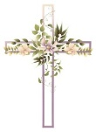
* * * * * * * * * * * * * * * * * * * * * * * * * * * * * * * * * * * * * * * * * *
THE ALTAR FLOWERS are given to the glory of God in honor of Fred Bouyack’s birthday on Monday, April 27th, 2026 and Brandis Stout’s birthday on Tuesday, April 28th, 2026.


* * * * * * * * * * * * * * * * * * * * * * * * * * * * * * * * * * * * * * * * *
James Sidoti, age 41, passed away peacefully on Monday, April 20, 2026. May God be with his family.

We welcome into God’s Family through Holy Baptism:
Stella Monroe Alejandro, Jasper Lou Ellis Alejandro &
Shiloh Storm Davenport on April 22, 2026.
Their sponsors are Walker and Shelby Davenport.

* * * * * * * * * * * * * * * * * * * * * * * * * * * * * * * * * * * * * * * * * *

Stella Alejandro
Alaura Anstead
Owen Cook
Harper Dearth
Knox Dearth
Danni Elfring
Stella Gibbs
Raiden Hayward
Benjamin Riggs
Blake Williams

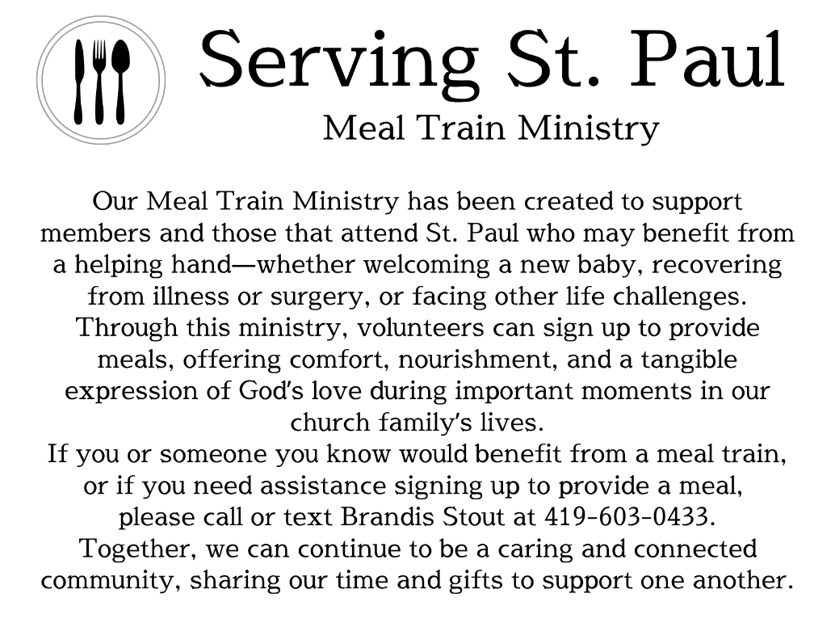
* * * * * * * * * * * * * * * * * * * * * * * * * * * * * * * * * * * * * * * * *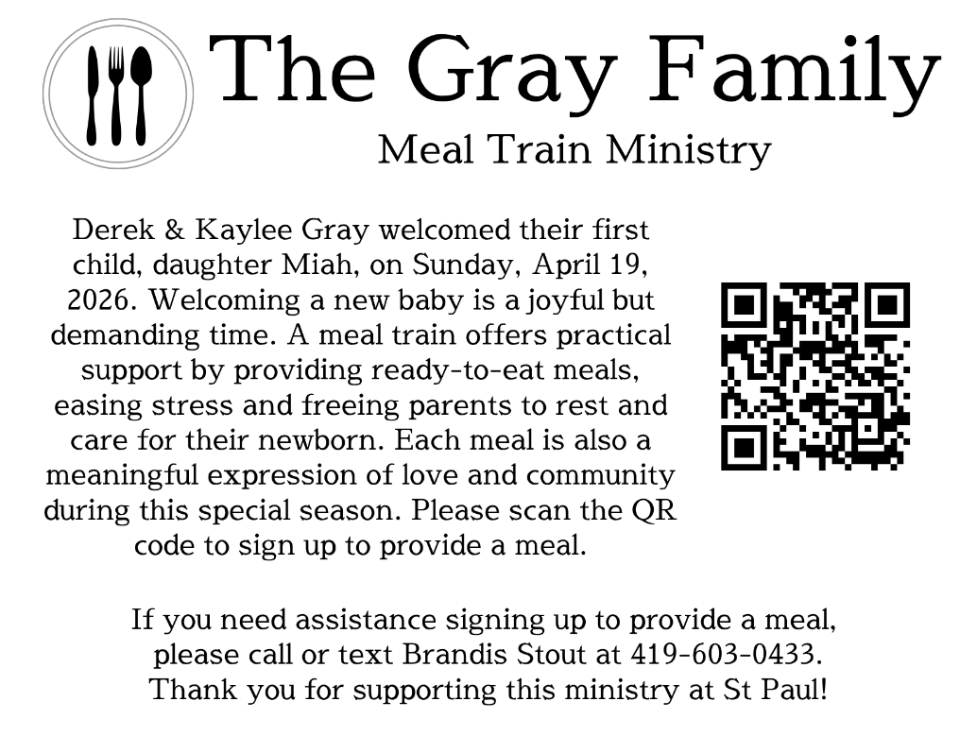
LOVE PACKAGES
Do you have older Bibles or religious materials-books, paperbacks, magazines, daily devotionals, CDs, DVDs, Biblical puzzles & games, puppets, nativity sets, or anything that helps teach the gospel-just sitting around because you’re not sure what to do with them? We have a plan…the company Love Packages collects all these items, sorts them by category & sends them overseas to share the word of God.
We will begin collecting these items in the Parish Hall on April 6th. There will be a container marked as such. We will end the collection on May 1st. We have a volunteer who will drive our donations to their collection point in Delaware, Ohio.
Love Packages started in Butler, IL and has a 2nd location in Decatur, AL. Once the materials are sorted, they are shipped overseas in a 20-ton container. Monetary donations are accepted to maintain and expand the ministry. The priority is to pay for the container expenses. There are also “unseen” costs for fuel and truck expenses to pick up the donations from publishers and other ministries. They note the most important element is to pray because the ministry is depending on God, not people.

Any questions contact DeAnn Krauss 419-937-7514
Their website is lovepackages.org if you’d like to check them out.

April 26, 2026 – May 3, 2026
Sunday the 26th | 8:00 am ~ Worship  9:15 am ~ Sunday School  10:30 am ~ Worship & First Communion  3:00 pm ~ BUNCO
Monday the 27th | 6:30 pm ~ Co-Ed Bible Study
Tuesday the 28th | 6:30pm ~ Men’s Bible Study
Wednesday the 29th | 6:00 pm ~ Women’s Bible Study
Thursday the 30th | 7:00 pm ~ Al-Anon Meeting  8:00 pm ~ AA Meeting
Friday the 1st
Saturday the 2nd | 8:00 am ~ Men’s Bible Study  5:00 pm ~ Worship
Sunday the 3rd | 8:00 am ~ Worship  9:15 am ~ Sunday School  10:30 am ~ Worship & Confirmation  12:00 pm ~ Parish Hall Rental

Attendance for April 18-19, 2026 ~ 198

10:30 am Service
ACOLYTE: Keaton & Owen Cook
USHERS: Steve Jess
Tammy Baker
Dawn Sumner
Kris Wott
COUNTERS: Mel Cook
Karen Jess
NURSERY WORKER: Tammy Baker
* * * * * * * * * * * * * * * * * * * * * * * * * * * * * * * * * * * *
Church Office Phone: 419-547-9225
Pastor Samuel Dagg Phone: 567-342-2137
pastor@stpaulclyde.org
Matt Woodland ~ Council President Phone: 419-603-0567
prez@stpaulclyde.org
Sherry Bouyack ~ Clerical Secretary Phone: 419-547-9225
fisec@stpaulclyde.org
Jim Shull ~ Treasurer Phone: 419-355-6499
treas@stpaulclyde.org
Brian Farrar ~ P & W Leader Phone: 419-271-3085
pwl@stpaulclyde.org
Ashley Reed ~ Assistant Secretary Phone: 419-547-9225 asst.sec@stpaulclyde.org
* * * * * * * * * * * * * * * * * * * * * * * * * * * * * * * * * * * * * * * * * * * * * * * * * * *


We offer many ways to donate to St Paul Lutheran Church. The above QR code is the latest way. It can be used to direct you to St. Paul Lutheran Church’s electronic giving sign up page. You can always give using the church envelopes, the link on St Paul’s website at stpaulclyde.org, or donate by texting Donate/Donations to 844-440-0253 as well. Thank you for your continued support!

