Fourth Sunday of Easter
Sunday, April 26, 2026
8:00 am

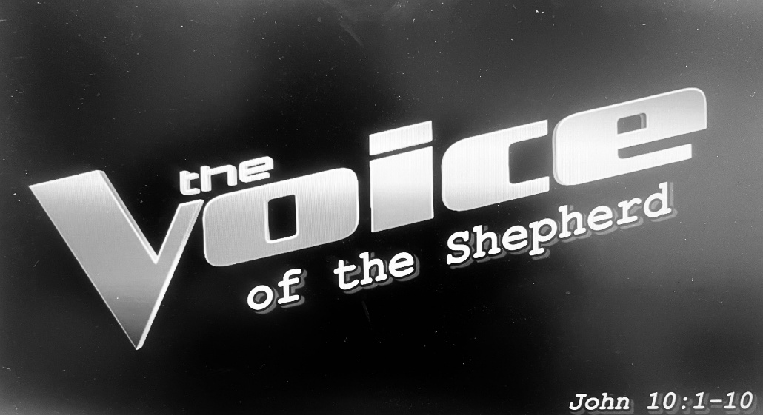

147 W. Forest Street Clyde, Ohio
Prelude, Bell & Announcements
Confession & Forgiveness Pg. 94
P: In the name of the Father, and of the ☩ Son, and of the Holy Spirit.
C: Amen.
P: God of all mercy and consolation, come to the help of your people, turning us from our sin to live for you alone. Give us the power of your Holy Spirit that we may confess our sin, receive your forgiveness and grow into the fullness of Jesus Christ, our Savior and Lord.
C: Amen.
P: Let us confess our sin in the presence of God and of one another.
P: Most merciful God,
C: we confess that we are captive to sin and cannot free ourselves. We have sinned against you in thought, word, and deed, by what we have done and by what we have left undone. We have not loved you with our whole heart; we have not loved our neighbors as ourselves. For the sake of your Son, Jesus Christ, have mercy on us. Forgive us, renew us, and lead us, so that we may delight in your will and walk in your ways, to the glory of your holy name. Amen.
P: God who is rich in mercy, loved us even when we were dead in sin, and made us alive together with Christ. By grace you have been saved. In the name of Jesus Christ, the entirety of your sins are forgiven. Almighty God strengthen you with power through the Holy Spirit, that Christ may live in your hearts through faith.
C: Amen.
Hymn “He Leadeth Me” CCLI #62762
The Apostolic Greeting Pg. 147
P: The grace of our Lord Jesus Christ, the love of God, and the communion of the Holy Spirit be with you all.
C: And also with you.
The Kyrie Pg. 147
P: In peace, let us pray to the Lord.
C: Lord, have mercy.
P: For the peace from above, and for our salvation, let us pray to the Lord.
C: Lord, have mercy.
P: For the peace of the whole world, for the well-being of the church of God, and for the unity of all, let us pray to the Lord.
C: Lord, have mercy.
P: For this holy house, and for all who offer here their worship and praise, let us pray to the Lord.
C: Lord, have mercy.
P: Help, save, comfort, and defend us gracious Lord.
C: Amen.
The Hymn of Praise Pg. 149
P: This is the feast of victory for our God. Alleluia.
Worthy is Christ, the Lamb who was slain, whose blood set us free to be people of God. Power and riches and wisdom and strength, and honor and blessing and glory are his.
This is the feast of victory for our God. Alleluia.
Sing with all the people of God and join in the hymn of all creation: Blessing and honor and glory and might be to God and the Lamb forever. Amen.
This is the feast of victory for our God, for the Lamb who was slain has begun his reign. Alleluia. Alleluia.
The Prayer of the Day
Almighty God, you show those in error the light of your truth that they may return into the way of righteousness. Grant to all that are admitted into fellowship with Christ the power to avoid all things that are contrary to the faith and to follow you according to the will of your Son, Jesus Christ, our Lord, who lives and reigns with you and the Holy Spirit, one God, now and forever. Amen.
The First Reading: Acts 2:42-47
⁴²{The believers} devoted themselves to the apostles’ teaching and the fellowship, to the breaking of bread and the prayers. ⁴³And awe came upon every soul, and many wonders and signs were being done through the apostles. ⁴⁴And all who believed were together and had all things in common. ⁴⁵And they were selling their possessions and belongings and distributing the proceeds to all, as any had need. ⁴⁶And day by day, attending the temple together and breaking bread in their homes, they received their food with glad and generous hearts, ⁴⁷praising God and having favor with all the people. And the Lord added to their number day by day those who were being saved.
L: The Word of the Lord.
C: Thanks be to God.
Psalm 23
¹The Lord is my shepherd; I shall not want.
²He makes me lie down in green pastures. He leads me beside still waters.
³He restores my soul. He leads me in paths of righteousness for his name’s sake.
⁴Even though I walk through the valley of the shadow of death, I will fear no evil, for you are with me; your rod and your staff, they comfort me.
⁵You prepare a table before me in the presence of my enemies; you anoint my head with oil; my cup overflows.
⁶Surely goodness and mercy shall follow me all the days of my life, and I shall dwell in the house of the Lord forever.
L: Here ends the reading of the Psalm.
C: Thanks be to God.
The Second Reading: 1 Peter 2:19-25
¹⁹For this is a gracious thing, when, mindful of God, one endures sorrows while suffering unjustly. ²⁰For what credit is it if, when you sin and are beaten for it, you endure? But if when you do good and suffer for it you endure, this is a gracious thing in the sight of God. ²¹For to this you have been called, because Christ also suffered for you, leaving you an example, so that you might follow in his steps. ²²He committed no sin, neither was deceit found in his mouth. ²³When he was reviled, he did not revile in return; when he suffered, he did not threaten, but continued entrusting himself to him who judges justly. ²⁴He himself bore our sins in his body on the tree, that we might die to sin and live to righteousness. By his wounds you have been healed. ²⁵For you were straying like sheep, but have now returned to the Shepherd and Overseer of your souls.
L: The Word of the Lord.
C: Thanks be to God.
The Gospel Acclamation Pg. 151
Alleluia. Lord, to whom shall we go? You have the words of eternal life. Alleluia.
P: The Holy Gospel according to St. John, the 10th chapter.
C: Glory to You, O Lord.

The Gospel: John 10:1-10
¹{Jesus said to the Jews,} “Truly, truly, I say to you, he who does not enter the sheepfold by the door but climbs in by another way, that man is a thief and a robber. ²But he who enters by the door is the shepherd of the sheep. ³To him the gatekeeper opens. The sheep hear his voice, and he calls his own sheep by name and leads them out. ⁴When he has brought out all his own, he goes before them, and the sheep follow him, for they know his voice. ⁵A stranger they will not follow, but they will flee from him, for they do not know the voice of strangers.” ⁶This figure of speech Jesus used with them, but they did not understand what he was saying to them. ⁷So Jesus again said to them, “Truly, truly, I say to you, I am the door of the sheep. ⁸All who came before me are thieves and robbers, but the sheep did not listen to them. ⁹I am the door. If anyone enters by me, he will be saved and will go in and out and find pasture. ¹⁰The thief comes only to steal and kill and destroy. I came that they may have life and have it abundantly.”
P: The Gospel of the Lord.
C: Praise to You, O Christ.
Sermon:
"The Voice of the Shepherd"
John 10: 1-10
Pastor Sam Dagg
The Hymn “Savior, like a Shepherd Lead Us” #789
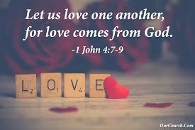
Prayers of Intercession
Vickie Aldrich
Gwendolyn Baughn
Michelle Borodkin
Jack Cooper
Tim Cooper
Toni Dagg
Crew Dearth
Louie Duskin
Sharon Duskin
John Glass
Becky Karr
Kris Larkins
Karen Nimms
Matt Pumphrey
Maverick Salazar
Sue Shull
Lindsay Sooy
Larry Sumner
Conner Whaley
Sandy Wott

THE APOSTLES’ CREED (back cover of the hymnal)
The Peace of the Lord Pg. 152
P: The peace of the Lord be with you.
C: And also, with you.
The Passing of the Peace
The Offering
The Offering Prayer
Blessed are you, O God, maker of all things. Through your goodness you have blessed us with these gifts: our possessions. Use us, and what we have gathered, in feeding the world with your love, through the one who gave himself for us, Jesus Christ, our Savior and Lord. Amen.
The Great Thanksgiving Pg. 152
P: The Lord be with you.
C: And also, with you.
P: Lift up your hearts.
C: We lift them to the Lord.
P: Let us give thanks to the Lord our God.
C: It is right to give our thanks and praise.
The Proper Preface
P: It is indeed right, our duty and our joy, that we should at all times and in all places give thanks and praise to you, almighty and merciful God, for the glorious resurrection of our Savior Jesus Christ, the true Paschal Lamb who gave himself to take away our sin; who in dying has destroyed death, and in rising has brought us to eternal life. And so, with all the choirs of angels, with the church on earth and the hosts of heaven, we praise your name and join their unending hymn:
C: Holy, holy, holy Lord,
Lord God of power and might,
heav’n and earth are full of your glory.
Hosanna in the highest.
Blessed is he who comes in the name of the Lord.
Hosanna in the highest.
The Words of Institution
The Lord’s Prayer Pg. 154
P: Gathered into one by the Holy Spirit, let us pray as Jesus taught us.
C: Our Father, Who art in heaven, hallowed be Thy name, Thy kingdom come, Thy will be done, on earth as it is in heaven. Give us this day our daily bread; and forgive us our trespasses, as we forgive those who trespass against us; and lead us not into temptation, but deliver us from evil. For Thine is the kingdom, and the power, and the glory, forever and ever. Amen.
Invitation to Communion Pg. 154
P: Come to the banquet, for all is now ready.

Holy Communion
All baptized believers in Jesus Christ as Lord are invited to receive communion today. Please follow the directions of the ushers. Children who have not yet received their first communion are also invited to come forward, to receive a blessing.
The Post Communion Blessing
P: The body and blood of our Lord Jesus Christ strengthen you and keep you in His grace.
C: Amen.
Prayer After Communion
P: Let us pray.
C: O God, we give You thanks that You have set before us this feast, the body and blood of Your Son. By Your Spirit strengthen us to serve all in need and to give ourselves away as bread for the hungry, through Jesus Christ our Lord. Amen.
The Hymn “Will You Come and Follow Me” #798
The Benediction
Numbers 6:24-26
“The Lord bless you and keep you;
the Lord make his face to shine upon you and be
gracious to you;
the Lord lift up his countenance upon you and give you
peace.”
The Dismissal
P: GO IN PEACE. SERVE THE LORD!
C: Thanks be to God.
The Postlude


* * * * * * * * * * * * * * * * * * * * * * * * * * * * * * * * * * * * * * * * * *
THE ALTAR FLOWERS are given to the glory of God in honor of Fred Bouyack’s birthday on Monday, April 27th, 2026 and Brandis Stout’s birthday on Tuesday, April 28th, 2026.


* * * * * * * * * * * * * * * * * * * * * * * * * * * * * * * * * * * * * * * * *
James Sidoti, age 41, passed away peacefully on Monday, April 20, 2026. May God be with his family.

* * * * * * * * * * * * * * * * * * * * * * * * * * * * * * * * * * * * * * * * *
We welcome into God’s Family through Holy Baptism:
Stella Monroe Alejandro, Jasper Lou Ellis Alejandro &
Shiloh Storm Davenport on April 22, 2026.
Their sponsors are Walker and Shelby Davenport.

* * * * * * * * * * * * * * * * * * * * * * * * * * * * * * * * * * * * * * * * * *

Stella Alejandro
Alaura Anstead
Owen Cook
Harper Dearth
Knox Dearth
Danni Elfring
Stella Gibbs
Raiden Hayward
Benjamin Riggs
Blake Williams

* * * * * * * * * * * * * * * * * * * * * * * * * * * * * * * * * * * * * * * *
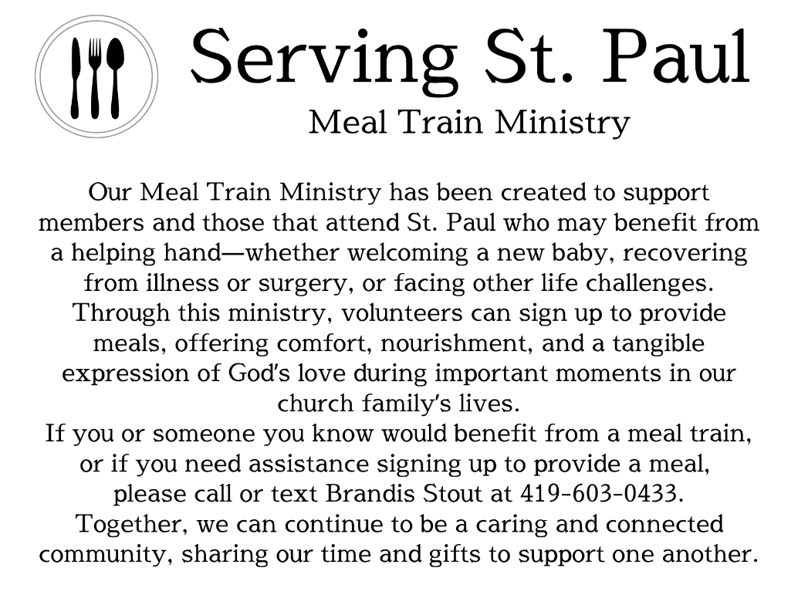
* * * * * * * * * * * * * * * * * * * * * * * * * * * * * * * * * * * * * * * * *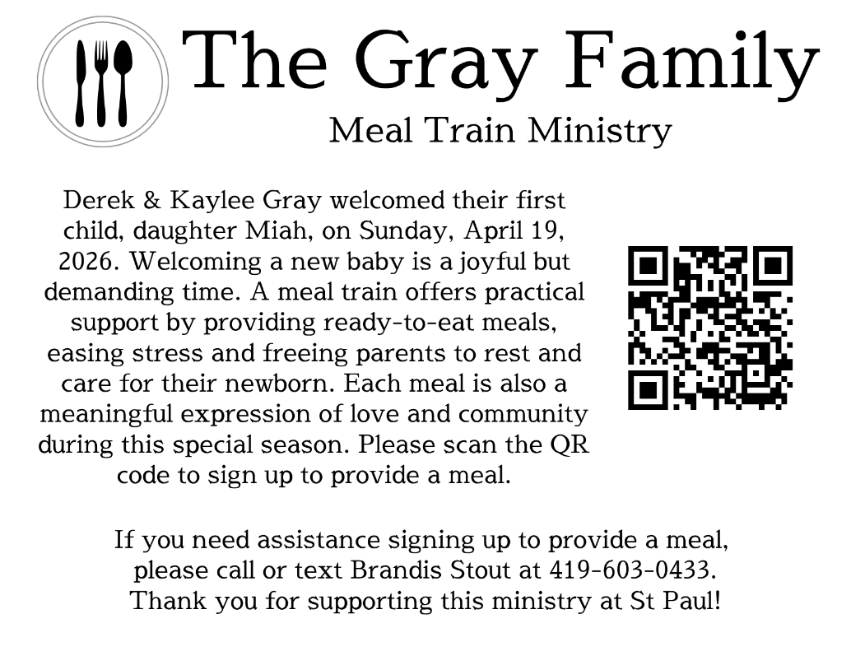
LOVE PACKAGES
Do you have older Bibles or religious materials-books, paperbacks, magazines, daily devotionals, CDs, DVDs, Biblical puzzles & games, puppets, nativity sets, or anything that helps teach the gospel-just sitting around because you’re not sure what to do with them? We have a plan…the company Love Packages collects all these items, sorts them by category & sends them overseas to share the word of God.
We will begin collecting these items in the Parish Hall on April 6th. There will be a container marked as such. We will end the collection on May 1st. We have a volunteer who will drive our donations to their collection point in Delaware, Ohio.
Love Packages started in Butler, IL and has a 2nd location in Decatur, AL. Once the materials are sorted, they are shipped overseas in a 20-ton container. Monetary donations are accepted to maintain and expand the ministry. The priority is to pay for the container expenses. There are also “unseen” costs for fuel and truck expenses to pick up the donations from publishers and other ministries. They note the most important element is to pray because the ministry is depending on God, not people.

Any questions contact DeAnn Krauss 419-937-7514
Their website is lovepackages.org if you’d like to check them out.

April 26, 2026 – May 3, 2026
Sunday the 26th | 8:00 am ~ Worship  9:15 am ~ Sunday School  10:30 am ~ Worship & First Communion  3:00 pm ~ BUNCO
Monday the 27th | 6:30 pm ~ Co-Ed Bible Study
Tuesday the 28th | 6:30pm ~ Men’s Bible Study
Wednesday the 29th | 6:00 pm ~ Women’s Bible Study
Thursday the 30th | 7:00 pm ~ Al-Anon Meeting  8:00 pm ~ AA Meeting
Friday the 1st
Saturday the 2nd | 8:00 am ~ Men’s Bible Study  5:00 pm ~ Worship
Sunday the 3rd | 8:00 am ~ Worship  9:15 am ~ Sunday School  10:30 am ~ Worship & Confirmation  12:00 pm ~ Parish Hall Rental

Attendance for April 18-19, 2026 ~ 198

8:00 am Service
COMPUTER TECH: Matt Woodland
READER: Bob Jennings
USHERS: Tim Billings
Duane Kimmet
Jeanie Kimmet

* * * * * * * * * * * * * * * * * * * * * * * * * * * * * * * * * * * * * * * * * *
Church Office Phone: 419-547-9225
Pastor Samuel Dagg Phone: 567-342-2137
pastor@stpaulclyde.org
Matt Woodland ~ Council President Phone: 419-603-0567
prez@stpaulclyde.org
Sherry Bouyack ~ Clerical Secretary Phone: 419-547-9225
fisec@stpaulclyde.org
Jim Shull ~ Treasurer Phone: 419-355-6499
treas@stpaulclyde.org
Brian Farrar ~ P & W Leader Phone: 419-271-3085
pwl@stpaulclyde.org
Ashley Reed ~ Assistant Secretary Phone: 419-547-9225
asst.sec@stpaulclyde.org
Organist
Mary Ellen Wollenslegel
* * * * * * * * * * * * * * * * * * * * * * * * * * * * * * * * * * * * *

We offer many different ways to donate to St Paul Lutheran Church. The following QR code is the latest way. It can be used to direct you to St. Paul Lutheran Church’s electronic giving sign up page. You can always give using the church envelopes, the link on St Paul’s website at stpaulclyde.org, or donate by texting Donate/Donations to 844-440-0253 as well. Thank you for your continued support!

