St. Paul Lutheran Church
147 West Forest Street
Clyde, OH

Fifth Sunday in Lent
Contemporary Service
Sunday, April 6, 2025
10:30 a.m.



Opening Song
“Chain Breaker” by Zach Williams

Welcome/Announcements

Holy Baptism
Julia Lynn Rieman

Evangelical Lutheran Worship Book Pg. 227

Presentation
The child, sponsors, and parents gather with the ministers at the font. The congregation is seated.

The presiding minister may address the congregation in these or similar words:

God, who is rich in mercy and love, gives us a new birth into a living hope through the sacrament of baptism. By water and the Word God delivers us from sin and death and raises us to new life in Jesus Christ. We are united with all the baptized in the one body of Christ, anointed with the gift of the Holy Spirit, and joined in God's mission for the life of the world.

Sponsors present the child:

I present Julia Lynn Rieman for baptism.

The Pastor addresses the parents:

Called by the Holy Spirit, trusting in the grace and love of God, do you desire to have Julia baptized into Christ?

Response: I do.

As you bring Julia to receive the gift of baptism, you are entrusted with responsibilities:

- to live with Julia among God's faithful people,
- bring Julia to the word of God and the holy supper,
- teach Julia the Lord's Prayer, the Creed, and the Ten Commandments,
- place in Julia hands in the holy scriptures,
- and nurture Julia in faith and prayer,
- so that Julia may learn to trust God,
- proclaim Christ through word and deed,
- care for others and the world God made,
- and work for justice and peace.

Do you promise to help Julia grow in the Christian faith and life?

Response: I do.

The presiding minister addresses sponsors:

Sponsors, do you promise to nurture Julia in the Christian faith as you are empowered by God's Spirit, and to help her live in the covenant of baptism and in communion with the church?

Response: I do.

The presiding minister addresses the congregation:

People of God, do you promise to support Julia and pray for her in her new life in Christ?

We do.

The congregation stands.

Profession of Faith
The presiding minister addresses the parents and sponsors of Julia. The congregation may join in the responses.

I ask you to profess your faith in Christ Jesus, reject sin, and confess the faith of the church.

Do you renounce the devil and all the forces that defy God, the powers of this world that rebel against God, and the ways of sin that draw you from God?

Response: I renounce them.

The presiding minister addresses the parents, sponsors and the congregation.

Do you believe in God the Father?

I believe in God, the Father almighty,
creator of heaven and earth.

Do you believe in Jesus Christ, the Son of God?

I believe in Jesus Christ, God’s only Son, our Lord,
He was conceived by the Holy Spirit,
born of the virgin Mary,
suffered under Pontius Pilate,
was crucified, died, and was buried;
he descended into Hell.
On the third day he rose again;
he ascended into heaven,
he is seated at the right hand of the Father,
and he will come to judge the living and the dead.

Do you believe in God the Holy Spirit?

I believe in the Holy Spirit,
the holy catholic church,
the communion of saints,
the forgiveness of sins,
the resurrection of the body,
and the life everlasting.

Thanksgiving at the Font
At the font, the presiding minister begins the thanksgiving:

The Lord be with you.
And also with you.

Let us give thanks to the Lord our God.
It is right to give our thanks and praise.

We give You thanks, O God, for in the beginning Your Spirit moved over the waters and by Your Word You created the world, calling forth life in which You took delight. Through the waters of the flood, You delivered Noah and his family, and through the sea You led your people Israel from slavery into freedom. At the river Your Son was baptized by John and anointed with the Holy Spirit. By the baptism of Jesus' death and resurrection You set us free from the power of sin and death and raise us up to live in You.

Pour out Your Holy Spirit, the power of Your living Word, that Julia who is washed in the waters of baptism may be given new life. To You be given honor and praise through Jesus Christ our Lord, in the unity of the Holy Spirit, now and forever.

Amen.

The congregation may be seated.

Baptism
The presiding minister baptizes the child. Water poured on the child's head, as the presiding minister says:

Julia Rieman, I baptize you in the name of the Father,

A second time:

and of the Son,

A third time:

and of the Holy Spirit.

Amen.

The congregation may respond with.

You belong to Christ,
in whom you have been baptized.
Alleluia.

The presiding minister continues:

Let us pray.

We give You thanks, O God, that through water and the Holy Spirit You give Your daughter’s new birth, cleanse her from sin, and raise her to eternal life.

Laying both hands on her head the minister prays for Julia:

Sustain Julia with the gift of Your Holy Spirit: the spirit of wisdom and understanding, the spirit of counsel and might, the spirit of knowledge and the fear of the Lord, the spirit of joy in Your presence, both now and forever.

Amen.

The presiding minister marks the sign of the cross on the forehead of the baptized. Oil prepared for this purpose may be used. As the sign of the cross is made, the minister says:

Julia, child of God, you have been sealed by the Holy Spirit and marked with the cross of Christ forever.

Amen.

Welcome
A lighted candle may be given to the newly baptized (to a sponsor of a young child) as a representative of the congregation says:

I am the light of the world

Jesus said, I am the light of the world.
Whoever follows Me
will have the light of life.

Let us welcome the newly baptized.

We welcome you into the body of Christ and into the mission we share:
join us in giving thanks and praise to God
and bearing God's creative and redeeming word to all the world.

The service continues with the prayers of intercession.

From sundaysandseasons.com.
Copyright © 2022 Augsburg Fortress. All rights reserved.

Children’s Time

Confession & Forgiveness

Worship Songs
“How Can It Be” by Lauren Diagle
“Tremble” by Mosiac MSC

Scripture Reading

Sermon
“I Press On”
based on Philippians 3:4b-14
The Rev. Dr. Tim Hubert

Prayers
for the sick and those in need:

Ron
Hazel
Betty
Tim
Diane
Toni
Crew
Rebecca
Bill
Larry
Ed
Emily & baby Sophia

Words of Institution

Holy Communion
“No Longer Slaves” by Zach Williams

The Lord’s Prayer

Closing Song
“Holy Spirit” by Kari Jobe

Parting Blessing
Go in peace. Serve the Lord.
Thanks be to God.

Post – Service Music

* * * * * * * * * * * * * * * * * * * * * * * *

From wherever you’ve come, we extend a hearty welcome! It’s our intention to be warmhearted. Please introduce yourself to those near you and especially to the worship leaders.

* * * * * * * * * * * * * * * * * * * * * * * *

THE ALTAR FLOWERS are given to the glory of God from the women’s “Cross of Lilies” Fund.

* * * * * * * * * * * * * * * * * * * * * * * *


PRAY FOR ALL OUR HOMEBOUND AND/OR IN MEDICAL CARE FACILITIES:

Thelma Blair, Larry Bower, Bev Bush, Naomi Conley, Diane Dagg, Jim & Norma Fish, Janet Kauble, LaVerde Kuns, Florence Pocock, Jeanette Pumphrey, Tina Walker, Carlos & Joyce Weiker, Joanne Wise, Sandy Wott. If you know of other members who are not listed, please inform the church office, 419-547-9225.
* * * * * * * * * * * * * * * * * * * * * * * *
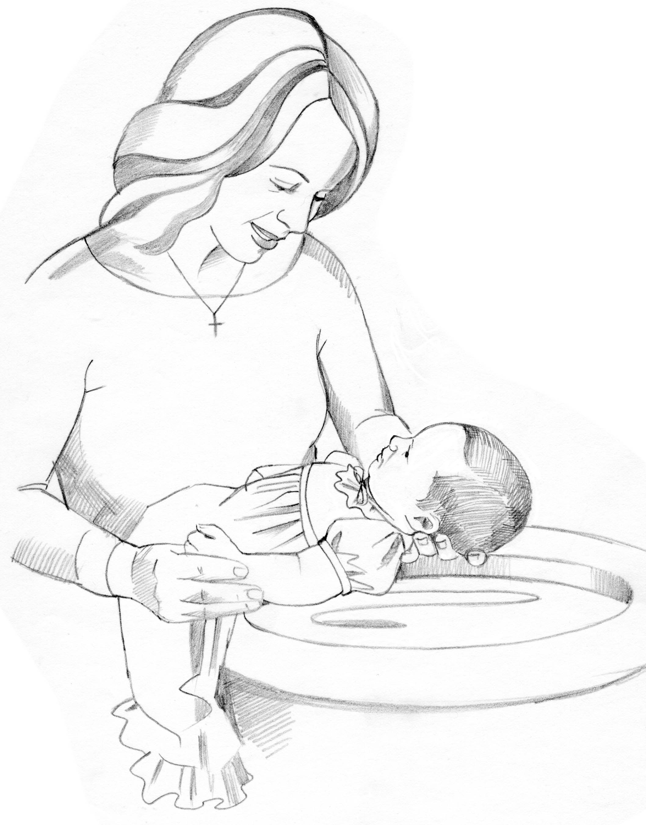
WE WELCOME INTO GOD’S FAMILY through sacrament of Holy Baptism on Sunday, April 6, 2025, at the 10:30 am service, Julia Lynn Rieman, daughter of Collin & Jacquelyn (nee: Becker) Rieman. Julia was born in Toledo, OH on September 15, 2024. The sponsors for Julia are Ginny Mowry & Carson Rieman. Proud grandparents are: Kendall & Lisa Rieman.
April 6, 2025 – April 13, 2025
Sunday the  6th | 8:00 am ~ Holy Communion Worship  9:15 am ~ Sunday School  9:15 am ~ Women’s Board Meeting  10:30 am ~ Holy Communion\  Worship/baptism/Rieman
Monday the 7th | 6:00 pm ~ Women’s Bible Study
Tuesday the 8th | 1:00 pm ~ Pericope Meeting  7:00 pm ~ Property Board Meeting
Wednesday the 9th | 12:00 pm ~ Community Lenten Luncheon @ 1st UMC  6:00 pm ~ Youth Choir practice  7:00 pm ~ Midweek Lenten Service @ St. Paul
Thursday the 10th | REFLECTOR DEADLINE / noon  5:00 pm ~ Evangelism/Social Board Meeting  6:00 pm ~ Worship Board Meeting  7:00 pm ~ Church Council  7:00 pm – 8:00 pm ~ Al-Anon Meeting  8:00 pm ~ AA Meeting
Friday the 11th

Saturday the 12th | 8:00 am – 9:30 am ~ Men’s Bible Study  9:00 am – 2:00 pm ~ Call Committee Worship  5:00 pm ~ Holy Communion Service
Sunday the  13th | 8:00 am ~ Holy Communion Worship  9:15 am ~ Sunday School  10:30 am ~ Holy Communion Worship  6:30 pm ~ CCYG
* * * * * * * * * * * * * * * * * * * * * * * *
LENTEN MIDWEEK WEDNESDAY DEVOTIONS!
2025 Lenten Series

Wednesdays @ 7:00 pm @ St. Paul Lutheran Church

Wednesday, April 9, 2025: The Second Table as Lent
The Second Table of the 10 Commandments are number 4-10 and are an explanation of the First Table, a living out of the First Table.

* * * * * * * * * * * * * * * * * * * * * * * *

Clyde Area Ministerial Association
Community Lenten Luncheons Schedule

Wednesdays at noon
All lunches will be taking place at
1st United Methodist Church (Clyde)

THE STATIONS OF THE CROSS

Wednesday, April 9, 2025
“Stations 10 – 12” ~ Jesus is crucified; Jesus promises His kingdom to the repentant thief; Jesus entrusts Mary and John to each other.

Presented by Rev. Tim Hubert
Meal by St. Paul Lutheran Church

* * * * * * * * * * * * * * * * * * * * * * *

COMMUNITY GOOD FRIDAY SERVICE

Friday, April 18, 2025 held at
Clyde Christian Church, 206 South Main Street, Clyde
@ NOON

(no lunch)

“Stations 13 & 14” ~ Jesus dies on the cross and Jesus is laid in the tomb.

Presented by Rev. Chuck Butcher

* * * * * * * * * * * * * * * * * * * * * * *


His name is Crew Dearth, he was just baptized last month at St Paul, his first birthday is this coming Saturday, March 29, 2025. He was recently diagnosed with Liver Cancer.

At this time the plan is that he will be having 3 months of chemotherapy, then a liver transplant, then more chemotherapy. They have created a Facebook page, it's called Crew's Fight Club, to share his story & gather all the prayers they can. Please pray for
Crew & his family.

* * * * * * * * * * * * * * * * * * * * * * * *

* * * * * * * * * * * * * * * * * * * * * * * *



It’s time for the Easter Bake Sale. This year we would like to offer frozen homemade soups to the offerings. Get your recipes for your favorite baked goods, candy and freezable soups to share with fellow parishioners. There will be freezer containers available on the back counter in the kitchen. Please have your donations in the kitchen by 5:00 pm on Friday, April 18, 2025. The soup can go in the freezer outside of the kitchen. The sale will start on Saturday, April 19, 2025, and end after 10:30 am Easter Sunday service. The sale is by donation and there will be a box on the table for your donations. This Easter Soup and Bake Sale helps St. Paul Women to support our many missions. Thanks for your help!
Brenda Sieger
* * * * * * * * * * * * * * * * * * * * * * * *


REFLECTOR DEADLINE !

Due to additional duties in the church office during HOLY WEEK the DEADLINE TO GET ARTICLES IN THE NEXT “REFLECTOR” is Thursday, April 10, 2025, at noon!! Thank you for your cooperation!!
* * * * * * * * * * * * * * * * * * * * * * * *


CALL COMMITTEE NEEDS YOUR HELP:
ALL adult members of St. Paul are invited to a Congregational Workshop on Saturday, APRIL 12, 2025. The workshop will begin at 9:00 am in the Parish hall and end at 2:00 pm. Lunch will be served by the Women of the Church.

The purpose of this workshop is to assist the Call Committee in developing a profile of the St. Paul community. We will assess our strengths, acknowledge our growth areas, and heal from past hurts. Together we will form a refined vision of our congregation - who we are, and who we want to be. Please prayerfully consider attending! Everyone has unique insights, ideas, and experiences to share.
* * * * * * * * * * * * * * * * * * * * * * * *


Mt. Carmel
United Methodist Church
(corner of County Roads 177 & 183, Clyde)

Saturday, April 12, 2025
9:00 am – 3:00 pm

Free Admission
Lots Of Crafts – Bake Sale – Lunch Stand & Homemade Pies

Craft Tables Available
Contact: Sharon Baxter 419-603-3188

* * * * * * * * * * * * * * * * * * * * * * * *


We offer many different ways to donate to St Paul Lutheran Church. The following QR code is the latest way. It can be used to direct you to St. Paul Lutheran Church’s electronic giving sign up page. You can always give using the church envelopes, the link on St Paul’s website at stpaulclyde.org, or donate by texting Donate/Donations to 844-440-0253 as well. Thank you for your continued support!

10:30 am Service
ACOLYTE:

USHERS: Gary Wott
Keyli Billings
Tom Billings
Steve Jess

COUNTERS: Sherry Frasher
Jennie McCoy

NURSERY WORKER: Jennie McCoy

* * * * * * * * * * * * * * * * * * * * * * * *

The Rev. Dr. Tim Hubert Phone: 217-778-8017

Office Manager – Stephanie Stull Phone: 419-547-9225

Clerical Secretary – Sherry Bouyack Phone: 419-547-9225

Custodian – Terry Langham Phone: 419-547-9225

Treasurer – Jim Shull Phone: 419-355-6499

P & W Leader – Brian Farrar Phone: 419-271-3085

http://www.stpaulclyde.org

* * * * * * * * * * * * * * * * * * * * * * * *
OUR STEWARDSHIP Totals for Year-to-Date 2025

Worship Attendance for weekend of March 29 & 30, 2025 141

Income from January – February 28, 2025 $ 45,859.75
Expense for January – February 28, 2025 $ 62,379.75
Shortage for January – February 28, 2025 $ 16,529.00

Fourth Wednesday Lenten Worship Attendance ~ April 2, 2025 23
Fourth Lenten Wednesday Midweek Giving $ 180.00

