Fifth Sunday in Lent
ELW Holy Communion
Traditional Service
Sunday, April 6, 2025
8:00 am


This Photo by Unknown Author is licensed under CC BY

ST. PAUL LUTHERAN CHURCH
147 West Forest Street
Clyde, Ohio

Fifth Sunday in Lent

April 6, 2025

8:00 am

Holy Communion ~ Setting Four

* = those who are able may stand
Song numbers with “BB” are from the “The Best of the Best” songbook

Prelude

Bell & Announcements

*Confession & Forgiveness Pg. 94
P: In the name of the Father,
and of the ☩ Son,
and of the Holy Spirit.
C: Amen.

P: God of all mercy and consolation, come to the help of your people, turning us from our sin to live for you alone. Give us the power of your Holy Spirit that we may confess our sin, receive your forgiveness and grow into the fullness of Jesus Christ, our Savior and Lord.
C: Amen.

P: Let us confess our sin in the presence of God and of one another.

P: Most merciful God,
C: we confess that we are captive to sin and cannot free ourselves. We have sinned against you in thought, word, and deed, by what we have done and by what we have left undone. We have not loved you with our whole heart; we have not loved our neighbors as ourselves. For the sake of your Son, Jesus Christ, have mercy on us. Forgive us, renew us, and lead us, so that we may delight in your will and walk in your ways, to the glory of your holy name. Amen.

P: In the mercy of almighty God, Jesus Christ was given to die for us, and for his sake God forgives us all our sins. As a called and ordained minister of the church of Christ, and by his authority, I therefore declare to you the entire forgiveness of all your sins, in the name of the Father, and of the ☩ Son, and of the Holy Spirit.
C: Amen.

*The Hymn “Great Is Thy Faithfulness” No. 733

*The Apostolic Greeting Pg. 147
P: The grace of our Lord Jesus Christ, the love of God, and the communion of the Holy Spirit be with you all.
C: And also, with you.

*The Kyrie Pg. 147
P: In peace, let us pray to the Lord.
C: Lord, have mercy.

P: For the peace from above, and for our salvation, let us pray to the Lord.
C: Lord, have mercy.

P: For the peace of the whole world, for the well-being of the church of God, and for the unity of all, let us pray to the Lord.
C: Lord, have mercy.

P: For this holy house, and for all who offer here their worship and praise, let us pray to the Lord.
C: Lord, have mercy.

P: Help, save, comfort, and defend us gracious Lord.
C: Amen.

The Prayer of the Day (in unison)
Almighty God, look favorably upon Your family. Graciously rule our bodies lest we are enticed to love the world and guard our spirits lest we fail to recognize Your love. Grant this, we pray, through Jesus Christ, Your Son, our Lord, Who lives and reigns with You and the Holy Spirit, one God, now and forever. Amen.

The First Lesson ~ Isaiah 43:16-21
¹⁶Thus says the Lord, who makes a way in the sea, a path in the mighty waters, ¹⁷who brings forth chariot and horse, army and warrior; they lie down, they cannot rise, they are extinguished, quenched like a wick: ¹⁸“Remember not the former things, nor consider the things of old. ¹⁹Behold, I am doing a new thing; now it springs forth, do you not perceive it? I will make a way in the wilderness and rivers in the desert. ²⁰The wild beasts will honor me, the jackals and the ostriches, for I give water in the wilderness, rivers in the desert, to give drink to my chosen people, ²¹the people whom I formed for myself that they might declare My praise.”

L: The Word of the Lord.
C: Thanks be to God.

Psalm 126
¹When the Lord restored the fortunes of Zion, then were we like those who dream.

²Then was our mouth filled with laughter, and our tongue with shouts of joy.

³Then they said among the nations, “The Lord has done great things for them.”

⁴The Lord has done great things for us, and we are glad indeed.

⁵Restore our fortunes, O Lord, like the watercourses of the Negev.

⁶Those who sowed with tears will reap with songs of joy.

⁷Those who go out weeping, carrying the seed, will come again with joy, shouldering their sheaves.

L: Here ends the reading of the Psalm.
C: Thanks be to God.

The Second Lesson ~ Philippians 3:4b–14
^{4b}… (T)hough I myself have reason for confidence in the flesh also. If anyone else thinks he has reason for confidence in the flesh, I have more: ⁵circumcised on the eighth day, of the people of Israel, of the tribe of Benjamin, a Hebrew of Hebrews; as to the law, a Pharisee; ⁶as to zeal, a persecutor of the church; as to righteousness under the law, blameless. ⁷But whatever gain I had, I counted as loss for the sake of Christ. ⁸Indeed, I count everything as loss because of the surpassing worth of knowing Christ Jesus my Lord. For his sake I have suffered the loss of all things and count them as rubbish, in order that I may gain Christ ⁹and be found in him, not having a righteousness of my own that comes from the law, but that which comes through faith in Christ, the righteousness from God that depends on faith — ¹⁰that I may know him and the power of his resurrection, and may share his sufferings, becoming like him in his death, ¹¹that by any means possible I may attain the resurrection from the dead. ¹²Not that I have already obtained this or am already perfect, but I press on to make it my own, because Christ Jesus has made me his own. ¹³Brothers, I do not consider that I have made it my own. But one thing I do: forgetting what lies behind and straining forward to what lies ahead, ¹⁴I press on toward the goal for the prize of the upward call of God in Christ Jesus.

L: The Word of the Lord.
C: Thanks be to God.

*The “Gospel Acclamation” Pg. 151
Return to the Lord, your God, for He is gracious and merciful, slow to anger, and abounding in steadfast love.

P: The Holy Gospel according to St. Luke, the 20th chapter.
C: Glory to You, O Lord.

*The Gospel ~ Luke 20:9-20
⁹{Jesus} began to tell the people this parable: “A man planted a vineyard and let it out to tenants and went into another country for a long while. ¹⁰When the time came, he sent a servant to the tenants, so that they would give him some of the fruit of the vineyard. But the tenants beat him and sent him away empty-handed. ¹¹And he sent another servant. But they also beat and treated him shamefully and sent him away empty-handed. ¹²And he sent yet a third. This one also they wounded and cast out. ¹³Then the owner of the vineyard said, ‘What shall I do? I will send my beloved son; perhaps they will respect him.’ ¹⁴But when the tenants saw him, they said to themselves, ‘This is the heir. Let us kill him, so that the inheritance may be ours.’ ¹⁵And they threw him out of the vineyard and killed him. What then will the owner of the vineyard do to them? ¹⁶He will come and destroy those tenants and give the vineyard to others.” When they heard this, they said, “Surely not!” ¹⁷But he looked directly at them and said, “What then is this that is written: ‘The stone that the builders rejected has become the cornerstone’? ¹⁸Everyone who falls on that stone will be broken to pieces, and when it falls on anyone, it will crush him.” ¹⁹The scribes and the chief priests sought to lay hands on him at that very hour, for they perceived that he had told this parable against them, but they feared the people. ²⁰So they watched him and sent spies, who pretended to be sincere, that they might catch him in something he said, so as to deliver him up to the authority and jurisdiction of the governor.

P: The Gospel of the Lord.
C: Praise to You, O Christ.

Sermon “I Press On”
based on Philippians 3:4b-14
The Rev. Dr. Tim Hubert

*Song “Just a Closer Walk with Thee” No. 697

*Prayers of Intercession
Let us humbly beseech God for His mercy upon the Church, the world, and one another.

A brief silence

Father, give us a new heart. Take away our heart of stone. Give us the only heart that can beat in us forever – the heart of Your dear Son Jesus.

Lord, in Your mercy, hear our prayer.

Put a new and right heart within Your Church. Make it cling in perfect faith to Jesus and do Your will. Cleanse it from wrongful teaching and shameful deeds. By the power of Your Holy Spirit, make it shine with Your Son’s forgiveness, righteousness, and mercy.

Lord, in Your mercy, hear our prayer.

Put a new and faithful heart in Your people when they are persecuted for Jesus’ sake. Give them the joy of knowing that they indeed drink with Jesus from His cup.

Lord, in Your mercy, Hear our prayer.

Put a new and joyful heart within this congregation. By the power of Your Holy Spirit, unite us to Jesus’ death and rising. Cause us to bear much fruit in His name. And use us to draw others to His cross.

Lord, in Your mercy, hear our prayer.

Put a new and patient heart within all who care for family members with special needs. Give them compassion, strength, and the joy of knowing that what they do for their loved one, they do for You.

Lord, in Your mercy, hear our prayer.

Put a new and wise heart within our earthly leaders, so they do justice, love mercy, and walk humbly before You. Give to all of us a desire to help our neighbors, even the difficult ones. Teach us to live together in peace.

Lord, in Your mercy, hear our prayer.

Put a new and steadfast heart into all who serve our country. Give them courage, wisdom, and competence. Strengthen and shield their loved ones. Bring them home safely when their work is done.

Lord, in Your mercy, hear our prayer.

Put a new and trustful heart into all who cry to You for help including:

Ron
Hazel
Betty
Tim
Diane
Toni
Crew
Rebecca
Bill
Larry
Ed
Emily & baby Sophia

Give them the joy of Your saving help and give to all who care for them the comfort and guidance of Your Holy Spirit.

Lord, in Your mercy, hear our prayer.

Dear Father, we commend into Your care all whose deaths we mourn. Put a new and faith-filled heart into us as we walk life’s troubled pathways. Give us grace to believe that we who are buried with Christ shall also be raised with Him. Bring us, with all whom You have redeemed, into the joy of Your kingdom.

Lord, in Your mercy, hear our prayer.

For these things, and for whatever else is needful, dear Father, we pray in the name of Your Son, Jesus Christ, our Lord, who with You and the Holy Spirit reigns, one God, now and forever. Amen.

*THE APOSTLES’ CREED (back cover of hymnal)
I believe in God, the Father almighty,
creator of heaven and earth.

I believe in Jesus Christ, His only Son, our Lord,
He was conceived by the Holy Spirit,
born of the virgin Mary,
suffered under Pontius Pilate,
was crucified, died, and was buried;
he descended into hell.
On the third day he rose again;
he ascended into heaven,
he is seated at the right hand of the Father,
and he will come to judge the living and the dead.

I believe in the Holy Spirit,
the holy catholic church,
the communion of saints,
the forgiveness of sins,
the resurrection of the body,
and the life everlasting. Amen

*The Peace of the Lord Pg. 152
P: The peace of the Lord be with you.
C: And also, with you.

*The Passing of the Peace (please remain in place)

The Offering

*The Offering Prayer (#3)
Blessed are you, O God, maker of all things. Through your goodness you have blessed us with these gifts: our possessions. Use us, and what we have gathered, in feeding the world with your love, through the one who gave himself for us, Jesus Christ, our Savior and Lord. Amen.

*The Great Thanksgiving Pg. 152
P: The Lord be with you.
C: And also, with you.

P: Lift up your hearts.
C: We lift them to the Lord.

P: Let us give thanks to the Lord our God.
C: It is right to give our thanks and praise.

*The Proper Preface
P: It is indeed right, our duty and our joy, that we should at all times and in all places give thanks and praise to You, almighty and merciful God, through our Savior Jesus Christ. You call your people to cleanse their hearts and prepare with joy for the paschal feast, that, renewed in the gift of baptism, we may come to the fullness of your grace. And so, with all the choirs of angels, with the church on earth and the hosts of heaven, we praise your name and join their unending hymn:

*“Holy, Holy, Holy…” Pg. 153
Holy, holy, holy Lord,
God of power and might,
heav’n and earth are full of your glory.
Hosanna in the highest.
Blessed is he who comes in the name of the Lord.
Hosanna in the highest.

*The Words of Institution
In the night in which he was betrayed,
our Lord Jesus took bread, and gave thanks,
broke it, and gave it to his disciples, saying:

Take and eat; this is my body, given for you.
Do this for the remembrance of me.

Again, after supper, he took the cup, gave thanks,
and gave it for all to drink, saying:

This cup is the new covenant in my blood,
shed for you and for all people for the forgiveness of sin.
Do this for the remembrance of me.

*The “Lord’s Prayer” Pg. 154
P: Gathered into one by the Holy Spirit, let us pray as Jesus taught us.
Our Father, who art in heaven,
hallowed be thy name,
thy kingdom come,
thy will be done,
on earth as it is in heaven.

Give us this day our daily bread;
and forgive us our trespasses,
as we forgive those
who trespass against us;
and lead us not into temptation,
but deliver us from evil.
For thine is the kingdom,
and the power, and the glory,
forever and ever. Amen.

*Invitation to Communion Pg. 154
Come to the banquet, for all is now ready.

Holy Communion
All baptized believers in Jesus Christ as Lord are invited to receive communion today. Please follow the directions of the ushers. Children who have not yet received their “first communion” are also invited to come forward, to receive a blessing.

*The Post Communion Blessing
The body and blood…

*Prayer After Communion
P: Let us pray.
O God, we give You thanks that You have set before us this feast, the body and blood of You Son. By Your Spirit strengthen us to serve all in need and to give ourselves away as bread for the hungry, through Jesus Christ our Lord.
C: Amen.

*The Hymn “Change My Heart, O God” No. 801
(1 time)

*The Benediction Pg. 155

*The Dismissal
L: Go in peace. . .
C: Thanks be to God.

The Postlude

* * * * * * * * * * * * * * * * * * * * * * * *

From wherever you’ve come, we extend a hearty welcome! It’s our intention to be warmhearted. Please introduce yourself to those near you and especially to the worship leaders.

* * * * * * * * * * * * * * * * * * * * * * * *

THE ALTAR FLOWERS are given to the glory of God from the women’s “Cross of Lilies” Fund.

* * * * * * * * * * * * * * * * * * * * * * * *


PRAY FOR ALL OUR HOMEBOUND AND/OR IN MEDICAL CARE FACILITIES:

Thelma Blair, Larry Bower, Bev Bush, Naomi Conley, Diane Dagg, Jim & Norma Fish, Janet Kauble, LaVerde Kuns, Florence Pocock, Jeanette Pumphrey, Tina Walker, Carlos & Joyce Weiker, Joanne Wise, Sandy Wott. If you know of other members who are not listed, please inform the church office, 419-547-9225.
* * * * * * * * * * * * * * * * * * * * * * * *
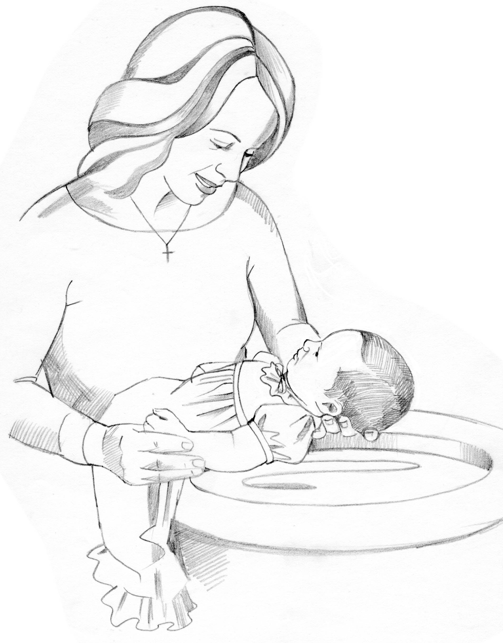
WE WELCOME INTO GOD’S FAMILY through sacrament of Holy Baptism on Sunday, April 6, 2025, at the 10:30 am service, Julia Lynn Rieman, daughter of Collin & Jacquelyn (nee: Becker) Rieman. Julia was born in Toledo, OH on September 15, 2024. The sponsors for Julia are Ginny Mowry & Carson Rieman. Proud grandparents are: Kendall & Lisa Rieman.
April 6, 2025 – April 13, 2025
Sunday the  6th | 8:00 am ~ Holy Communion Worship  9:15 am ~ Sunday School  9:15 am ~ Women’s Board Meeting  10:30 am ~ Holy Communion\  Worship/baptism/Rieman
Monday the 7th | 6:00 pm ~ Women’s Bible Study
Tuesday the 8th | 1:00 pm ~ Pericope Meeting  7:00 pm ~ Property Board Meeting
Wednesday the 9th | 12:00 pm ~ Community Lenten Luncheon @ 1st UMC  6:00 pm ~ Youth Choir practice  7:00 pm ~ Midweek Lenten Service @ St. Paul
Thursday the 10th | REFLECTOR DEADLINE / noon  5:00 pm ~ Evangelism/Social Board Meeting  6:00 pm ~ Worship Board Meeting  7:00 pm ~ Church Council  7:00 pm – 8:00 pm ~ Al-Anon Meeting  8:00 pm ~ AA Meeting
Friday the 11th

Saturday the 12th | 8:00 am – 9:30 am ~ Men’s Bible Study  9:00 am – 2:00 pm ~ Call Committee Worship  5:00 pm ~ Holy Communion Service
Sunday the  13th | 8:00 am ~ Holy Communion Worship  9:15 am ~ Sunday School  10:30 am ~ Holy Communion Worship  6:30 pm ~ CCYG
* * * * * * * * * * * * * * * * * * * * * * * *
LENTEN MIDWEEK WEDNESDAY DEVOTIONS!
2025 Lenten Series

Wednesdays @ 7:00 pm @ St. Paul Lutheran Church

Wednesday, April 9, 2025: The Second Table as Lent
The Second Table of the 10 Commandments are number 4-10 and are an explanation of the First Table, a living out of the First Table.

* * * * * * * * * * * * * * * * * * * * * * * *

Clyde Area Ministerial Association
Community Lenten Luncheons Schedule

Wednesdays at noon
All lunches will be taking place at
1st United Methodist Church (Clyde)

THE STATIONS OF THE CROSS

Wednesday, April 9, 2025
“Stations 10 – 12” ~ Jesus is crucified; Jesus promises His kingdom to the repentant thief; Jesus entrusts Mary and John to each other.

Presented by Rev. Tim Hubert
Meal by St. Paul Lutheran Church

* * * * * * * * * * * * * * * * * * * * * * *

COMMUNITY GOOD FRIDAY SERVICE

Friday, April 18, 2025 held at
Clyde Christian Church, 206 South Main Street, Clyde
@ NOON

(no lunch)

“Stations 13 & 14” ~ Jesus dies on the cross and Jesus is laid in the tomb.

Presented by Rev. Chuck Butcher
* * * * * * * * * * * * * * * * * * * * * * *


His name is Crew Dearth, he was just baptized last month at St Paul, his first birthday is this coming Saturday, March 29, 2025. He was recently diagnosed with Liver Cancer.

At this time the plan is that he will be having 3 months of chemotherapy, then a liver transplant, then more chemotherapy. They have created a Facebook page, it's called Crew's Fight Club, to share his story & gather all the prayers they can. Please pray for
Crew & his family.

* * * * * * * * * * * * * * * * * * * * * * * *

* * * * * * * * * * * * * * * * * * * * * * * *



It’s time for the Easter Bake Sale. This year we would like to offer frozen homemade soups to the offerings. Get your recipes for your favorite baked goods, candy and freezable soups to share with fellow parishioners. There will be freezer containers available on the back counter in the kitchen. Please have your donations in the kitchen by 5:00 pm on Friday, April 18, 2025. The soup can go in the freezer outside of the kitchen. The sale will start on Saturday, April 19, 2025, and end after 10:30 am Easter Sunday service. The sale is by donation and there will be a box on the table for your donations. This Easter Soup and Bake Sale helps St. Paul Women to support our many missions. Thanks for your help!
Brenda Sieger
* * * * * * * * * * * * * * * * * * * * * * * *


REFLECTOR DEADLINE !

Due to additional duties in the church office during HOLY WEEK the DEADLINE TO GET ARTICLES IN THE NEXT “REFLECTOR” is Thursday, April 10, 2025, at noon!! Thank you for your cooperation!!
* * * * * * * * * * * * * * * * * * * * * * * *


CALL COMMITTEE NEEDS YOUR HELP:
ALL adult members of St. Paul are invited to a Congregational Workshop on Saturday, APRIL 12, 2025. The workshop will begin at 9:00 am in the Parish hall and end at 2:00 pm. Lunch will be served by the Women of the Church.

The purpose of this workshop is to assist the Call Committee in developing a profile of the St. Paul community. We will assess our strengths, acknowledge our growth areas, and heal from past hurts. Together we will form a refined vision of our congregation - who we are, and who we want to be. Please prayerfully consider attending! Everyone has unique insights, ideas, and experiences to share.
* * * * * * * * * * * * * * * * * * * * * * * *


Mt. Carmel
United Methodist Church
(corner of County Roads 177 & 183, Clyde)

Saturday, April 12, 2025
9:00 am – 3:00 pm

Free Admission
Lots Of Crafts – Bake Sale – Lunch Stand & Homemade Pies

Craft Tables Available
Contact: Sharon Baxter 419-603-3188

* * * * * * * * * * * * * * * * * * * * * * * *


We offer many different ways to donate to St Paul Lutheran Church. The following QR code is the latest way. It can be used to direct you to St. Paul Lutheran Church’s electronic giving sign up page. You can always give using the church envelopes, the link on St Paul’s website at stpaulclyde.org, or donate by texting Donate/Donations to 844-440-0253 as well. Thank you for your continued support!

8:00 a.m. Service

COMPUTER TECH: Matt Woodland

READER: Jane Hilton

USHERS: Kevin Larkins
Michelle Larkins
Brenda Sieger
Jim Sieger

* * * * * * * * * * * * * * * * * * * * * * * *

The Rev. Dr. Tim Hubert Phone: 217-778-8017

Office Manager – Stephanie Stull Phone: 419-547-9225

Clerical Secretary – Sherry Bouyack Phone: 419-547-9225

Custodian – Terry Langham Phone: 419-547-9225

Treasurer – Jim Shull Phone: 419-355-6499

P & W Leader – Brian Farrar Phone: 419-271-3085

Organists
Linda Thorbahn
Mary Ellen Wollenslegel

http://www.stpaulclyde.org

* * * * * * * * * * * * * * * * * * * * * * * *
OUR STEWARDSHIP Totals for Year-to-Date 2025

Worship Attendance for weekend of March 29 & 30, 2025 141

Income from January – February 28, 2025 $ 45,859.75
Expense for January – February 28, 2025 $ 62,379.75
Shortage for January – February 28, 2025 $ 16,529.00

Fourth Wednesday Lenten Worship Attendance ~ April 2, 2025 23
Fourth Lenten Wednesday Midweek Giving $ 180.00

