St. Paul Lutheran Church
147 West Forest Street
Clyde, OH

Fourth Sunday of Easter
Contemporary Service
Sunday, May 11, 2025
10:30 am

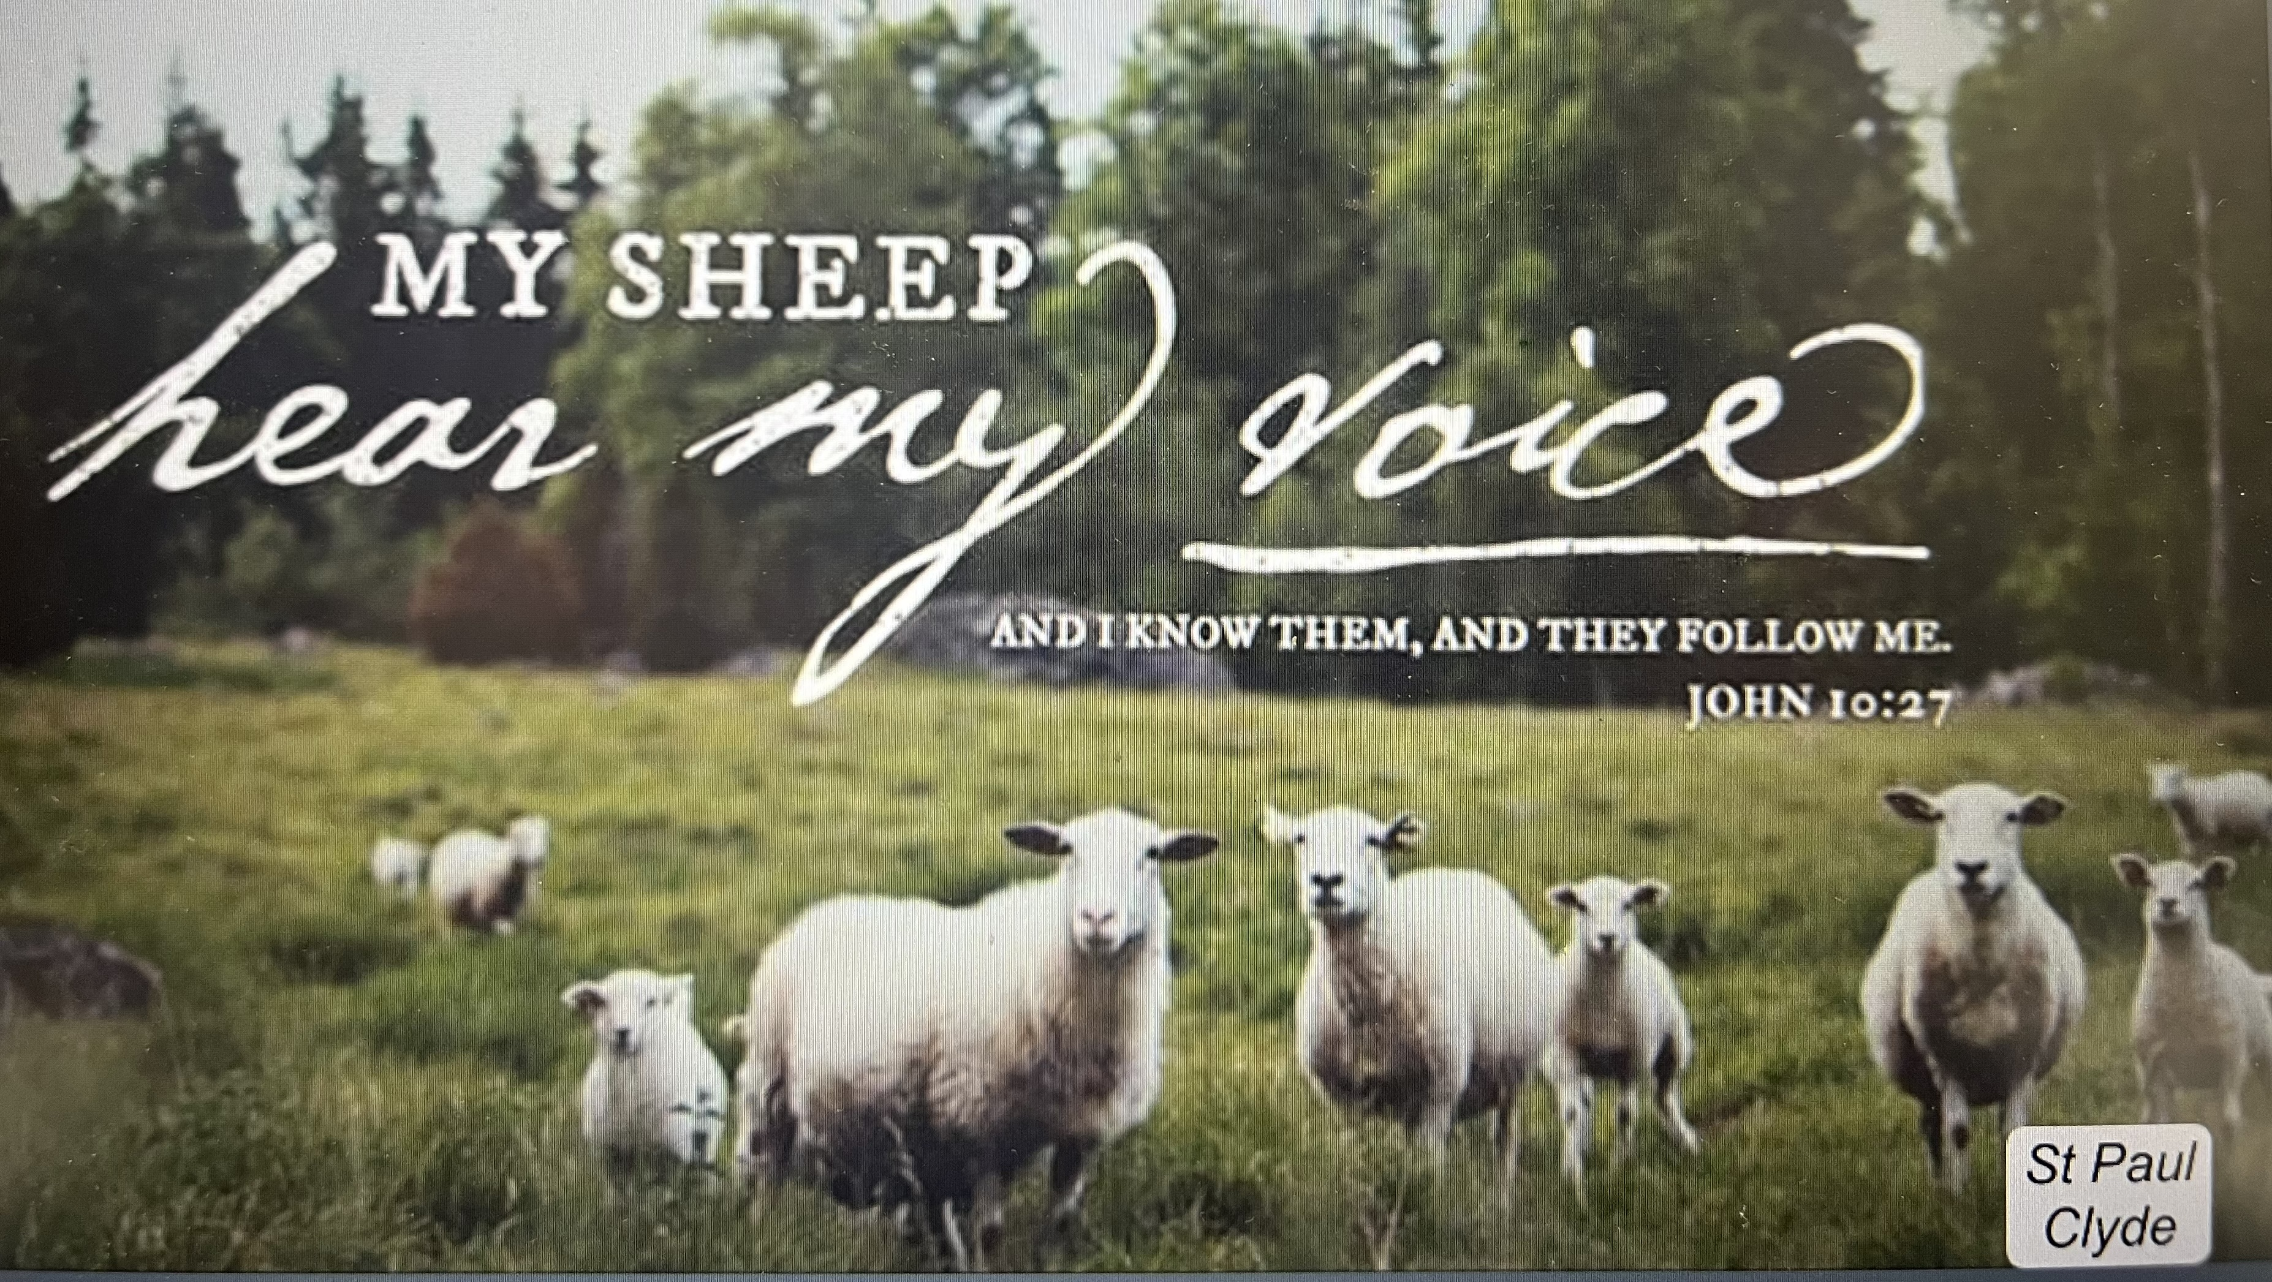

Opening Song
“The Lion and the Lamb” by Big Daddy Weave

Welcome/Announcements

Children’s Time

Confession & Forgiveness
Worship Songs
“This is Amazing Grace” by Chris Tomlin
“Hosanna” by Hillsong Worship

Scripture Reading

Sermon
“My Sheep”
based on John 10:22-30
The Rev. Dr. Tim Hubert

Prayers
for the sick and those in need:

Ron
Hazel
Betty
Tim
Diane
Toni
Crew
Ryker
Denise
Rebecca
Sue
Bill
Larry
Linda
Ed
DEPLOYED
Kyle

Words of Institution

Holy Communion
“Run to the Father” by Cody Carnes

The Lord’s Prayer

Closing Song
“Holy Forever” by Ce Ce Williams

Parting Blessing
Go in peace. Serve the Lord.
Thanks be to God.

Post – Service Music

* * * * * * * * * * * * * * * * * * * * * * * *


Friends, we welcome you in the name of the one God who has defeated death forever by raising Jesus from the tomb. We too now walk in new life.

* * * * * * * * * * * * * * * * * * * * * * * *
THE ALTAR FLOWERS are given to the glory of God in appreciation of all the amazing Sunday School/Catechism teachers who dedicate their time to help children learn about Jesus.
* * * * * * * * * * * * * * * * * * * * * * * *


WE EXTEND OUR DEEPEST SYMPATHY AND
PRAYERS to the family and friends of:

Donald G. Tornow, passed away on Tuesday, April 29, 2025, at the age of 86 following a battle with cancer

And to the family & friends of:

The Rev. Lance Franke passed away on Thursday, May 8, 2025.

* * * * * * * * * * * * * * * * * * * * * * *


WE EXTEND CONGRATULATIONS TO:

Brody & Brittany (nee: Shetzer) Fultz on the birth of a son, Booker Leland Fultz, born on Tuesday, April 8, 2025, in Bellevue, OH. Booker was also welcomed by proud grandparents, Joe & Connie Shetzer.
May 11, 2025 – May 18, 2025

Sunday the  11th | 8:00 am ~ Holy Communion Worship  9:15 am ~ Sunday School  10:30 am ~ Holy Communion Worship  7:00 pm ~ Baccalaureate 1st UMC
Monday the 12th

Tuesday the 13th | 9:00 am ~ Kitchen Clean Up  1:00 pm ~ Pericope Meeting  6:00 pm ~ Property Board Meeting  7:00 pm ~ Stewardship/Finance Board Meeting
Wednesday the 14th | 6:00 pm ~ Women’s Bible Study
Thursday the 15th | REFLECTOR DEADLINE / noon  Noon – 6:00 pm ~ Bloodmobile @ St. Paul  7:00 pm ~ Church Council  7:00 pm – 8:00 pm ~ Al-Anon Meeting  8:00 pm ~ AA Meeting
Friday the 16th

Saturday the 17th | 8:00 am – 9:30 am ~ Men’s Bible Study  5:00 pm ~ Holy Communion Service
Sunday the  18th | 8:00 am ~ Holy Communion Worship  9:15 am ~ Sunday School/last day  10:30 am ~ Holy Communion  Noon ~ 80+ Birthday Luncheon
FOUR SCORE AND MORE
BIRTHDAY BASH
The “Four Score and More Birthday” Luncheon will be held on Sunday, May 18, 2025, following the 10:30 am service IN THE PARISH HALL. The Worship Board is planning to honor those St. Paul members who are 80 years or older. It is our way of showing them they are still a very important part of our congregation. The celebration will be for those having birthdays during the months of January – December 2025. Those being honored are:

Patsy Aldrich March 17 Mari Lou Miller December 3
Calvin Anstead January 8 Robert Miller September 10
Shirley Anstead January 1 Willard Miller December 29
Donna Avers December 20 Dot Mowry June 26
Kenneth Avers April 29 Edward Noftz August 13
Carolyn Bannister October 5 Richard O’Donnell January 2
Ralph Bannister December 26 Florence Pocock September 4
Carolyn Billings October 13 Jeanette Pumphrey Sept. 21
Thelma Blair January 7 Dallas Rakes December 11
Gerald Bogner October 4 Jeanette Ricker September 7
Tina Bogner June 29 Kathryn Rosen March 31
Larry Bower October 22 Gene Ross December 21
Beverly Bush March 6 Sandra Ross February 24
Pari Carter June 27 Dennis Scheck December 31
Naomi Conley January 31 Betty Scheer October 17
Diane Dagg August 7 Gene Schwochow May 11
Nancy Dagg February 2 Gary Schwochow January 18
William Dagg May 21 Ralph Shetzer February 6
James Duskin August 22 Gege Smith October 13
Sharon Duskin October 14 Norwood ‘Bud’ Smith April 8
Donald Franks November 8 Kathryn Spence March 19
Fred Gesell November 9 Ed Stout April 13
Barb Gosnell September 5 Sue Stout May 19
Gerry Gosnell November 10 Marlene Tornow January 13
Sandy Gray January 14 Tina Walker November 26
Judy Jones December 4 Marc Wayland-Smith June 8
Janet Kauble January 26 Yvonne Wayland-Smith Sept. 10
Robert Kessler June 6 Carlos Weiker May 27
Sandy Kessler July 26 Joyce Weiker December 7
Shirley Kuhn October 1 Gwen Wilson November 16
LaVerde Kuns December 23 Jim Wilson January 6
Norbert Mayer June 5 Joanne Wise August 10
Jill Wott February 2

The entire St. Paul congregation will be wishing them a very Happy Birthday on that weekend and all of God’s blessings.
* * * * * * * * * * * * * * * * * * * * * * *


There will be a special breakfast 🥞🍳 served for Mother's Day on Sunday, May 11, 2025. Bring Mom to St. Paul's parish hall for a special treat to start her day. She won't have to cook or clean up! What could be better than that!

* * * * * * * * * * * * * * * * * * * * * * *


The Women of St. Paul are planning a CLEANING UP DAY for the kitchen on Tuesday, May 13, 2025, at 9 am. Any help would be appreciated. We have a couple of men who will be helping us, so any men are also invited to help. Hope to see you then!
* * * * * * * * * * * * * * * * * * * * * * *


If anyone has the time and the interest in helping with maintaining and upkeeping the landscaping around the church, parish hall and courtyard — help is needed!

Questions?? Contact:
Sandy Kessler: 567-201-5053

Volunteer now! With teamwork we can accomplish spring cleanup and summer & fall maintenance. Thank you!

* * * * * * * * * * * * * * * * * * * * * * * *


We offer many different ways to donate to St Paul Lutheran Church. The following QR code is the latest way. It can be used to direct you to St. Paul Lutheran Church’s electronic giving sign up page. You can always give using the church envelopes, the link on St Paul’s website at stpaulclyde.org, or donate by texting Donate/Donations to 844-440-0253 as well. Thank you for your continued support!

Time to roll up your sleeves.

St. Paul Lutheran Church
Is sponsoring an American Red Cross Bloodmobile for the Clyde Community on:

Thursday, May 15, 2025

12 noon - 6:00 PM

at
St. Paul Lutheran Church
147 West Forest Street
Clyde

The need is critical.
Won’t you please consider volunteering to become a blood donor
on Thursday, May 15, 2025?

Call: Red Cross 1-800-733-2767 to schedule an appointment or
Visit: redcrossblood.org and enter code: STPAULCLYDE

GIVE BLOOD! ! !
GET HOMEMADE COOKIES! !

* * * * * * * * * * * * * * * * * * * * * * *



Sunday, May 11, 2025
* * * * * * * * * * * * * * * * * * * * * * * *


ANYONE who will be graduating from high school or college, please contact the church office, 419-547-9225, with the information of which high school or college with major by Thursday, May 15, 2025, before noon. Thank you for your cooperation! ! !

* * * * * * * * * * * * * * * * * * * * * * * *



Saturday, May 17, 2025

10:30 am Service
ACOLYTE:

USHERS: DeAnn Krauss
Christina Lowe
Tony Paradiso
Ada Williams

COUNTERS: Christine Potts
Brandis Stout

NURSERY WORKER: Lisa Rieman

* * * * * * * * * * * * * * * * * * * * * * * *

The Rev. Dr. Tim Hubert Phone: 217-778-8017

Office Manager – Stephanie Stull Phone: 419-547-9225

Clerical Secretary – Sherry Bouyack Phone: 419-547-9225

Custodian – Terry Langham Phone: 419-547-9225

Treasurer – Jim Shull Phone: 419-355-6499

P & W Leader – Brian Farrar Phone: 419-271-3085

http://www.stpaulclyde.org

* * * * * * * * * * * * * * * * * * * * * * * *
OUR STEWARDSHIP Totals for Year-to-Date 2025

Worship Attendance for weekend of May 3 & 4, 2025 193

Income from January – March 31, 2025 $ 79,687.15
Expense for January – March 31, 2025 $ 86,035.60
Shortage for January – March 31, 2025 $ 7,750.1

