Sixth Sunday of Easter
ELW Holy Communion
Traditional Service
Sunday, May 25, 2025
8:00 am

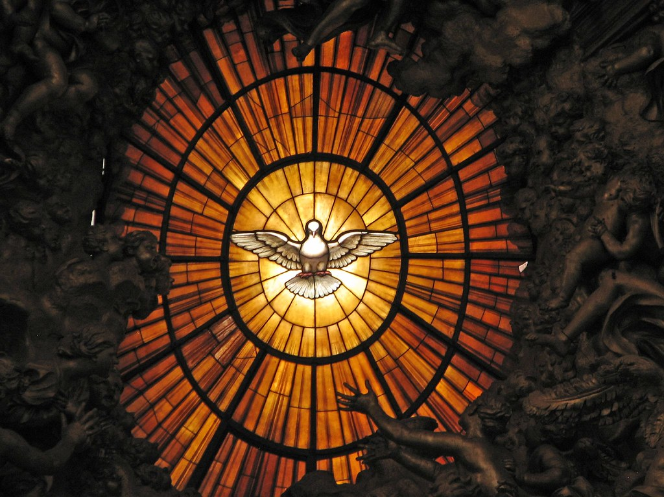

ST. PAUL LUTHERAN CHURCH
147 West Forest Street
Clyde, Ohio

Sixth Sunday of Easter

May 25, 2025

8:00 am

Holy Communion ~ Setting Four

* = those who are able may stand
Song numbers with “BB” are from the “The Best of the Best” songbook

Prelude

Bell & Announcements

*Confession & Forgiveness Pg. 94
P: In the name of the Father,
and of the ☩ Son,
and of the Holy Spirit.
C: Amen.

P: God of all mercy and consolation, come to the help of your people, turning us from our sin to live for you alone. Give us the power of your Holy Spirit that we may confess our sin, receive your forgiveness and grow into the fullness of Jesus Christ, our Savior and Lord.
C: Amen.

P: Let us confess our sin in the presence of God and of one another.

P: Most merciful God,
C: we confess that we are captive to sin and cannot free ourselves. We have sinned against you in thought, word, and deed, by what we have done and by what we have left undone. We have not loved you with our whole heart; we have not loved our neighbors as ourselves. For the sake of your Son, Jesus Christ, have mercy on us. Forgive us, renew us, and lead us, so that we may delight in your will and walk in your ways, to the glory of your holy name. Amen.

P: In the mercy of almighty God, Jesus Christ was given to die for us, and for his sake God forgives us all our sins. As a called and ordained minister of the church of Christ, and by his authority, I therefore declare to you the entire forgiveness of all your sins, in the name of the Father, and of the ☩ Son, and of the Holy Spirit.
C: Amen.

*The Hymn “Eternal Father, Strong to Save” No. 756

*The Apostolic Greeting Pg. 147
P: The grace of our Lord Jesus Christ, the love of God, and the communion of the Holy Spirit be with you all.
C: And also, with you.

*The Kyrie Pg. 147
P: In peace, let us pray to the Lord.
C: Lord, have mercy.

P: For the peace from above, and for our salvation, let us pray to the Lord.
C: Lord, have mercy.

P: For the peace of the whole world, for the well-being of the church of God, and for the unity of all, let us pray to the Lord.
C: Lord, have mercy.

P: For this holy house, and for all who offer here their worship and praise, let us pray to the Lord.
C: Lord, have mercy.

P: Help, save, comfort, and defend us gracious Lord.
C: Amen.

The Hymn of Praise Pg. 149

Refrain
P: This is the feast of victory for our God. Alleluia.

1. Worthy is Christ, the Lamb who was slain, whose blood set us free to be people of God. Power and riches and wisdom and strength, and honor and blessing and glory are his.

Refrain
This is the feast of victory for our God. Alleluia.

2. Sing with all the people of God and join in the hymn of all creation: Blessing and honor and glory and might be to God and the Lamb forever. Amen.

Refrain
This is the feast of victory for our God, for the Lamb who was slain has begun his reign. Alleluia. Alleluia.

The Prayer of the Day (in unison)
O God, all good things can come from You alone; generously consider then our humble prayers. Inspire us to consider what is true, and direct us to accomplish what is right; through Jesus Christ, Your Son, our Lord. He lives and reigns with You and the Holy Spirit, one God, now and forever. Amen.

The First Lesson ~ Acts 16:9-15
⁹A vision appeared to Paul in the night: a man of Macedonia was standing there, urging him and saying, “Come over to Macedonia and help us.” ¹⁰And when Paul had seen the vision, immediately we sought to go on into Macedonia, concluding that God had called us to preach the gospel to them. ¹¹So, setting sail from Troas, we made a direct voyage to Samothrace, and the following day to Neapolis, ¹²and from there to Philippi, which is a leading city of the district of Macedonia and a Roman colony. We remained in this city some days. ¹³And on the Sabbath day we went outside the gate to the riverside, where we supposed there was a place of prayer, and we sat down and spoke to the women who had come together. ¹⁴One who heard us was a woman named Lydia, from the city of Thyatira, a seller of purple goods, who was a worshiper of God. The Lord opened her heart to pay attention to what was said by Paul. ¹⁵And after she was baptized, and her household as well, she urged us, saying, “If you have judged me to be faithful to the Lord, come to my house and stay.” And she prevailed upon us.

L: The Word of the Lord.
C: Thanks be to God.

Psalm 67
¹May God be merciful to us and bless us, show us the light of His countenance and come to us.

²Let Your ways be known upon earth, Your saving health among all nations.

³Let the peoples praise You, O God; let all the peoples praise You.

⁴Let the nations be glad and sing for joy, for You judge the peoples with equity and guide all the nations upon earth.

⁵Let the peoples praise You, O God; let all the peoples praise You.

⁶The earth has brought forth her increase; may God, our own God, give us His blessing.

⁷May God give us His blessing, and may all the ends of the earth stand in awe of Him.

L: Here ends the reading of the Psalm.
C: Thanks be to God.

The Second Lesson ~ Revelation 21:9-14, 21-27
⁹Then came one of the seven angels who had the seven bowls full of the seven last plagues and spoke to me, saying, “Come, I will show you the Bride, the wife of the Lamb.” ¹⁰And he carried me away in the Spirit to a great, high mountain, and showed me the holy city Jerusalem coming down out of heaven from God, ¹¹having the glory of God, its radiance like a most rare jewel, like a jasper, clear as crystal. ¹²It had a great, high wall, with twelve gates, and at the gates twelve angels, and on the gates the names of the twelve tribes of the sons of Israel were inscribed — ¹³on the east three gates, on the north three gates, on the south three gates, and on the west three gates. ¹⁴And the wall of the city had twelve foundations, and on them were the twelve names of the twelve apostles of the Lamb. ²¹And the twelve gates were twelve pearls, each of the gates made of a single pearl, and the street of the city was pure gold, like transparent glass. ²²And I saw no temple in the city, for its temple is the Lord God the Almighty and the Lamb. ²³And the city has no need of sun or moon to shine on it, for the glory of God gives it light, and its lamp is the Lamb. ²⁴By its light will the nations walk, and the kings of the earth will bring their glory into it, ²⁵and its gates will never be shut by day — and there will be no night there. ²⁶They will bring into it the glory and the honor of the nations. ²⁷But nothing unclean will ever enter it, nor anyone who does what is detestable or false, but only those who are written in the Lamb’s book of life.

L: The Word of the Lord.
C: Thanks be to God.

*The “Gospel Acclamation” Pg. 151
Alleluia. Lord, to Whom shall we go? You have the words of eternal life. Alleluia.

P: The Holy Gospel according to St. John, the 16th chapter.
C: Glory to You, O Lord.

*The Gospel ~ John 16:23-33
²³{Jesus said to His disciples,} “In that day you will ask nothing of Me. Truly, truly, I say to you, whatever you ask of the Father in My name, He will give it to you. ²⁴Until now you have asked nothing in My name. Ask, and you will receive, that your joy may be full. ²⁵I have said these things to you in figures of speech. The hour is coming when I will no longer speak to you in figures of speech but will tell you plainly about the Father. ²⁶In that day you will ask in My name, and I do not say to you that I will ask the Father on your behalf; ²⁷for the Father Himself loves you, because you have loved Me and have believed that I came from God. ²⁸I came from the Father and have come into the world, and now I am leaving the world and going to the Father.” ²⁹His disciples said, “Ah, now you are speaking plainly and not using figurative speech! ³⁰Now we know that you know all things and do not need anyone to question you; this is why we believe that you came from God.” ³¹Jesus answered them, “Do you now believe? ³²Behold, the hour is coming, indeed it has come, when you will be scattered, each to his own home, and will leave me alone. Yet I am not alone, for the Father is with me. ³³I have said these things to you, that in Me you may have peace. In the world you will have tribulation. But take heart; I have overcome the world.”

P: The Gospel of the Lord.
C: Praise to You, O Christ.

Sermon “Take Heart!”
based on John 16:23-33
The Rev. Dr. Tim Hubert

*Song “What a Friend We Have in Jesus” No. 742

*Prayers of Intercession
Let us pray to our risen Savior on behalf of the Church, the world, and one another.

A brief silence

Lord Jesus, blessed Bridegroom, thank You for making us Your beloved Bride, even giving Your life for us! Thank You for making Your Church, now troubled by evils within and without, the glorious New Jerusalem! Thank You for promising us joy in our fellowship with You and one another!

Lord, in Your mercy, hear our prayer.

Give Your Church the grace and comfort of the Holy Spirit. Grant that, in a world shadowed by suffering, sorrow and sin, it proclaims Your promise of joy and shares the blessings of Your love.

Lord, in Your mercy, hear our prayer.

Confessing Your name brings great trouble to many Christians around the world. Assure them that You have overcome the world. Grant them such deep joy that their enemies are astonished, and repent.

Lord, in Your mercy, hear our prayer.

Let the Spirit fill every heart in this congregation with joy. Make that joy blossom into heartfelt worship, loving service, truthful witness, deep prayer, and loving fellowship. Use us to draw our friends and neighbors closer to You. Use us to shed the light of Your love and joy in the darkest corners of their lives. We pray for the LCMC & NALC, area congregations and today for First English Lutheran Church of Mansfield, Ohio and for Reverend Jay Jackson.

Lord, in Your mercy, hear our prayer.

Give Your joyous presence to our teenagers. It is easy to be preoccupied with school, sports, jobs, and friends. It can be hard to endure teasing or scorn because of faith in You. Fill them with Your love so they may share it and be a blessing to those around them.

Lord, in Your mercy, hear our prayer.

This world is filled with trouble, yet You have overcome the world and defeated the powers of sin, evil, and death. We pray for our world; for its leaders, for all people, especially those who are most burdened by the sorrows and horrors of human malice and natural calamity. Bestow Your Holy Spirit upon us all: the Spirit of wisdom, understanding, counsel and might, the Spirit of knowledge and fear of the Lord; and most of all, the Spirit of joy in Your presence.

Lord, in Your mercy, hear our prayer.

Grant healing and hope to all who suffer in body, mind or spirit, including:

Vickie
Ron
Hazel
Call Committee
Betty
Tim
Toni
Crew
Ryker
Denise
Rebecca
Sue
Bill
Larry
Linda
Ed
Joanne

DEPLOYED
Kyle

Be gracious and merciful to them, and to all who care for them. Restore the bonds of fellowship and affection that have been strained or sundered by suffering and adversity and give us all the joy of your saving help.

Lord, in Your mercy, hear our prayer.

Lord Jesus Christ, You have overcome the world, the devil, and our sins. Thank You for delivering our beloved dead from those powers. Let the fullness of Your joy touch and heal hearts still shadowed by grief. Help us all to live in faith and hope, love and kindness, gentleness and peace, self-control and patience. Give us a foretaste of that joy that You promise forever to all whom You love.

Lord, in Your mercy, hear our prayer.

Grant to us all that is in accordance with Your will, dear Jesus, and accomplish Your salvation among us; for You are risen from the dead and dwell in majesty with Your Father and the Holy Spirit, one God, now and forever.

Amen.

*THE APOSTLES’ CREED (back cover of hymnal)
I believe in God, the Father almighty,
creator of heaven and earth.

I believe in Jesus Christ, His only Son, our Lord,
He was conceived by the Holy Spirit,
born of the virgin Mary,
suffered under Pontius Pilate,
was crucified, died, and was buried;
he descended into hell.
On the third day he rose again;
he ascended into heaven,
he is seated at the right hand of the Father,
and he will come to judge the living and the dead.

I believe in the Holy Spirit,
the holy catholic church,
the communion of saints,
the forgiveness of sins,
the resurrection of the body,
and the life everlasting. Amen

*The Peace of the Lord Pg. 152
P: The peace of the Lord be with you.
C: And also, with you.

*The Passing of the Peace (please remain in place)

The Offering

*The Offering Prayer (#3)
Blessed are you, O God, maker of all things. Through your goodness you have blessed us with these gifts: our possessions. Use us, and what we have gathered, in feeding the world with your love, through the one who gave himself for us, Jesus Christ, our Savior and Lord. Amen.

*The Great Thanksgiving Pg. 152
P: The Lord be with you.
C: And also, with you.

P: Lift up your hearts.
C: We lift them to the Lord.

P: Let us give thanks to the Lord our God.
C: It is right to give our thanks and praise.

*The Proper Preface
P: It is indeed right, our duty and our joy, that we should at all times and in all places give thanks and praise to You, almighty and merciful God, for the glorious resurrection of our Savior Jesus Christ, the true Paschal Lamb Who gave Himself to take away our sin, Who in dying has destroyed death, and in rising has brought us to eternal life. And so, with Mary Magdalene and Peter and all the witnesses of the resurrection, with earth and sea and all their creatures, and with angels and archangels, cherubim and seraphim, we praise Your name and join their unending hymn:

*“Holy, Holy, Holy…” Pg. 153
Holy, holy, holy Lord,
God of power and might,
heav’n and earth are full of your glory.
Hosanna in the highest.
Blessed is he who comes in the name of the Lord.
Hosanna in the highest.

*The Words of Institution
In the night in which he was betrayed,
our Lord Jesus took bread, and gave thanks,
broke it, and gave it to his disciples, saying:

Take and eat; this is my body, given for you.
Do this for the remembrance of me.

Again, after supper, he took the cup, gave thanks,
and gave it for all to drink, saying:

This cup is the new covenant in my blood,
shed for you and for all people for the forgiveness of sin.
Do this for the remembrance of me.

*The “Lord’s Prayer” Pg. 154
P: Gathered into one by the Holy Spirit, let us pray as Jesus taught us.
Our Father, who art in heaven,
hallowed be thy name,
thy kingdom come,
thy will be done,
on earth as it is in heaven.

Give us this day our daily bread;
and forgive us our trespasses,
as we forgive those
who trespass against us;
and lead us not into temptation,
but deliver us from evil.
For thine is the kingdom,
and the power, and the glory,
forever and ever. Amen.

*Invitation to Communion Pg. 154
Come to the banquet, for all is now ready.

Holy Communion
All baptized believers in Jesus Christ as Lord are invited to receive communion today. Please follow the directions of the ushers. Children who have not yet received their “first communion” are also invited to come forward, to receive a blessing.

*The Post Communion Blessing
The body and blood…

*Prayer After Communion
P: Let us pray.
O God, we give You thanks that You have set before us this feast, the body and blood of You Son. By Your Spirit strengthen us to serve all in need and to give ourselves away as bread for the hungry, through Jesus Christ our Lord.
C: Amen.

*The Hymn “This Is My Song” No. 887

*The Benediction Pg. 155

*The Dismissal
L: Go in peace. . .
C: Thanks be to God.

The Postlude

* * * * * * * * * * * * * * * * * * * * * * * *
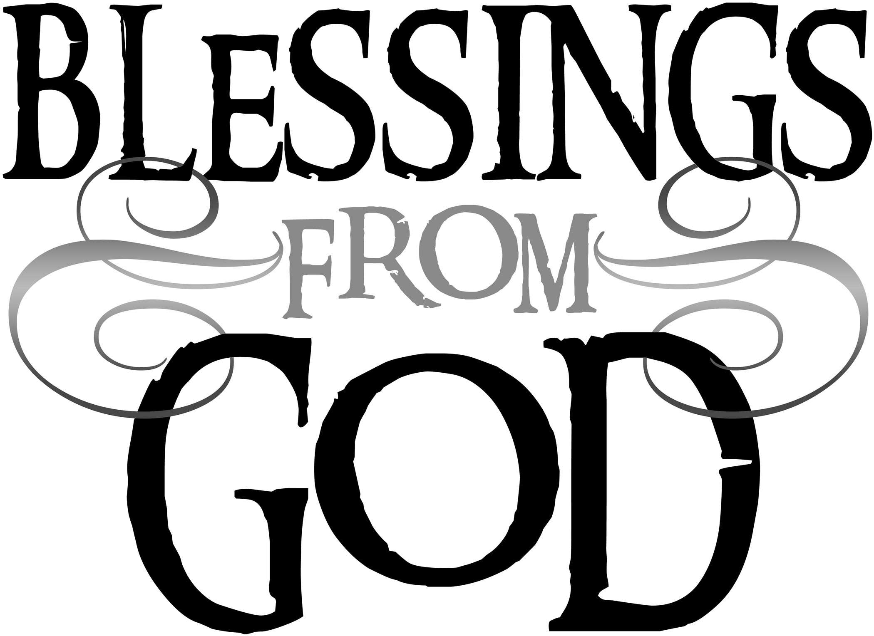
Friends, we welcome you in the name of the one God who has defeated death forever by raising Jesus from the tomb. We too now walk in new life.

* * * * * * * * * * * * * * * * * * * * * * * *

THE ALTAR FLOWERS are given to the glory of God in memory of our dad and mom, Herb & Margaret Bouyack.

* * * * * * * * * * * * * * * * * * * * * * * *

NURSERY WORKERS

Last day of supervised nursery class is Sunday, May 18, 2025. We will not have SUPERVISED nursery care during the summer months. We will start again in September with the start of Sunday School.
* * * * * * * * * * * * * * * * * * * * * * * *
DISHES NEED PICKED UP
There are dishes left in the parish hall kitchen from funeral dinners & special events. Please take time to stop and check the table in the parish hall and see if one could be the dish, casseroles, bowls or pans you are missing.
May 25, 2025 – June 1, 2025

Sunday the  25th | 8:00 am ~ Holy Communion Worship  9:15 am ~ Adult Sunday School  3:00 pm – 5:00 pm ~ Bunco
Monday the 26th

Tuesday the 27th | 1:00 pm ~ Pericope Meeting
Wednesday the 28th | 9:00 am ~ Quilt Ministry  6:00 pm ~ Women’s Bible Study
Thursday the 29th | 7:00 pm – 8:00 pm ~ Al-Anon Meeting  8:00 pm ~ AA Meeting
Friday the 30th

Saturday the 31st | 8:00 am – 9:30 am ~ Men’s Bible Study  10:30 am ~ 1st Communion Training  5:00 pm ~ Holy Communion Service
Sunday the  1st | 8:00 am ~ Holy Communion Worship  9:15 am ~ Adult Sunday School  9:15 am ~ Women’s Board Meeting  10:30 am ~ Holy Communion / 1st Communion
* * * * * * * * * * * * * * * * * * * * * * * *

READER’S SCHEDULE
JULY THROUGH DECEMBER 2025

Clip boards have been passed during church services in May for Scripture reader sign-ups involving services for Saturdays and 8AM Sundays. If you missed the clip boards, please contact Bev or Jane if:

- You want to be a NEW reader, or
- You want to CONTINUE to be a reader, or
- You have any special requests or need any accommodations

Please contact Bev or Jane with your information as soon as you can BUT no later than JUNE 9TH . Many thanks to all who have participated as a Scripture reader. You add much to our worship experience!!

Bev Mendoza 419-547-9151 Saturday services

Jane Hilton 419-547-7270 Sunday 8AM services

* * * * * * * * * * * * * * * * * * * * * * * *


We offer many different ways to donate to St Paul Lutheran Church. The following QR code is the latest way. It can be used to direct you to St. Paul Lutheran Church’s electronic giving sign up page. You can always give using the church envelopes, the link on St Paul’s website at stpaulclyde.org, or donate by texting Donate/Donations to 844-440-0253 as well. Thank you for your continued support!

8:00 am Service

COMPUTER TECH: Ashley Reed

READER: Diane Hurst

USHERS: Tim Billings
Deb Davenport
Tanner Davenport
Duane Kimmet

* * * * * * * * * * * * * * * * * * * * * * * *

The Rev. Dr. Tim Hubert Phone: 217-778-8017

Office Manager – Stephanie Stull Phone: 419-547-9225

Clerical Secretary – Sherry Bouyack Phone: 419-547-9225

Custodian – Terry Langham Phone: 419-547-9225

Treasurer – Jim Shull Phone: 419-355-6499

P & W Leader – Brian Farrar Phone: 419-271-3085

Organist
Mary Ellen Wollenslegel

http://www.stpaulclyde.org

* * * * * * * * * * * * * * * * * * * * * * * *
OUR STEWARDSHIP Totals for Year-to-Date 2025

Worship Attendance for weekend of May 17 & 18, 2025 146

Income from January – April 30, 2025 $ 103,899.98
Expense for January – April 30, 2025 $ 112,258.15
Shortage for January – April 30, 2025 $ - 8,358.17

