Fifth Sunday of Easter
Sunday, May 3, 2026
10:30 am

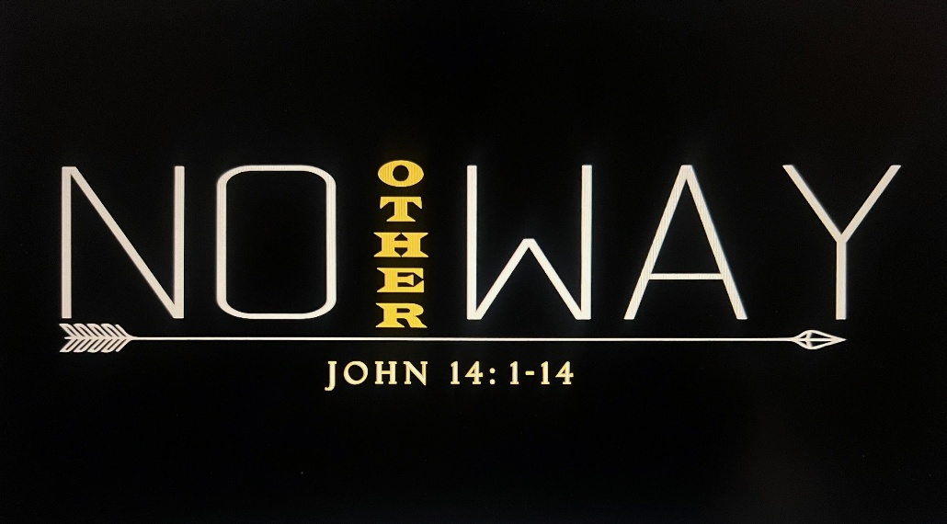

147 West Forest Street Clyde, Ohio
Opening Song
“The Way” by Pat Barrett
Welcome & Announcements
Confirmation

Knox Thomas Dearth
Trenton Paul Elfring
Zarek Robert Gibbs
Maggie Reese Howey
Kayla Nicole Reed
Luke Damon Runion
Confession & Forgiveness
Worship
“Goodness of God” by Bethel Music
Sermon
"No Other Way"
Luke 14: 1-14
Pastor Sam Dagg

Pastoral Prayer
Vickie Aldrich
Gwendolyn Baughn
Michelle Borodkin
Tim Cooper
Toni Dagg
Crew Dearth
Louie Duskin
Sharon Duskin
Pastor Gerry
John Glass
Becky Karr
Kris Larkins
Karen Nimms
Matt Pumphrey
Maverick Salazar
Sue Shull
Lindsay Sooy
Larry Sumner
Conner Whaley
Sandy Wott

Words of Institution
The Lord's prayer
Communion
(Song: "Mighty Name Of Jesus" by Hope Darst)
Closing Song
“The Blessing” by Elevation Worship
Benediction
Dismissal
P: Go in peace. Serve the Lord!
C: Thanks be to God!


* * * * * * * * * * * * * * * * * * * * * * * * * * * * * * * * * * * * * * * * * *
THE ALTAR FLOWERS are given to the glory of God In honor of Abigal Dendinger’s 10th birthday on Sunday, May 3rd, 2026.


* * * * * * * * * * * * * * * * * * * * * * * * * * * * * * * * * * * * * * * * *

In honor of our new members, cake will be served to everyone in the Parish Hall following the service today.

* * * * * * * * * * * * * * * * * * * * * * * * * * * * * * * * * * * * * * * * *

For Naomi Conley will be held Saturday, May 16, 2026. Graveside Service at 11am ~ McPherson Cemetery and
a luncheon at Noon ~ Parish Hall.
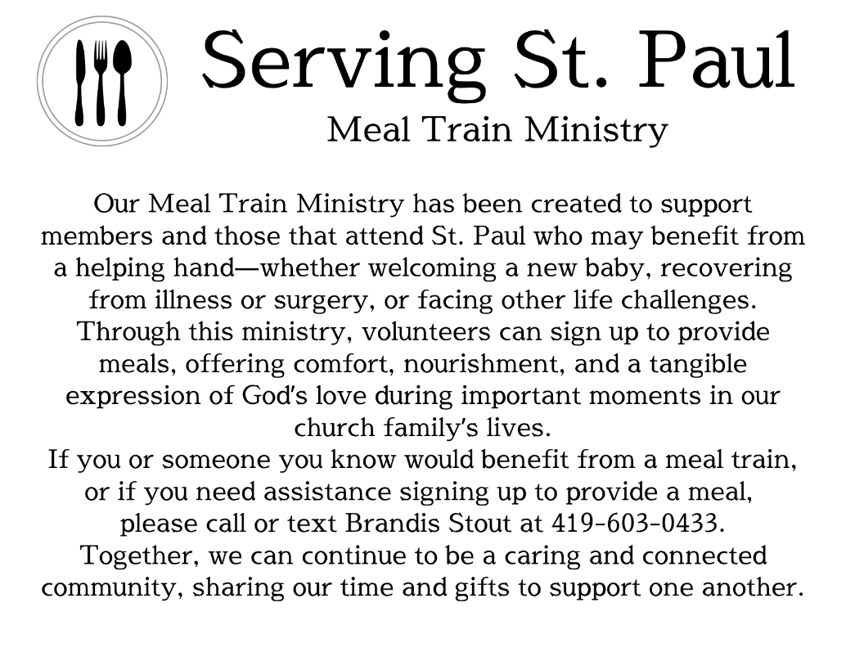
* * * * * * * * * * * * * * * * * * * * * * * * * * * * * * * * * * * * * * * * *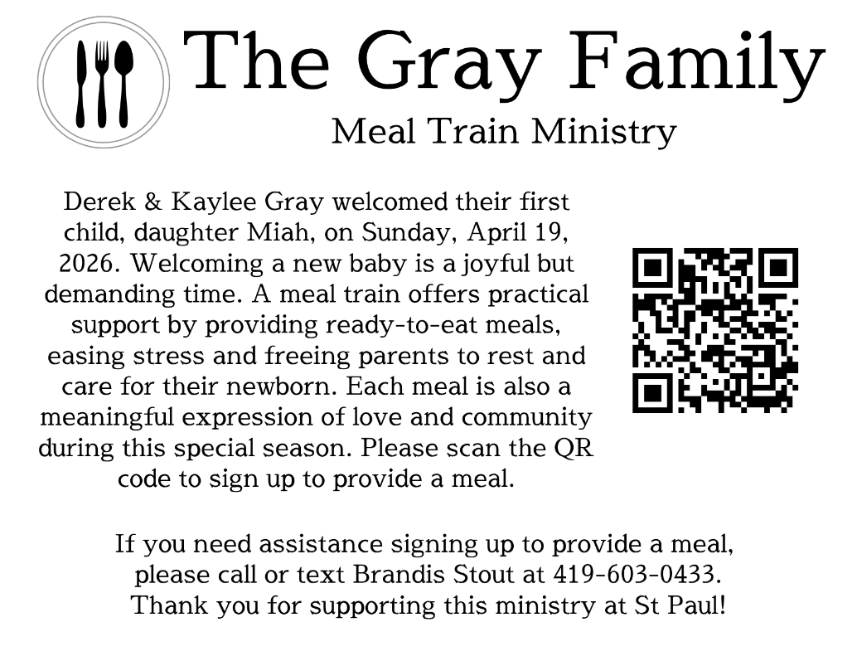


* * * * * * * * * * * * * * * * * * * * * * * * * * * * * * * * * * * * * * * * * *

Stella Alejandro
Alaura Anstead
Owen Cook
Harper Dearth
Knox Dearth
Danni Elfring
Stella Gibbs
Raiden Hayward
Benjamin Riggs
Zaiden Stacy
Blake Williams

We are grateful to the Stacy family for their kindness and grace concerning Zaiden’s absence from last week’s list.
* * * * * * * * * * * * * * * * * * * * * * * * * * * * * * * * * * * * * * * *

May 3, 2026 – May 10, 2026
Sunday the 3rd | 8:00 am ~ Worship  9:15 am ~ Sunday School  10:30 am ~ Worship & Confirmation  12:00 pm ~ Parish Hall Rental
Monday the 4th | 6:30 pm ~ Co-Ed Bible Study
Tuesday the 5th | 6:30pm ~ Men’s Bible Study  7:00 pm ~ Parish Ed & Youth Board Meeting
Wednesday the 6th | 6:00 pm ~ Women’s Bible Study
Thursday the 7th | 7:00 pm ~ Al-Anon Meeting  8:00 pm ~ AA Meeting
Friday the 8th
Saturday the 9th | 8:00 am ~ Men’s Bible Study  5:00 pm ~ Worship
Sunday the 10th | 8:00 am ~ Worship  9:15 am ~ Sunday School  10:30 am ~ Worship

Attendance for April 25-26, 2026 ~ 182

10:30 am Service
ACOLYTE: Stella Alejandro
Benny Riggs
USHERS: Gary Wott
Tom Billings
Keyli Billings
Steve Jess
COUNTERS: Sherry Frasher
Jennie McCoy
NURSERY WORKER: Emily Woodland
* * * * * * * * * * * * * * * * * * * * * * * * * * * * * * * * * * * *
Church Office Phone: 419-547-9225
Pastor Samuel Dagg Phone: 567-342-2137
pastor@stpaulclyde.org
Matt Woodland ~ Council President Phone: 419-603-0567
prez@stpaulclyde.org
Sherry Bouyack ~ Clerical Secretary Phone: 419-547-9225
fisec@stpaulclyde.org
Jim Shull ~ Treasurer Phone: 419-355-6499
treas@stpaulclyde.org
Brian Farrar ~ P & W Leader Phone: 419-271-3085
pwl@stpaulclyde.org
Ashley Reed ~ Assistant Secretary Phone: 419-547-9225 asst.sec@stpaulclyde.org
* * * * * * * * * * * * * * * * * * * * * * * * * * * * * * * * * * * * * * * * * * * * * * * * * * *


We offer many ways to donate to St Paul Lutheran Church. The above QR code is the latest way. It can be used to direct you to St. Paul Lutheran Church’s electronic giving sign up page. You can always give using the church envelopes, the link on St Paul’s website at stpaulclyde.org, or donate by texting Donate/Donations to 844-440-0253 as well. Thank you for your continued support!

