Fifth Sunday of Easter
Sunday, May 3, 2026
8:00 am

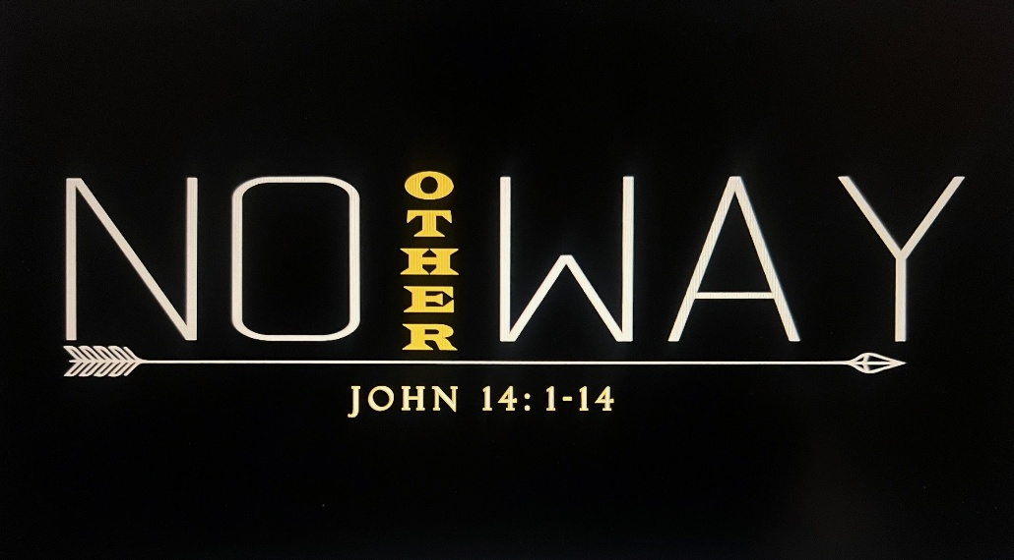

147 W. Forest Street Clyde, Ohio
Prelude, Bell & Announcements
Confession & Forgiveness Pg. 94
P: In the name of the Father, and of the ☩ Son, and of the Holy Spirit.
C: Amen.
P: God of all mercy and consolation, come to the help of your people, turning us from our sin to live for you alone. Give us the power of your Holy Spirit that we may confess our sin, receive your forgiveness and grow into the fullness of Jesus Christ, our Savior and Lord.
C: Amen.
P: Let us confess our sin in the presence of God and of one another.
P: Most merciful God,
C: we confess that we are captive to sin and cannot free ourselves. We have sinned against you in thought, word, and deed, by what we have done and by what we have left undone. We have not loved you with our whole heart; we have not loved our neighbors as ourselves. For the sake of your Son, Jesus Christ, have mercy on us. Forgive us, renew us, and lead us, so that we may delight in your will and walk in your ways, to the glory of your holy name. Amen.
P: God who is rich in mercy, loved us even when we were dead in sin, and made us alive together with Christ. By grace you have been saved. In the name of Jesus Christ, the entirety of your sins are forgiven. Almighty God strengthen you with power through the Holy Spirit, that Christ may live in your hearts through faith.
C: Amen.
Hymn “How Great Thou Art” #856
The Apostolic Greeting Pg. 147
P: The grace of our Lord Jesus Christ, the love of God, and the communion of the Holy Spirit be with you all.
C: And also with you.
The Kyrie Pg. 147
P: In peace, let us pray to the Lord.
C: Lord, have mercy.
P: For the peace from above, and for our salvation, let us pray to the Lord.
C: Lord, have mercy.
P: For the peace of the whole world, for the well-being of the church of God, and for the unity of all, let us pray to the Lord.
C: Lord, have mercy.
P: For this holy house, and for all who offer here their worship and praise, let us pray to the Lord.
C: Lord, have mercy.
P: Help, save, comfort, and defend us gracious Lord.
C: Amen.
The Hymn of Praise Pg. 149
P: This is the feast of victory for our God. Alleluia.
Worthy is Christ, the Lamb who was slain, whose blood set us free to be people of God. Power and riches and wisdom and strength, and honor and blessing and glory are his.
This is the feast of victory for our God. Alleluia.
Sing with all the people of God and join in the hymn of all creation: Blessing and honor and glory and might be to God and the Lamb forever. Amen.
This is the feast of victory for our God, for the Lamb who was slain has begun his reign. Alleluia. Alleluia.
The Prayer of the Day
O God, you make the minds of the faithful to be of one will. Grant that your people would love what you command and desire what you promise, that, among the manifold changes of this world, our hearts may be fixed where true joys are to be found; through your Son, Jesus Christ, our Lord, who lives and reigns with you and the Holy Spirit, one God, now and forever. Amen.
The First Reading: Acts 6:1-9; 7:2a, 51-60
¹Now in these days when the disciples were increasing in number, a complaint by the Hellenists arose against the Hebrews because their widows were being neglected in the daily distribution. ²And the twelve summoned the full number of the disciples and said, “It is not right that we should give up preaching the word of God to serve tables. ³Therefore, brothers, pick out from among you seven men of good repute, full of the Spirit and of wisdom, whom we will appoint to this duty. ⁴But we will devote ourselves to prayer and to the ministry of the word.” ⁵And what they said pleased the whole gathering, and they chose Stephen, a man full of faith and of the Holy Spirit, and Philip, and Prochorus, and Nicanor, and Timon, and Parmenas, and Nicolaus, a proselyte of Antioch. ⁶These they set before the apostles, and they prayed and laid their hands on them. ⁷And the word of God continued to increase, and the number of the disciples multiplied greatly in Jerusalem, and a great many of the priests became obedient to the faith. ⁸And Stephen, full of grace and power, was doing great wonders and signs among the people. ⁹Then some of those who belonged to the synagogue of the Freedmen (as it was called), and of the Cyrenians, and of the Alexandrians, and of those from Cilicia and Asia, rose up and disputed with Stephen.
^{2a} And Stephen said: ⁵¹“You stiff-necked people, uncircumcised in heart and ears, you always resist the Holy Spirit. As your fathers did, so do you. ⁵²Which of the prophets did your fathers not persecute? And they killed those who announced beforehand the coming of the Righteous One, whom you have now betrayed and murdered, ⁵³you who received the law as delivered by angels and did not keep it.” ⁵⁴Now when they heard these things they were enraged, and they ground their teeth at him. ⁵⁵But he, full of the Holy Spirit, gazed into heaven and saw the glory of God, and Jesus standing at the right hand of God. ⁵⁶And he said, “Behold, I see the heavens opened, and the Son of Man standing at the right hand of God.” ⁵⁷But they cried out with a loud voice and stopped their ears and rushed together at him. ⁵⁸Then they cast him out of the city and stoned him. And the witnesses laid down their garments at the feet of a young man named Saul. ⁵⁹And as they were stoning Stephen, he called out, “Lord Jesus, receive my spirit.” ⁶⁰And falling to his knees he cried out with a loud voice, “Lord, do not hold this sin against them.” And when he had said this, he fell asleep.
L: The Word of the Lord.
C: Thanks be to God.
Psalm 146
¹Praise the Lord! Praise the Lord, O my soul!
²I will praise the Lord as long as I live; I will sing praises to my God while I have my being.
³Put not your trust in princes, in a son of man, in whom there is no salvation.
⁴When his breath departs, he returns to the earth; on that very day his plans perish.
⁵Blessed is he whose help is the God of Jacob, whose hope is in the Lord his God,
⁶who made heaven and earth, the sea, and all that is in them, who keeps faith forever;
⁷who executes justice for the oppressed, who gives food to the hungry. The Lord sets the prisoners free;
⁸the Lord opens the eyes of the blind. The Lord lifts up those who are bowed down; the Lord loves the righteous.
⁹The Lord watches over the sojourners; he upholds the widow and the fatherless, but the way of the wicked he brings to ruin.
¹⁰The Lord will reign forever, your God, O Zion, to all generations. Praise the Lord!
L: Here ends the reading of the Psalm.
C: Thanks be to God.
The Second Reading: 1 Peter 2:2-10
²Like newborn infants, long for the pure spiritual milk, that by it you may grow up into salvation — ³if indeed you have tasted that the Lord is good. ⁴As you come to him, a living stone rejected by men but in the sight of God chosen and precious, ⁵you yourselves like living stones are being built up as a spiritual house, to be a holy priesthood, to offer spiritual sacrifices acceptable to God through Jesus Christ. ⁶For it stands in Scripture: “Behold, I am laying in Zion a stone, a cornerstone chosen and precious, and whoever believes in him will not be put to shame.” ⁷So the honor is for you who believe, but for those who do not believe, “The stone that the builders rejected has become the cornerstone,” ⁸and “A stone of stumbling, and a rock of offense.” They stumble because they disobey the word, as they were destined to do. ⁹But you are a chosen race, a royal priesthood, a holy nation, a people for his own possession, that you may proclaim the excellencies of him who called you out of darkness into his marvelous light. ¹⁰Once you were not a people, but now you are God’s people; once you had not received mercy, but now you have received mercy.
L: The Word of the Lord. C: Thanks be to God.
The Gospel Acclamation Pg. 151
Alleluia. Lord, to whom shall we go? You have the words of eternal life. Alleluia.
P: The Holy Gospel according to St. John, the 14th chapter.
C: Glory to You, O Lord.
The Gospel: John 14:1-14
¹{Jesus said,} “Let not your hearts be troubled. Believe in God; believe also in me. ²In my Father’s house are many rooms. If it were not so, would I have told you that I go to prepare a place for you? ³And if I go and prepare a place for you, I will come again and will take you to myself, that where I am you may be also. ⁴And you know the way to where I am going.” ⁵Thomas said to him, “Lord, we do not know where you are going. How can we know the way?” ⁶Jesus said to him, “I am the way, and the truth, and the life. No one comes to the Father except through me. ⁷If you had known me, you would have known my Father also. From now on you do know him and have seen him.” ⁸Philip said to him, “Lord, show us the Father, and it is enough for us.” ⁹Jesus said to him, “Have I been with you so long, and you still do not know me, Philip? Whoever has seen me has seen the Father. How can you say, ‘Show us the Father’? ¹⁰Do you not believe that I am in the Father and the Father is in me? The words that I say to you I do not speak on my own authority, but the Father who dwells in me does his works. ¹¹Believe me that I am in the Father and the Father is in me, or else believe on account of the works themselves. ¹²Truly, truly, I say to you, whoever believes in me will also do the works that I do; and greater works than these will he do, because I am going to the Father. ¹³Whatever you ask in my name, this I will do, that the Father may be glorified in the Son. ¹⁴If you ask me anything in my name, I will do it.”
P: The Gospel of the Lord.
C: Praise to You, O Christ.
Sermon:
"No Other Way"
Luke 14: 1-14
Pastor Sam Dagg
The Hymn “Beautiful Savior” #838
Prayers of Intercession
Vickie Aldrich
Gwendolyn Baughn
Michelle Borodkin
Tim Cooper
Toni Dagg
Crew Dearth
Louie Duskin
Sharon Duskin
Pastor Gerry
John Glass

Becky Karr
Kris Larkins
Karen Nimms
Matt Pumphrey
Maverick Salazar
Sue Shull
Lindsay Sooy
Larry Sumner
Conner Whaley
Sandy Wott

THE APOSTLES’ CREED (back cover of the hymnal)
The Peace of the Lord Pg. 152
P: The peace of the Lord be with you.
C: And also, with you.
The Passing of the Peace
The Offering
The Offering Prayer
Blessed are you, O God, maker of all things. Through your goodness you have blessed us with these gifts: our possessions. Use us, and what we have gathered, in feeding the world with your love, through the one who gave himself for us, Jesus Christ, our Savior and Lord. Amen.

The Great Thanksgiving Pg. 152
P: The Lord be with you.
C: And also, with you.
P: Lift up your hearts.
C: We lift them to the Lord.
P: Let us give thanks to the Lord our God.
C: It is right to give our thanks and praise.
The Proper Preface
P: It is indeed right, our duty and our joy, that we should at all times and in all places give thanks and praise to you, almighty and merciful God, for the glorious resurrection of our Savior Jesus Christ, the true Paschal Lamb who gave himself to take away our sin; who in dying has destroyed death, and in rising has brought us to eternal life. And so, with all the choirs of angels, with the church on earth and the hosts of heaven, we praise your name and join their unending hymn:
C: Holy, holy, holy Lord,
Lord God of power and might,
heav’n and earth are full of your glory.
Hosanna in the highest.
Blessed is he who comes in the name of the Lord.
Hosanna in the highest.
The Words of Institution
The Lord’s Prayer Pg. 154
P: Gathered into one by the Holy Spirit, let us pray as Jesus taught us.

C: Our Father, Who art in heaven, hallowed be Thy name, Thy kingdom come, Thy will be done, on earth as it is in heaven. Give us this day our daily bread; and forgive us our trespasses, as we forgive those who trespass against us; and lead us not into temptation, but deliver us from evil. For Thine is the kingdom, and the power, and the glory, forever and ever. Amen.
Invitation to Communion Pg. 154
P: Come to the banquet, for all is now ready.
Holy Communion
All baptized believers in Jesus Christ as Lord are invited to receive communion today. Please follow the directions of the ushers. Children who have not yet received their first communion are also invited to come forward, to receive a blessing.
The Post Communion Blessing
P: The body and blood of our Lord Jesus Christ strengthen you and keep you in His grace.
C: Amen.
Prayer After Communion
P: Let us pray.
C: O God, we give You thanks that You have set before us this feast, the body and blood of Your Son. By Your Spirit strengthen us to serve all in need and to give ourselves away as bread for the hungry, through Jesus Christ our Lord. Amen.
The Hymn “Be Thou My Vision” #793

The Benediction
Numbers 6:24-26
“The Lord bless you and keep you;
the Lord make his face to shine upon you and be
gracious to you;
the Lord lift up his countenance upon you and give you
peace.”
The Dismissal
P: GO IN PEACE. SERVE THE LORD!
C: Thanks be to God.
The Postlude
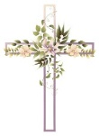
* * * * * * * * * * * * * * * * * * * * * * * * * * * * * * * * * * * * * * * * * *
THE ALTAR FLOWERS are given to the glory of God In honor of Abigal Dendinger’s 10th birthday on Sunday, May 3rd, 2026.


* * * * * * * * * * * * * * * * * * * * * * * * * * * * * * * * * * * * * * * * *

For Naomi Conley will be held Saturday, May 16, 2026. Graveside Service at 11am ~ McPherson Cemetery and
a luncheon at Noon ~ Parish Hall.

* * * * * * * * * * * * * * * * * * * * * * * * * * * * * * * * * * * * * * * * * *

In honor of our new members, cake will be served to everyone in the Parish Hall following the 10:30 service today.
Knox Thomas Dearth
Trenton Paul Elfring
Zarek Robert Gibbs

Maggie Reese Howey
Kayla Nicole Reed
Luke Damon Runion
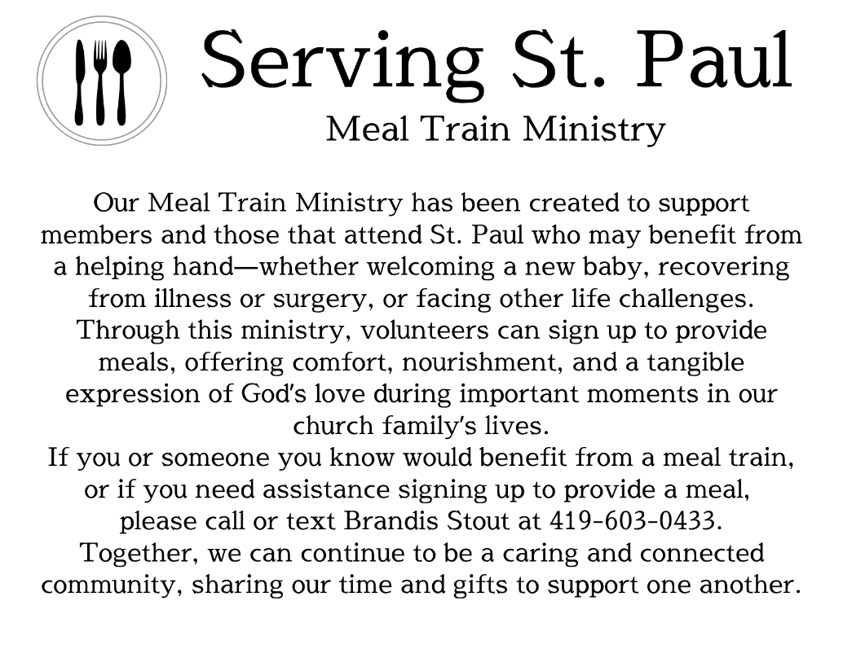
* * * * * * * * * * * * * * * * * * * * * * * * * * * * * * * * * * * * * * * * *

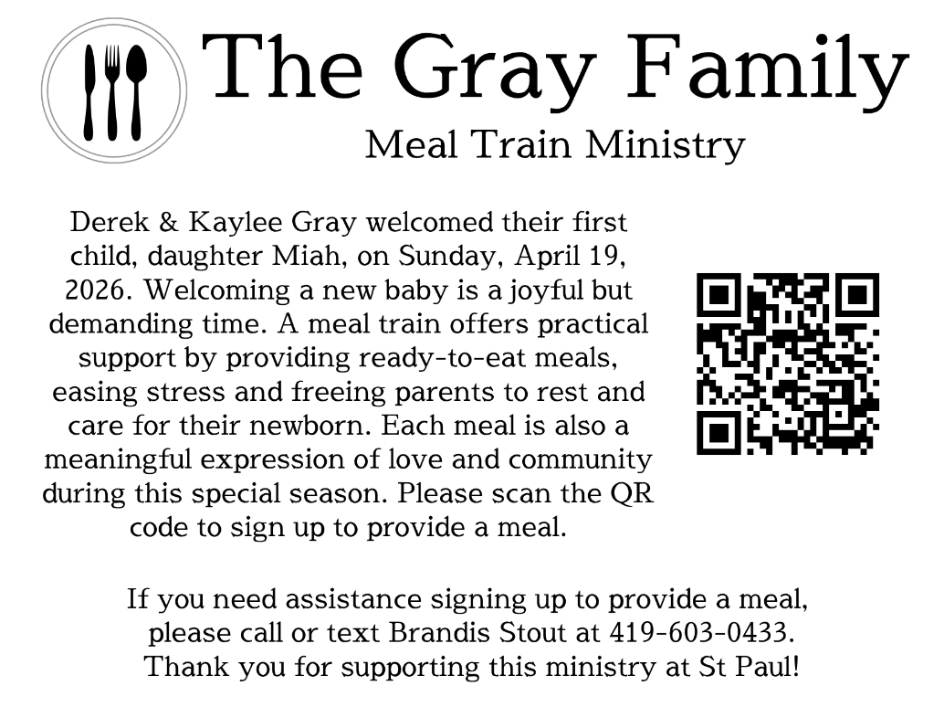
* * * * * * * * * * * * * * * * * * * * * * * * * * * * * * * * * * * * * * * * * *

Stella Alejandro
Alaura Anstead
Owen Cook
Harper Dearth
Knox Dearth
Danni Elfring
Stella Gibbs
Raiden Hayward
Benjamin Riggs
Zaiden Stacy
Blake Williams

We are grateful to the Stacy family for their kindness and grace concerning Zaiden’s absence from last week’s list.
May 3, 2026 – May 10, 2026
Sunday the 3rd | 8:00 am ~ Worship  9:15 am ~ Sunday School  10:30 am ~ Worship & Confirmation  12:00 pm ~ Parish Hall Rental
Monday the 4th | 6:30 pm ~ Co-Ed Bible Study
Tuesday the 5th | 6:30pm ~ Men’s Bible Study  7:00 pm ~ Parish Ed & Youth Board Meeting
Wednesday the 6th | 6:00 pm ~ Women’s Bible Study
Thursday the 7th | 7:00 pm ~ Al-Anon Meeting  8:00 pm ~ AA Meeting
Friday the 8th
Saturday the 9th | 8:00 am ~ Men’s Bible Study  5:00 pm ~ Worship
Sunday the 10th | 8:00 am ~ Worship  9:15 am ~ Sunday School  10:30 am ~ Worship

Attendance for April 25-26, 2026 ~ 182

8:00 am Service
COMPUTER TECH: Barb Wahl
READER: Bob Jennings
USHERS: Kevin Larkins
Michelle Larkins
Jim Sieger
Brenda Sieger

* * * * * * * * * * * * * * * * * * * * * * * * * * * * * * * * * * * * * * * * * *
Church Office Phone: 419-547-9225
Pastor Samuel Dagg Phone: 567-342-2137
pastor@stpaulclyde.org
Matt Woodland ~ Council President Phone: 419-603-0567
prez@stpaulclyde.org
Sherry Bouyack ~ Clerical Secretary Phone: 419-547-9225
fisec@stpaulclyde.org
Jim Shull ~ Treasurer Phone: 419-355-6499
treas@stpaulclyde.org
Brian Farrar ~ P & W Leader Phone: 419-271-3085
pwl@stpaulclyde.org
Ashley Reed ~ Assistant Secretary Phone: 419-547-9225
asst.sec@stpaulclyde.org
Organist
Mary Ellen Wollenslegel
* * * * * * * * * * * * * * * * * * * * * * * * * * * * * * * * * * * * *

We offer many different ways to donate to St Paul Lutheran Church. The following QR code is the latest way. It can be used to direct you to St. Paul Lutheran Church’s electronic giving sign up page. You can always give using the church envelopes, the link on St Paul’s website at stpaulclyde.org, or donate by texting Donate/Donations to 844-440-0253 as well. Thank you for your continued support!

