Ninth Sunday After Pentecost
Sunday, July 26, 2026
10:30 am



147 West Forest Street Clyde, Ohio
Prayer List
Vickie Aldrich
Gwendolyn Baughn
Molly Binder
Michelle Borodkin
Courtney Bouyack
Tim Cooper
Toni Dagg
Crew Dearth
Sharon Duskin
Becky Karr
Kris Larkins
Denise McCubbin
Karen Nimms
Matt Pumphrey
Maverick Salazar
Lindsay Sooy
Larry Sumner
Conner Whaley
Sandy Wott
Katie Spence
Millie Burr
Sharon McGlohn
Sandy Gray
Sandy Michaels
Riley Recker
Larry Bower
Jim Shull
Dennis Gossett


* * * * * * * * * * * * * * * * * * * * * * * * * * * * * * * * * * * * * * * * * *
ALTAR FLOWERS

Given in celebration of Fred and Sherry Bouyack’s 43rd Wedding Anniversary!
(CORRECTION: Zac and Keylie’s wedding was July 18, 2026)
* * * * * * * * * * * * * * * * * * * * * * * * * * * * * * * * * * * * * * * * *
* * * * * * * * * * * * * * * * * * * * * * * * * * * * * * * * * * * * * * * * * *
Special congregational meeting August 9th
Property Board requested and Church Council approved a special congregational meeting for August 9, 2026, after the 10:30 service. The meeting is to vote to approve or reject several projects that the property board brought to the council meeting on July 16th, 2026.
1. Replace the failing air conditioning unit for the sanctuary.
2. Address the water infiltration that is occurring in the masonry around the south sanctuary doors.
3. Replace several sections of concrete outside the southwest corner of the sanctuary that are cracked and becoming a safety hazard.
4. Replace the flower beds outside the east side of the parish hall along the driveway with concrete.
5. Install ADA operators on one door in the elevator entrance, the men’s room door and lady’s room door on the Sunday School side of the building.
6. Security camera upgrades for the entire building. Additional cameras would also be installed.
7. New blinds for the parish hall windows.
8. Re-key the entire building for increased safety and security purposes.
* * * * * * * * * * * * * * * * * * * * * * * * * * * * * * * * * * * * * * * * * *
ATTENTION:
Bodart Productions will be visiting each service on
July 25 & 26 to shoot a new video to make updates on our congregational video on our website.
* * * * * * * * * * * * * * * * * * * * * * * * * * * * * * * * * * * * * * * * * *
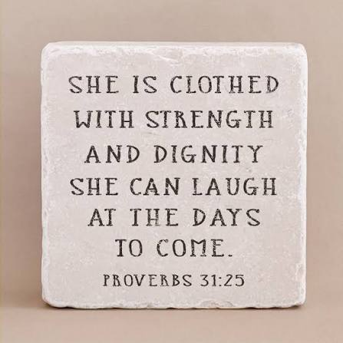
We are excited to welcome Jamie Farrar as the new Secretary at St. Paul!
Jamie will be in the church office Monday through Friday from 8:00 a.m. to 3:30 p.m., with a 30-minute lunch break.
If you need assistance, please contact the church office at 419-547-9225, call or text Jamie directly at 419-603-6731, or email her at sec@stpaulclyde.org.
Ashley's office hours will be limited going forward, so we encourage everyone to reach out to Jamie first for assistance.
Please join us in giving Jamie a warm St. Paul welcome!
* * * * * * * * * * * * * * * * * * * * * * * * * * * * * * * * * * * * * * * * * *

You will find a table in the Parish Hall filled with books that are offered free for the taking. Please visit the table and take as many as you wish. Happy Reading!
* * * * * * * * * * * * * * * * * * * * * * * * * * * * * * * * * * * * * * * * * *

* * * * * * * * * * * * * * * * * * * * * * * * * * * * * * * * * * * * * * * * * *


July and August 2026
Sunday  26 | 8:00 am ~ Worship  10:30 am ~ Worship  3:00 pm ~ BUNCO
Monday  27 | 6:30 pm ~ Co-Ed Bible Study
Tuesday  28 | 6:30 pm ~ Men’s Bible Study
Wednesday 29 | 6:00 pm ~ Women’s Bible Study
Thursday  30 | 7:00 pm ~ Al-Anon Meeting  8:00 pm ~ AA Meeting
Friday
31
Saturday  1 | 8:00 am ~ Men’s Bible Study  5:00 pm ~ Worship
Sunday  2 | 8:00 am ~ Worship  9:15 am ~ Women’s Board Meeting  10:30 am ~ Worship

June 18-19 Attendance: 150

10:30 Service
ACOLYTE: Ellie Stout
USHERS: Steve Jess
Tammy Baker
Dawn Sumner
Kris Wott
COUNTERS: Mel Cook
Karen Jess

* * * * * * * * * * * * * * * * * * * * * * * * * * * * * * * * * * * *
Church Office Phone: 419-547-9225
Jamie Farrar Phone: 419-603-6731
sec@stpaulclyde.org
Pastor Samuel Dagg Phone: 567-342-2137
pastor@stpaulclyde.org
Matt Woodland ~ Council President Phone: 419-603-0567
prez@stpaulclyde.org
Jim Shull ~ Treasurer Phone: 419-355-6499
treas@stpaulclyde.org
Brian Farrar ~ P & W Leader Phone: 419-271-3085
pwl@stpaulclyde.org
Ashley Reed ~ Assistant Secretary asst.sec@stpaulclyde.org
Sherry Bouyack ~ Clerical Secretary fisec@stpaulclyde.org

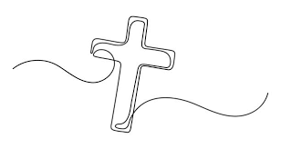
Sermon Notes

