Ninth Sunday after Pentecost
Sunday, July 26, 2026
8:00 am

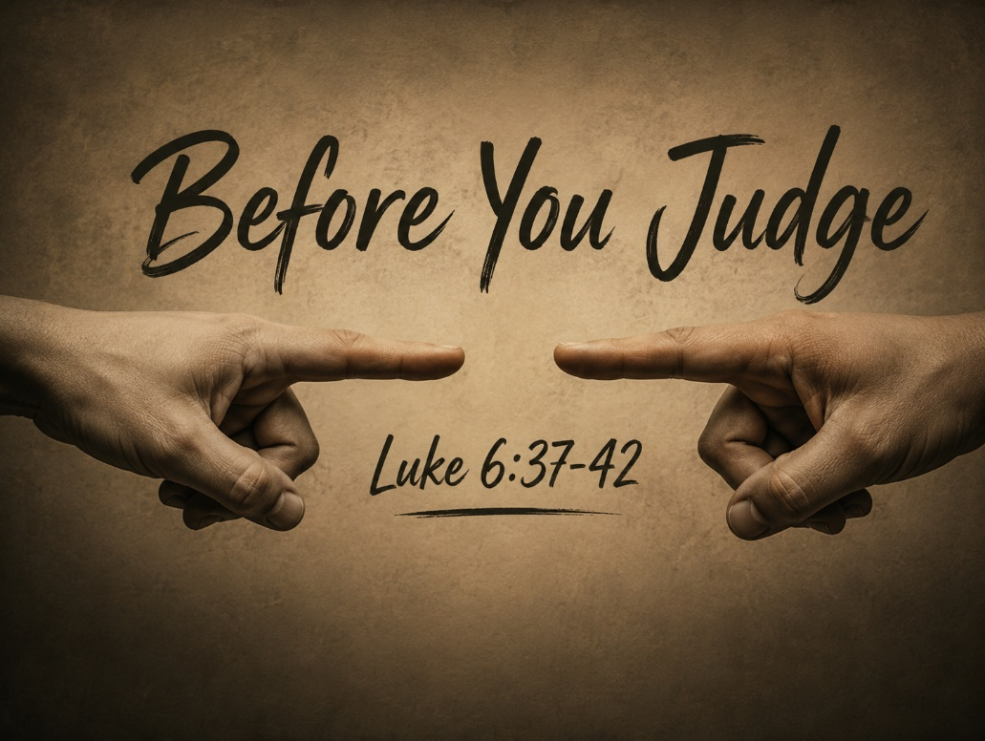

147 West Forest Street Clyde, Ohio
Prelude, Bell & Announcements
Confession & Forgiveness Pg. 94
P: In the name of the Father, and of the ☩ Son, and of the Holy Spirit.
C: Amen.
P: God of all mercy and consolation, come to the help of your people, turning us from our sin to live for you alone. Give us the power of your Holy Spirit that we may confess our sin, receive your forgiveness and grow into the fullness of Jesus Christ, our Savior and Lord.
C: Amen.
P: Let us confess our sin in the presence of God and of one another.
P: Most merciful God,
C: We confess that we are captive to sin and cannot free ourselves. We have sinned against you in thought, word, and deed, by what we have done and by what we have left undone. We have not loved you with our whole heart; we have not loved our neighbors as ourselves. For the sake of your Son, Jesus Christ, have mercy on us. Forgive us, renew us, and lead us, so that we may delight in your will and walk in your ways, to the glory of your holy name. Amen.
P: God who is rich in mercy, loved us even when we were dead in sin, and made us alive together with Christ. By grace you have been saved. In the name of Jesus Christ, the entirety of your sins are forgiven. Almighty God strengthen you with power through the Holy Spirit, that Christ may live in your hearts through faith.
C: Amen.
Hymn “Amazing Grace” #779
The Apostolic Greeting Pg. 147
P: The grace of our Lord Jesus Christ, the love of God, and the communion of the Holy Spirit be with you all.
C: And also with you.
The Kyrie Pg. 147
P: In peace, let us pray to the Lord.
C: Lord, have mercy.
P: For the peace from above, and for our salvation, let us pray to the Lord.
C: Lord, have mercy.
P: For the peace of the whole world, for the well-being of the church of God, and for the unity of all, let us pray to the Lord.
C: Lord, have mercy.
P: For this holy house, and for all who offer here their worship and praise, let us pray to the Lord.
C: Lord, have mercy.
P: Help, save, comfort, and defend us gracious Lord.
C: Amen.
The Hymn of Praise Pg. 149
P: This is the feast of victory for our God. Alleluia.
Worthy is Christ, the Lamb who was slain, whose blood set us free to be people of God. Power and riches and wisdom and strength, and honor and blessing and glory are his.
This is the feast of victory for our God. Alleluia.
Sing with all the people of God and join in the hymn of all creation: Blessing and honor and glory and might be to God and the Lamb forever. Amen.
This is the feast of victory for our God, for the Lamb who was slain has begun his reign. Alleluia. Alleluia.
The Prayer of the Day
O God, your almighty power is most clearly shown in your mercy and pity. Multiply your grace that we may run to your promises and be made to share in your heavenly joy; through Jesus Christ, your Son, our Lord. He lives and reigns with you and the Holy Spirit, one God, now and forever. Amen.
The First Reading: 2 Samuel 12:1-7
¹And the Lord sent Nathan to David. He came to him and said to him, “There were two men in a certain city, the one rich and the other poor. ²The rich man had very many flocks and herds, ³but the poor man had nothing but one little ewe lamb, which he had bought. And he brought it up, and it grew up with him and with his children. It used to eat of his morsel and drink from his cup and lie in his arms, and it was like a daughter to him. ⁴Now there came a traveler to the rich man, and he was unwilling to take one of his own flock or herd to prepare for the guest who had come to him, but he took the poor man’s lamb and prepared it for the man who had come to him.” ⁵Then David’s anger was greatly kindled against the man, and he said to Nathan, “As the Lord lives, the man who has done this deserves to die, ⁶and he shall restore the lamb fourfold, because he did this thing, and because he had no pity.” ⁷Nathan said to David, “You are the man! Thus says the Lord, the God of Israel, ‘I anointed you king over Israel, and I delivered you out of the hand of Saul.
L: The Word of the Lord.
C: Thanks be to God.
Psalm 51:1–12
¹Have mercy on me, O God, according to your steadfast love; according to your abundant mercy blot out my transgressions.
²Wash me thoroughly from my iniquity, and cleanse me from my sin!
³For I know my transgressions, and my sin is ever before me.
⁴Against you, you only, have I sinned and done what is evil in your sight, so that you may be justified in your words and blameless in your judgment.
⁵Behold, I was brought forth in iniquity, and in sin did my mother conceive me.
⁶Behold, you delight in truth in the inward being, and you teach me wisdom in the secret heart.
⁷Purge me with hyssop, and I shall be clean; wash me, and I shall be whiter than snow.
⁸Let me hear joy and gladness; let the bones that you have broken rejoice.
⁹Hide your face from my sins, and blot out all my iniquities.
¹⁰Create in me a clean heart, O God, and renew a right spirit within me.
¹¹Cast me not away from your presence, and take not your Holy Spirit from me.
¹²Restore to me the joy of your salvation, and uphold me with a willing spirit.
L: Here ends the reading of the Psalm.
C: Thanks be to God.
The Second Reading: Romans 2:1–4
¹Therefore you have no excuse, O man, every one of you who judges. For in passing judgment on another you condemn yourself, because you, the judge, practice the very same things. ²We know that the judgment of God rightly falls on those who practice such things. ³Do you suppose, O man—you who judge those who practice such things and yet do them yourself—that you will escape the judgment of God? ⁴Or do you presume on the riches of his kindness and forbearance and patience, not knowing that God’s kindness is meant to lead you to repentance?
L: The Word of the Lord.
C: Thanks be to God.
The Gospel Acclamation Pg. 151
Alleluia. Lord, to whom shall we go? You have the words of eternal life. Alleluia.
P: The Holy Gospel according to St. Luke, the 6th chapter.
C: Glory to You, O Lord.
The Gospel: Luke 6:37-42
³⁷“Judge not, and you will not be judged; condemn not, and you will not be condemned; forgive, and you will be forgiven; ³⁸give, and it will be given to you. Good measure, pressed down, shaken together, running over, will be put into your lap. For with the measure you use it will be measured back to you.” ³⁹He also told them a parable: “Can a blind man lead a blind man? Will they not both fall into a pit? ⁴⁰A disciple is not above his teacher, but everyone when he is fully trained will be like his teacher. ⁴¹Why do you see the speck that is in your brother’s eye, but do not notice the log that is in your own eye? ⁴²How can you say to your brother, ‘Brother, let me take out the speck that is in your eye,’ when you yourself do not see the log that is in your own eye? You hypocrite, first take the log out of your own eye, and then you will see clearly to take out the speck that is in your brother’s eye.
P: The Gospel of the Lord.
C: Praise to You, O Christ.
Guest Speaker:
“Before You Judge”
Luke 6:37-42
Pastor Sam Dagg
The Hymn “Let Us Break Bread Together” #471
Prayers of Intercession
Vickie Aldrich
Gwendolyn Baughn
Molly Binder
Michelle Borodkin
Courtney Bouyack
Tim Cooper
Toni Dagg
Crew Dearth
Sharon Duskin
Becky Karr
Kris Larkins
Denise McCubbin
Karen Nimms
Matt Pumphrey
Maverick Salazar
Lindsay Sooy
Larry Sumner
Conner Whaley
Sandy Wott
Katie Spence
Millie Burr
Sharon McGlohn
Sandy Gray
Sandy Michaels
Riley Recker
Larry Bower
Jim Shull
Dennis Gossett

THE APOSTLES’ CREED (back cover of the hymnal)
The Peace of the Lord Pg. 152
P: The peace of the Lord be with you.
C: And also, with you.
The Passing of the Peace
The Offering
The Offering Prayer
Blessed are you, O God, maker of all things. Through your goodness you have blessed us with these gifts: our possessions. Use us, and what we have gathered, in feeding the world with your love, through the one who gave himself for us, Jesus Christ, our Savior and Lord. Amen.
The Great Thanksgiving Pg. 152
P: The Lord be with you.
C: And also, with you.
P: Lift up your hearts.
C: We lift them to the Lord.
P: Let us give thanks to the Lord our God.
C: It is right to give our thanks and praise.
The Proper Preface
P: It is indeed right, our duty and our joy, that we should at all times and in all places give thanks and praise to You, almighty and merciful God. You reveal Your glory as the glory of the Father, the Son, and the Holy Spirit; equal in majesty, undivided in splendor, one Lord, one God, ever to be adored in Your eternal glory. And so, with all the choirs of angels, with the church on earth and the hosts of heaven, we praise Your name and join their unending hymn:
C: Holy, holy, holy Lord,
Lord God of power and might,
heav’n and earth are full of your glory.
Hosanna in the highest.
Blessed is he who comes in the name of the Lord.
Hosanna in the highest.
The Words of Institution
The Lord’s Prayer Pg. 154
P: Gathered into one by the Holy Spirit, let us pray as Jesus taught us.
C: Our Father, Who art in heaven, hallowed be Thy name, Thy kingdom come, Thy will be done, on earth as it is in heaven. Give us this day our daily bread; and forgive us our trespasses, as we forgive those who trespass against us; and lead us not into temptation, but deliver us from evil. For Thine is the kingdom, and the power, and the glory, forever and ever. Amen.
Invitation to Communion Pg. 154 P: Come to the banquet, for all is now ready.
Holy Communion
All baptized believers in Jesus Christ as Lord are invited to receive communion today. Please follow the directions of the ushers. Children who have not yet received their first communion are also invited to come forward, to receive a blessing.
The Post Communion Blessing
P: The body and blood of our Lord Jesus Christ strengthen you and keep you in His grace.
C: Amen.
Prayer After Communion
P: Let us pray.
C: O God, we give You thanks that You have set before us this feast, the body and blood of Your Son. By Your Spirit strengthen us to serve all in need and to give ourselves away as bread for the hungry, through Jesus Christ our Lord. Amen.
The Hymn “Just As I Am, Without One Plea” #592
The Benediction
P: May the Lord bless you and keep you;
the Lord make his face shine on you and be gracious to you;
the Lord turn his face toward you and give you peace.
In the name of the Father,
and of the ☩ Son,
and of the Holy Spirit.
C: Amen.
The Dismissal
P: GO IN PEACE. SERVE THE LORD!
C: Thanks be to God.
The Postlude


* * * * * * * * * * * * * * * * * * * * * * * * * * * * * * * * * * * * * * * * * *
ALTAR FLOWERS

Given in celebration of Fred and Sherry Bouyack’s 43rd Wedding Anniversary!
(Correction: Zac and Keylie’s wedding was July 18, 2026)
* * * * * * * * * * * * * * * * * * * * * * * * * * * * * * * * * * * * * * * * *
Special congregational meeting August 9th
Property Board requested and Church Council approved a special congregational meeting for August 9, 2026, after the 10:30 service. The meeting is to vote to approve or reject several projects that the property board brought to the council meeting on July 16th, 2026.
1. Replace the failing air conditioning unit for the sanctuary.
2. Address the water infiltration that is occurring in the masonry around the south sanctuary doors.
3. Replace several sections of concrete outside the southwest corner of the sanctuary that are cracked and becoming a safety hazard.
4. Replace the flower beds outside the east side of the parish hall along the driveway with concrete.
5. Install ADA operators on one door in the elevator entrance, the men’s room door and lady’s room door on the Sunday School side of the building.
6. Security camera upgrades for the entire building. Additional cameras would also be installed.
7. New blinds for the parish hall windows.
8. Re-key the entire building for increased safety and security purposes.
* * * * * * * * * * * * * * * * * * * * * * * * * * * * * * * * * * * * * * * * * *
ATTENTION:
Bodart Productions will be visiting each service on
July 25 & 26 to shoot a new video to make updates on our congregational video on our website.
* * * * * * * * * * * * * * * * * * * * * * * * * * * * * * * * * * * * * * * * * *
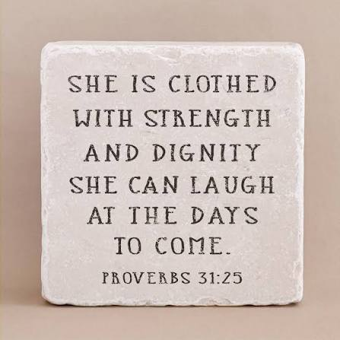
We are excited to welcome Jamie Farrar as the new Secretary at St. Paul!
Jamie will be in the church office Monday through Friday from 8:00 a.m. to 3:30 p.m., with a 30-minute lunch break.
If you need assistance, please contact the church office at 419-547-9225, call or text Jamie directly at 419-603-6731, or email her at sec@stpaulclyde.org.
Ashley's office hours will be limited going forward, so we encourage everyone to reach out to Jamie first for assistance.
Please join us in giving Jamie a warm St. Paul welcome!
* * * * * * * * * * * * * * * * * * * * * * * * * * * * * * * * * * * * * * * * * *

You will find a table in the Parish Hall filled with books that are offered free for the taking. Please visit the table and take as many as you wish. Happy Reading!
* * * * * * * * * * * * * * * * * * * * * * * * * * * * * * * * * * * * * * * * * *

* * * * * * * * * * * * * * * * * * * * * * * * * * * * * * * * * * * * * * * * * *

July and August 2026
Sunday  26 | 8:00 am ~ Worship  10:30 am ~ Worship  3:00 pm ~ BUNCO
Monday  27 | 6:30 pm ~ Co-Ed Bible Study
Tuesday  28 | 6:30 pm ~ Men’s Bible Study
Wednesday 29 | 6:00 pm ~ Women’s Bible Study
Thursday  30 | 7:00 pm ~ Al-Anon Meeting  8:00 pm ~ AA Meeting
Friday
31
Saturday  1 | 8:00 am ~ Men’s Bible Study  5:00 pm ~ Worship
Sunday  2 | 8:00 am ~ Worship  9:15 am ~ Women’s Board Meeting  10:30 am ~ Worship

June 18-19 Attendance: 150

8:00 am Service
COMPUTER TECH: Barb Wahl
READER: Duane Kimmet
USHERS: Tim Billings
Duane Kimmet
Jeanie Kimmet

* * * * * * * * * * * * * * * * * * * * * * * * * * * * * * * * * * * * * * * * * *
Church Office Phone: 419-547-9225
Jamie Farrar Phone: 419-603-6731
sec@stpaulclyde.org
Pastor Samuel Dagg Phone: 567-342-2137
pastor@stpaulclyde.org
Matt Woodland ~ Council President Phone: 419-603-0567
prez@stpaulclyde.org
Jim Shull ~ Treasurer Phone: 419-355-6499
treas@stpaulclyde.org
Brian Farrar ~ P & W Leader Phone: 419-271-3085
pwl@stpaulclyde.org
Ashley Reed ~ Assistant Secretary asst.sec@stpaulclyde.org
Sherry Bouyack ~ Clerical Secretary fisec@stpaulclyde.org
Organist
Mary Ellen Wollenslegel
* * * * * * * * * * * * * * * * * * * * * * * * * * * * * * * * * * * * *


Sermon Notes

