Sixth Sunday After Pentecost
Sunday, July 5, 2026
10:30 am



147 West Forest Street Clyde, Ohio

Prayer List
Vickie Aldrich
Gwendolyn Baughn
Molly Binder
Michelle Borodkin
Courtney Bouyack
Tim Cooper
Toni Dagg
Crew Dearth
Sharon Duskin
Don Franks
Becky Karr
Kris Larkins
Denise McCubbin
Karen Nimms
Matt Pumphrey
Maverick Salazar
Lindsay Sooy
Larry Sumner
Conner Whaley
Sandy Wott
Katie Spence

* * * * * * * * * * * * * * * * * * * * * * * * * * * * * * * * * * * * * * * * * *

ALTAR FLOWERS

Given in Honor of the“250th”Birthday of America & in Memory of Peer Dalzell’s birthday and in Honor of Rachel Davis’s birthday on July 12th. Given by the Sumner Family.

* * * * * * * * * * * * * * * * * * * * * * * * * * * * * * * * * * * * * * * * * *


We want to welcome Michael Binder and Bill Riggs into God’s family through Baptism on June 28, 2026.

* * * * * * * * * * * * * * * * * * * * * * * * * * * * * * * * * * * * * * * * * *

If you or a loved one needs an
electric lift chair, please reach out to
Tom Thorbahn 419-366-8135 or
Kevin Larkins 567-201-3838.

* * * * * * * * * * * * * * * * * * * * * * * * * * * * * * * * * * * * * * * * * *

Vacation Bible School (VBS)
July 12-16 5:45 – 8:15 p.m.
Location: Methodist Church
Need the following:
- 2 adult volunteers to lead 1-4th grade classes from place to place
- A puppeteer
If interested in helping contact Amber Keegan 419-455-5887
* * * * * * * * * * * * * * * * * * * * * * * * * * * * * * * * * * * * * * * * * *

* * * * * * * * * * * * * * * * * * * * * * * * * * * * * * * * * * * * * * * * * *
Women’s Bible Study will be cancelled
Wednesday, July 8th, 2026.
Due to a family vacation.
If you have questions, please contact Sherry Frasher
@ 419-765-7016. Thank you.
* * * * * * * * * * * * * * * * * * * * * * * * * * * * * * * * * * * * * * * * * *

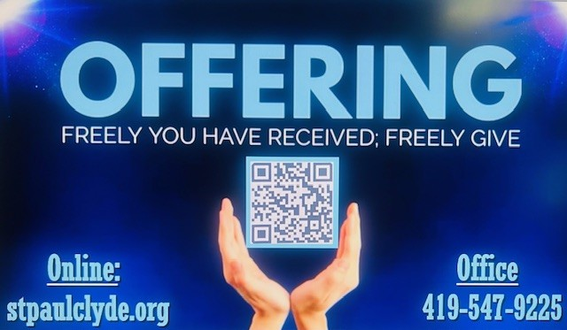

July 2026
Sunday  5 | 8:00 am ~ Worship  9:15 am ~ Women’s Board Meeting  10:30 am ~ Worship
Monday  6 | 6:30 pm ~ Co-Ed Bible Study
Tuesday  7 | 6:30 pm ~ Men’s Bible Study  7:00 pm ~ Parish Ed/Youth Board Meeting
Wednesday 8 | 6:00 pm ~ Women’s Bible Study
Thursday  9 | 5:00 pm ~ Evangelism/Social Board Meeting  6:00 pm ~ Worship Board Meeting  7:00 pm ~ Al-Anon Meeting  8:00 pm ~ AA Meeting
Friday
10
Saturday  11 | 8:00 am ~ Men’s Bible Study  5:00 pm ~ Worship
Sunday  12 | 8:00 am ~ Worship  10:30 am ~ Worship  5:45 pm ~ VBS@First United Methodist Church
June 27-28 Attendance: 153
10:30 Service
ACOLYTE:
USHERS: Gary Wott
Tom Billings
Keyli Billings
Steve Jess
COUNTERS: Sherry Frasher
Jennie McCoy
Michelle Dagg
* * * * * * * * * * * * * * * * * * * * * * * * * * * * * * * * * * * *
Church Office Phone: 419-547-9225
Pastor Samuel Dagg Phone: 567-342-2137
pastor@stpaulclyde.org
Matt Woodland ~ Council President Phone: 419-603-0567
prez@stpaulclyde.org
Sherry Bouyack ~ Clerical Secretary Phone: 419-547-9225
fisec@stpaulclyde.org
Jim Shull ~ Treasurer Phone: 419-355-6499
treas@stpaulclyde.org
Brian Farrar ~ P & W Leader Phone: 419-271-3085
pwl@stpaulclyde.org
Ashley Reed ~ Assistant Secretary Phone: 419-547-9225 asst.sec@stpaulclyde.org
* * * * * * * * * * * * * * * * * * * * * * * * * * * * * * * * * * * * * * * * * * * * * * * * * * *



Sermon Notes

