Fourth Sunday after Pentecost
ELW Holy Communion
Traditional Service
Sunday, July 6, 2025
8:00 am



ST. PAUL LUTHERAN CHURCH
147 West Forest Street
Clyde, Ohio

Fourth Sunday after Pentecost

July 6, 2025

8:00 am

Holy Communion ~ Setting Four

* = those who are able may stand
Song numbers with “BB” are from the “The Best of the Best” songbook

Prelude

Bell & Announcements

*Confession & Forgiveness Pg. 94
P: In the name of the Father,
and of the ☩ Son,
and of the Holy Spirit.

C: Amen.

P: God of all mercy and consolation, come to the help of your people, turning us from our sin to live for you alone. Give us the power of your Holy Spirit that we may confess our sin, receive your forgiveness and grow into the fullness of Jesus Christ, our Savior and Lord.

C: Amen.

P: Let us confess our sin in the presence of God and of one another.

P: Most merciful God,

C: we confess that we are captive to sin and cannot free ourselves. We have sinned against you in thought, word, and deed, by what we have done and by what we have left undone. We have not loved you with our whole heart; we have not loved our neighbors as ourselves. For the sake of your Son, Jesus Christ, have mercy on us. Forgive us, renew us, and lead us, so that we may delight in your will and walk in your ways, to the glory of your holy name. Amen.

P: In the mercy of almighty God, Jesus Christ was given to die for us, and for his sake God forgives us all our sins. As a called and ordained minister of the church of Christ, and by his authority, I therefore declare to you the entire forgiveness of all your sins, in the name of the Father, and of the ☩ Son, and of the Holy Spirit.

C: Amen.

*The Hymn “O Beautiful for Spacious Skies” No. 888

*The Apostolic Greeting Pg. 147
P: The grace of our Lord Jesus Christ, the love of God, and the communion of the Holy Spirit be with you all.

C: And also with you.

*The Kyrie Pg. 147
P: In peace, let us pray to the Lord.
C: Lord, have mercy.

P: For the peace from above, and for our salvation, let us pray to the Lord.
C: Lord, have mercy.

P: For the peace of the whole world, for the well-being of the church of God, and for the unity of all, let us pray to the Lord.
C: Lord, have mercy.

P: For this holy house, and for all who offer here their worship and praise, let us pray to the Lord.
C: Lord, have mercy.

P: Help, save, comfort, and defend us gracious Lord.
C: Amen.

The Hymn of Praise Pg. 149

Refrain
P: This is the feast of victory for our God. Alleluia.

1. Worthy is Christ, the Lamb who was slain, whose blood set us free to be people of God. Power and riches and wisdom and strength, and honor and blessing and glory are his.

Refrain
This is the feast of victory for our God. Alleluia.

2. Sing with all the people of God and join in the hymn of all creation: Blessing and honor and glory and might be to God and the Lamb forever. Amen.

Refrain
This is the feast of victory for our God, for the Lamb who was slain has begun his reign. Alleluia. Alleluia.

The Prayer of the Day (in unison)
O God, You never undermine Your purpose, as You perfectly provide for all that You create. Remove from our way all that is harmful and give us what will profit that we may share in Your invincible grace; through Jesus Christ, Your Son, our Lord, Who lives and reigns with You and the Holy Spirit, one God, now and forever. Amen.

The First Lesson ~ Isaiah 66:10-14
¹⁰“Rejoice with Jerusalem, and be glad for her, all you who love her; rejoice with her in joy, all you who mourn over her; ¹¹that you may nurse and be satisfied from her consoling breast; that you may drink deeply with delight from her glorious abundance.” ¹²For thus says the Lord: “Behold, I will extend peace to her like a river, and the glory of the nations like an overflowing stream; and you shall nurse, you shall be carried upon her hip, and bounced upon her knees. ¹³As one whom his mother comforts, so I will comfort you; you shall be comforted in Jerusalem. ¹⁴You shall see, and your heart shall rejoice; your bones shall flourish like the grass; and the hand of the Lord shall be known to His servants, and He shall show His indignation against His enemies.”

L: The Word of the Lord.
C: Thanks be to God.

Psalm 66:1-6
¹Be joyful in God, all you lands; sing the glory of His name; sing the glory of His praise.

²Say to God, “How awesome are Your deeds! because of Your great strength Your enemies cringe before You.

³All the earth bows down before You, sings to You, sings out Your name.”

⁴Come now and see the works of God, how wonderful He is in His doing toward all people.

⁵He turned the sea into dry land, so that they went through the water on foot, and there we rejoiced in Him.

⁶In His might He rules forever; His eyes keep watch over the nations; let no rebel rise up against Him.

L: Here ends the reading of the Psalm.
C: Thanks be to God.

The Second Lesson ~ Galatians 6:1-10, 14-18
¹Brothers, if anyone is caught in any transgression, you who are spiritual should restore him in a spirit of gentleness. Keep watch on yourself, lest you too be tempted. ²Bear one another’s burdens, and so fulfill the law of Christ. ³For if anyone thinks he is something, when he is nothing, he deceives himself. ⁴But let each one test his own work, and then his reason to boast will be in himself alone and not in his neighbor. ⁵For each will have to bear his own load. ⁶Let the one who is taught the word share all good things with the one who teaches. ⁷Do not be deceived: God is not mocked, for whatever one sows, that will he also reap. ⁸For the one who sows to his own flesh will from the flesh reap corruption, but the one who sows to the Spirit will from the Spirit reap eternal life. ⁹And let us not grow weary of doing good, for in due season we will reap, if we do not give up. ¹⁰So then, as we have opportunity, let us do good to everyone, and especially to those who are of the household of faith.

¹⁴But far be it from me to boast except in the cross of our Lord Jesus Christ, by which the world has been crucified to me, and I to the world. ¹⁵For neither circumcision counts for anything, nor uncircumcision, but a new creation. ¹⁶And as for all who walk by this rule, peace and mercy be upon them, and upon the Israel of God. ¹⁷From now on let no one cause me trouble, for I bear on my body the marks of Jesus. ¹⁸The grace of our Lord Jesus Christ be with your spirit, brothers. Amen.

L: The Word of the Lord.
C: Thanks be to God.

*The “Gospel Acclamation” Pg. 151
Alleluia. Lord, to whom shall we go? You have the words of eternal life. Alleluia.

P: The Holy Gospel according to St. Luke, the 10th chapter.
C: Glory to You, O Lord.

*The Gospel ~ Luke 10:1-20
¹After this the Lord appointed seventy-two others and sent them on ahead of Him, two by two, into every town and place where He Himself was about to go. ²And He said to them, “The harvest is plentiful, but the laborers are few. Therefore pray earnestly to the Lord of the harvest to send out laborers into His harvest. ³Go your way; behold, I am sending you out as lambs in the midst of wolves. ⁴Carry no moneybag, no knapsack, no sandals, and greet no one on the road. ⁵Whatever house you enter, first say, ‘Peace be to this house!’ ⁶And if a son of peace is there, your peace will rest upon him. But if not, it will return to you. ⁷And remain in the same house, eating and drinking what they provide, for the laborer deserves his wages. Do not go from house to house. ⁸Whenever you enter a town and they receive you, eat what is set before you. ⁹Heal the sick in it and say to them, ‘The kingdom of God has come near to you.’ ¹⁰But whenever you enter a town and they do not receive you, go into its streets and say, ¹¹‘Even the dust of your town that clings to our feet we wipe off against you. Nevertheless know this, that the kingdom of God has come near.’ ¹²I tell you, it will be more bearable on that day for Sodom than for that town. ¹³Woe to you, Chorazin! Woe to you, Bethsaida! For if the mighty works done in you had been done in Tyre and Sidon, they would have repented long ago, sitting in sackcloth and ashes. ¹⁴But it will be more bearable in the judgment for Tyre and Sidon than for you. ¹⁵And you, Capernaum, will you be exalted to heaven? You shall be brought down to Hades. ¹⁶The one who hears you hears me, and the one who rejects you rejects me, and the one who rejects me rejects him who sent me.” ¹⁷The seventy-two returned with joy, saying, “Lord, even the demons are subject to us in your name!” ¹⁸And he said to them, “I saw Satan fall like lightning from heaven. ¹⁹Behold, I have given you authority to tread on serpents and scorpions, and over all the power of the enemy, and nothing shall hurt you. ²⁰Nevertheless, do not rejoice in this, that the spirits are subject to you, but rejoice that your names are written in heaven.”

P: The Gospel of the Lord.
C: Praise to You, O Christ.

The Moment with Children

The Sermon “Plentiful”
Luke 10:1-10
The Rev. Dr. Tim Hubert

*The Hymn “What a Friend We Have in Jesus” No. 742

*Prayers of Intercession
By the power of the Holy Spirit, let us pray to God our Father in the name of Christ Jesus our Lord, making intercession for the Church, the world, and for all people according to their need.

A brief silence

Heavenly Father, thank You for entrusting us with the mission of spreading the Gospel throughout the world! Thank You for the Holy Spirit, Who reminds us of everything Jesus has taught, for Your Son’s grace and forgiveness when we fall short and for His promise to give us His strength and authority, which is sufficient for all our needs.

Lord, in Your mercy, hear our prayer.

Your Son sent the Seventy to announce Your Kingdom’s close approach. We pray for the Church across the earth. Grant that, in the power of the Spirit, it sows Your Word in many hearts. Let it correct, encourage, comfort, and instruct sinners gently. May it reap a harvest of salvation in Jesus Christ.

Lord, in Your mercy, hear our prayer.

Make this congregation eager to worship, pray, and serve. Help us to endure rejection and to focus on the joy in heaven over each sinner who repents and turns to Jesus in faith. We pray for the LCMC & NALC, area congregations and today for Oakland Lutheran Church of Mansfield, Ohio and for Reverend Paul Lintern.

Lord, in Your mercy, hear our prayer.

As a mother comforts her children, we pray that You would comfort Your persecuted Church. Give it gentle and valiant faith, so the hearts of its tormentors may be softened with repentance and remorse.

Lord, in Your mercy, hear our prayer.

Thank You for our country, especially as we celebrate the blessings of independence, liberty, and justice for all. Guide us, especially our elected leaders, in pathways of righteousness and truth. Let us continue to be a beacon of freedom to the world. Grant the blessings of justice and peace throughout the world, so that all people may live, work, and serve You with glad and quiet hearts.

Lord, in Your mercy, hear our prayer.

Guard and protect all who travel this summer, especially families enjoying time together on vacation. Grant them refreshment and relaxation and renew their love for each other, for You, and for the loveliness of Your creation.

Lord, in Your mercy, hear our prayer.

We pray that all who suffer in body, mind or spirit may know that Your Kingdom has indeed drawn near to them. Today we remember:

Vickie
Hazel
Call Committee
Betty
Steve
Tim
Toni
Crew
Ryker
Bob
The Agora Group
Jackie
Bill
Emily
Linda

DEPLOYED
Kyle

Give wisdom and competence to their doctors, nurses, and caregivers. Grant them healing and hope, so they may praise Your awesome deeds.

Lord, in Your mercy, hear our prayer.

Gracious Lord, comfort Your children who mourn the death of a loved one. Turn sorrow into rejoicing and despair into confident hope. Give us such a spirit of gentleness that through our witness, those who have strayed are encouraged to return to Your forgiving and merciful care. Lead us into the full splendor of Your Kingdom, where with all the redeemed, we shall delight in praising and worshipping You forever.

Lord, in Your mercy, hear our prayer.

Into Your hands, gracious Father, we commend all for whom we pray, trusting in Your mercy; for the sake of Your Son, Jesus Christ our Lord.

Amen.

*The Apostles’ Creed (back cover of hymnal)

The Peace of the Lord Pg. 152
P: The peace of the Lord be with you.
C: And also, with you.

*The Passing of the Peace (please remain in place)

The Offering

*The Offering Prayer (#3)
Blessed are you, O God, maker of all things. Through your goodness you have blessed us with these gifts: our possessions. Use us, and what we have gathered, in feeding the world with your love, through the one who gave himself for us, Jesus Christ, our Savior and Lord. Amen.

*The Great Thanksgiving Pg. 152
P: The Lord be with you.
C: And also, with you.

P: Lift up your hearts.
C: We lift them to the Lord.

P: Let us give thanks to the Lord our God.
C: It is right to give our thanks and praise.

*The Proper Preface
P: It is indeed right, our duty and our joy, that we should at all times and in all places give thanks and praise to You, almighty and merciful God. You reveal Your glory as the glory of the Father, the Son, and the Holy Spirit; equal in majesty, undivided in splendor, one Lord, one God, ever to be adored in Your eternal glory. And so, with all the choirs of angels, with the church on earth and the hosts of heaven, we praise Your name and join their unending hymn:

*“Holy, Holy, Holy…” Pg. 153
Holy, holy, holy Lord,
Lord God of power and might,
heav’n and earth are full of your glory.
Hosanna in the highest.
Blessed is he who comes in the name of the Lord.
Hosanna in the highest.

*The Words of Institution
In the night in which he was betrayed,
our Lord Jesus took bread, and gave thanks;
broke it, and gave it to his disciples, saying:
Take and eat; this is my body, given for you.
Do this for the remembrance of me.

Again, after supper, he took the cup, gave thanks,
and gave it for all to drink, saying:
This cup is the new covenant in my blood,
shed for you and for all people for the forgiveness of sin.
Do this for the remembrance of me.

*The “Lord’s Prayer” Pg. 154
P: Gathered into one by the Holy Spirit, let us pray as Jesus taught us.

Our Father, who art in heaven,
hallowed be thy name,
thy kingdom come,
thy will be done,
on earth as it is in heaven.

Give us this day our daily bread;
and forgive us our trespasses,
as we forgive those
who trespass against us;
and lead us not into temptation,
but deliver us from evil.

For thine is the kingdom,
and the power, and the glory,
forever and ever. Amen.

*Invitation to Communion Pg. 154
Come to the banquet, for all is now ready.

Holy Communion
All baptized believers in Jesus Christ as Lord are invited to receive communion today. Please follow the directions of the ushers. Children who have not yet received their “first communion” are also invited to come forward, to receive a blessing.

*The Post Communion Blessing
The body and blood…

*Prayer After Communion
P: Let us pray.
O God, we give You thanks that You have set before us this feast, the body and blood of Your Son. By Your Spirit strengthen us to serve all in need and to give ourselves away as bread for the hungry, through Jesus Christ our Lord.
C: Amen.

*The Hymn “My Country, ‘Tis of Thee” No. 566 LBW

VERSE 1

My Country ‘tis of thee, Sweet land of liberty, Of thee I sing: Land where my fathers died, Land of the pilgrims’ pride, From every mountainside Let freedom ring.

VERSE 2

My native country, thee, Land of the noble free, Thy name I love; I love thy rocks and rills, Thy woods and templed hills; My heart with rapture thrills Like that above.

VERSE 3

Let music swell the breeze, And ring from all the trees Sweet freedom's song; Let mortal tongues awake; Let all that breathe partake; Let rocks their silence break, The sound prolong.

VERSE 4

Our fathers' God, to thee, Author of liberty, To thee we sing: Long may our land be bright With freedom's holy light. Protect us by thy might, Great God, our King.

*The Benediction Pg. 155

*The Dismissal
L: Go in peace. . .
C: Thanks be to God.

The Postlude

* * * * * * * * * * * * * * * * * * * * * * *


Our Good Shepherd calls us into the safekeeping of this fold. May all gathered here feel the welcome and love of God in Christ.

* * * * * * * * * * * * * * * * * * * * * * * *

THE ALTAR FLOWERS are given to the Glory of God by Fred & Sherry Bouyack.

* * * * * * * * * * * * * * * * * * * * * * * *


As much as I love each and everyone of you, the time has come for me to say good-bye. My wife has been very patient with me for many years, but is now saying, "Tim, it's time to come home." My last Sunday with you will be August 31st. You have a very good and active Call Committee. Pray now that our good Lord will send a good, new pastor soon if not sooner! Blessings, all!

Pr Tim+

July 6, 2025 – July 13, 2025

Sunday the  6th | 8:00 am ~ Holy Communion Worship  9:15 am ~ Women’s Board Meeting  10:30 am ~ Holy Communion Worship Service
Monday the 7th

Tuesday the 8th | 1:00 pm ~ Pericope Meeting  6:00 pm ~ Property Board Meeting
Wednesday the 9th
Thursday the 10th | 6:00 pm Worship Board Meeting  7:00 pm – 8:00 pm ~ Al-Anon Meeting  8:00 pm ~ AA Meeting
Friday the 11th

Saturday the 12th | 8:00 am – 9:30 a.m. ~ Men’s Bible Study  5:00 pm ~ Holy Communion Worship
Sunday the  13th | 8:00 am ~ Holy Communion Worship  5:15 pm – 8:15 pm ~ VBS @ 1st UMC BEGINS  10:30 am ~ Holy Communion Worship Service
* * * * * * * * * * * * * * * * * * * * * * * *
With not having a July Reflector the weekly birthdays for July will be in the bulletin each week for the month of July.

Tuesday, July 1 – Saturday, July 12, 2025
1 Andrew Barrett
Tawny Chumley
Jeff Hall
2 Michele Rogers
3 Carol Jones
4 Graham Andrews
6 Kaitlynn Bush
Gregory Hall
Jim Sieger
7 Kelsey Andecover
Alek Gregg
Ryan Kuns
8 Anthony Paradiso
Kimberly Prentice
11 Rick Albright
Brad Elfring
David Parkhurst, Jr.
12 Rachel Davis
James Shull, Jr.
Robin Snyder
* * * * * * * * * * * * * * * * * * * * * * * *

We offer many different ways to donate to St Paul Lutheran Church. The following QR code is the latest way. It can be used to direct you to St. Paul Lutheran Church’s electronic giving sign up page. You can always give using the church envelopes, the link on St Paul’s website at stpaulclyde.org, or donate by texting Donate/Donations to 844-440-0253 as well. Thank you for your continued support!

WHO WANTS TO HELP WITH SUNDAY SCHOOL?
Our Parish Ed & Youth Board is looking for help with our Sunday School. Please consider supporting us & our families with implementing Sunday School to serve our children to grow in their relationship with Jesus and their faith. If you can help with any of these tasks please contact DeAnn Krauss @ 419-937-7514. Thank you for your consideration, we appreciate you, your commitment to our church families & your time.
* Use Sunday School Curriculum to plan or co-plan lessons for each week
* Help organize the Sunday School Materials into binders for teachers to use
* Monitoring the hallway 9:00-10:25 each week or weeks that you are available to do so to greet families and help with restroom breaks, get needed supplies, etc
* Find a craft to go with each lesson (that is prepared) and be ordered & paid for by the church
* Find supplies (floor puzzles, games, etc) to keep the kids busy while waiting for the lesson to start to be ordered and paid for by the church
* Co-Teach Sunday School, 4th/5th Grade
* Substitute Sunday School Co-Teacher
* Create student name tags for boxes in classrooms for the start of the year

WHO WANTS TO REGISTER THEIR CHILD FOR SUNDAY SCHOOL? USE THE QR CODE BELOW TO HELP US START PLANNING & COMMUNICATING WITH YOU.

* * * * * * * * * * * * * * * * * * * * * * * *

Women’s Bible Study Notice

The Women’s Bible Study on Wednesday evening from 6:00 - 7:30 p.m.
has been canceled effective 06/18/2025 for a short time during the summer.
We are also waiting for Season 5 of “The Chosen” to be available on DVD and as well as the Season 5 Study Guide. We are hoping to resume meeting sometime in August, 2025.
Stay tuned for notices in the bulletin. Questions, please call Sherry Frasher at 419-765-7016. Thank you.

* * * * * * * * * * * * * * * * * * * * * * * *

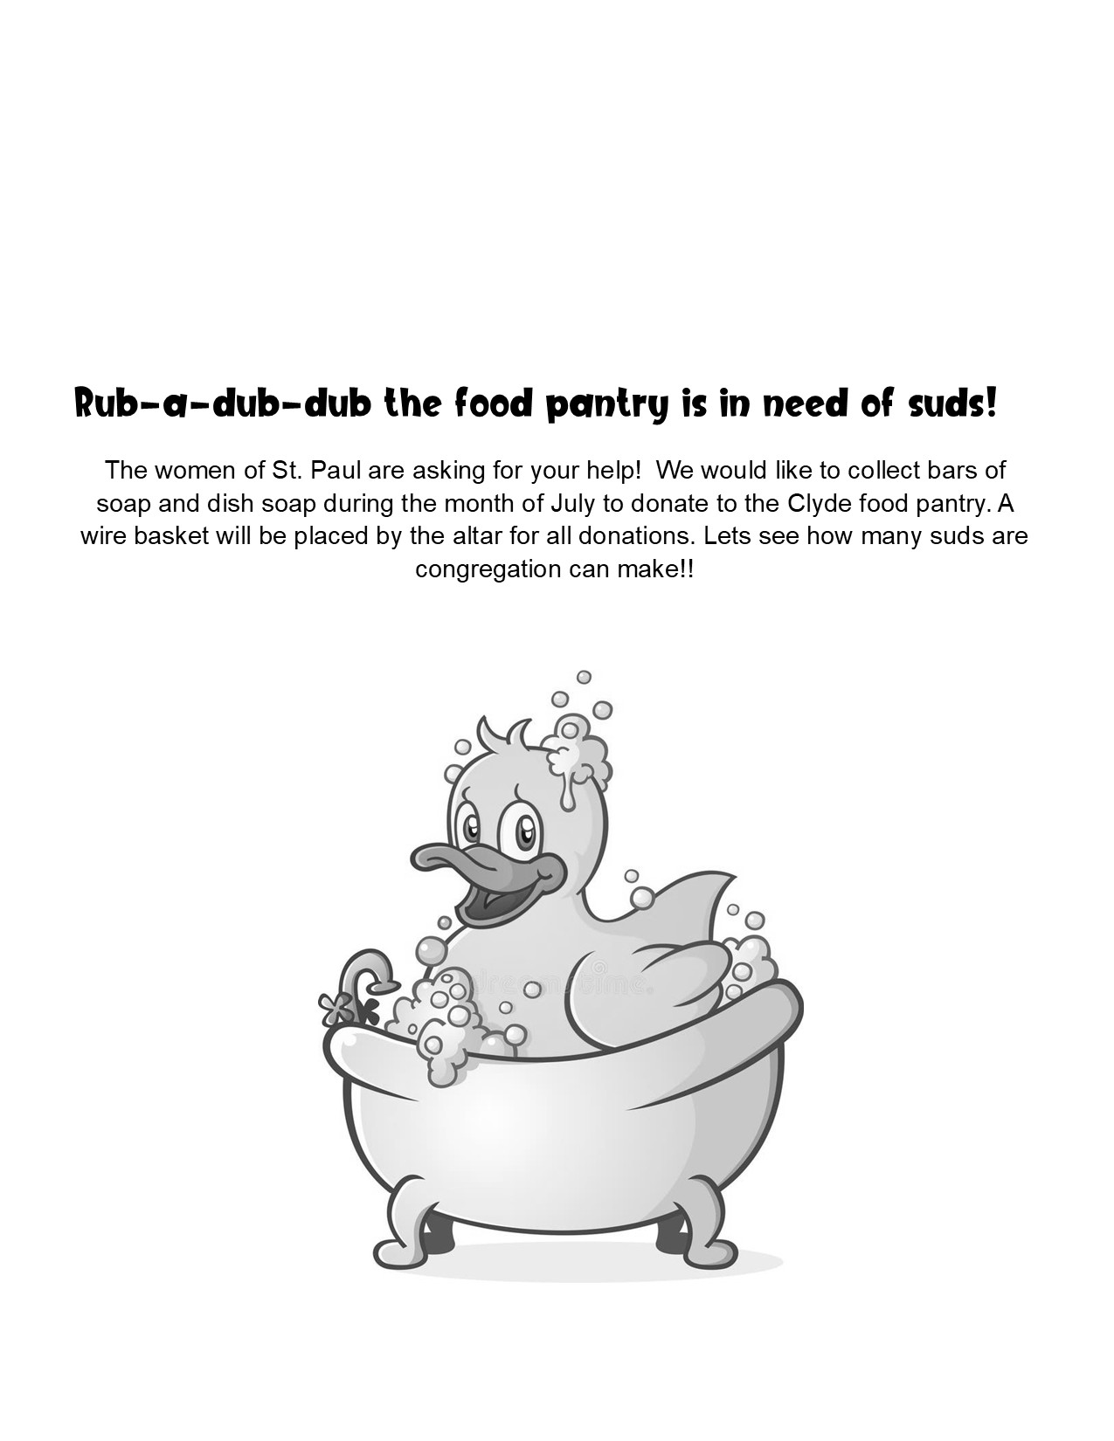

8:00 am Service

COMPUTER TECH: Matt Woodland

READER: Jane Hilton

USHERS: Kevin Larkins
Michelle Larkins
Brenda Sieger
Jim Sieger

* * * * * * * * * * * * * * * * * * * * * * * *

The Rev. Dr. Tim Hubert Phone: 217-778-8017

Office Manager – Stephanie Stull Phone: 419-547-9225

Clerical Secretary – Sherry Bouyack Phone: 419-547-9225

Custodian – Terry Langham Phone: 419-547-9225

Treasurer – Jim Shull Phone: 419-355-6499

P & W Leader – Brian Farrar Phone: 419-271-3085

Organist
Mary Ellen Wollenslegel

http://www.stpaulclyde.org

* * * * * * * * * * * * * * * * * * * * * * * *
OUR STEWARDSHIP Totals for Year-to-Date 2025

Worship Attendance for weekend of June 28 & 29, 2025 121

Income from January – April 30, 2025 $ 103,899.98
Expense for January – April 30, 2025 $ 112,258.15
Shortage for January – April 30, 2025 $ - 8,358.17

