Twelfth Sunday after Pentecost
Sunday, August 16, 2026
8:00 am

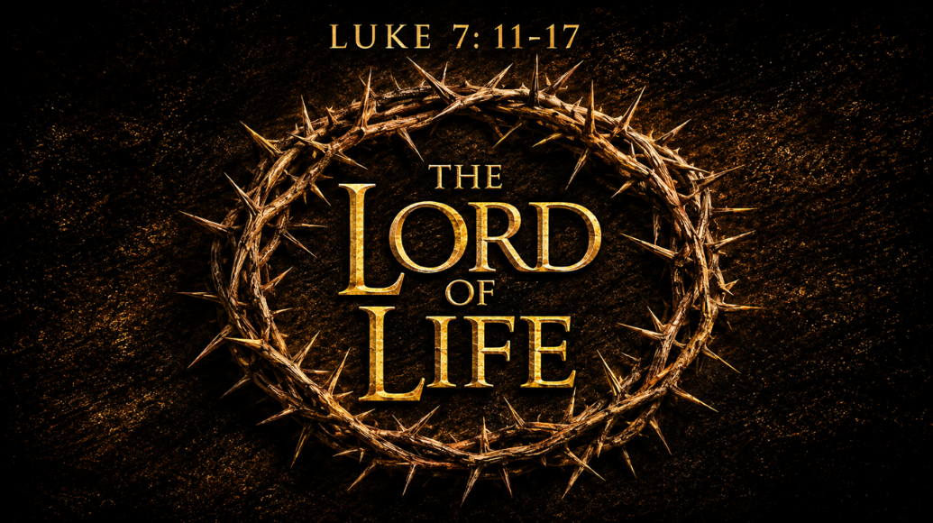

147 West Forest Street Clyde, Ohio
Prelude, Bell & Announcements
Confession & Forgiveness Pg. 94
P: In the name of the Father, and of the ☩ Son, and of the Holy Spirit.
C: Amen.
P: God of all mercy and consolation, come to the help of your people, turning us from our sin to live for you alone. Give us the power of your Holy Spirit that we may confess our sin, receive your forgiveness and grow into the fullness of Jesus Christ, our Savior and Lord.
C: Amen.
P: Let us confess our sin in the presence of God and of one another.
P: Most merciful God,
C: We confess that we are captive to sin and cannot free ourselves. We have sinned against you in thought, word, and deed, by what we have done and by what we have left undone. We have not loved you with our whole heart; we have not loved our neighbors as ourselves. For the sake of your Son, Jesus Christ, have mercy on us. Forgive us, renew us, and lead us, so that we may delight in your will and walk in your ways, to the glory of your holy name. Amen.
P: God who is rich in mercy, loved us even when we were dead in sin, and made us alive together with Christ. By grace you have been saved. In the name of Jesus Christ, the entirety of your sins are forgiven. Almighty God strengthen you with power through the Holy Spirit, that Christ may live in your hearts through faith.
C: Amen.
Hymn “We Come To You For Healing Lord” 5vs #617
The Apostolic Greeting Pg. 147
P: The grace of our Lord Jesus Christ, the love of God, and the communion of the Holy Spirit be with you all.
C: And also with you.
The Kyrie Pg. 147
P: In peace, let us pray to the Lord.
C: Lord, have mercy.
P: For the peace from above, and for our salvation, let us pray to the Lord.
C: Lord, have mercy.
P: For the peace of the whole world, for the well-being of the church of God, and for the unity of all, let us pray to the Lord.
C: Lord, have mercy.
P: For this holy house, and for all who offer here their worship and praise, let us pray to the Lord.
C: Lord, have mercy.
P: Help, save, comfort, and defend us gracious Lord.
C: Amen.
The Hymn of Praise Pg. 149
P: This is the feast of victory for our God. Alleluia.
Worthy is Christ, the Lamb who was slain, whose blood set us free to be people of God. Power and riches and wisdom and strength, and honor and blessing and glory are his.
This is the feast of victory for our God. Alleluia.
Sing with all the people of God and join in the hymn of all creation: Blessing and honor and glory and might be to God and the Lamb forever. Amen.
This is the feast of victory for our God, for the Lamb who was slain has begun his reign. Alleluia. Alleluia.
The Prayer of the Day
Almighty, eternal God, increase in us your gifts of faith, hope and love; and in order that love may abide in us, help us to celebrate what your love has done for us. Grant this, we pray, through Jesus Christ, your Son, our Lord, who lives and reigns with you and the Holy Spirit, one God, now and forever. Amen.
The First Reading: 1 Kings 17:17–24
¹⁷After this the son of the woman, the mistress of the house, became ill. And his illness was so severe that there was no breath left in him. ¹⁸And she said to Elijah, “What have you against me, O man of God? You have come to me to bring my sin to remembrance and to cause the death of my son!” ¹⁹And he said to her, “Give me your son.” And he took him from her arms and carried him up into the upper chamber where he lodged, and laid him on his own bed. ²⁰And he cried to the Lord, “O Lord my God, have you brought calamity even upon the widow with whom I sojourn, by killing her son?” ²¹Then he stretched himself upon the child three times and cried to the Lord, “O Lord my God, let this child’s life come into him again.” ²²And the Lord listened to the voice of Elijah. And the life of the child came into him again, and he revived. ²³And Elijah took the child and brought him down from the upper chamber into the house and delivered him to his mother. And Elijah said, “See, your son lives.” ²⁴And the woman said to Elijah, “Now I know that you are a man of God, and that the word of the Lord in your mouth is truth.”
L: The Word of the Lord.
C: Thanks be to God.
Psalm 30:1–5, 10–12
¹I will extol you, O Lord, for you have drawn me up
and have not let my foes rejoice over me.
²O Lord my God, I cried to you for help,
and you have healed me.
³O Lord, you have brought up my soul from Sheol;
you restored me to life from among those who go down to the pit.
⁴Sing praises to the Lord, O you his saints,
and give thanks to his holy name.
⁵ For his anger is but for a moment,
and his favor is for a lifetime.
Weeping may tarry for the night,
but joy comes with the morning.
¹⁰ Hear, O Lord, and be merciful to me!
O Lord, be my helper!”
¹¹You have turned for me my mourning into dancing;
you have loosed my sackcloth
and clothed me with gladness,
¹²that my glory may sing your praise and not be silent.
L: Here ends the reading of the Psalm.
C: Thanks be to God.
The Second Reading: 1 Corinthians 15:20–26
²⁰But in fact Christ has been raised from the dead, the firstfruits of those who have fallen asleep.²¹For as by a man came death, by a man has come also the resurrection of the dead.²²For as in Adam all die, so also in Christ shall all be made alive.²³But each in his own order: Christ the firstfruits, then at his coming those who belong to Christ.²⁴Then comes the end, when he delivers the kingdom to God the Father after destroying every rule and every authority and power.²⁵For he must reign until he has put all his enemies under his feet. ²⁶The last enemy to be destroyed is death.
L: The Word of the Lord.
C: Thanks be to God.

The Gospel Acclamation Pg. 151
Alleluia. Lord, to whom shall we go? You have the words of eternal life. Alleluia.
P: The Holy Gospel according to St. Luke, the 7th chapter.
C: Glory to You, O Lord.
The Gospel: Luke 7:11-17
¹¹Soon afterward he went to a town called Nain, and his disciples and a great crowd went with him. ¹²As he drew near to the gate of the town, behold, a man who had died was being carried out, the only son of his mother, and she was a widow, and a considerable crowd from the town was with her. ¹³And when the Lord saw her, he had compassion on her and said to her, “Do not weep.” ¹⁴Then he came up and touched the bier, and the bearers stood still. And he said, “Young man, I say to you, arise.” ¹⁵And the dead man sat up and began to speak, and Jesus gave him to his mother. ¹⁶Fear seized them all, and they glorified God, saying, “A great prophet has arisen among us!” and “God has visited his people!” ¹⁷And this report about him spread through the whole of Judea and all the surrounding country.
P: Gospel of the Lord
C: Praise to You, O Christ.
Sermon:
“The Lord of Life”
Luke 7:11-17
Pastor Sam Dagg
The Hymn “How Firm A Foundation” 4vs #796

Prayers of Intercession
Vickie Aldrich
Gwendolyn Baughn
Molly Binder
Michelle Borodkin
Courtney Bouyack
Tim Cooper
Toni Dagg
Crew Dearth
Sharon Duskin
Becky Karr
Kris Larkins
Denise McCubbin
Matt Pumphrey
Maverick Salazar
Lindsay Sooy
Larry Sumner
Conner Whaley
Sandy Wott
Jim Shull
Matt Woodland
Sandy Gray
Deacon Norbert
THE APOSTLES’ CREED (back cover of the hymnal)
The Peace of the Lord Pg. 152
P: The peace of the Lord be with you.
C: And also, with you.
The Passing of the Peace
The Offering
The Offering Prayer
Blessed are you, O God, maker of all things. Through your goodness you have blessed us with these gifts: our possessions. Use us, and what we have gathered, in feeding the world with your love, through the one who gave himself for us, Jesus Christ, our Savior and Lord. Amen.

The Great Thanksgiving Pg. 152
P: The Lord be with you.
C: And also, with you.
P: Lift up your hearts.
C: We lift them to the Lord.
P: Let us give thanks to the Lord our God.
C: It is right to give our thanks and praise.
The Proper Preface
P: It is indeed right, our duty and our joy, that we should at all times and in all places give thanks and praise to You, almighty and merciful God. You reveal Your glory as the glory of the Father, the Son, and the Holy Spirit; equal in majesty, undivided in splendor, one Lord, one God, ever to be adored in Your eternal glory. And so, with all the choirs of angels, with the church on earth and the hosts of heaven, we praise Your name and join their unending hymn:
C: Holy, holy, holy Lord,
Lord God of power and might,
heav’n and earth are full of your glory.
Hosanna in the highest.
Blessed is he who comes in the name of the Lord.
Hosanna in the highest.
The Words of Institution
The Lord’s Prayer Pg. 154
P: Gathered into one by the Holy Spirit, let us pray as Jesus taught us.
C: Our Father, Who art in heaven, hallowed be Thy name, Thy kingdom come, Thy will be done, on earth as it is in heaven. Give us this day our daily bread; and forgive us our trespasses, as we forgive those who trespass against us; and lead us not into temptation, but deliver us from evil. For Thine is the kingdom, and the power, and the glory, forever and ever. Amen.
Invitation to Communion Pg. 154 P: Come to the banquet, for all is now ready.
Holy Communion
All baptized believers in Jesus Christ as Lord are invited to receive communion today. Please follow the pastor’s instructions.
The Post Communion Blessing
P: The body and blood of our Lord Jesus Christ strengthen you and keep you in His grace.
C: Amen.
Prayer After Communion
P: Let us pray.
C: O God, we give You thanks that You have set before us this feast, the body and blood of Your Son. By Your Spirit strengthen us to serve all in need and to give ourselves away as bread for the hungry, through Jesus Christ our Lord. Amen.
The Hymn “When Morning Gilds The Skies”5vs #853
The Benediction
P: May the Lord bless you and keep you;
the Lord make his face shine on you and be gracious to you;
the Lord turn his face toward you and give you peace.
In the name of the Father,
and of the ☩ Son,
and of the Holy Spirit.
C: Amen.
The Dismissal
P: GO IN PEACE. SERVE THE LORD!
C: Thanks be to God.
The Postlude
Lutheran Disaster Response Flood Buckets
You’ll notice five-gallon buckets at the front of the church. We’ve invited our whole congregation to help assemble flood relief buckets for Lutheran Disaster Response.
These buckets are to be filled with cleaning supplies and given to families after floods, hurricanes and other natural disasters. It’s a simple practical way for our church family to serve people in their time of need and show the love of Christ. If you have buckets, please return them by August 30th. Thank you!
* * * * * * * * * * * * * * * * * * * * * * * * * * * * * * * * * * * * * * * * * *


* * * * * * * * * * * * * * * * * * * * * * * * * * * * * * * * * * * * * * * * * *
ALTAR FLOWERS

The altar flowers are given to the Glory of God by Tammy Baker in honor of her daughter Shelby’s birthday on August 11th.
* * * * * * * * * * * * * * * * * * * * * * * * * * * * * * * * * * * * * * * * * *

You will find a table in the Parish Hall filled with books that are offered free for the taking. Please visit the table and take as many as you wish. Happy Reading!
* * * * * * * * * * * * * * * * * * * * * * * * * * * * * * * * * * * * * * * * * *
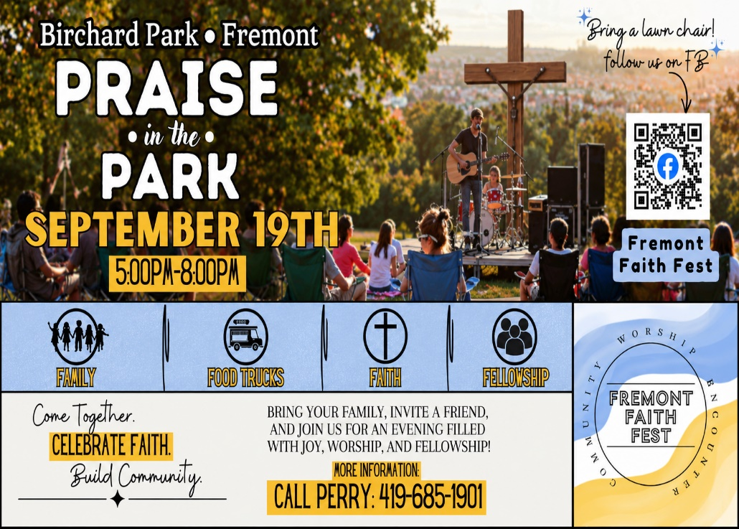

August 2026
Sunday  16 | 8:00 am ~ Worship  10:30 am ~ Worship
Monday  17 | 11:00 am ~ Don Franks Funeral Service  6:30 pm ~ Co-Ed Bible Study
Tuesday  18 | 6:30 pm ~ Men’s Bible Study  7:00 pm ~ Fun Board Meeting
Wednesday 19 | 6:00 pm ~ Women’s Bible Study
Thursday  20 | 7:00 pm ~ Council Meeting  7:00 pm ~ Al-Anon Meeting  8:00 pm ~ AA Meeting
Friday
21
Saturday  22 | 8:00 am ~ Men’s Bible Study  5:00 pm ~ Worship
Sunday  23 | 8:00 am ~ Worship  10:30 am ~ Worship

August 8-9 Attendance: 171
8:00 am Service
COMPUTER TECH: Kevin Larkins
READER: Barb Wahl
USHERS: Tim Billings
Jeff Haughawout
Diane Hurst
Bob Kessler

* * * * * * * * * * * * * * * * * * * * * * * * * * * * * * * * * * * * * * * * * *
Church Office Phone: 419-547-9225
Jamie Farrar Phone: 419-603-6731
sec@stpaulclyde.org
Pastor Samuel Dagg Phone: 567-342-2137
pastor@stpaulclyde.org
Matt Woodland ~ Council President Phone: 419-603-0567
prez@stpaulclyde.org
Jim Shull ~ Treasurer Phone: 419-355-6499
treas@stpaulclyde.org
Brian Farrar ~ P & W Leader Phone: 419-271-3085
pwl@stpaulclyde.org
Ashley Reed ~ Assistant Secretary asst.sec@stpaulclyde.org
Sherry Bouyack ~ Clerical Secretary fisec@stpaulclyde.org
Organist
Mary Ellen Wollenslegel
* * * * * * * * * * * * * * * * * * * * * * * * * * * * * * * * * * * * *

