Twelfth Sunday After Pentecost
Sunday, August 16, 2026
10:30 am

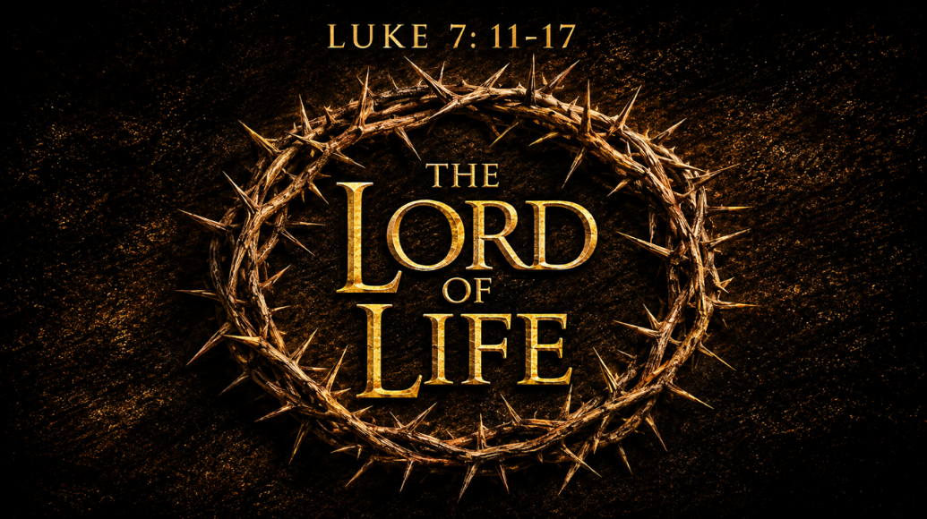

147 West Forest Street Clyde, Ohio

Prayer List
Vickie Aldrich
Gwendolyn Baughn
Molly Binder
Michelle Borodkin
Courtney Bouyack
Tim Cooper
Toni Dagg
Crew Dearth
Sharon Duskin
Becky Karr
Kris Larkins
Denise McCubbin
Matt Pumphrey
Maverick Salazar
Lindsay Sooy
Larry Sumner
Conner Whaley
Sandy Wott
Jim Shull
Matt Woodland
Sandy Gray
Deacon Norbert


* * * * * * * * * * * * * * * * * * * * * * * * * * * * * * * * * * * * * * * * * *
ALTAR FLOWERS

The altar flowers are given to the Glory of God by Tammy Baker in honor of her daughter Shelby’s birthday on August 11th.
* * * * * * * * * * * * * * * * * * * * * * * * * * * * * * * * * * * * * * * * * *

Lutheran Disaster Response Flood Buckets
You’ll notice five-gallon buckets at the front of the church. We’ve invited our whole congregation to help assemble flood relief buckets for Lutheran Disaster Response.
These buckets are filled with cleaning supplies and given to families after floods, hurricanes and other natural disasters. It’s a simple practical way for our church family to serve people in their time of need and show the love of Christ. If you have buckets, please return them by August 30th. Thank you!

* * * * * * * * * * * * * * * * * * * * * * * * * * * * * * * * * * * * * * * * * *

* * * * * * * * * * * * * * * * * * * * * * * * * * * * * * * * * * * * * * * * * *


* * * * * * * * * * * * * * * * * * * * * * * * * * * * * * * * * * * * * * * * * *


You will find a table in the Parish Hall filled with books that are offered free for the taking. Please visit the table and take as many as you wish. Happy Reading!
* * * * * * * * * * * * * * * * * * * * * * * * * * * * * * * * * * * * * * * * * *


August 2026
Sunday  16 | 8:00 am ~ Worship  10:30 am ~ Worship
Monday  17 | 11:00 am ~ Don Franks Funeral Service  6:30 pm ~ Co-Ed Bible Study
Tuesday  18 | 6:30 pm ~ Men’s Bible Study  7:00 pm ~ Fun Board Meeting
Wednesday 19 | 6:00 pm ~ Women’s Bible Study
Thursday  20 | 7:00 pm ~ Council Meeting  7:00 pm ~ Al-Anon Meeting  8:00 pm ~ AA Meeting
Friday
21
Saturday  22 | 8:00 am ~ Men’s Bible Study  5:00 pm ~ Worship
Sunday  23 | 8:00 am ~ Worship  10:30 am ~ Worship

August 8-9 Attendance: 171

10:30 Service
ACOLYTE:
USHERS: Gary Wott
Kendall Rieman
Lisa Rieman
Deanna Turner
COUNTERS: Jackie Hoppe
Lisa Rieman
Nursery Supervision:

Aug 16th - Dawn Sumner
Aug 23rd - Lisa Reiman
Aug 30th - Christine Potts

* * * * * * * * * * * * * * * * * * * * * * * * * * * * * * * * * * * *
Church Office Phone: 419-547-9225
Jamie Farrar Phone: 419-603-6731
sec@stpaulclyde.org
Pastor Samuel Dagg Phone: 567-342-2137
pastor@stpaulclyde.org
Matt Woodland ~ Council President Phone: 419-603-0567
prez@stpaulclyde.org
Jim Shull ~ Treasurer Phone: 419-355-6499
treas@stpaulclyde.org
Brian Farrar ~ P & W Leader Phone: 419-271-3085
pwl@stpaulclyde.org
Ashley Reed ~ Assistant Secretary asst.sec@stpaulclyde.org
Sherry Bouyack ~ Clerical Secretary fisec@stpaulclyde.org

