Tenth Sunday after Pentecost
Sunday, August 2, 2026
8:00 am

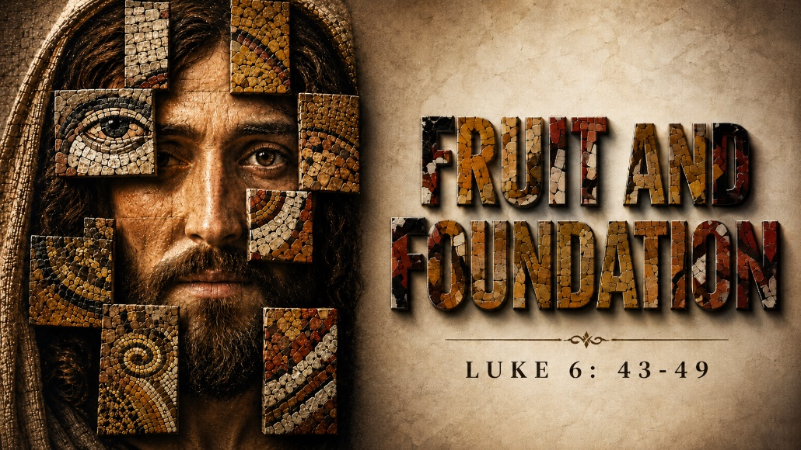

147 West Forest Street Clyde, Ohio
Prelude, Bell & Announcements
Confession & Forgiveness Pg. 94
P: In the name of the Father, and of the ☩ Son, and of the Holy Spirit.
C: Amen.
P: God of all mercy and consolation, come to the help of your people, turning us from our sin to live for you alone. Give us the power of your Holy Spirit that we may confess our sin, receive your forgiveness and grow into the fullness of Jesus Christ, our Savior and Lord.
C: Amen.
P: Let us confess our sin in the presence of God and of one another.
P: Most merciful God,
C: We confess that we are captive to sin and cannot free ourselves. We have sinned against you in thought, word, and deed, by what we have done and by what we have left undone. We have not loved you with our whole heart; we have not loved our neighbors as ourselves. For the sake of your Son, Jesus Christ, have mercy on us. Forgive us, renew us, and lead us, so that we may delight in your will and walk in your ways, to the glory of your holy name. Amen.
P: God who is rich in mercy, loved us even when we were dead in sin, and made us alive together with Christ. By grace you have been saved. In the name of Jesus Christ, the entirety of your sins are forgiven. Almighty God strengthen you with power through the Holy Spirit, that Christ may live in your hearts through faith.
C: Amen.
Hymn “Trust & Obey” CCLI 22094
The Apostolic Greeting Pg. 147
P: The grace of our Lord Jesus Christ, the love of God, and the communion of the Holy Spirit be with you all.
C: And also with you.
The Kyrie Pg. 147
P: In peace, let us pray to the Lord.
C: Lord, have mercy.
P: For the peace from above, and for our salvation, let us pray to the Lord.
C: Lord, have mercy.
P: For the peace of the whole world, for the well-being of the church of God, and for the unity of all, let us pray to the Lord.
C: Lord, have mercy.
P: For this holy house, and for all who offer here their worship and praise, let us pray to the Lord.
C: Lord, have mercy.
P: Help, save, comfort, and defend us gracious Lord.
C: Amen.
The Hymn of Praise Pg. 149
P: This is the feast of victory for our God. Alleluia.
Worthy is Christ, the Lamb who was slain, whose blood set us free to be people of God. Power and riches and wisdom and strength, and honor and blessing and glory are his.
This is the feast of victory for our God. Alleluia.
Sing with all the people of God and join in the hymn of all creation: Blessing and honor and glory and might be to God and the Lamb forever. Amen.
This is the feast of victory for our God, for the Lamb who was slain has begun his reign. Alleluia. Alleluia.
The Prayer of the Day
Almighty, eternal God, your kindness is far more than we desire or deserve. Generously pour out your mercy to forgive where our conscience is afraid and to provide that for which by ourselves, we do not even presume to pray; through Jesus Christ, your Son, our Lord, who lives and reigns with you and the Holy Spirit, one God, now and forever. Amen.
The First Reading: Isaiah 28:14–17
¹⁴Therefore hear the word of the Lord, you scoffers, who rule this people in Jerusalem! ¹⁵Because you have said, “We have made a covenant with death, and with Sheol we have an agreement, when the overwhelming whip passes through it will not come to us, for we have made lies our refuge, and in falsehood we have taken shelter”; ¹⁶therefore thus says the Lord God, “Behold, I am the one who has laid as a foundation in Zion, a stone, a tested stone, a precious cornerstone, of a sure foundation: ‘Whoever believes will not be in haste.’ ¹⁷And I will make justice the line, and righteousness the plumb line; and hail will sweep away the refuge of lies, and waters will overwhelm the shelter.”
L: The Word of the Lord.
C: Thanks be to God.
Psalm 62:1–8
¹For God alone my soul waits in silence; from him comes my salvation.
²He alone is my rock and my salvation, my fortress; I shall not be greatly shaken.
³How long will all of you attack a man to batter him, like a leaning wall, a tottering fence?
⁴They only plan to thrust him down from his high position. They take pleasure in falsehood. They bless with their mouths, but inwardly they curse.
⁵For God alone, O my soul, wait in silence, for my hope is from him.
⁶He only is my rock and my salvation, my fortress; I shall not be shaken.
⁷On God rests my salvation and my glory; my mighty rock, my refuge is God.
⁸ Trust in him at all times, O people; pour out your heart before him; God is a refuge for us.
L: Here ends the reading of the Psalm.
C: Thanks be to God.
The Second Reading: James 1:22-27
²²But be doers of the word, and not hearers only, deceiving yourselves. ²³For if anyone is a hearer of the word and not a doer, he is like a man who looks intently at his natural face in a mirror. ²⁴For he looks at himself and goes away and at once forgets what he was like. ²⁵But the one who looks into the perfect law, the law of liberty, and perseveres, being no hearer who forgets but a doer who acts, he will be blessed in his doing. ²⁶If anyone thinks he is religious and does not bridle his tongue but deceives his heart, this person’s religion is worthless. ²⁷Religion that is pure and undefiled before God the Father is this: to visit orphans and widows in their affliction, and to keep oneself unstained from the world.
L: The Word of the Lord.
C: Thanks be to God.
The Gospel Acclamation Pg. 151
Alleluia. Lord, to whom shall we go? You have the words of eternal life. Alleluia.
P: The Holy Gospel according to St. Luke, the 6th chapter.
C: Glory to You, O Lord.

The Gospel: Luke 6:43-49
⁴³“For no good tree bears bad fruit, nor again does a bad tree bear good fruit, ⁴⁴for each tree is known by its own fruit. For figs are not gathered from thornbushes, nor are grapes picked from a bramble bush. ⁴⁵The good person out of the good treasure of his heart produces good, and the evil person out of his evil treasure produces evil, for out of the abundance of the heart his mouth speaks.⁴⁶“Why do you call me ‘Lord, Lord,’ and not do what I tell you? ⁴⁷Everyone who comes to me and hears my words and does them, I will show you what he is like: ⁴⁸he is like a man building a house, who dug deep and laid the foundation on the rock. And when a flood arose, the stream broke against that house and could not shake it, because it had been well built. ⁴⁹But the one who hears and does not do them is like a man who built a house on the ground without a foundation. When the stream broke against it, immediately it fell, and the ruin of that house was great.”P: The Gospel of the Lord.
C: Praise to You, O Christ.
Sermon:
“Fruit and Foundation”
Luke 6:43-49
Pastor Sam Dagg
The Hymn “The Church's One Foundation” #654

Prayers of Intercession
Vickie Aldrich
Gwendolyn Baughn
Molly Binder
Michelle Borodkin
Courtney Bouyack
Tim Cooper
Toni Dagg
Crew Dearth
Sharon Duskin
Becky Karr
Kris Larkins
Denise McCubbin
Karen Nimms
Matt Pumphrey
Maverick Salazar
Lindsay Sooy
Larry Sumner
Conner Whaley
Sandy Wott
Katie Spence
Millie Burr
Sharon McGlohn
Sandy Gray
Riley Recker
Larry Bower
Jim Shull
Dennis Gossett
Matt Woodland
Family & Friends of Don Franks
THE APOSTLES’ CREED (back cover of the hymnal)
The Peace of the Lord Pg. 152
P: The peace of the Lord be with you.
C: And also, with you.
The Passing of the Peace
The Offering
The Offering Prayer
Blessed are you, O God, maker of all things. Through your goodness you have blessed us with these gifts: our possessions. Use us, and what we have gathered, in feeding the world with your love, through the one who gave himself for us, Jesus Christ, our Savior and Lord. Amen.
The Great Thanksgiving Pg. 152
P: The Lord be with you.
C: And also, with you.
P: Lift up your hearts.
C: We lift them to the Lord.
P: Let us give thanks to the Lord our God.
C: It is right to give our thanks and praise.
The Proper Preface
P: It is indeed right, our duty and our joy, that we should at all times and in all places give thanks and praise to You, almighty and merciful God. You reveal Your glory as the glory of the Father, the Son, and the Holy Spirit; equal in majesty, undivided in splendor, one Lord, one God, ever to be adored in Your eternal glory. And so, with all the choirs of angels, with the church on earth and the hosts of heaven, we praise Your name and join their unending hymn:
C: Holy, holy, holy Lord,
Lord God of power and might,
heav’n and earth are full of your glory.
Hosanna in the highest.
Blessed is he who comes in the name of the Lord.
Hosanna in the highest.
The Words of Institution
The Lord’s Prayer Pg. 154
P: Gathered into one by the Holy Spirit, let us pray as Jesus taught us.
C: Our Father, Who art in heaven, hallowed be Thy name, Thy kingdom come, Thy will be done, on earth as it is in heaven. Give us this day our daily bread; and forgive us our trespasses, as we forgive those who trespass against us; and lead us not into temptation, but deliver us from evil. For Thine is the kingdom, and the power, and the glory, forever and ever. Amen.
Invitation to Communion Pg. 154 P: Come to the banquet, for all is now ready.
Holy Communion
All baptized believers in Jesus Christ as Lord are invited to receive communion today. Please follow the directions of the ushers. Children who have not yet received their first communion are also invited to come forward, to receive a blessing.
The Post Communion Blessing
P: The body and blood of our Lord Jesus Christ strengthen you and keep you in His grace.
C: Amen.
Prayer After Communion
P: Let us pray.
C: O God, we give You thanks that You have set before us this feast, the body and blood of Your Son. By Your Spirit strengthen us to serve all in need and to give ourselves away as bread for the hungry, through Jesus Christ our Lord. Amen.
The Hymn “My Hope is Built on Nothing Less” #596
The Benediction
P: May the Lord bless you and keep you;
the Lord make his face shine on you and be gracious to you;
the Lord turn his face toward you and give you peace.
In the name of the Father,
and of the ☩ Son,
and of the Holy Spirit.
C: Amen.
The Dismissal
P: GO IN PEACE. SERVE THE LORD!
C: Thanks be to God.
The Postlude


* * * * * * * * * * * * * * * * * * * * * * * * * * * * * * * * * * * * * * * * * *
ALTAR FLOWERS

The altar flowers are given to the Glory of God by Jane Hilton and Bev Mendoza in memory of their father, Glenn Douglas Pettys, who passed away on July 29, 1961.
* * * * * * * * * * * * * * * * * * * * * * * * * * * * * * * * * * * * * * * * * *
Worship Board will not be meeting the month of August. Their next meeting will be September 10th at 6:00pm.
* * * * * * * * * * * * * * * * * * * * * * * * * * * * * * * * * * * * * * * * * *
Special congregational meeting August 9th
Property Board requested and Church Council approved a special congregational meeting for August 9, 2026, after the 10:30 service. The meeting is to vote to approve or reject several projects that the property board brought to the council meeting on July 16th, 2026.
1. Replace the failing air conditioning unit for the sanctuary.
2. Address the water infiltration that is occurring in the masonry around the south sanctuary doors.
3. Replace several sections of concrete outside the southwest corner of the sanctuary that are cracked and becoming a safety hazard.
4. Replace the flower beds outside the east side of the parish hall along the driveway with concrete.
5. Install ADA operators on one door in the elevator entrance, the men’s room door and lady’s room door on the Sunday School side of the building.
6. Security camera upgrades for the entire building. Additional cameras would also be installed.
7. New blinds for the parish hall windows.
8. Re-key the entire building for increased safety and security purposes.
* * * * * * * * * * * * * * * * * * * * * * * * * * * * * * * * * * * * * * * * * *

* * * * * * * * * * * * * * * * * * * * * * * * * * * * * * * * * * * * * * * * * *
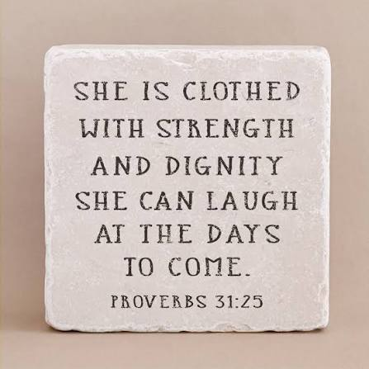
We are excited to welcome Jamie Farrar as the new Secretary at St. Paul!
Jamie will be in the church office Monday through Friday from 8:00 a.m. to 3:30 p.m., with a 30-minute lunch break.
If you need assistance, please contact the church office at 419-547-9225, call or text Jamie directly at 419-603-6731, or email her at sec@stpaulclyde.org.
Ashley's office hours will be limited going forward, so we encourage everyone to reach out to Jamie first for assistance.
Please join us in giving Jamie a warm St. Paul welcome!
* * * * * * * * * * * * * * * * * * * * * * * * * * * * * * * * * * * * * * * * * *

You will find a table in the Parish Hall filled with books that are offered free for the taking. Please visit the table and take as many as you wish. Happy Reading!

* * * * * * * * * * * * * * * * * * * * * * * * * * * * * * * * * * * * * * * * * *
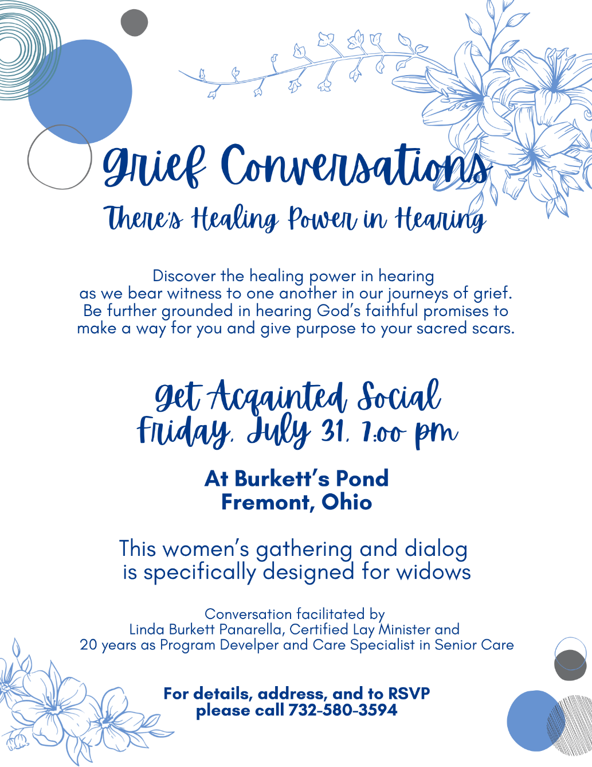
* * * * * * * * * * * * * * * * * * * * * * * * * * * * * * * * * * * * * * * *

August 2026
Sunday  2 | 8:00 am ~ Worship  9:15 am ~ Women’s Board Meeting  10:30 am ~ Worship
Monday  3 | 6:30 pm ~ Co-Ed Bible Study
Tuesday  4 | 6:30 pm ~ Men’s Bible Study  7:00 pm ~ Parish Ed & Youth
Wednesday 5 | 6:00 pm ~ Women’s Bible Study
Thursday  6 | 7:00 pm ~ Al-Anon Meeting  8:00 pm ~ AA Meeting
Friday
7
Saturday  8 | 8:00 am ~ Men’s Bible Study  5:00 pm ~ Worship
Sunday  9 | 8:00 am ~ Worship  10:30 am ~ Worship

July 25-26 Attendance: 162

8:00 am Service
COMPUTER TECH: Ashley Reed
READER: Ashley Reed
USHERS: Kevin Larkins
Michelle Larkins
Jim Sieger
Brenda Sieger

* * * * * * * * * * * * * * * * * * * * * * * * * * * * * * * * * * * * * * * * * *
Church Office Phone: 419-547-9225
Jamie Farrar Phone: 419-603-6731
sec@stpaulclyde.org
Pastor Samuel Dagg Phone: 567-342-2137
pastor@stpaulclyde.org
Matt Woodland ~ Council President Phone: 419-603-0567
prez@stpaulclyde.org
Jim Shull ~ Treasurer Phone: 419-355-6499
treas@stpaulclyde.org
Brian Farrar ~ P & W Leader Phone: 419-271-3085
pwl@stpaulclyde.org
Ashley Reed ~ Assistant Secretary asst.sec@stpaulclyde.org
Sherry Bouyack ~ Clerical Secretary fisec@stpaulclyde.org
Organist
Mary Ellen Wollenslegel
* * * * * * * * * * * * * * * * * * * * * * * * * * * * * * * * * * * * *

