Tenth Sunday After Pentecost
Sunday, August 2, 2026
10:30 am



147 West Forest Street Clyde, Ohio

Prayer List
Vickie Aldrich
Gwendolyn Baughn
Molly Binder
Michelle Borodkin
Courtney Bouyack
Tim Cooper
Toni Dagg
Crew Dearth
Sharon Duskin
Becky Karr
Kris Larkins
Denise McCubbin
Karen Nimms
Matt Pumphrey
Maverick Salazar

Lindsay Sooy
Larry Sumner
Conner Whaley
Sandy Wott
Katie Spence
Millie Burr
Sharon McGlohn
Sandy Gray
Riley Recker
Larry Bower
Jim Shull
Dennis Gossett
Matt Woodland
Family & Friends of Don Franks


* * * * * * * * * * * * * * * * * * * * * * * * * * * * * * * * * * * * * * * * * *
ALTAR FLOWERS

The altar flowers are given to the Glory of God by Jane Hilton and Bev Mendoza in memory of their father, Glenn Douglas Pettys, who passed away on July 29, 1961.
* * * * * * * * * * * * * * * * * * * * * * * * * * * * * * * * * * * * * * * * * *
Worship Board will not be meeting the month of August. Their next meeting will be September 10th at 6:00pm.
* * * * * * * * * * * * * * * * * * * * * * * * * * * * * * * * * * * * * * * * * *
Special congregational meeting August 9th
Property Board requested and Church Council approved a special congregational meeting for August 9, 2026, after the 10:30 service. The meeting is to vote to approve or reject several projects that the property board brought to the council meeting on July 16th, 2026.
1. Replace the failing air conditioning unit for the sanctuary.
2. Address the water infiltration that is occurring in the masonry around the south sanctuary doors.
3. Replace several sections of concrete outside the southwest corner of the sanctuary that are cracked and becoming a safety hazard.
4. Replace the flower beds outside the east side of the parish hall along the driveway with concrete.
5. Install ADA operators on one door in the elevator entrance, the men’s room door and lady’s room door on the Sunday School side of the building.
6. Security camera upgrades for the entire building. Additional cameras would also be installed.
7. New blinds for the parish hall windows.
8. Re-key the entire building for increased safety and security purposes.
* * * * * * * * * * * * * * * * * * * * * * * * * * * * * * * * * * * * * * * * * *

* * * * * * * * * * * * * * * * * * * * * * * * * * * * * * * * * * * * * * * * * *
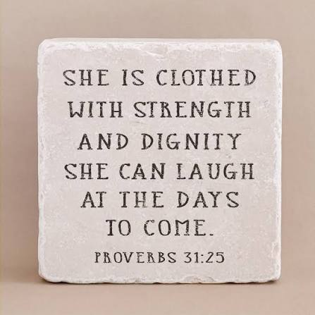
We are excited to welcome Jamie Farrar as the new Secretary at St. Paul!
Jamie will be in the church office Monday through Friday from 8:00 a.m. to 3:30 p.m., with a 30-minute lunch break.
If you need assistance, please contact the church office at 419-547-9225, call or text Jamie directly at 419-603-6731, or email her at sec@stpaulclyde.org.
Ashley's office hours will be limited going forward, so we encourage everyone to reach out to Jamie first for assistance.
Please join us in giving Jamie a warm St. Paul welcome!
* * * * * * * * * * * * * * * * * * * * * * * * * * * * * * * * * * * * * * * * * *

You will find a table in the Parish Hall filled with books that are offered free for the taking. Please visit the table and take as many as you wish. Happy Reading!
* * * * * * * * * * * * * * * * * * * * * * * * * * * * * * * * * * * * * * * * * *


* * * * * * * * * * * * * * * * * * * * * * * * * * * * * * * * * * * * * * * * *

August 2026
Sunday  2 | 8:00 am ~ Worship  9:15 am ~ Women’s Board Meeting  10:30 am ~ Worship
Monday  3 | 6:30 pm ~ Co-Ed Bible Study
Tuesday  4 | 6:30 pm ~ Men’s Bible Study  7:00 pm ~ Parish Ed & Youth
Wednesday 5 | 6:00 pm ~ Women’s Bible Study
Thursday  6 | 7:00 pm ~ Al-Anon Meeting  8:00 pm ~ AA Meeting
Friday
7
Saturday  8 | 8:00 am ~ Men’s Bible Study  5:00 pm ~ Worship
Sunday  9 | 8:00 am ~ Worship  10:30 am ~ Worship

July 25-26 Attendance: 162

10:30 Service
ACOLYTE:
USHERS: Gary Wott
Tom Billings
Keyli Billings
Steve Jess
COUNTERS: Sherry Frasher
Jennie McCoy
Michelle Dagg
* * * * * * * * * * * * * * * * * * * * * * * * * * * * * * * * * * * *
Church Office Phone: 419-547-9225
Jamie Farrar Phone: 419-603-6731
sec@stpaulclyde.org
Pastor Samuel Dagg Phone: 567-342-2137
pastor@stpaulclyde.org
Matt Woodland ~ Council President Phone: 419-603-0567
prez@stpaulclyde.org
Jim Shull ~ Treasurer Phone: 419-355-6499
treas@stpaulclyde.org
Brian Farrar ~ P & W Leader Phone: 419-271-3085
pwl@stpaulclyde.org
Ashley Reed ~ Assistant Secretary asst.sec@stpaulclyde.org
Sherry Bouyack ~ Clerical Secretary fisec@stpaulclyde.org


Sermon Notes

