14th Sunday after Pentecost
Sunday August 30, 2026
8:00 am

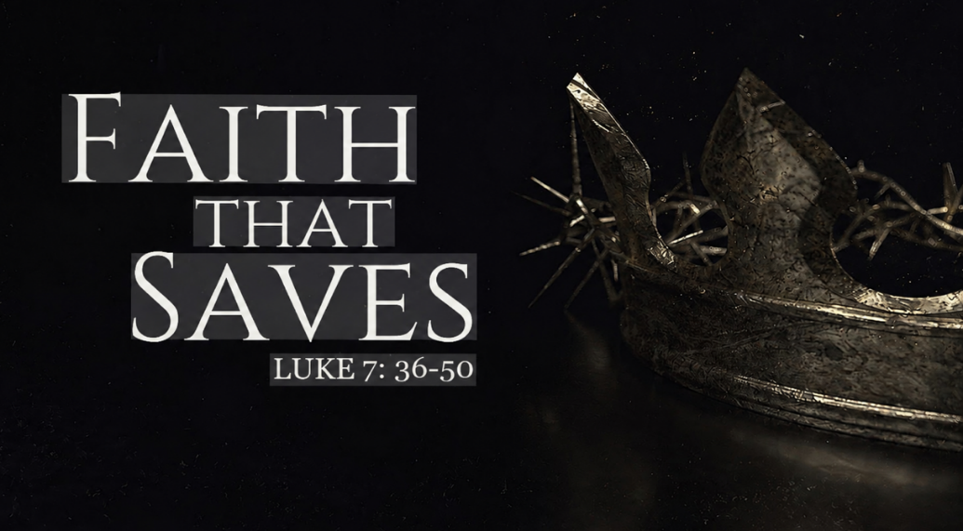

147 West Forest Street Clyde, Ohio
Prelude, Bell & Announcements
Confession & Forgiveness Pg. 94
P: In the name of the Father, and of the ☩ Son, and of the Holy Spirit.
C: Amen.
P: God of all mercy and consolation, come to the help of your people, turning us from our sin to live for you alone. Give us the power of your Holy Spirit that we may confess our sin, receive your forgiveness and grow into the fullness of Jesus Christ, our Savior and Lord.
C: Amen.
P: Let us confess our sin in the presence of God and of one another.
P: Most merciful God,
C: We confess that we are captive to sin and cannot free ourselves. We have sinned against you in thought, word, and deed, by what we have done and by what we have left undone. We have not loved you with our whole heart; we have not loved our neighbors as ourselves. For the sake of your Son, Jesus Christ, have mercy on us. Forgive us, renew us, and lead us, so that we may delight in your will and walk in your ways, to the glory of your holy name. Amen.
P: God who is rich in mercy, loved us even when we were dead in sin, and made us alive together with Christ. By grace you have been saved. In the name of Jesus Christ, the entirety of your sins are forgiven. Almighty God strengthen you with power through the Holy Spirit, that Christ may live in your hearts through faith.
C: Amen.
Hymn “Rock of Ages” 4vs #623

The Apostolic Greeting Pg. 147
P: The grace of our Lord Jesus Christ, the love of God, and the communion of the Holy Spirit be with you all.
C: And also with you.
The Kyrie Pg. 147
P: In peace, let us pray to the Lord.
C: Lord, have mercy.
P: For the peace from above, and for our salvation, let us pray to the Lord.
C: Lord, have mercy.
P: For the peace of the whole world, for the well-being of the church of God, and for the unity of all, let us pray to the Lord.
C: Lord, have mercy.
P: For this holy house, and for all who offer here their worship and praise, let us pray to the Lord.
C: Lord, have mercy.
P: Help, save, comfort, and defend us gracious Lord.
C: Amen.
The Hymn of Praise Pg. 149
P: This is the feast of victory for our God. Alleluia.
Worthy is Christ, the Lamb who was slain, whose blood set us free to be people of God. Power and riches and wisdom and strength, and honor and blessing and glory are his.
This is the feast of victory for our God. Alleluia.
Sing with all the people of God and join in the hymn of all creation: Blessing and honor and glory and might be to God and the Lamb forever. Amen.
This is the feast of victory for our God, for the Lamb who was slain has begun his reign. Alleluia. Alleluia.
The Prayer of the Day
O Lord, mercifully continue to purify and defend your Church. Since she cannot stand firmly without your power, govern her always by your grace; through Jesus Christ, your Son, our Lord, who lives and reigns with you and the Holy Spirit, one God, now and forever. Amen.
The First Reading: Genesis 15:1-6
¹After these things the word of the Lord came to Abram in a vision: “Fear not, Abram, I am your shield; your reward shall be very great.” ²But Abram said, “O Lord God, what will you give me, for I continue childless, and the heir of my house is Eliezer of Damascus?” ³And Abram said, “Behold, you have given me no offspring, and a member of my household will be my heir.” ⁴And behold, the word of the Lord came to him: “This man shall not be your heir; your very own son shall be your heir.” ⁵And he brought him outside and said, “Look toward heaven, and number the stars, if you are able to number them.” Then he said to him, “So shall your offspring be.” ⁶And he believed the Lord, and he counted it to him as righteousness.
L: The Word of the Lord.
C: Thanks be to God.
Psalm 32:1-7
¹Blessed is the one whose transgression is forgiven, whose sin is covered.
²Blessed is the man against whom the Lord counts no iniquity, and in whose spirit there is no deceit.
³For when I kept silent, my bones wasted away through my groaning all day long.
⁴For day and night your hand was heavy upon me; my strength was dried up as by the heat of summer.

⁵I acknowledged my sin to you,and I did not cover my iniquity;I said, “I will confess my transgressions to the Lord,” and you forgave the iniquity of my sin.
⁶Therefore let everyone who is godly offer prayer to you at a time when you may be found; surely in the rush of great waters, they shall not reach him.
⁷You are a hiding place for me; you preserve me from trouble; you surround me with shouts of deliverance.
L: Here ends the reading of the Psalm.
C: Thanks be to God.
The Second Reading: Romans 3:21-26
²¹But now the righteousness of God has been manifested apart from the law, although the Law and the Prophets bear witness to it—²²the righteousness of God through faith in Jesus Christ for all who believe. For there is no distinction: ²³for all have sinned and fall short of the glory of God, ²⁴and are justified by his grace as a gift, through the redemption that is in Christ Jesus, ²⁵whom God put forward as a propitiation by his blood, to be received by faith. This was to show God’s righteousness, because in his divine forbearance he had passed over former sins.²⁶It was to show his righteousness at the present time, so that he might be just and the justifier of the one who has faith in Jesus.
L: The Word of the Lord.
C: Thanks be to God.
The Gospel Acclamation Pg. 151
Alleluia. Lord, to whom shall we go? You have the words of eternal life. Alleluia.
P: The Holy Gospel according to St. Luke, the 7th chapter.
C: Glory to You, O Lord.
The Gospel: Luke 7:36-50
³⁶One of the Pharisees asked him to eat with him, and he went into the Pharisee’s house and reclined at table. ³⁷And behold, a woman of the city, who was a sinner, when she learned that he was reclining at table in the Pharisee’s house, brought an alabaster flask of ointment, ³⁸and standing behind him at his feet, weeping, she began to wet his feet with her tears and wiped them with the hair of her head and kissed his feet and anointed them with the ointment. ³⁹Now when the Pharisee who had invited him saw this, he said to himself, “If this man were a prophet, he would have known who and what sort of woman this is who is touching him, for she is a sinner.” ⁴⁰And Jesus answering said to him, “Simon, I have something to say to you.” And he answered, “Say it, Teacher.” ⁴¹“A certain moneylender had two debtors. One owed five hundred denarii, and the other fifty. ⁴²When they could not pay, he cancelled the debt of both. Now which of them will love him more?” ⁴³Simon answered, “The one, I suppose, for whom he cancelled the larger debt.” And he said to him, “You have judged rightly.” ⁴⁴Then turning toward the woman he said to Simon, “Do you see this woman? I entered your house; you gave me no water for my feet, but she has wet my feet with her tears and wiped them with her hair. ⁴⁵You gave me no kiss, but from the time I came in she has not ceased to kiss my feet. ⁴⁶You did not anoint my head with oil, but she has anointed my feet with ointment. ⁴⁷Therefore I tell you, her sins, which are many, are forgiven—for she loved much. But he who is forgiven little, loves little.” ⁴⁸And he said to her, “Your sins are forgiven.” ⁴⁹Then those who were at table with him began to say among themselves, “Who is this, who even forgives sins?” ⁵⁰And he said to the woman, “Your faith has saved you; go in peace.”
P: Gospel of the Lord
C: Praise to You, O Christ.

Sermon:
“Faith That Saves”
Luke 7:36-50
Pastor Sam Dagg
The Hymn “Just a Closer Walk With Thee” 3vs #697
Prayers of Intercession
Vickie Aldrich
Gwendolyn Baughn
Molly Binder
Michelle Borodkin
Courtney Bouyack
Tim Cooper
Toni Dagg
Crew Dearth
Sharon Duskin
Becky Karr
Kris Larkins
Denise McCubbin
Matt Pumphrey
Maverick Salazar
Lindsay Sooy
Larry Sumner
Conner Whaley
Sandy Wott
Matt Woodland
Sandy Gray
Deacon Norbert
Tim and his Family
Fran Morris
THE APOSTLES’ CREED (back cover of the hymnal)
The Peace of the Lord Pg. 152
P: The peace of the Lord be with you.
C: And also, with you.
The Passing of the Peace
The Offering
The Offering Prayer
Blessed are you, O God, maker of all things. Through your goodness you have blessed us with these gifts: our possessions. Use us, and what we have gathered, in feeding the world with your love, through the one who gave himself for us, Jesus Christ, our Savior and Lord. Amen.
The Great Thanksgiving Pg. 152
P: The Lord be with you.
C: And also, with you.
P: Lift up your hearts.
C: We lift them to the Lord.
P: Let us give thanks to the Lord our God.
C: It is right to give our thanks and praise.
The Proper Preface
P: It is indeed right, our duty and our joy, that we should at all times and in all places give thanks and praise to You, almighty and merciful God. You reveal Your glory as the glory of the Father, the Son, and the Holy Spirit; equal in majesty, undivided in splendor, one Lord, one God, ever to be adored in Your eternal glory. And so, with all the choirs of angels, with the church on earth and the hosts of heaven, we praise Your name and join their unending hymn:
C: Holy, holy, holy Lord,
Lord God of power and might,
heav’n and earth are full of your glory.
Hosanna in the highest.
Blessed is he who comes in the name of the Lord.
Hosanna in the highest.
The Words of Institution
The Lord’s Prayer Pg. 154
P: Gathered into one by the Holy Spirit, let us pray as Jesus taught us.
C: Our Father, Who art in heaven, hallowed be Thy name, Thy kingdom come, Thy will be done, on earth as it is in heaven. Give us this day our daily bread; and forgive us our trespasses, as we forgive those who trespass against us; and lead us not into temptation, but deliver us from evil. For Thine is the kingdom, and the power, and the glory, forever and ever. Amen.
Invitation to Communion Pg. 154 P: Come to the banquet, for all is now ready.
Holy Communion
All baptized believers in Jesus Christ as Lord are invited to receive communion today. Please follow the pastor’s instructions.
The Post Communion Blessing
P: The body and blood of our Lord Jesus Christ strengthen you and keep you in His grace.
C: Amen.
Prayer After Communion
P: Let us pray.
C: O God, we give You thanks that You have set before us this feast, the body and blood of Your Son. By Your Spirit strengthen us to serve all in need and to give ourselves away as bread for the hungry, through Jesus Christ our Lord. Amen.
The Hymn “On Our Way Rejoicing” 2vs #537
The Benediction
P: May the Lord bless you and keep you;
the Lord make his face shine on you and be gracious to you;
the Lord turn his face toward you and give you peace.
In the name of the Father,
and of the ☩ Son,
and of the Holy Spirit.
C: Amen.
The Dismissal
P: GO IN PEACE. SERVE THE LORD!
C: Thanks be to God.
The Postlude
Lutheran Disaster Response Flood Buckets
You’ll notice five-gallon buckets at the front of the church. We’ve invited our whole congregation to help assemble flood relief buckets for Lutheran Disaster Response.

These buckets are to be filled with cleaning supplies and given to families after floods, hurricanes and other natural disasters. It’s a simple practical way for our church family to serve people in their time of need and show the love of Christ. If you have buckets, please return them by August 30th. Thank you!
* * * * * * * * * * * * * * * * * * * * * * * * * * * * * * * * * * * * * * * * * *


* * * * * * * * * * * * * * * * * * * * * * * * * * * * * * * * * * * * * * * * * *
ALTAR FLOWERS

The altar flowers are given to the Glory of God by Gary Hirt & Kelly Evans in memory of Rollin & Doris Hirt.
* * * * * * * * * * * * * * * * * * * * * * * * * * * * * * * * * * * * * * * * * *
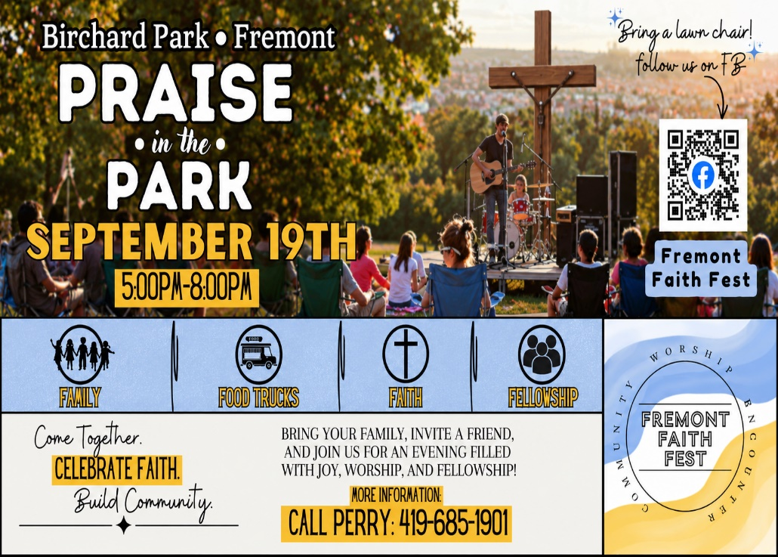



August/September 2026
Sunday  30 | 8:00 am ~ Worship  10:30 am ~ Worship
Monday  31 | 6:30 pm ~ Co-Ed Bible Study
Tuesday  1 | 6:30 pm ~ Men’s Bible Study  7:00 pm ~ Parish Ed/Youth Meeting
Wednesday 2 | 6:00 pm ~ Women’s Bible Study
Thursday  3 | 7:00 pm ~ Al-Anon Meeting  8:00 pm ~ AA Meeting
Friday
4
Saturday  5 | 8:00 am ~ Men’s Bible Study  5:00 pm ~ Worship
Sunday  6 | 8:00 am ~ Worship  9:15 am ~ Women’s Meeting  10:30 am ~ Worship
August 22-23 Attendance: 152

8:00 am Service
COMPUTER TECH: Barb Wahl
READER: Bev Mendoza
USHERS: Kevin Larkins
Tim Billings
Bob Kessler
Jeff Haughawout

* * * * * * * * * * * * * * * * * * * * * * * * * * * * * * * * * * * * * * * * *
Church Office Phone: 419-547-9225
Jamie Farrar Phone: 419-603-6731
sec@stpaulclyde.org
Pastor Samuel Dagg Phone: 567-342-2137
pastor@stpaulclyde.org
Matt Woodland ~ Council President Phone: 419-603-0567
prez@stpaulclyde.org
Jim Shull ~ Treasurer Phone: 419-355-6499
treas@stpaulclyde.org
Brian Farrar ~ P & W Leader Phone: 419-547-9225
pwl@stpaulclyde.org
Ashley Reed ~ Assistant Secretary asst.sec@stpaulclyde.org
Sherry Bouyack ~ Clerical Secretary fisec@stpaulclyde.org
Organist
Mary Ellen Wollenslegel
* * * * * * * * * * * * * * * * * * * * * * * * * * * * * * * * * * * * *
Sermon Notes

