Eighth Sunday after Pentecost
ELW Holy Communion
Traditional Service
Sunday, August 3, 2025
8:00 am



ST. PAUL LUTHERAN CHURCH
147 West Forest Street
Clyde, Ohio

Eighth Sunday after Pentecost

August 3, 2025

8:00 am

Holy Communion ~ Setting Four

* = those who are able may stand
Song numbers with “BB” are from the “The Best of the Best” songbook

Prelude

Bell & Announcements

*Confession & Forgiveness Pg. 94
P: In the name of the Father,
and of the ☩ Son,
and of the Holy Spirit.

C: Amen.

P: God of all mercy and consolation, come to the help of your people, turning us from our sin to live for you alone. Give us the power of your Holy Spirit that we may confess our sin, receive your forgiveness and grow into the fullness of Jesus Christ, our Savior and Lord.

C: Amen.

P: Let us confess our sin in the presence of God and of one another.

P: Most merciful God,

C: we confess that we are captive to sin and cannot free ourselves. We have sinned against you in thought, word, and deed, by what we have done and by what we have left undone. We have not loved you with our whole heart; we have not loved our neighbors as ourselves. For the sake of your Son, Jesus Christ, have mercy on us. Forgive us, renew us, and lead us, so that we may delight in your will and walk in your ways, to the glory of your holy name. Amen.

P: In the mercy of almighty God, Jesus Christ was given to die for us, and for his sake God forgives us all our sins. As a called and ordained minister of the church of Christ, and by his authority, I therefore declare to you the entire forgiveness of all your sins, in the name of the Father, and of the ☩ Son, and of the Holy Spirit.

C: Amen.

*The Hymn “Rock of Ages, Cleft for Me” No. 623

*The Apostolic Greeting Pg. 147
P: The grace of our Lord Jesus Christ, the love of God, and the communion of the Holy Spirit be with you all.

C: And also with you.

*The Kyrie Pg. 147
P: In peace, let us pray to the Lord.
C: Lord, have mercy.

P: For the peace from above, and for our salvation, let us pray to the Lord.
C: Lord, have mercy.

P: For the peace of the whole world, for the well-being of the church of God, and for the unity of all, let us pray to the Lord.
C: Lord, have mercy.

P: For this holy house, and for all who offer here their worship and praise, let us pray to the Lord.
C: Lord, have mercy.

P: Help, save, comfort, and defend us gracious Lord.
C: Amen.

The Hymn of Praise Pg. 149

Refrain
P: This is the feast of victory for our God. Alleluia.

1. Worthy is Christ, the Lamb who was slain, whose blood set us free to be people of God. Power and riches and wisdom and strength, and honor and blessing and glory are his.

Refrain
This is the feast of victory for our God. Alleluia.

2. Sing with all the people of God and join in the hymn of all creation: Blessing and honor and glory and might be to God and the Lamb forever. Amen.

Refrain
This is the feast of victory for our God, for the Lamb who was slain has begun his reign. Alleluia. Alleluia.

The Prayer of the Day (in unison)
Almighty, eternal God, Your kindness is far more than we desire or deserve. Generously pour out Your mercy to forgive where our conscience is afraid and to provide that for which by ourselves, we do not even presume to pray; through Jesus Christ, Your Son, our Lord, Who lives and reigns with You and the Holy Spirit, one God, now and forever. Amen.

The First Lesson ~ Ecclesiastes 1:2, 12-14; 2:18-26
²Vanity of vanities, says the Preacher, vanity of vanities! All is vanity.

¹²I the Preacher have been king over Israel in Jerusalem. ¹³And I applied my heart to seek and to search out by wisdom all that is done under heaven. It is an unhappy business that God has given to the children of man to be busy with. ¹⁴I have seen everything that is done under the sun, and behold, all is vanity and a striving after wind.

¹⁸I hated all my toil in which I toil under the sun, seeing that I must leave it to the man who will come after me, ¹⁹and who knows whether he will be wise or a fool? Yet he will be master of all for which I toiled and used my wisdom under the sun. This also is vanity. ²⁰So I turned about and gave my heart up to despair over all the toil of my labors under the sun, ²¹because sometimes a person who has toiled with wisdom and knowledge and skill must leave everything to be enjoyed by someone who did not toil for it. This also is vanity and a great evil. ²²What has a man from all the toil and striving of heart with which he toils beneath the sun? ²³For all his days are full of sorrow, and his work is a vexation. Even in the night his heart does not rest. This also is vanity. ²⁴There is nothing better for a person than that he should eat and drink and find enjoyment in his toil. This also, I saw, is from the hand of God, ²⁵for apart from him who can eat or who can have enjoyment? ²⁶For to the one who pleases him God has given wisdom and knowledge and joy, but to the sinner he has given the business of gathering and collecting, only to give to one who pleases God. This also is vanity and a striving after wind.

L: The Word of the Lord.
C: Thanks be to God.

Psalm 100
¹Make a joyful noise to the Lord, all the earth!

²Serve the Lord with gladness! Come into His presence with singing!

³Know that the Lord, He is God! It is He who made us, and we are His; we are His people, and the sheep of His pasture.

⁴Enter His gates with thanksgiving, and His courts with praise! Give thanks to Him; bless His name!

⁵For the Lord is good; His steadfast love endures forever, and His faithfulness to all generations.

L: Here ends the reading of the Psalm.
C: Thanks be to God.

The Second Lesson ~ Colossians 3:1-11
¹If then you have been raised with Christ, seek the things that are above, where Christ is, seated at the right hand of God. ²Set your minds on things that are above, not on things that are on earth. ³For you have died, and your life is hidden with Christ in God. ⁴When Christ who is your life appears, then you also will appear with Him in glory. ⁵Put to death therefore what is earthly in you: sexual immorality, impurity, passion, evil desire, and covetousness, which is idolatry. ⁶On account of these the wrath of God is coming. ⁷In these you too once walked, when you were living in them. ⁸But now you must put them all away: anger, wrath, malice, slander, and obscene talk from your mouth. ⁹Do not lie to one another, seeing that you have put off the old self with its practices ¹⁰and have put on the new self, which is being renewed in knowledge after the image of its creator. ¹¹Here there is not Greek and Jew, circumcised and uncircumcised, barbarian, Scythian, slave, free; but Christ is all, and in all.

L: The Word of the Lord.
C: Thanks be to God.

*The “Gospel Acclamation” Pg. 151
Alleluia. Lord, to whom shall we go? You have the words of eternal life. Alleluia.

P: The Holy Gospel according to St. Luke, the 12th chapter.
C: Glory to You, O Lord.

*The Gospel ~ Luke 12:13-21
¹³Someone in the crowd said to {Jesus}, “Teacher, tell my brother to divide the inheritance with me.” ¹⁴But he said to him, “Man, who made me a judge or arbitrator over you?” ¹⁵And he said to them, “Take care, and be on your guard against all covetousness, for one’s life does not consist in the abundance of his possessions.” ¹⁶And he told them a parable, saying, “The land of a rich man produced plentifully, ¹⁷and he thought to himself, ‘What shall I do, for I have nowhere to store my crops?’ ¹⁸And he said, ‘I will do this: I will tear down my barns and build larger ones, and there I will store all my grain and my goods. ¹⁹And I will say to my soul, “Soul, you have ample goods laid up for many years; relax, eat, drink, be merry.”’ ²⁰But God said to him, ‘Fool! This night your soul is required of you, and the things you have prepared, whose will they be?’ ²¹So is the one who lays up treasure for himself and is not rich toward God.”

P: The Gospel of the Lord.
C: Praise to You, O Christ.

The Moment with Children

The Sermon “Be on Your Guard”
Luke 12:13-21
The Rev. Dr. Tim Hubert

*The Hymn “Abide with Me” No. 629

*Prayers of Intercession
Let us pray for the Church, the world, and for one another.

A brief silence

Heavenly Father, You bless us greatly, even when we think we have very little! You give us life and breath. Each new day gives us a chance to repent, forgive, and share Jesus’ love. Help us to thank You for these things, to enjoy them rightly; and to share them generously.

Lord, in Your mercy, hear our prayer.

Clothe Your Church with Christ. Put away from it all evil desires, words, and deeds. Fill it with Your Spirit, so it abounds in every good gift, overflows with Jesus’ life, and leads many to faith in Him.

Lord, in Your mercy, hear our prayer.

Fill the people of this congregation with wisdom and humility. Remind us that everything is done for You, not for ourselves, and that we must one day render an account of our stewardship of Your blessings. Make us faithful, generous, and holy. Use us to draw many people into Your fatherly embrace. We pray for the LCMC & NALC, area congregations and today for St. Paul Lutheran Church of Clyde, Ohio and for Reverend Tim Hubert.

Lord, in Your mercy, hear our prayer.

Keep Your persecuted Church in Your care and bless their faithful witness. Help us to provide for our suffering sisters and brothers from the storehouses of our spiritual and material riches.

Lord, in Your mercy, hear our prayer.

We pray for Your blessing upon our nation – and for all nations. Guide our leaders with Your Spirit of wisdom and understanding, counsel and might. Remind them that they are to be faithful and honest stewards of the power and authority entrusted to them.

Lord, in Your mercy, hear our prayer.

Lord, lead us on the hard path of discipleship. Teach us virtues that are often unpopular: responsibility, accountability, and self-sacrifice, grounded in faith toward You and fervent love for one another.

Lord, in Your mercy, hear our prayer.

We lift before You the suffering and sorrow of Your people, including:

Vickie
Call Committee
Betty
Tim
Toni
Crew
Bob
Helen
Bill
Emily
Katie
Linda
Ed
Kandy
Jill

DEPLOYED
Kyle

Anoint them with the oil of gladness. Heal wounds to body, mind, and soul. Grant that, with those who love them, they may enter Your gates with thanksgiving, and go into Your courts with praise.

Lord, in Your mercy, hear our prayer.

Heavenly Father, keep our beloved dead close to Your heart. Comfort all whose grief runs deep. By the power of Your Spirit, turn our hearts from the folly of sin. Keep us focused on Jesus and His love for us. Make us channels of His forgiveness and grace, because so many people need them. By Your mercy, bring us into Your Kingdom, where with all the redeemed, we shall praise and adore You forever.

Lord, in Your mercy, hear our prayer.

Hear our prayers, gracious Father, offered through the power of the Spirit; and for the sake of Your dear Son, grant us all that is in accordance with Your merciful will, to Your glory and for the good of Your people.

AMEN.

*The Apostles’ Creed (back cover of hymnal)

I believe in God, the Father almighty,
creator of heaven and earth.

I believe in Jesus Christ, His only Son, our Lord,
He was conceived by the Holy Spirit,
born of the virgin Mary,
suffered under Pontius Pilate,
was crucified, died, and was buried;
he descended into hell.
On the third day he rose again;
he ascended into heaven,
he is seated at the right hand of the Father,
and he will come to judge the living and the dead.

I believe in the Holy Spirit,
the holy catholic church,
the communion of saints,
the forgiveness of sins,
the resurrection of the body,
and the life everlasting. Amen

The Peace of the Lord Pg. 152
P: The peace of the Lord be with you.
C: And also, with you.

*The Passing of the Peace (please remain in place)

The Offering

*The Offering Prayer (#3)
Blessed are you, O God, maker of all things. Through your goodness you have blessed us with these gifts: our possessions. Use us, and what we have gathered, in feeding the world with your love, through the one who gave himself for us, Jesus Christ, our Savior and Lord. Amen.

*The Great Thanksgiving Pg. 152
P: The Lord be with you.
C: And also, with you.

P: Lift up your hearts.
C: We lift them to the Lord.

P: Let us give thanks to the Lord our God.
C: It is right to give our thanks and praise.

*The Proper Preface
P: It is indeed right, our duty and our joy, that we should at all times and in all places give thanks and praise to You, almighty and merciful God. You reveal Your glory as the glory of the Father, the Son, and the Holy Spirit; equal in majesty, undivided in splendor, one Lord, one God, ever to be adored in Your eternal glory. And so, with all the choirs of angels, with the church on earth and the hosts of heaven, we praise Your name and join their unending hymn:

*“Holy, Holy, Holy…” Pg. 153
Holy, holy, holy Lord,
Lord God of power and might,
heav’n and earth are full of your glory.
Hosanna in the highest.
Blessed is he who comes in the name of the Lord.
Hosanna in the highest.

*The Words of Institution
In the night in which he was betrayed,
our Lord Jesus took bread, and gave thanks;
broke it, and gave it to his disciples, saying:
Take and eat; this is my body, given for you.
Do this for the remembrance of me.

Again, after supper, he took the cup, gave thanks,
and gave it for all to drink, saying:
This cup is the new covenant in my blood,
shed for you and for all people for the forgiveness of sin.
Do this for the remembrance of me.

*The “Lord’s Prayer” Pg. 154
P: Gathered into one by the Holy Spirit, let us pray as Jesus taught us.

Our Father, who art in heaven,
hallowed be thy name,
thy kingdom come,
thy will be done,
on earth as it is in heaven.

Give us this day our daily bread;
and forgive us our trespasses,
as we forgive those
who trespass against us;
and lead us not into temptation,
but deliver us from evil.

For thine is the kingdom,
and the power, and the glory,
forever and ever. Amen.

*Invitation to Communion Pg. 154
Come to the banquet, for all is now ready.

Holy Communion
All baptized believers in Jesus Christ as Lord are invited to receive communion today. Please follow the directions of the ushers. Children who have not yet received their “first communion” are also invited to come forward, to receive a blessing.

*The Post Communion Blessing
The body and blood…

*Prayer After Communion
P: Let us pray.
O God, we give You thanks that You have set before us this feast, the body and blood of Your Son. By Your Spirit strengthen us to serve all in need and to give ourselves away as bread for the hungry, through Jesus Christ our Lord.
C: Amen.

*The Hymn “Praise and Thanksgiving” No. 689

*The Benediction Pg. 155

*The Dismissal
L: Go in peace. . .
C: Thanks be to God.

The Postlude

* * * * * * * * * * * * * * * * * * * * * * *


Our Good Shepherd calls us into the safekeeping of this fold. May all gathered here feel the welcome and love of God in Christ.

* * * * * * * * * * * * * * * * * * * * * * * *
THE ALTAR FLOWERS are given to the glory of God in loving memories of our grandmothers given by Kevin & Michelle Larkins.

* * * * * * * * * * * * * * * * * * * * * * * *

PRAY FOR ALL OUR HOMEBOUND AND/OR IN MEDICAL CARE FACILITIES:

Thelma Blair, Larry Bower, Bev Bush, Naomi Conley, Jim & Norma Fish, Janet Kauble, LaVerde Kuns, Florence Pocock, Jeanette Pumphrey, Katie Spence, Tina Walker, Carlos & Joyce Weiker, Sandy Wott. If you know of other members who are not listed, please inform the church office, 419-547-9225.

* * * * * * * * * * * * * * * * * * * * * * * *


WE EXTEND OUR DEEPEST SYMPATHY AND
PRAYERS to the family and friends of:

Steven E. Cooper, grandfather of Ryder Cooper & Kendall Cooper, peacefully passed away on Sunday, July 20, 2025, surrounded by the love of his family after a courageous battle with lung cancer.
August 3, 2025 – August 10, 2025

Sunday the  3rd | 8:00 am ~ Holy Communion Worship  9:15 am ~ Women’s Board Meeting  10:30 am ~ Holy Communion Worship Service  NALC CONVOCATION in Pittsburg, PA
Monday the 4th | NALC CONVOCATION in Pittsburg, PA
Tuesday the 5th | 1:00 pm ~ Pericope Meeting  7:00 pm ~ Parish Education Board Meeting  NALC CONVOCATION in Pittsburg, PA
Wednesday the 6th | 10:00 am ~ Women leaving for “Day Tripping” to Pickwick Place in Bucyrus, OH  NALC CONVOCATION in Pittsburg, PA
Thursday the 7th | 7:00 pm – 8:00 pm ~ Al-Anon Meeting  8:00 pm ~ AA Meeting  NALC CONVOCATION in Pittsburg, PA
Friday the 8th | NALC CONVOCATION in Pittsburg, PA
Saturday the 9th | 8:00 am – 9:30 a.m. ~ Men’s Bible Study  10:00 am – 5:00 pm ~ Parish Hall Reserved  5:00 pm ~ Holy Communion Worship
Sunday the  10th | 8:00 am ~ Holy Communion Worship  10:30 am ~ Holy Communion Worship Service
* * * * * * * * * * * * * * * * * * *


WOMEN’S Day Trip

The St. Paul Women’s group will be day-tripping to Pickwick Place in Bucyrus, OH on Wednesday, August 6, 2025.

The Pickwick Place is a multi-generational farm family that turned 3 run-down brick horse barns into exceptional vendor stalls, a market with Ohio-sourced foods, and an upscale cafe.

Leaving the parking lot at 10:00 am, we will have lunch at Pickwick and enjoy an afternoon of fellowship and shopping.

Debbie
* * * * * * * * * * * * * * * * * * * * * * * *
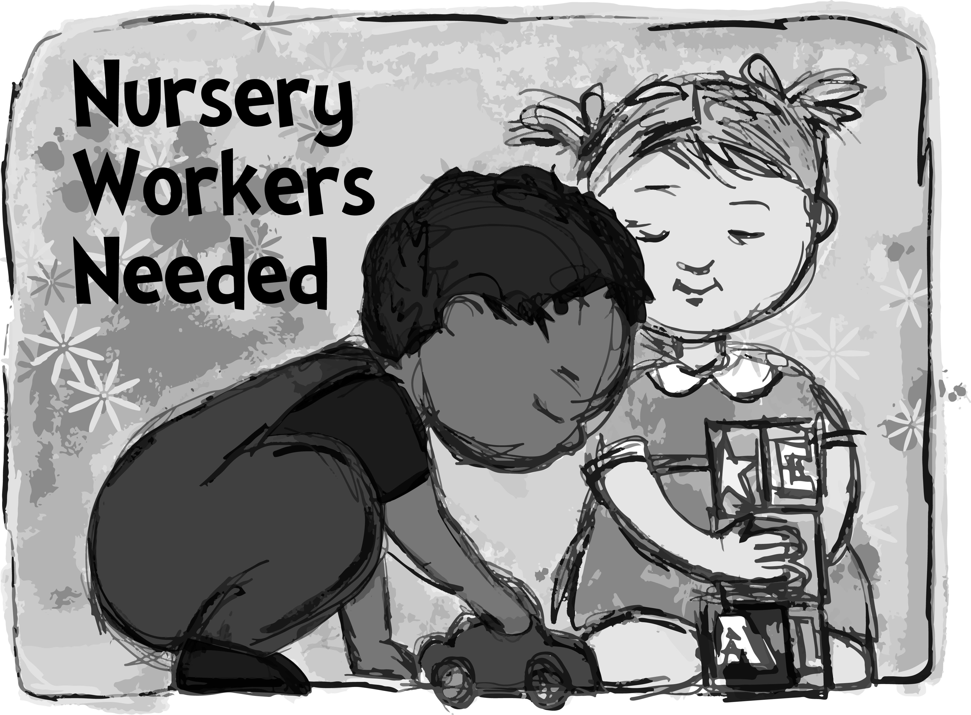

We are looking to have nursery again in the fall at 10:30 a.m. service. Please contact Deanna Turner if you are willing to help in the nursery once every 2 – 3 months. Call or text Deanna at 419-603-0552.
* * * * * * * * * * * * * * * * * * * * * * * *


Pastor Tim’s home address after Sunday, August 31, 2025:

Pastor Tim Hubert
2500 Cleveland Road #102
Wooster, Ohio 44691-1756

* * * * * * * * * * * * * * * * * * * * * * * *


We offer many different ways to donate to St Paul Lutheran Church. The following QR code is the latest way. It can be used to direct you to St. Paul Lutheran Church’s electronic giving sign up page. You can always give using the church envelopes, the link on St Paul’s website at stpaulclyde.org, or donate by texting Donate/Donations to 844-440-0253 as well. Thank you for your continued support!




WHO WANTS TO HELP WITH SUNDAY SCHOOL?
Our Parish Ed & Youth Board is looking for help with our Sunday School. Please consider supporting us & our families with implementing Sunday School to serve our children to grow in their relationship with Jesus and their faith. If you can help with any of these tasks please contact DeAnn Krauss @ 419-937-7514. Thank you for your consideration, we appreciate you, your commitment to our church families & your time.
* Use Sunday School Curriculum to plan or co-plan lessons for each week
* Help organize the Sunday School Materials into binders for teachers to use
* Monitoring the hallway 9:00-10:25 each week or weeks that you are available to do so to greet families and help with restroom breaks, get needed supplies, etc
* Find a craft to go with each lesson (that is prepared) and be ordered & paid for by the church
* Find supplies (floor puzzles, games, etc) to keep the kids busy while waiting for the lesson to start to be ordered and paid for by the church
* Co-Teach Sunday School, 4th/5th Grade
* Substitute Sunday School Co-Teacher
* Create student name tags for boxes in classrooms for the start of the year

WHO WANTS TO REGISTER THEIR CHILD FOR SUNDAY SCHOOL? USE THE QR CODE BELOW TO HELP US START PLANNING & COMMUNICATING WITH YOU.



8:00 am Service

COMPUTER TECH: Barbara Wahl

READER: Diane Hurst

USHERS: Kevin Larkins
Michelle Larkins
Brenda Sieger
Jim Sieger

* * * * * * * * * * * * * * * * * * * * * * * *

The Rev. Dr. Tim Hubert Phone: 217-778-8017

Council President ~ Matt Woodland Phone: 419-603-0567

Office Manager – Stephanie Stull Phone: 419-547-9225

Clerical Secretary – Sherry Bouyack Phone: 419-547-9225

Custodian – Terry Langham Phone: 419-547-9225

Treasurer – Jim Shull Phone: 419-355-6499

P & W Leader – Brian Farrar Phone: 419-271-3085

Organist
Mary Ellen Wollenslegel

http://www.stpaulclyde.org

* * * * * * * * * * * * * * * * * * * * * * * *
OUR STEWARDSHIP Totals for Year-to-Date 2025

Worship Attendance for weekend of July 26 & 27, 2025 130

Income from January – June 30, 2025 $ 158,047.44
Expense for January – June 30, 2025 $ 164,435.78
Shortage for January – June 30, 2025 $ - 6,388.34

