Eleventh Sunday After Pentecost
Sunday, August 9, 2026
10:30 am

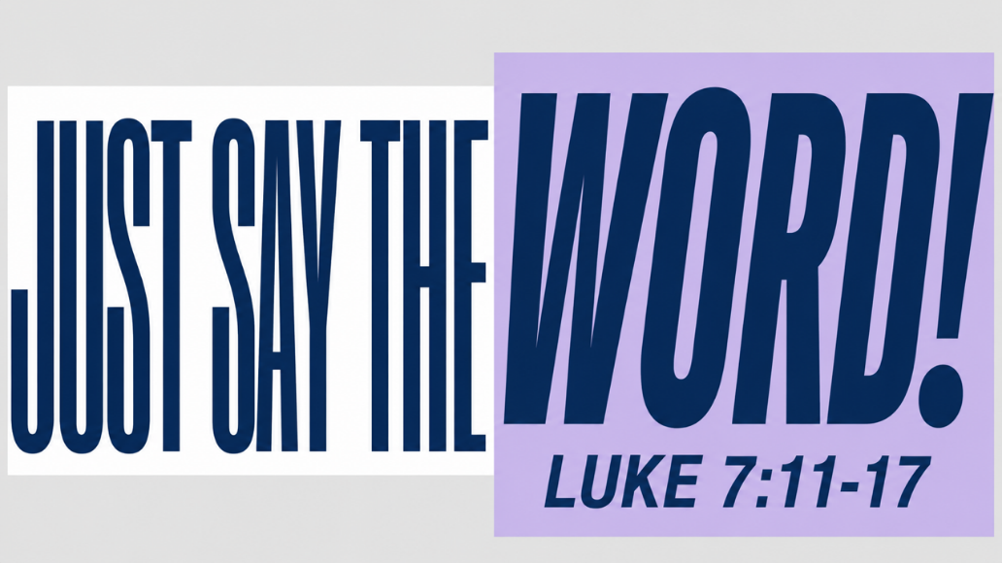

147 West Forest Street Clyde, Ohio

Prayer List
Vickie Aldrich
Gwendolyn Baughn
Molly Binder
Michelle Borodkin
Courtney Bouyack
Tim Cooper
Toni Dagg
Crew Dearth
Sharon Duskin
Becky Karr
Kris Larkins
Denise McCubbim
Matt Pumphrey
Maverick Salazar
Lindsay Sooy
Larry Sumner
Conner Whaley
Sandy Wott
Riley Recker
Larry Bower
Jim Shull
Dennis Gossett
Matt Woodland
Sandy Gray


* * * * * * * * * * * * * * * * * * * * * * * * * * * * * * * * * * * * * * * * * *
ALTAR FLOWERS

The altar flowers are given to the Glory of God by Diane Hurst in memory of her sister Mary Sedoti.
* * * * * * * * * * * * * * * * * * * * * * * * * * * * * * * * * * * * * * * * * *
Worship Board will not be meeting the month of August. Their next meeting will be September 10th at 6:00pm.
* * * * * * * * * * * * * * * * * * * * * * * * * * * * * * * * * * * * * * * * * *
* * * * * * * * * * * * * * * * * * * * * * * * * * * * * * * * * * * * * * * * * *


You will find a table in the Parish Hall filled with books that are offered free for the taking. Please visit the table and take as many as you wish. Happy Reading!
* * * * * * * * * * * * * * * * * * * * * * * * * * * * * * * * * * * * * * * * * *


August 2026
Sunday  9 | 8:00 am ~ Worship  10:30 am ~ Worship
Monday  10 | 6:30 pm ~ Co-Ed Bible Study
Tuesday  11 | 6:30 pm ~ Men’s Bible Study  6:00 pm ~ Property Board Meeting
Wednesday 12 | 6:00 pm ~ Women’s Bible Study
Thursday  13 | 5:00 pm ~ Evangelism Board Meeting  7:00 pm ~ Al-Anon Meeting  8:00 pm ~ AA Meeting
Friday
14
Saturday  15 | 8:00 am ~ Men’s Bible Study  5:00 pm ~ Worship
Sunday  16 | 8:00 am ~ Worship  10:30 am ~ Worship

August 1-2 Attendance: 150

10:30 Service
ACOLYTE: Keaton Cook
Owen Cook
USHERS: DeAnn Krauss
Tony Paradiso
Christina Lowe
Ada Williams
COUNTERS: Theresa Elfring
Christine Potts
Brandis Stout
Nursery Supervision:

Aug 9th - Jennie McCoy
Aug 16th - Dawn Sumner
Aug 23rd - Lisa Reiman
Aug 30th - Christine Potts

* * * * * * * * * * * * * * * * * * * * * * * * * * * * * * * * * * * *
Church Office Phone: 419-547-9225
Jamie Farrar Phone: 419-603-6731
sec@stpaulclyde.org
Pastor Samuel Dagg Phone: 567-342-2137
pastor@stpaulclyde.org
Matt Woodland ~ Council President Phone: 419-603-0567
prez@stpaulclyde.org
Jim Shull ~ Treasurer Phone: 419-355-6499
treas@stpaulclyde.org
Brian Farrar ~ P & W Leader Phone: 419-271-3085
pwl@stpaulclyde.org
Ashley Reed ~ Assistant Secretary asst.sec@stpaulclyde.org
Sherry Bouyack ~ Clerical Secretary fisec@stpaulclyde.org

Sermon Notes

