16th Sunday After Pentecost
Sunday September 13, 2026
10:30 am



147 West Forest Street Clyde, Ohio

Prayer List
Vickie Aldrich
Gwendolyn Baughn
Molly Binder
Michelle Borodkin
Courtney Bouyack
Tim Cooper
Toni Dagg
Crew Dearth
Sharon Duskin
Becky Karr
Kris Larkins
Denise McCubbin
Matt Pumphrey
Maverick Salazar
Lindsay Sooy
Larry Sumner
Conner Whaley
Sandy Wott
Dean Tea
Matt Woodland
Sandy Gray
Duane Kimmet
Deacon Norbert
Ray Wasson
Terry Langham

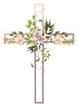
* * * * * * * * * * * * * * * * * * * * * * * * * * * * * * * * * * * * * * * * * *
ALTAR FLOWERS

The altar flowers are given to the Glory of God in honor of Mike and Danyelle Lantz's wedding anniversary on September 10th.
* * * * * * * * * * * * * * * * * * * * * * * * * * * * * * * * * * * * * * * * * *
Eucharistic Team Meeting
A Lay Communion Team meeting has been scheduled for
Tuesday, September 22nd, 2026 at 7 p.m. in the church lounge. If you are interested in becoming a Lay Communion Minister, you are welcome to join us. If you are aware of any member who may need visiting, please call Sherry Frasher at

419-765-7016.
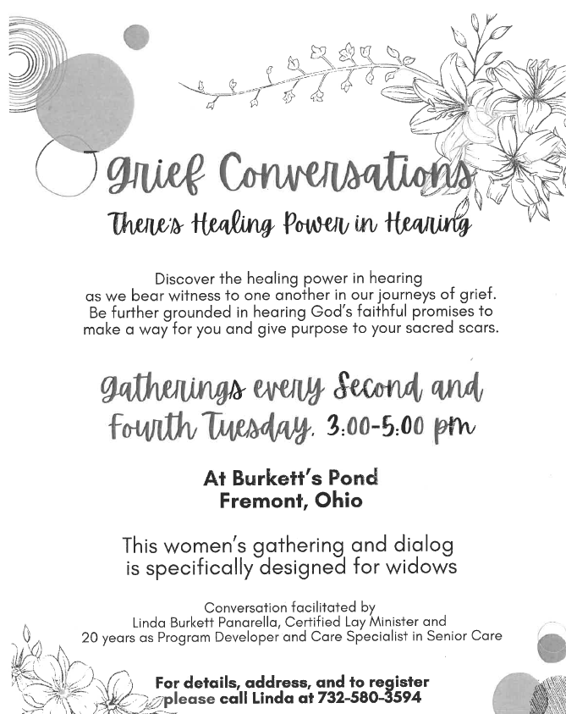
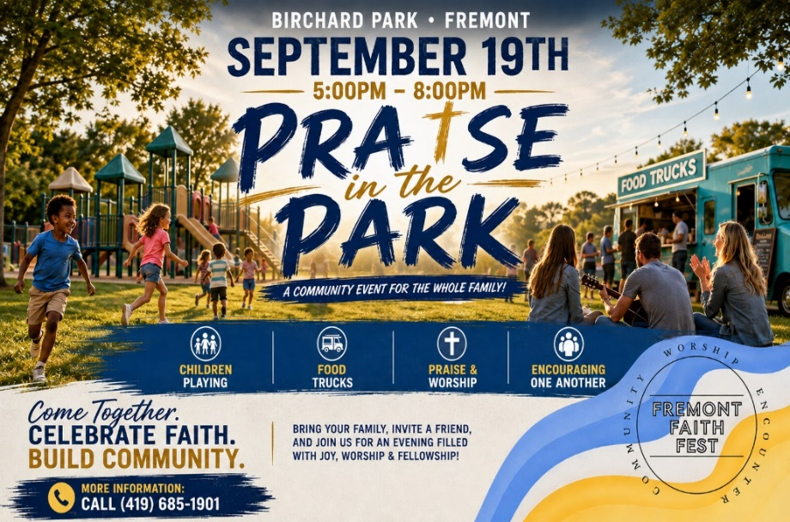

Sunday School Decorating Team
To the incredible volunteers who took on the task of decorating the hallway for our students to welcome them back, WOW! I can’t say enough! The amount of work, time, energy, thought and talent you all put into that job is AMAZING! The way you incorporated the lessons into real life visuals is fantastic! In my almost 30 years of working with our children, this absolutely tops the list for decorating. We are so blessed to have so much talent and willingness to help out in our church family. I thank and praise God dearly every day for you all. God bless you all!
With Love,
Tammy Baker



September 2026
Sunday  13 | 8:00 am ~ Worship  10:30 am ~ Worship
Monday  14 | 6:30 pm ~ Co-Ed Bible Study
Tuesday  15 | 6:30 pm ~ Men’s Bible Study  7:00 pm ~ Finance Meeting
Wednesday 16 | 6:00 pm ~ Women’s Bible Study  7:00 pm ~ Endowment Meeting
Thursday  17 | 7:00 pm ~ Council Meeting  7:00 pm ~ Al-Anon Meeting  8:00 pm ~ AA Meeting
Friday
18
Saturday  19 | 8:00 am ~ Men’s Bible Study  5:00 pm ~ Worship
Sunday  20 | 8:00 am ~ Worship  10:30 am ~ Worship
September 5-6 Attendance: 161

10:30 Service
ACOLYTE: Lilly Jones
Ben Riggs
USHERS: DeAnn Krauss
Tony Paradiso
Christina Lowe
Ada Williams
COUNTERS: Theresa Elfring
Christine Potts
Brandis Stout
Nursery Supervision:
Sept.13- Deanna Turner
Sept.20- Jenni McCoy
Sept. 27- Dawn Sumner

* * * * * * * * * * * * * * * * * * * * * * * * * * * * * * * * * * * *
Church Office Phone: 419-547-9225
Jamie Farrar Phone: 419-603-6731
sec@stpaulclyde.org
Pastor Samuel Dagg Phone: 567-342-2137
pastor@stpaulclyde.org
Matt Woodland ~ Council President Phone: 419-603-0567
prez@stpaulclyde.org
Jim Shull ~ Treasurer Phone: 419-355-6499
treas@stpaulclyde.org
Brian Farrar ~ P & W Leader Phone: 419-547-9225
pwl@stpaulclyde.org
Sherry Bouyack ~ Clerical Secretary fisec@stpaulclyde.org

Sermon Notes

