16th Sunday after Pentecost
Sunday September 13, 2026
8:00 am



147 West Forest Street Clyde, Ohio
Prelude, Bell & Announcements
Confession & Forgiveness Pg. 94
P: In the name of the Father, and of the ☩ Son, and of the Holy Spirit.
C: Amen.
P: God of all mercy and consolation, come to the help of your people, turning us from our sin to live for you alone. Give us the power of your Holy Spirit that we may confess our sin, receive your forgiveness and grow into the fullness of Jesus Christ, our Savior and Lord.
C: Amen.
P: Let us confess our sin in the presence of God and of one another.
P: Most merciful God,
C: We confess that we are captive to sin and cannot free ourselves. We have sinned against you in thought, word, and deed, by what we have done and by what we have left undone. We have not loved you with our whole heart; we have not loved our neighbors as ourselves. For the sake of your Son, Jesus Christ, have mercy on us. Forgive us, renew us, and lead us, so that we may delight in your will and walk in your ways, to the glory of your holy name. Amen.
P: God who is rich in mercy, loved us even when we were dead in sin, and made us alive together with Christ. By grace you have been saved. In the name of Jesus Christ, the entirety of your sins are forgiven. Almighty God strengthen you with power through the Holy Spirit, that Christ may live in your hearts through faith.
C: Amen.
Hymn “My Faith Looks Up to Thee” 4vs #759

The Apostolic Greeting Pg. 147
P: The grace of our Lord Jesus Christ, the love of God, and the communion of the Holy Spirit be with you all.
C: And also with you.
The Kyrie Pg. 147
P: In peace, let us pray to the Lord.
C: Lord, have mercy.
P: For the peace from above, and for our salvation, let us pray to the Lord.
C: Lord, have mercy.
P: For the peace of the whole world, for the well-being of the church of God, and for the unity of all, let us pray to the Lord.
C: Lord, have mercy.
P: For this holy house, and for all who offer here their worship and praise, let us pray to the Lord.
C: Lord, have mercy.
P: Help, save, comfort, and defend us gracious Lord.
C: Amen.
The Hymn of Praise Pg. 149
P: This is the feast of victory for our God. Alleluia.
Worthy is Christ, the Lamb who was slain, whose blood set us free to be people of God. Power and riches and wisdom and strength, and honor and blessing and glory are his.
This is the feast of victory for our God. Alleluia.
Sing with all the people of God and join in the hymn of all creation: Blessing and honor and glory and might be to God and the Lamb forever. Amen.
This is the feast of victory for our God, for the Lamb who was slain has begun his reign. Alleluia. Alleluia.
The Prayer of the Day
O Lord, help your people to avoid the infection of the evil one, and with pure hearts to follow you, our only Lord. Grant this, we pray, through Jesus Christ, your Son, our Lord, who lives and reigns with you and the Holy Spirit, one God, now and forever. Amen.
The First Reading: Job 38:1-11
¹Then the Lord answered Job out of the whirlwind and said: ²“Who is this that darkens counsel by words without knowledge? ³Dress for action like a man; I will question you, and you make it known to me. ⁴“Where were you when I laid the foundation of the earth? Tell me, if you have understanding.⁵Who determined its measurements—surely you know! Or who stretched the line upon it? ⁶On what were its bases sunk, or who laid its cornerstone, ⁷when the morning stars sang together and all the sons of God shouted for joy? ⁸“Or who shut in the sea with doors when it burst out from the womb, ⁹when I made clouds its garment and thick darkness its swaddling band, ¹⁰and prescribed limits for it and set bars and doors, ¹¹and said, ‘Thus far shall you come, and no farther, and here shall your proud waves be stayed’?
L: The Word of the Lord.
C: Thanks be to God.
Psalm 107:23-32
²³Some went down to the sea in ships, doing business on the great waters;
²⁴they saw the deeds of the Lord, his wondrous works in the deep.
²⁵For he commanded and raised the stormy wind, which lifted up the waves of the sea.
²⁶They mounted up to heaven; they went down to the depths; their courage melted away in their evil plight;
²⁷they reeled and staggered like drunken men and were at their wits’ end.
²⁸ Then they cried to the Lord in their trouble, and he delivered them from their distress.
²⁹He made the storm be still, and the waves of the sea were hushed.
³⁰Then they were glad that the waters were quiet, and he brought them to their desired haven.
³¹ Let them thank the Lord for his steadfast love, for his wondrous works to the children of man!
³²Let them extol him in the congregation of the people, and praise him in the assembly of the elders.
L: Here ends the reading of the Psalm.
C: Thanks be to God.
The Second Reading: 2 Corinthians 4:7–18
⁷But we have this treasure in jars of clay, to show that the surpassing power belongs to God and not to us. ⁸We are afflicted in very way, but not crushed; perplexed, but not driven to despair; ⁹persecuted, but not forsaken; struck down, but not destroyed; ¹⁰always carrying in the body the death of Jesus, so that the life of Jesus also may be manifested in our bodies. ¹¹For we who live are always being given over to death for Jesus’ sake, so that the life of Jesus also may be manifested in our mortal flesh. ¹²So death is at work in us, but life in you. ¹³Since we have the same spirit of faith according to what has been written, “I believed, and so I spoke,” we also believe, and so we also speak, ¹⁴knowing that he who raised the Lord Jesus will raise us also with Jesus and bring us with you into his presence. ¹⁵For it is all for your sake, so that as grace extends to more and more people it may increase thanksgiving, to the glory of God. ¹⁶So we do not lose heart. Though our outer self is wasting away, our inner self is being renewed day by day. ¹⁷For this light momentary affliction is preparing for us an eternal weight of glory beyond all comparison, ¹⁸as we look not to the things that are seen but to the things that are unseen. For the things that are seen are transient, but the things that are unseen are eternal.
L: The Word of the Lord.
C: Thanks be to God.
The Gospel Acclamation Pg. 151
Alleluia. Lord, to whom shall we go? You have the words of eternal life. Alleluia.
P: The Holy Gospel according to St. Luke, the 8th chapter.
C: Glory to You, O Lord.
The Gospel: Luke 8:22-25
²²One day he got into a boat with his disciples, and he said to them, “Let us go across to the other side of the lake.” So they set out, ²³and as they sailed he fell asleep. And a windstorm came down on the lake, and they were filling with water and were in danger. ²⁴And they went and woke him, saying, “Master, Master, we are perishing!” And he awoke and rebuked the wind and the raging waves, and they ceased, and there was a calm. ²⁵He said to them, “Where is your faith?” And they were afraid, and they marveled, saying to one another, “Who then is this, that he commands even winds and water, and they obey him?”
P: Gospel of the Lord
C: Praise to You, O Christ.
Sermon:
“Where Is Your Faith?”
Luke 8:22-25
Pastor Sam Dagg
The Hymn “Eternal Father Strong to Save” 4vs #756

Prayers of Intercession
Vickie Aldrich
Gwendolyn Baughn
Molly Binder
Michelle Borodkin
Courtney Bouyack
Tim Cooper
Toni Dagg
Crew Dearth
Sharon Duskin
Becky Karr
Kris Larkins
Denise McCubbin
Matt Pumphrey
Maverick Salazar
Lindsay Sooy
Larry Sumner
Conner Whaley
Sandy Wott
Dean Tea
Matt Woodland
Sandy Gray
Duane Kimmet
Deacon Norbert
Ray Wasson
Terry Langham
THE APOSTLES’ CREED (back cover of the hymnal)
The Peace of the Lord Pg. 152
P: The peace of the Lord be with you.
C: And also, with you.
The Passing of the Peace
The Offering
The Offering Prayer
Blessed are you, O God, maker of all things. Through your goodness you have blessed us with these gifts: our possessions. Use us, and what we have gathered, in feeding the world with your love, through the one who gave himself for us, Jesus Christ, our Savior and Lord. Amen.
The Great Thanksgiving Pg. 152
P: The Lord be with you.
C: And also, with you.
P: Lift up your hearts.
C: We lift them to the Lord.
P: Let us give thanks to the Lord our God.
C: It is right to give our thanks and praise.
The Proper Preface
P: It is indeed right, our duty and our joy, that we should at all times and in all places give thanks and praise to You, almighty and merciful God. You reveal Your glory as the glory of the Father, the Son, and the Holy Spirit; equal in majesty, undivided in splendor, one Lord, one God, ever to be adored in Your eternal glory. And so, with all the choirs of angels, with the church on earth and the hosts of heaven, we praise Your name and join their unending hymn:

C: Holy, holy, holy Lord,
Lord God of power and might,
heav’n and earth are full of your glory.
Hosanna in the highest.
Blessed is he who comes in the name of the Lord.
Hosanna in the highest.
The Words of Institution
The Lord’s Prayer Pg. 154
P: Gathered into one by the Holy Spirit, let us pray as Jesus taught us.
C: Our Father, Who art in heaven, hallowed be Thy name, Thy kingdom come, Thy will be done, on earth as it is in heaven. Give us this day our daily bread; and forgive us our trespasses, as we forgive those who trespass against us; and lead us not into temptation, but deliver us from evil. For Thine is the kingdom, and the power, and the glory, forever and ever. Amen.
Invitation to Communion Pg. 154 P: Come to the banquet, for all is now ready.
Holy Communion
All baptized believers in Jesus Christ as Lord are invited to receive communion today. Please follow the pastor’s instructions.
The Post Communion Blessing
P: The body and blood of our Lord Jesus Christ strengthen you and keep you in His grace.
C: Amen.
Prayer After Communion
P: Let us pray.
C: O God, we give You thanks that You have set before us this feast, the body and blood of Your Son. By Your Spirit strengthen us to serve all in need and to give ourselves away as bread for the hungry, through Jesus Christ our Lord. Amen.
The Hymn “Jesus Savior Pilot Me” 3vs #755
The Benediction
P: May the Lord bless you and keep you;
the Lord make his face shine on you and be gracious to you;
the Lord turn his face toward you and give you peace.
In the name of the Father,
and of the ☩ Son,
and of the Holy Spirit.
C: Amen.
The Dismissal
P: GO IN PEACE. SERVE THE LORD!
C: Thanks be to God.
The Postlude


ALTAR FLOWERS
The altar flowers are given to the Glory of God in honor of Mike and Danyelle Lantz's wedding anniversary on September 10th.
* * * * * * * * * * * * * * * * * * * * * * * * * * * * * * * * * * * * * * * * *

Eucharistic Team Meeting

A Lay Communion Team meeting has been scheduled for
Tuesday, September 22nd, 2026 at 7 p.m. in the church lounge. If you are interested in becoming a Lay Communion Minister, you are welcome to join us. If you are aware of any member who may need visiting, please call Sherry Frasher at
419-765-7016.
* * * * * * * * * * * * * * * * * * * * * * * * * * * * * * * * * * * * * * * * *

Sunday School Decorating Team
To the incredible volunteers who took on the task of decorating the hallway for our students to welcome them back, WOW! I can’t say enough! The amount of work, time, energy, thought and talent you all put into that job is AMAZING! The way you incorporated the lessons into real life visuals is fantastic! In my almost 30 years of working with our children, this absolutely tops the list for decorating. We are so blessed to have so much talent and willingness to help out in our church family. I thank and praise God dearly every day for you all. God bless you all!
With Love,
Tammy Baker
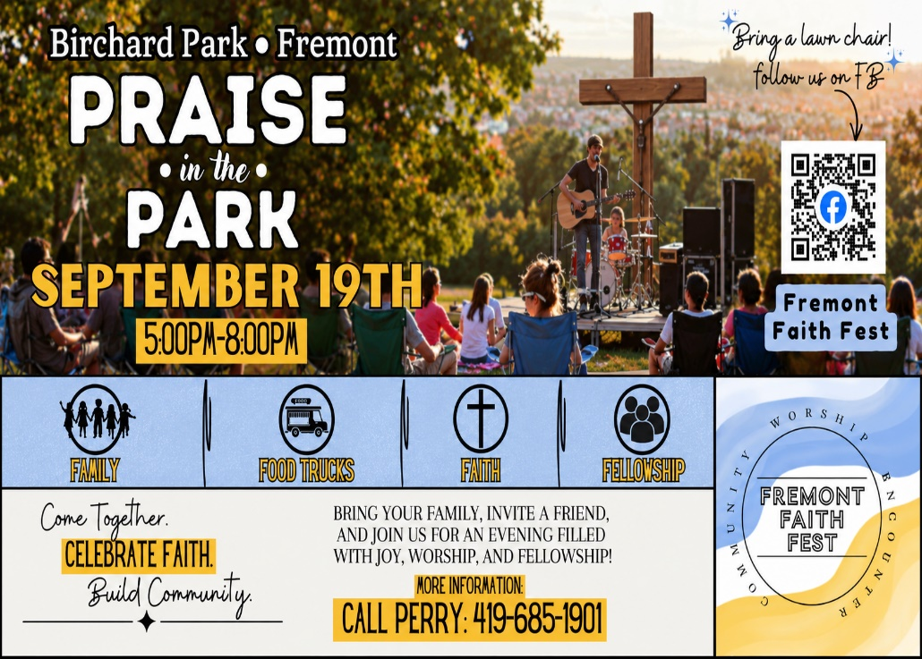

September 2026
Sunday  13 | 8:00 am ~ Worship  10:30 am ~ Worship
Monday  14 | 6:30 pm ~ Co-Ed Bible Study
Tuesday  15 | 6:30 pm ~ Men’s Bible Study  7:00 pm ~ Finance Meeting
Wednesday 16 | 6:00 pm ~ Women’s Bible Study  7:00 pm ~ Endowment Meeting
Thursday  17 | 7:00 pm ~ Council Meeting  7:00 pm ~ Al-Anon Meeting  8:00 pm ~ AA Meeting
Friday
18
Saturday  19 | 8:00 am ~ Men’s Bible Study  5:00 pm ~ Worship
Sunday  20 | 8:00 am ~ Worship  10:30 am ~ Worship
September 5-6 Attendance: 161

8:00 am Service
COMPUTER TECH: Barb Wahl
READER: Diane Hurst
USHERS: Tim Billings
Jeff Haughawout
Diane Hurst
Bob Kessler

* * * * * * * * * * * * * * * * * * * * * * * * * * * * * * * * * * * * * * * * *
Church Office Phone: 419-547-9225
Jamie Farrar Phone: 419-603-6731
sec@stpaulclyde.org
Pastor Samuel Dagg Phone: 567-342-2137
pastor@stpaulclyde.org
Matt Woodland ~ Council President Phone: 419-603-0567
prez@stpaulclyde.org
Jim Shull ~ Treasurer Phone: 419-355-6499
treas@stpaulclyde.org
Brian Farrar ~ P & W Leader Phone: 419-547-9225
pwl@stpaulclyde.org
Sherry Bouyack ~ Clerical Secretary fisec@stpaulclyde.org
Organist
Mary Ellen Wollenslegel
* * * * * * * * * * * * * * * * * * * * * * * * * * * * * * * * * * * * *
Sermon Notes

